**RELATIONSHIP AND VIEWS IN POWER BI REPORT**

**Introduction**

* **Purpose**: The purpose of this Power BI dashboard is to provide an analytical view of sales data, enabling the team to track key metrics such as weekly orders, customer engagement, and product performance. The dashboard is intended to help the business make data-driven decisions, optimize sales strategies, and improve customer satisfaction.
* **Data Source**: The dashboard pulls data from the Sales_Analysis_Report dataset, which contains Sales_Orders, Customer_Data, Region_Data, and Products_Data tablestaken from Kaggle.

**Key Insights**



**Total Orders**

**Description**: This KPI displays the total count i.e 2510 of orders placed within the selected period. It is a crucial metric that provides insight into overall demand and customer activity. Tracking total orders over time helps identify growth trends, peak ordering periods, and any sudden drops or spikes that might indicate issues or opportunities.

**Average Order Quantity**

**Description**: This KPI shows the average quantity of items per order i.e. 8.41. It is helpful for understanding customer purchasing patterns and preferences. A higher average order quantity might indicate bulk purchases or successful promotions targeting larger orders, while a lower value could suggest individual or smaller purchases. Monitoring this KPI over time aids in inventory planning and sales strategy adjustments.

**Total Customers**

**Description**: This KPI represents the total number of unique customers i.e. 50 placing orders. It provides an overview of customer reach and engagement levels. Increasing total customers over time is a positive sign of market expansion, while any declines may suggest a need for enhanced customer acquisition and retention strategies.

**Total Products**

**Description**: This KPI indicates the number of distinct products sold i.e. 15. This metric helps track the diversity of product offerings and customer interest in different products. A broad product range can attract a wider customer base, whereas a more focused range might appeal to specific customer segments. Monitoring this KPI supports product portfolio management and guides potential expansion or consolidation efforts.

**Total Regions**

**Description**: This KPI shows the number of regions i.e. 100 where orders were placed. It helps measure geographic reach and market penetration. Higher values indicate a broader market presence, which can be crucial for understanding regional demand and planning localized marketing or sales strategies. Analyzing regional coverage over time can also help identify growth opportunities in new areas.

**Total Warehouses**

**Description**: This KPI represents the total count of warehouses i.e. 4 involved in fulfilling orders. It is a key measure for logistics and supply chain efficiency. Monitoring this KPI helps ensure that warehousing resources are aligned with order volumes and geographic demand. It also aids in evaluating whether the current number of warehouses optimally supports the business’s distribution network.

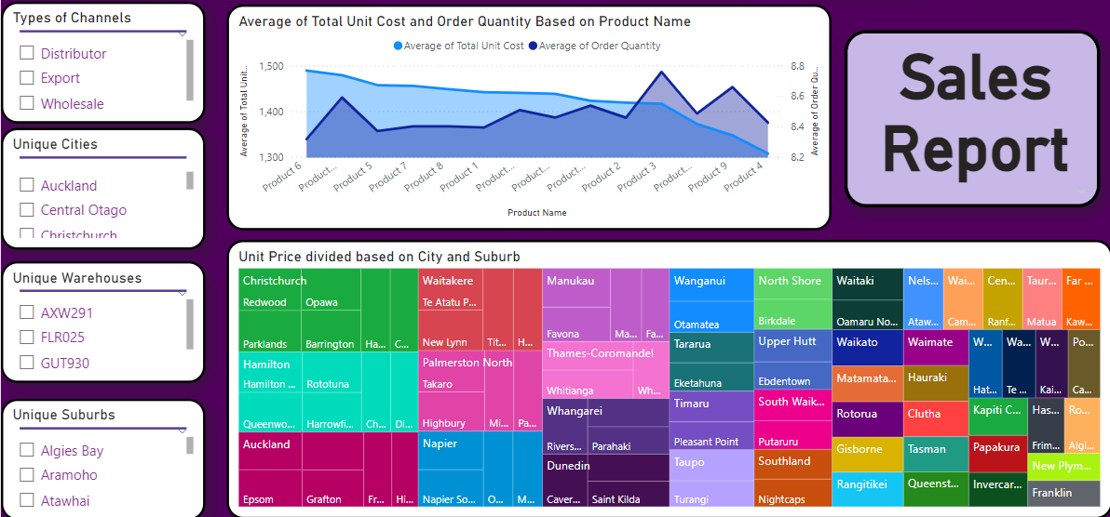

The lower half of the first page contains certain slicers to help the user investigate the types of channels, I,e, different types of uses of the products sold, unique cities i.e. all different cities the products are supplied to, and similarly the unique warehouses were the products are made, and the suburbs which is a division of the cities the products are sold to.

**Visualizations**

**Area Chart: Average of Total Unit Cost and Average of Order Quantity by Product Name**

**Description:** This area chart displays the average total unit cost and the average order quantity for each product. It provides a visual comparison between the cost of products and how frequently they are ordered. By observing the height and width of the areas in the chart, viewers can quickly identify products with high costs and high order volumes. This visualization helps in understanding cost-effectiveness and product popularity.

**Tree Map: Average of Unit Price by City and Suburb**

**Description**: This tree map shows the average unit price of products, organized by city and suburb. Each rectangle represents a suburb within a city, with the size indicating the relative level of average unit price. The colour intensity within each rectangle further emphasizes variations in price, with darker shades indicating higher average prices. This visualization allows for a quick assessment of price distribution across different regions and helps identify areas where products are priced higher or lower on average.

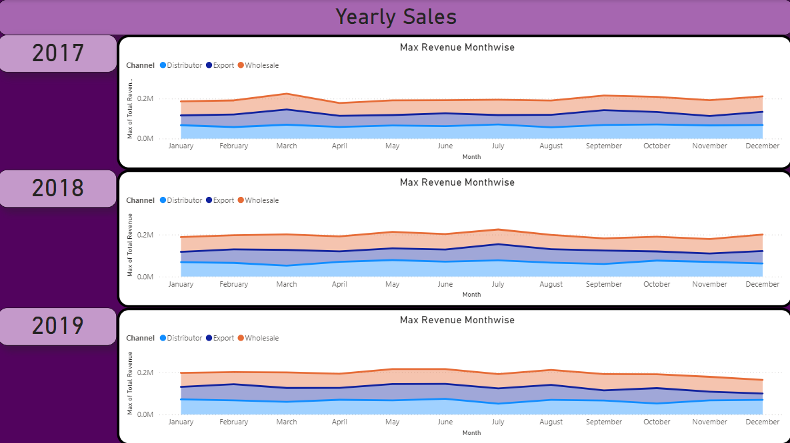

**Monthly Sales Analysis (2017-2019)**

**Description**: This page of the report visualizes the monthly sales performance of Superstore Mart across three years: 2017, 2018, and 2019. By analyzing monthly sales figures year-over-year, we can identify trends, seasonal patterns, and growth or decline in sales across specific months. Each year’s data is displayed separately to make it easier to compare and contrast monthly performance without the overlap of combined data.

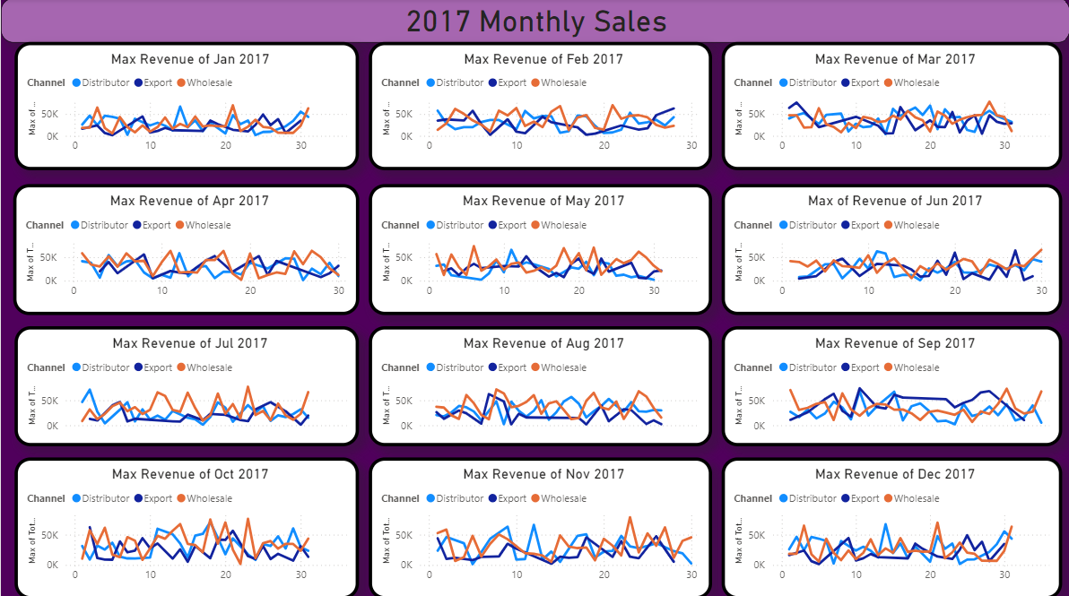

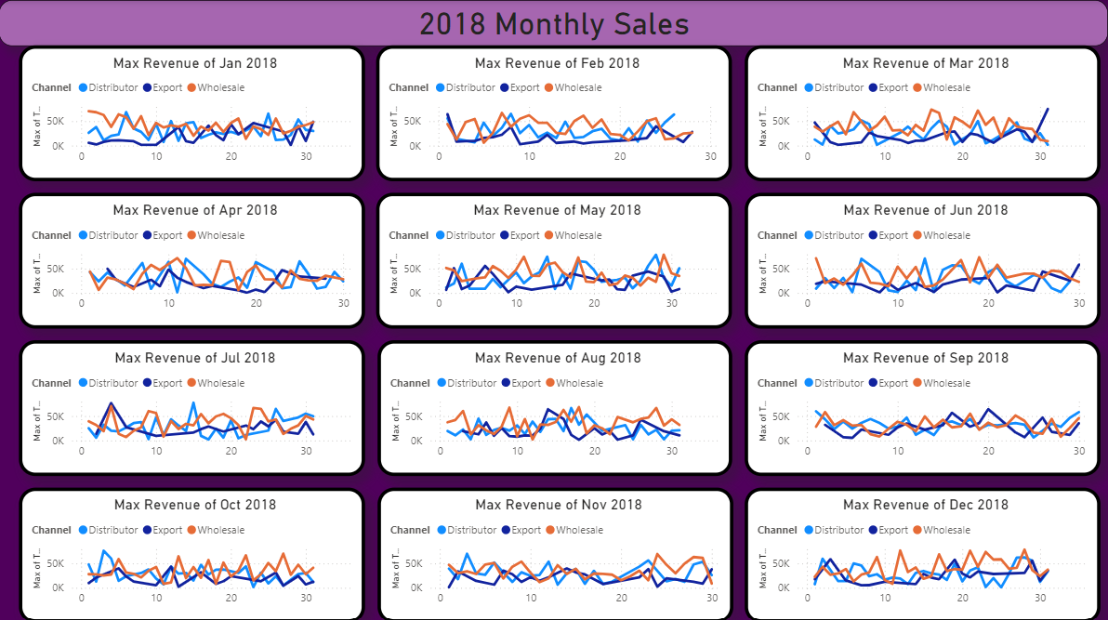

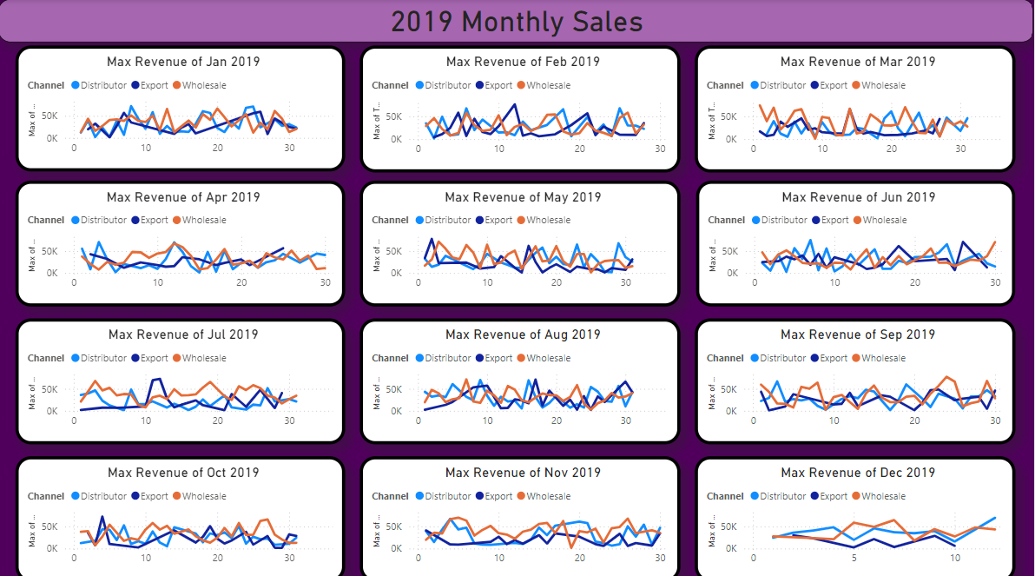

**Yearly Sales Analysis (2017, 2018, 2019) - Max of Total Revenue by Day and Channel**

**Description**: Each of these three pages provides a detailed look at daily sales for a specific year (2017, 2018, or 2019) at Superstore Mart. The line chart tracks the maximum total revenue achieved each day, segmented by sales channel. By analyzing daily revenue peaks, this visualization offers insights into high-performing channels and highlights daily sales trends.

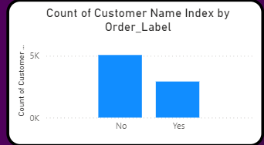

**Bulk Orders by Unique Customer Count**

**Description**: This bar chart displays the number of unique customers based on whether their orders are categorized as bulk ("Yes") or not ("No"). A bulk order is defined as an order with a quantity greater than nine. By showing the unique customer count for both bulk and non-bulk orders, this chart provides insight into customer purchasing behaviour and order size preferences.

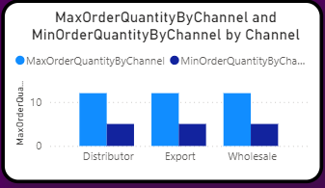

**Maximum Order Quantity by Channel**

**Description**: This donut chart illustrates the maximum order quantity across different sales channels, providing a snapshot of where the largest orders are being placed. Each segment of the chart represents a channel, with its size proportional to the highest quantity ordered through that channel. This visualization helps highlight which channels are driving the largest individual orders and offers insight into channel-specific customer behavior.

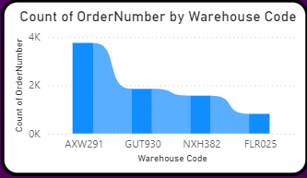

**Minimum Total Unit Cost by Warehouse**

**Description**: This pie chart displays the minimum total unit cost across different warehouses, represented by their warehouse codes. Each slice of the pie corresponds to a specific warehouse and reflects the lowest unit cost recorded for products handled by that location. By showing the minimum unit costs by warehouse, this chart provides insight into cost variations across warehouses, highlighting the locations with the most cost-effective handling.

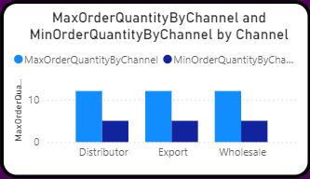

**Max Order Quantity by Channel**

**Description**: This metric displays the highest number of units ordered in a single transaction across each sales channel. It helps identify which channels handle the largest bulk orders, offering insights into demand patterns and inventory needs for each distribution method.

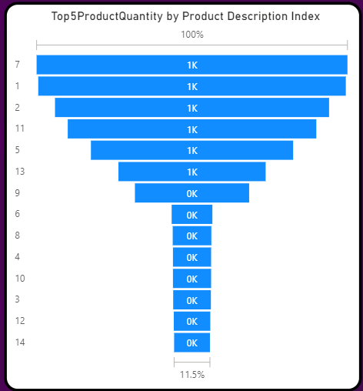

**Top 5 Product Quantity by Product Description Index**:

**Description**: This metric lists the top five products with the highest sales quantity, organized by product description index, giving a clear view of best-selling products. This helps in understanding customer preferences and prioritizing stock for the most popular items.counts fluctuate over time. This visualization helps to highlight weekly customer engagement and identify seasonal trends or shifts in customer activity.