**Global Market Dashboard Report**

**Introduction**

The Global Market Dashboard provides an interactive view of global stock market data, sourced from Kaggle. It includes key metrics such as stock prices, trading volumes, and market trends, all processed and enhanced using DAX functions to create calculated columns like daily gains, percent changes, and investment targets. The data is modeled efficiently with relationships between fact and dimension tables to ensure optimal query performance.

**Data Preprocessing**

The dataset was cleaned by removing duplicates and handling missing values. Calculated columns were created using DAX to track daily gains/losses, percent changes, and other important metrics like moving averages. These calculations enhanced the dataset’s value and made the data more insightful for analysis.

**Data Modeling**

The data model used a star schema with fact tables for stock market data and dimension tables for tickers, dates, and industries. Relationships were carefully structured to ensure that all relevant metrics could be linked together and analyzed effectively, supporting both high performance and detailed analysis.

**Data Visualization**

Power BI was used to create interactive charts, KPIs, and slicers. Visualizations include line charts, bar charts, pie charts, and candlestick charts to help users quickly interpret market trends, stock performance, and the correlation between various factors. Slicers allow users to filter data dynamically, providing tailored views for different time periods, tickers, industries, and other criteria.

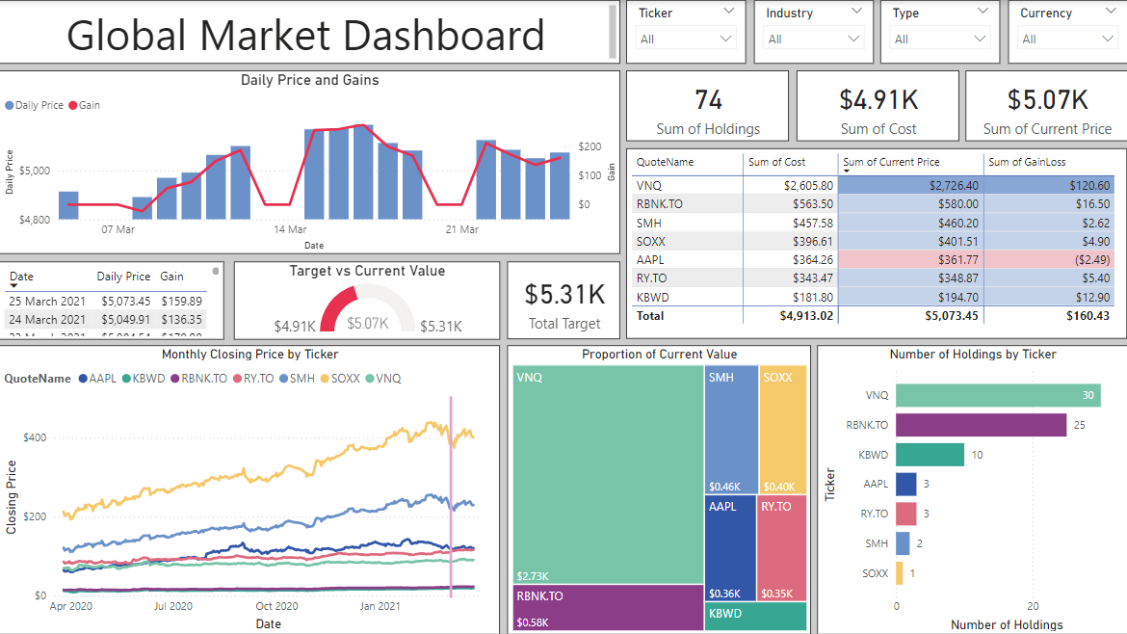

**1. Global Market Dashboard**

This section provides an interactive overview of portfolio performance, featuring key indicators such as Total Holdings, Cost, Current Price, and Target Value. Users can filter the data using slicers for ticker, industry, and currency type to view the relevant data based on their specific interests. The visualizations include:

* **Daily Price vs. Gain Graph:** A line or bar graph that tracks daily price movements alongside the calculated gain or loss, giving users a clear picture of the daily performance of the stocks.
* **Comparative Graph (Target vs. Current vs. Gain/Loss):** A bar chart that compares the target value, current value, and the gain or loss of the investments, allowing users to quickly assess how their portfolio is performing compared to their goals.
* **Proportion of Current Price by Ticker:** A pie chart or bar chart showing the proportion of the total portfolio value represented by each ticker. This helps users understand which stocks are contributing most to the portfolio's value.
* **Monthly Closing Price by Ticker:** A line chart displaying the historical closing price trends of each ticker over the months, enabling users to analyze long-term price movements.
* **Detailed Data Table:** This table includes detailed information on each stock, such as quote name, sum of cost, sum of current price, and gain or loss, providing users with a granular view of their portfolio’s performance.

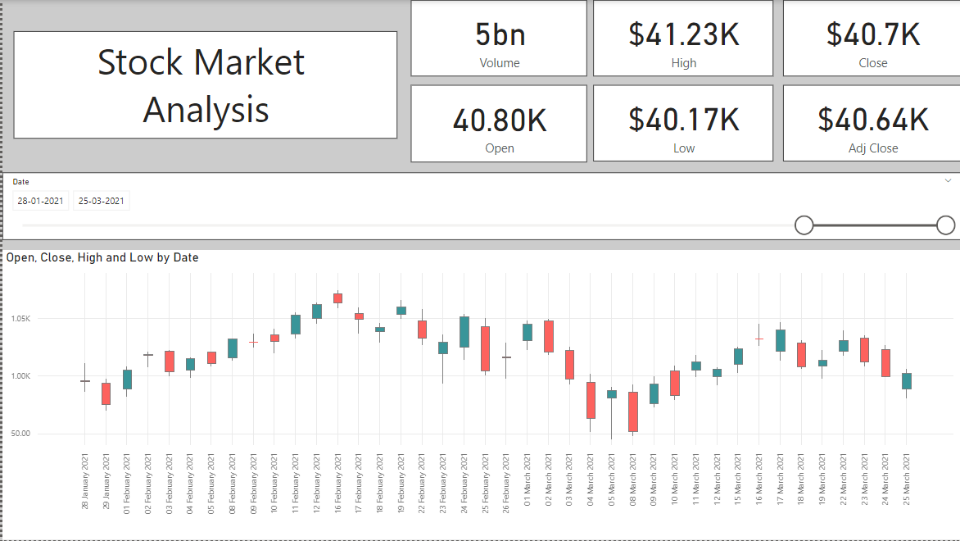

**2. Stock Market Analysis**

The Stock Market Analysis section dives into the individual stock performance, with KPIs and charts that provide insights into various aspects of market behavior:

* **KPIs:** These include Volume, High, Low, Open, Close, and Adjusted Close prices, providing a snapshot of stock activity over a given period.
* **Candlestick Chart:** This interactive chart displays the daily price movement of stocks using the open, high, low, and close values. The chart includes a date slicer, which allows users to narrow the view to specific periods. The candlestick visualization helps to identify trends, reversals, and market sentiment over time.

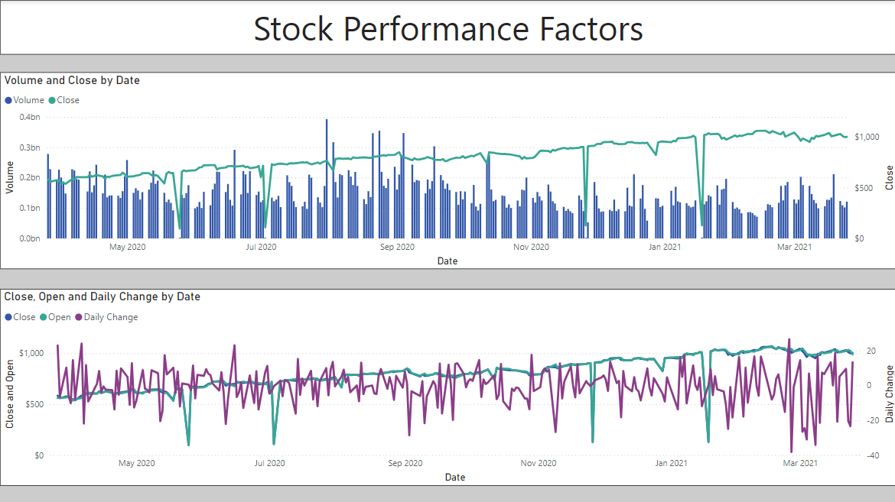

**3. Stock Market Performance Factors**

This section highlights the factors influencing stock price fluctuations and market trends, providing additional insights into trading behavior and volatility:

* **Volume and Close Price by Date:** A line chart that shows the relationship between volume and closing price over time. This visualization helps users understand how trading volume correlates with price movements and market activity.
* **Close vs. Open Price & Daily Change by Date:** This multi-line chart compares closing and opening prices for each day and shows the daily price change. It helps users identify daily price fluctuations and understand the market volatility on a day-to-day basis.