**Quantum-based refinement of the conformer problem**

Q|R team

**Abstract**

Quantum-based refinement utilized chemical restraints derived from quantum chemical methods, instead of the standard parameterized restraints used in refinement packages. This study, we introduce the conformers dataset……………………. They contain conformers,

**Keywords**: quantum refinement, multiple conformations, structural biology, X-ray diffraction, neutron diffraction, cryo-EM, CCTBX.

1. **Introduction**

First, why we need to solve alt-loc problem?

Most protein contain alt-loc

**However, a major problem** **with quantum** [**refinement**](https://reference.iucr.org/dictionary/Refinement) **has been that it could not deal with multiple conformations within the QM system.**

**As the split of the side chain “dilutes” the electron density in each branch by 1/n, disordered side chains with many n fluctuating positions are not distinct in electron density.**

Second, why we do Quantum refinement, introduction about Q|R project, there are several groups are doing quantum refinement using different method, like Ryde*1*, Min Zheng*2, 3*

Multiple conformations are frequently seen in crystal structures, especially for metal sites, either because the original sample is not in a pure state or owing to photo-reduction during data collection. Quantum refinement is a powerful technique for detecting the presence of multiple conformations, characterized by the fact that no single structural interpretation fits the crystallographic data satisfactorily .(Copy from Cao, L., and Ryde, U. (2020) Quantum refinement with multiple conformations.)

Here, we suggest a solution for this problem by implementing quantum refinement with multiple conformations in the QM system. Such an approach requires two QM calculations, one of each state, but the implementation is otherwise straightforward. We apply it to the 3nir.

1. **Methods**

In this study, we select one model that contain alt-locs, showing the Q|R is capable with protein contain conformers, also showing the improve after quantum refinement.

Why we choose 3nir, (@Pavel)

3nir paper*4*

High resolution with bad quality, also a lot of alt-locs

The Strategy of Q|R deal with different conformers.

1. **Results and Discussion**

Res 22 and res 25, which is 2 conformers but different residue, can be a point to discuss.

1. **Conclusions**

**Acknowledgments**

This work was enabled by the financial support from the National Natural Science Foundation of China (Grant No. 31870738).

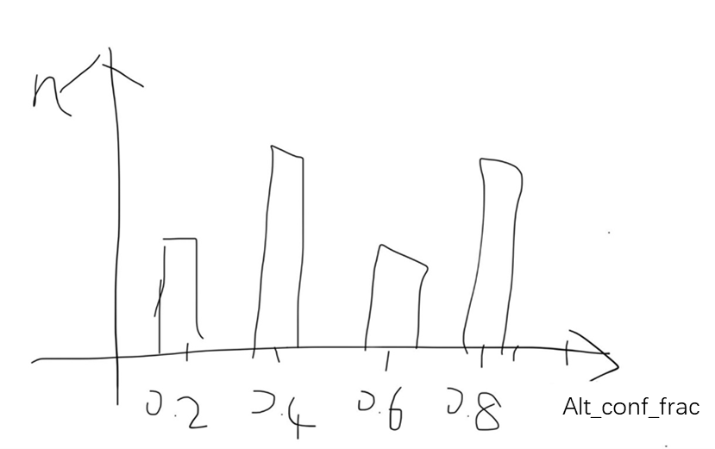

**Fig. 1** The fraction in RCSB PDB contain conformers

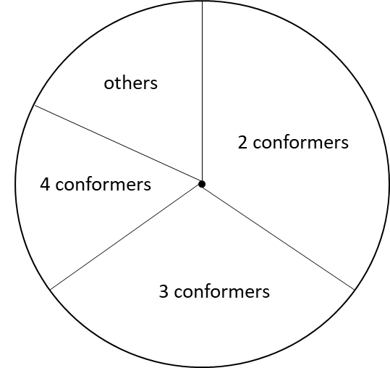

**Fig. 2** The plot showing most conformers is 2 conformers or 3 conformers

**References**

[1] Cao, L., and Ryde, U. (2020) Quantum refinement with multiple conformations: application to the P-cluster in nitrogenase, *Acta Crystallogr D* *76*, 1145-1156.

[2] Zheng, M., Reimers, J. R., Waller, M. P., and Afonine, P. V. (2017) Q|R: quantum-based refinement, *Acta Crystallogr D Struct Biol* *73*, 45-52.

[3] Zheng, M., Moriarty, N. W., Xu, Y., Reimers, J. R., Afonine, P. V., and Waller, M. P. (2017) Solving the scalability issue in quantum-based refinement: Q|R#1, *Acta Crystallogr D Struct Biol* *73*, 1020-1028.

[4] Schmidt, A., Teeter, M., Weckert, E., and Lamzin, V. S. (2011) Crystal structure of small protein crambin at 0.48 A resolution, *Acta Crystallogr Sect F Struct Biol Cryst Commun* *67*, 424-428.