I2CoverHisport 链路验证报告
- 修改root.sr打桩
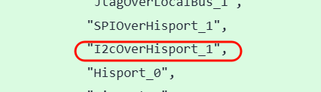
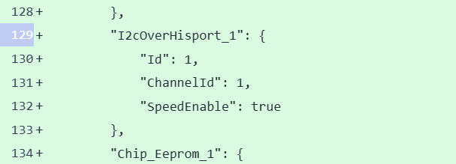
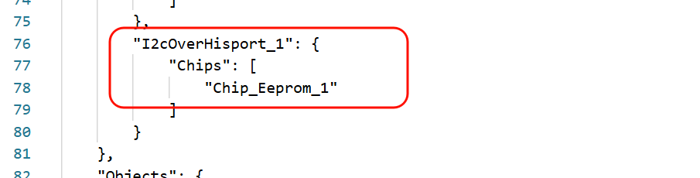
打桩路径: complex chip(Chip_Eeprom_1) -> I2cOverHisport_1 -> I2C内存桩模拟

- 下沉版本打桩 (在hisport驱动中模拟i2c内存桩), 代理子器件的读写访问
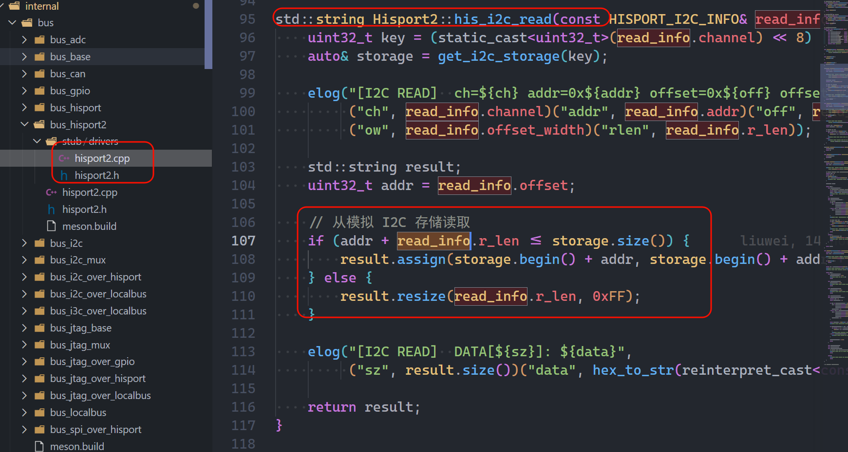
- 黄区lua打桩

- 测试脚本
主要测试命令:

# ── 设备检查 ──
busctl --user introspect bmc.kepler.hwproxy /bmc/kepler/Chip/Complex/Chip_Eeprom_1_01

# ── BlockIO 接口 ──
# Write: 写入 8 字节到偏移 256
busctl --user call bmc.kepler.hwproxy /bmc/kepler/Chip/Complex/Chip_Eeprom_1_01 bmc.kepler.Chip.BlockIO Write "a{ss}uay" 0 256 8 222 173 190 239 1 2 3 4

# Read: 从偏移 256 读取 8 字节
busctl --user call bmc.kepler.hwproxy /bmc/kepler/Chip/Complex/Chip_Eeprom_1_01 bmc.kepler.Chip.BlockIO Read "a{ss}uu" 0 256 8

# ── BitIO 接口 ──
# Write: 写入 1 字节 (0xCC) 到偏移 512, mask=0xFF
busctl --user call bmc.kepler.hwproxy /bmc/kepler/Chip/Complex/Chip_Eeprom_1_01 bmc.kepler.Chip.BitIO Write "a{ss}uyuay" 0 512 1 0xff 1 204

# Read: 从偏移 512 读取 1 字节, mask=0xFF
busctl --user call bmc.kepler.hwproxy /bmc/kepler/Chip/Complex/Chip_Eeprom_1_01 bmc.kepler.Chip.BitIO Read "a{ss}uyu" 0 512 1 0xff

# Read: 从偏移 512 读取 1 字节低4位, mask=0x0F
busctl --user call bmc.kepler.hwproxy /bmc/kepler/Chip/Complex/Chip_Eeprom_1_01 bmc.kepler.Chip.BitIO Read "a{ss}uyu" 0 512 1 0x0f

# ── bmc.kepler.Chip 属性 ──
# HealthStatus
busctl --user get-property bmc.kepler.hwproxy /bmc/kepler/Chip/Complex/Chip_Eeprom_1_01 bmc.kepler.Chip HealthStatus

# LockStatus
busctl --user get-property bmc.kepler.hwproxy /bmc/kepler/Chip/Complex/Chip_Eeprom_1_01 bmc.kepler.Chip LockStatus

# ── SetAccessibility ──
# 禁用访问 2 秒
busctl --user call bmc.kepler.hwproxy /bmc/kepler/Chip/Complex/Chip_Eeprom_1_01 bmc.kepler.Chip SetAccessibility "a{ss}a{ss}bq" 1 "Requestor" "TestClient" 1 "Requestor" "TestClient" false 2

# 恢复访问
busctl --user call bmc.kepler.hwproxy /bmc/kepler/Chip/Complex/Chip_Eeprom_1_01 bmc.kepler.Chip SetAccessibility "a{ss}a{ss}bq" 1 "Requestor" "TestClient" 1 "Requestor" "TestClient" true 1

# ── SetLockStatus ──
# ClientA 锁定 (op_type=1, lock_time=30)
busctl --user call bmc.kepler.hwproxy /bmc/kepler/Chip/Complex/Chip_Eeprom_1_01 bmc.kepler.Chip SetLockStatus "a{ss}a{ss}yu" 1 "Requestor" "ClientA" 1 "Requestor" "ClientA" 1 30

# ClientA 续锁 (lock_time=60)
busctl --user call bmc.kepler.hwproxy /bmc/kepler/Chip/Complex/Chip_Eeprom_1_01 bmc.kepler.Chip SetLockStatus "a{ss}a{ss}yu" 1 "Requestor" "ClientA" 1 "Requestor" "ClientA" 1 60

# ClientB 解锁 (应返回 3=RequestorMismatched)
busctl --user call bmc.kepler.hwproxy /bmc/kepler/Chip/Complex/Chip_Eeprom_1_01 bmc.kepler.Chip SetLockStatus "a{ss}a{ss}yu" 1 "Requestor" "ClientB" 1 "Requestor" "ClientB" 0 0

# ClientA 解锁 (应返回 0=OK)
busctl --user call bmc.kepler.hwproxy /bmc/kepler/Chip/Complex/Chip_Eeprom_1_01 bmc.kepler.Chip SetLockStatus "a{ss}a{ss}yu" 1 "Requestor" "ClientA" 1 "Requestor" "ClientA" 0 0

# ClientA 重复解锁 (应返回 2=AlreadyUnlocked)
busctl --user call bmc.kepler.hwproxy /bmc/kepler/Chip/Complex/Chip_Eeprom_1_01 bmc.kepler.Chip SetLockStatus "a{ss}a{ss}yu" 1 "Requestor" "ClientA" 1 "Requestor" "ClientA" 0 0

# 超时锁定 lock_time=1801 (应返回 1=InvalidParameter)
busctl --user call bmc.kepler.hwproxy /bmc/kepler/Chip/Complex/Chip_Eeprom_1_01 bmc.kepler.Chip SetLockStatus "a{ss}a{ss}yu" 1 "Requestor" "ClientA" 1 "Requestor" "ClientA" 1 1801

- 蓝区下沉版本测试结果:
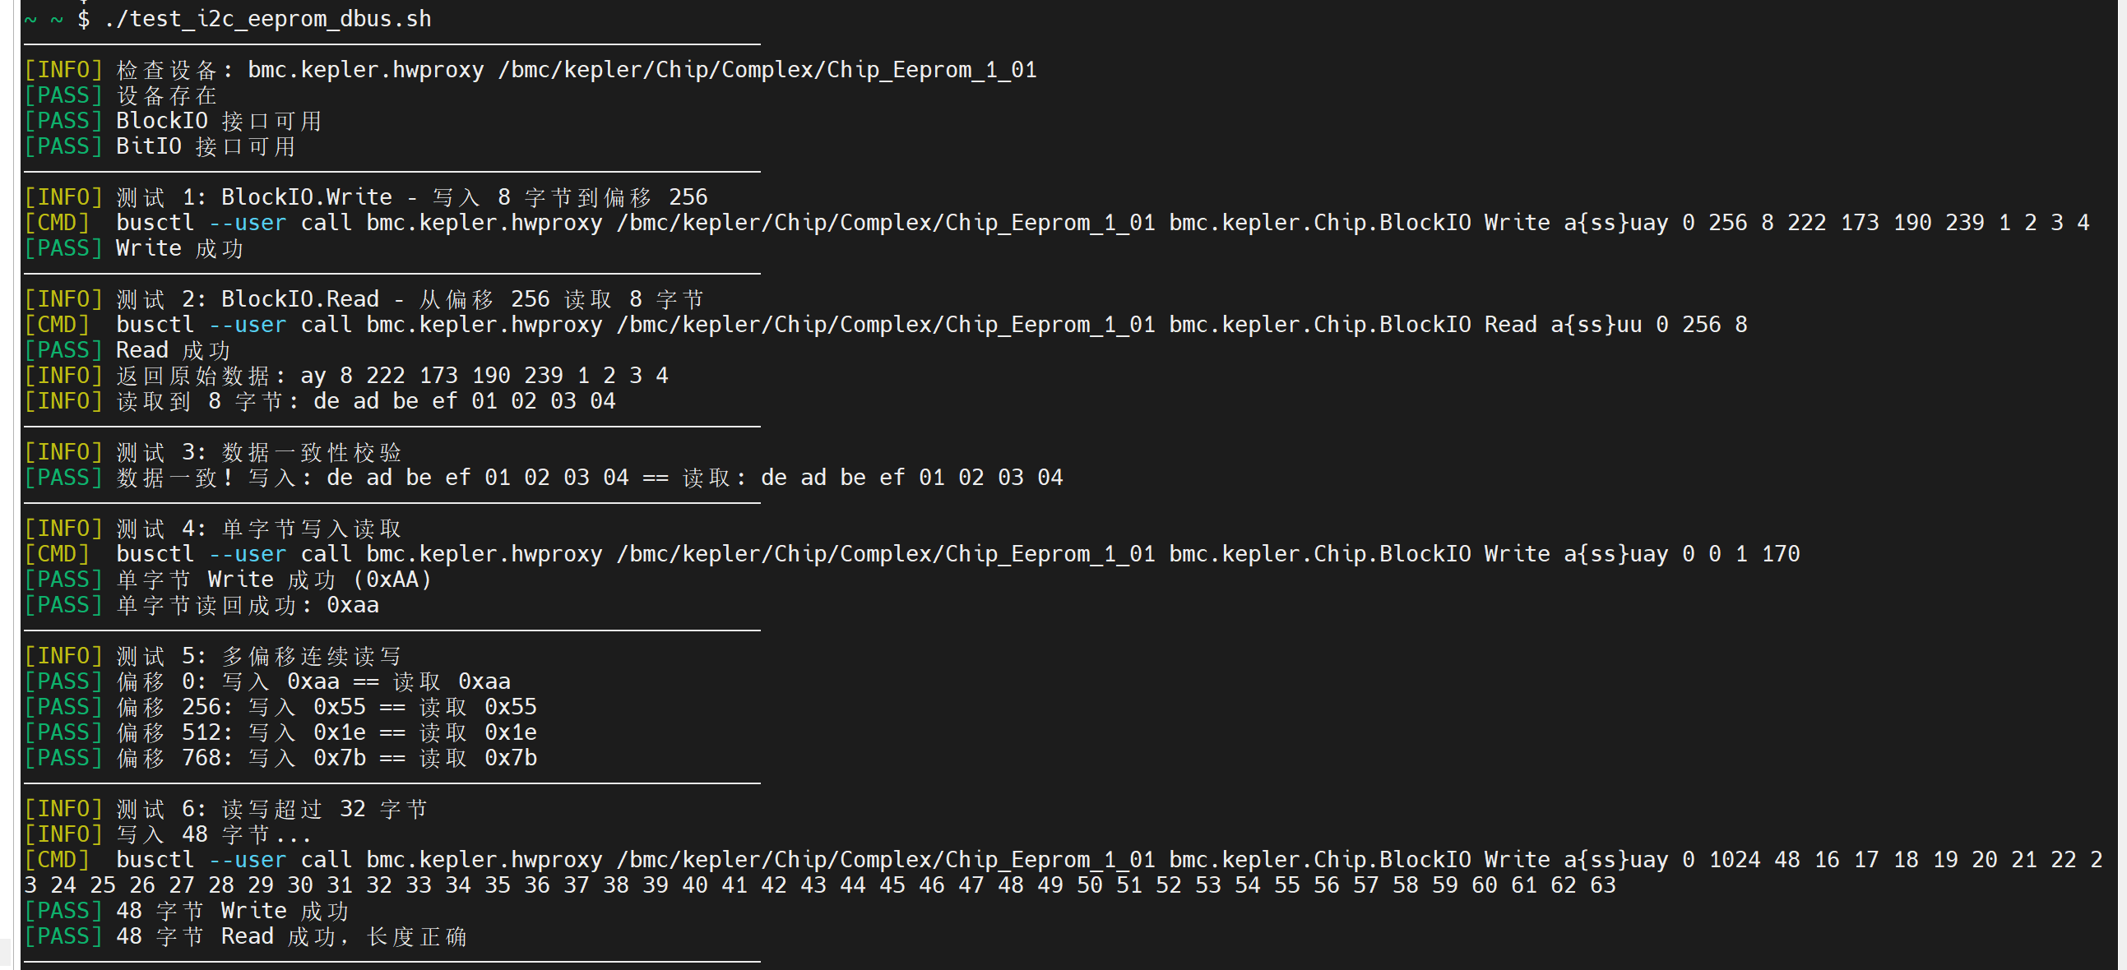
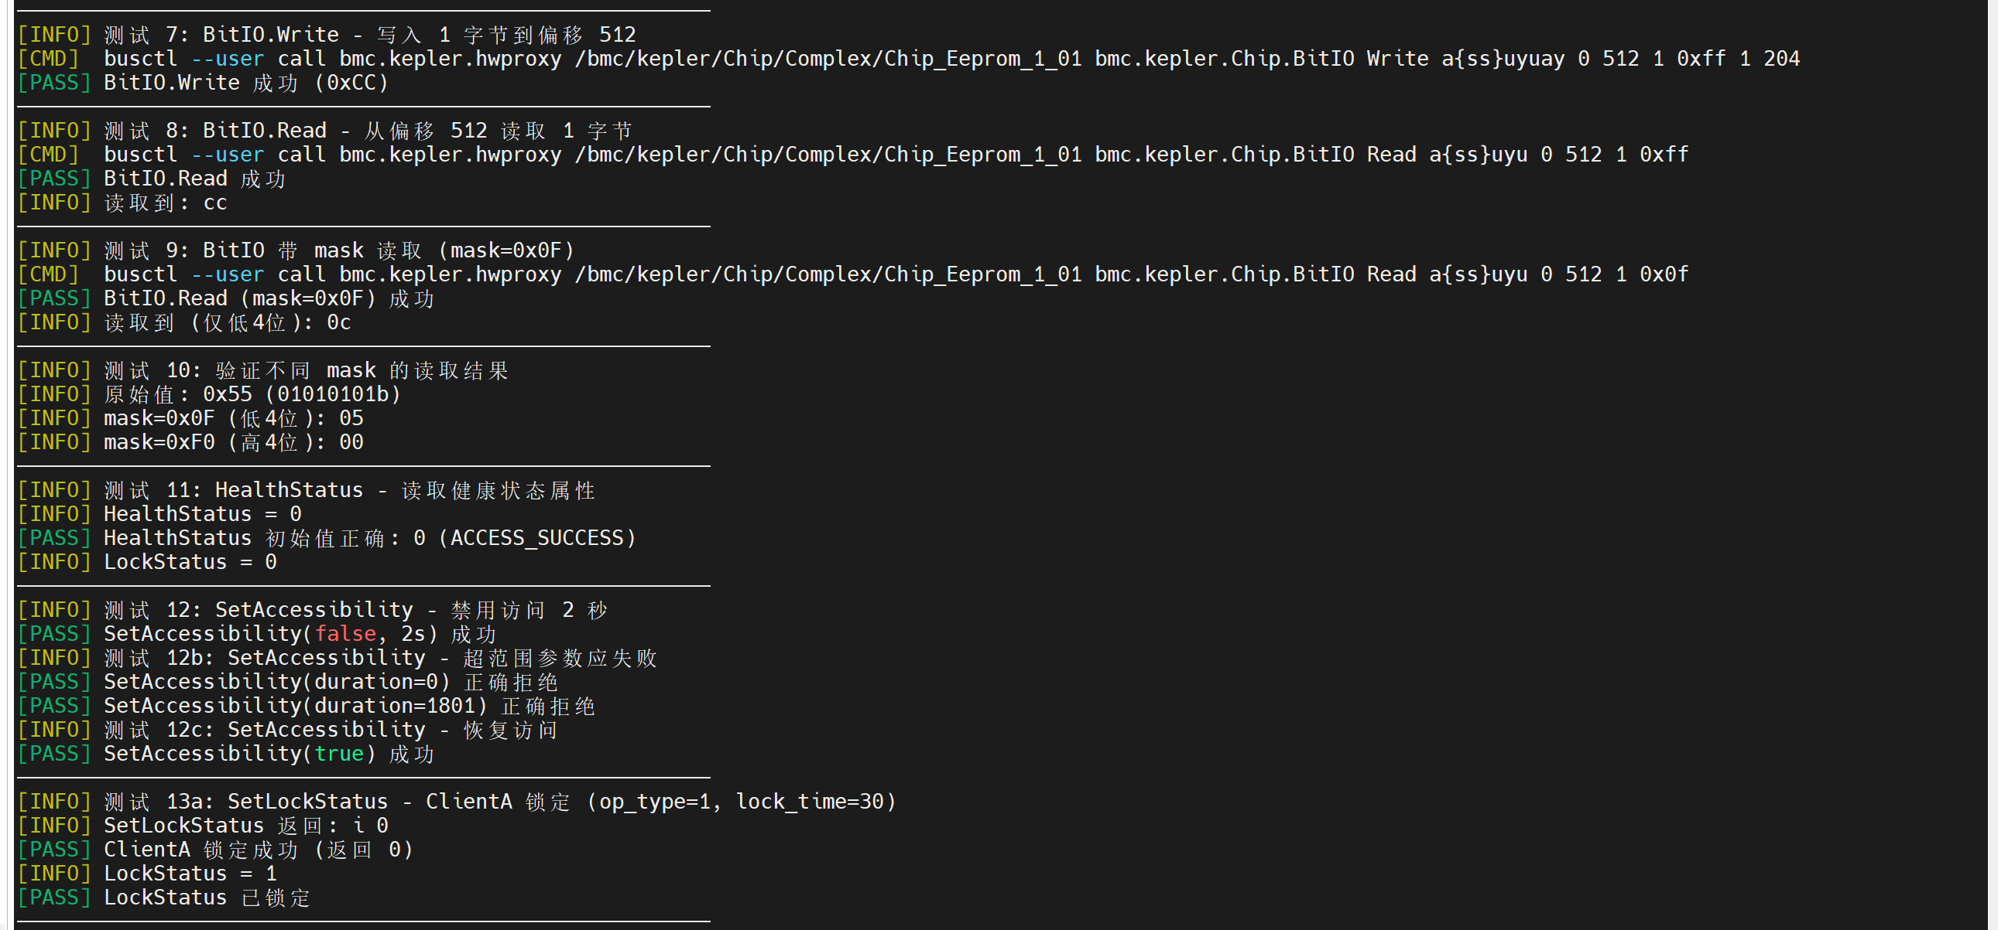
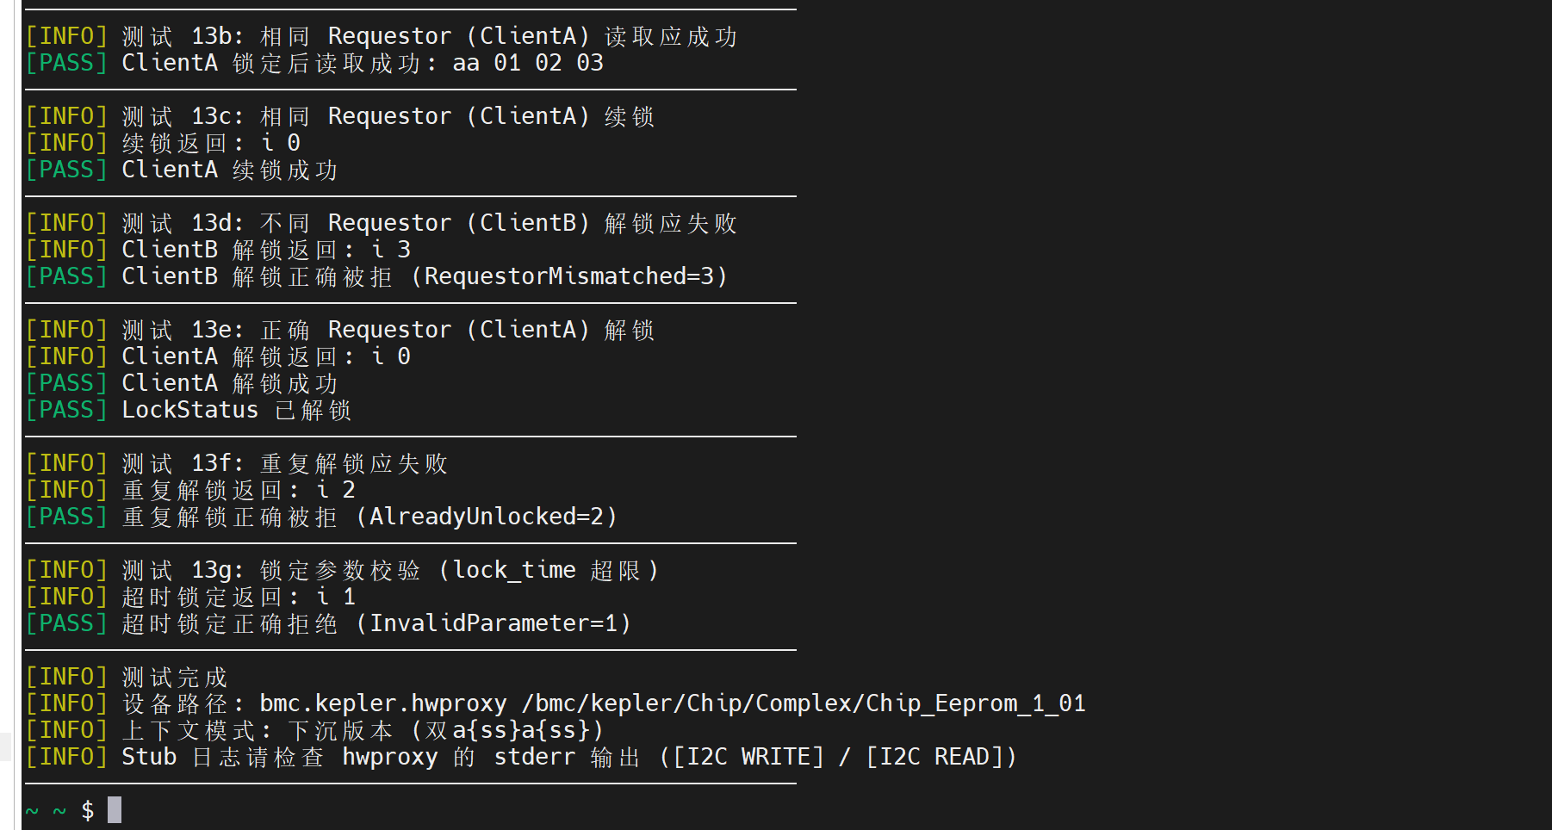

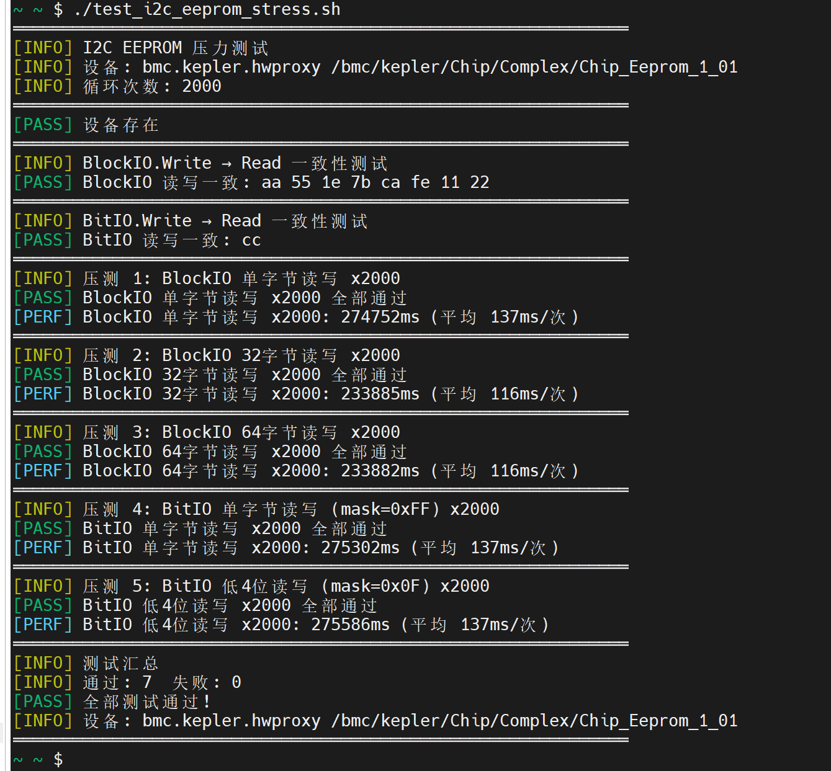

- 黄区lua版本测试结果

