JtagOverHisport 链路验证报告

- 修改root.sr
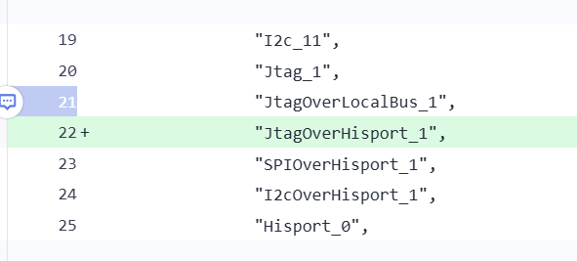
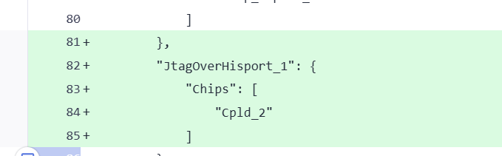
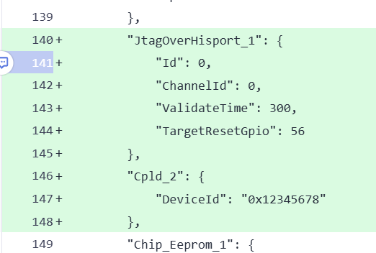
新增JtagOverHisport_1总线, 下挂Cpld_2用于验证链路联通性

- 黄区打桩
- 蓝区打桩
添加DRIVER_JTAG::Jtag桩和DRIVER_HISPORT2:: Hisport2
DRIVER_JTAG::Jtag负责实际的读写逻辑, DRIVER_HISPORT2:: Hisport2负责初始化链路.
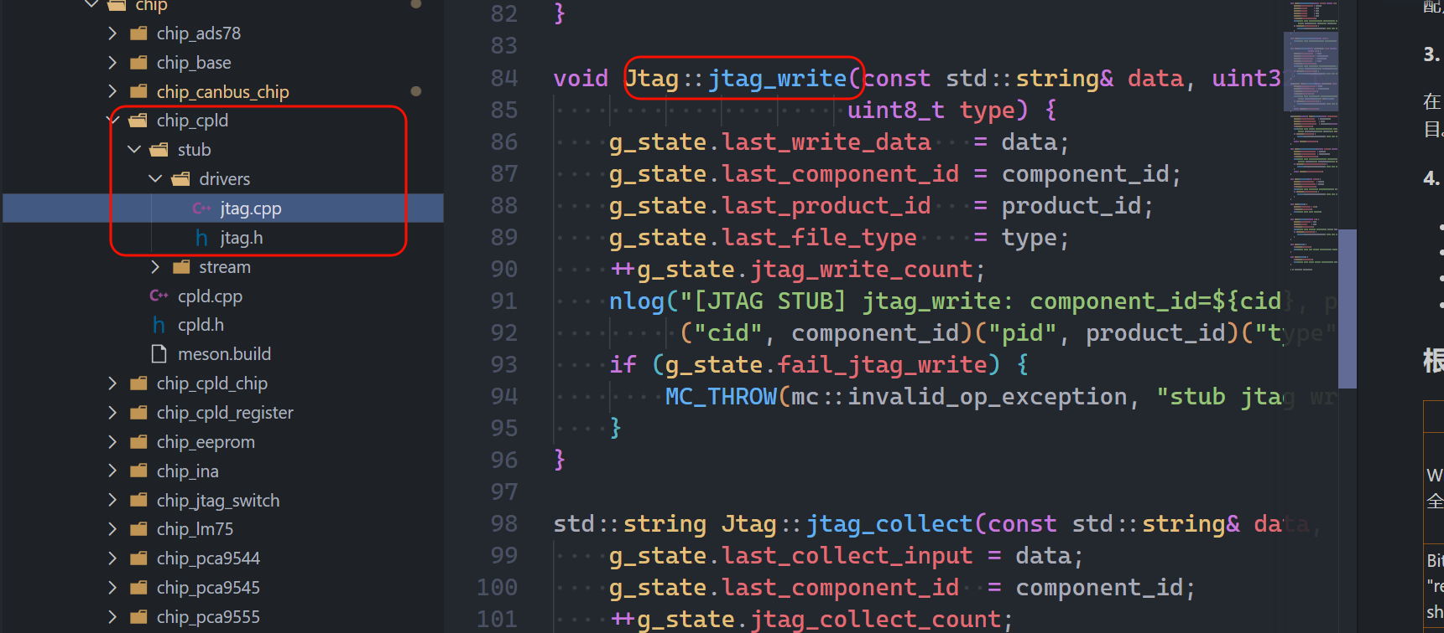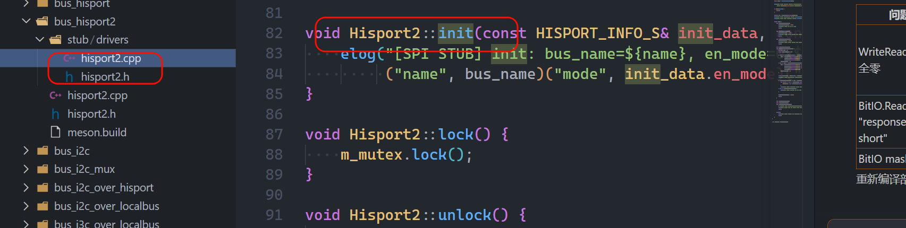
- 测试脚本

测试项:
# ── JtagOverHisport总线检查 ──
busctl --user introspect bmc.kepler.hwproxy /bmc/kepler/Bus/JtagOverHisport/JtagOverHisport_1

# ── CPLD 芯片检查 ──
busctl --user introspect bmc.kepler.hwproxy /bmc/kepler/Chip/Cpld/Cpld_2_01

# ── bmc.kepler.Chip.JtagTarget 接口 (CPLD 芯片) ──
# GetChipIdcode - 获取芯片 ID
busctl --user call bmc.kepler.hwproxy /bmc/kepler/Chip/Cpld/Cpld_2_01 bmc.kepler.Chip.JtagTarget GetChipIdcode "a{ss}" 0

# SetTargetNumber - 设置目标编号
busctl --user call bmc.kepler.hwproxy /bmc/kepler/Chip/Cpld/Cpld_2_01 bmc.kepler.Chip.JtagTarget SetTargetNumber "a{ss}u" 0 1

# SetBypassMode - 设置 Bypass 模式
busctl --user call bmc.kepler.hwproxy /bmc/kepler/Chip/Cpld/Cpld_2_01 bmc.kepler.Chip.JtagTarget SetBypassMode "a{ss}b" 0 true

# BypassChannelTest - 测试 Bypass 通道
busctl --user call bmc.kepler.hwproxy /bmc/kepler/Chip/Cpld/Cpld_2_01 bmc.kepler.Chip.JtagTarget BypassChannelTest "a{ss}yy" 0 0 0

# ── 准备 SVF 文件 (BlockIO.Write 需要) ──
touch /tmp/test.svf

# ── bmc.kepler.Chip.BlockIO 接口 (CPLD 芯片) ──
# 注意: CPLD 不支持 BlockIO.Read，只支持 BlockIO.Write
# Write: 写入 SVF 文件路径 (数据量必须 >32 字节)
# 路径 "/tmp/test.svf" 的 ASCII 编码: 47 116 109 112 47 116 101 115 116 46 115 118 102
busctl --user call bmc.kepler.hwproxy /bmc/kepler/Chip/Cpld/Cpld_2_01 bmc.kepler.Chip.BlockIO Write "a{ss}uay" 0 0 40 0 0 0 0 0 0 0 0 0 0 0 0 67 0 0 0 0 0 0 0 49 0 0 13 0 0 0 47 116 109 112 47 116 101 115 116 46 115 118 102

# ── JtagTarget 升级验证接口 ──
# Collect - 采集数据
busctl --user call bmc.kepler.hwproxy /bmc/kepler/Chip/Cpld/Cpld_2_01 bmc.kepler.Chip.JtagTarget Collect "a{ss}sys" 0 "/dev/shm/upgrade/aaa" 1 "/dev/shm/tmp/collect_registers/bbb"

# Upgrade - 升级固件
busctl --user call bmc.kepler.hwproxy /bmc/kepler/Chip/Cpld/Cpld_2_01 bmc.kepler.Chip.JtagTarget Upgrade "a{ss}sy" 0 "/dev/shm/upgrade/aaa" 1

# Verify - 验证固件
busctl --user call bmc.kepler.hwproxy /bmc/kepler/Chip/Cpld/Cpld_2_01 bmc.kepler.Chip.JtagTarget Verify "a{ss}sy" 0 "/dev/shm/upgrade/aaa" 1

# ── bmc.kepler.Bus 属性 (JtagOverHisport 总线) ──
# 注意: JtagOverHisport 总线只有 bmc.kepler.Bus 接口，没有 bmc.kepler.Bus.Jtag 接口
# AccessEnabled
busctl --user get-property bmc.kepler.hwproxy /bmc/kepler/Bus/JtagOverHisport/JtagOverHisport_1 bmc.kepler.Bus AccessEnabled

# Timeout
busctl --user get-property bmc.kepler.hwproxy /bmc/kepler/Bus/JtagOverHisport/JtagOverHisport_1 bmc.kepler.Bus Timeout

# ── bmc.kepler.Chip 属性 (CPLD 芯片) ──
# HealthStatus
busctl --user get-property bmc.kepler.hwproxy /bmc/kepler/Chip/Cpld/Cpld_2_01 bmc.kepler.Chip HealthStatus

# LockStatus
busctl --user get-property bmc.kepler.hwproxy /bmc/kepler/Chip/Cpld/Cpld_2_01 bmc.kepler.Chip LockStatus

# ── SetAccessibility (CPLD 芯片) ──
# 禁用访问 2 秒
busctl --user call bmc.kepler.hwproxy /bmc/kepler/Chip/Cpld/Cpld_2_01 bmc.kepler.Chip SetAccessibility "a{ss}a{ss}bq" 1 "Requestor" "TestClient" 1 "Requestor" "TestClient" false 2

# 恢复访问
busctl --user call bmc.kepler.hwproxy /bmc/kepler/Chip/Cpld/Cpld_2_01 bmc.kepler.Chip SetAccessibility "a{ss}a{ss}bq" 1 "Requestor" "TestClient" 1 "Requestor" "TestClient" true 1

# ── SetLockStatus (CPLD 芯片) ──
# ClientA 锁定 (op_type=1, lock_time=30)
busctl --user call bmc.kepler.hwproxy /bmc/kepler/Chip/Cpld/Cpld_2_01 bmc.kepler.Chip SetLockStatus "a{ss}a{ss}yu" 1 "Requestor" "ClientA" 1 "Requestor" "ClientA" 1 30

# ClientA 续锁 (lock_time=60)
busctl --user call bmc.kepler.hwproxy /bmc/kepler/Chip/Cpld/Cpld_2_01 bmc.kepler.Chip SetLockStatus "a{ss}a{ss}yu" 1 "Requestor" "ClientA" 1 "Requestor" "ClientA" 1 60

# ClientB 解锁 (应返回 3=RequestorMismatched)
busctl --user call bmc.kepler.hwproxy /bmc/kepler/Chip/Cpld/Cpld_2_01 bmc.kepler.Chip SetLockStatus "a{ss}a{ss}yu" 1 "Requestor" "ClientB" 1 "Requestor" "ClientB" 0 0

# ClientA 解锁 (应返回 0=OK)
busctl --user call bmc.kepler.hwproxy /bmc/kepler/Chip/Cpld/Cpld_2_01 bmc.kepler.Chip SetLockStatus "a{ss}a{ss}yu" 1 "Requestor" "ClientA" 1 "Requestor" "ClientA" 0 0

# ClientA 重复解锁 (应返回 2=AlreadyUnlocked)
busctl --user call bmc.kepler.hwproxy /bmc/kepler/Chip/Cpld/Cpld_2_01 bmc.kepler.Chip SetLockStatus "a{ss}a{ss}yu" 1 "Requestor" "ClientA" 1 "Requestor" "ClientA" 0 0

# 超时锁定 lock_time=1801 (应返回 1=InvalidParameter)
busctl --user call bmc.kepler.hwproxy /bmc/kepler/Chip/Cpld/Cpld_2_01 bmc.kepler.Chip SetLockStatus "a{ss}a{ss}yu" 1 "Requestor" "ClientA" 1 "Requestor" "ClientA" 1 1801

# ── 清理测试文件 ──
rm -f /tmp/test.svf

- 蓝区下沉版本验证
设备树:
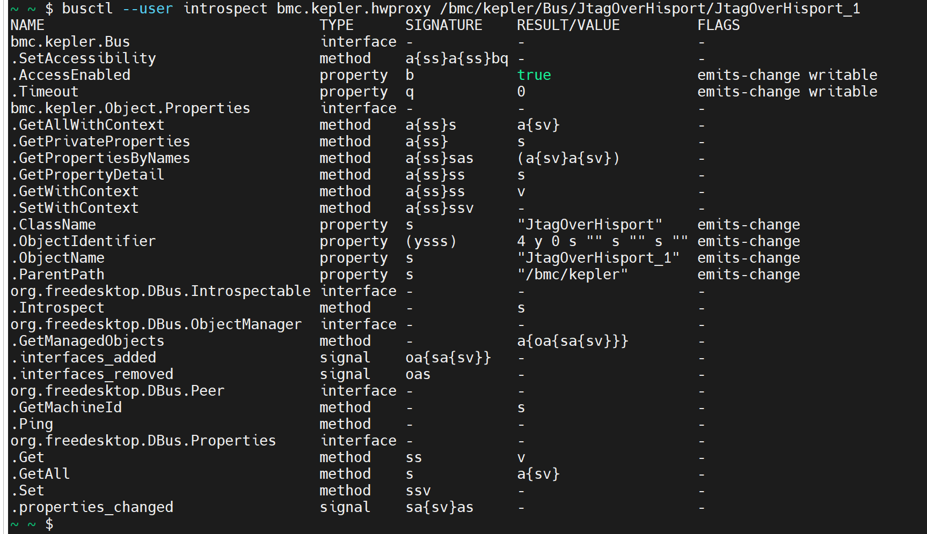
接口验证:
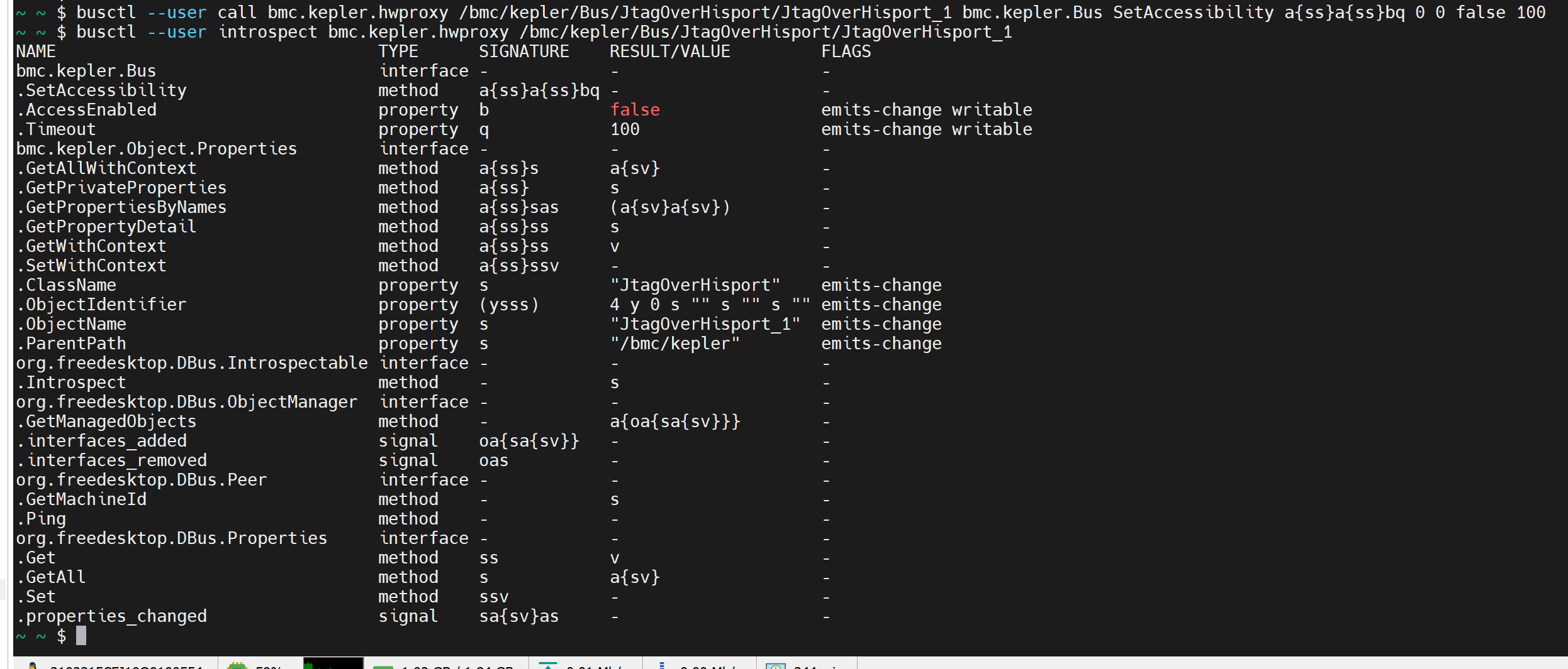
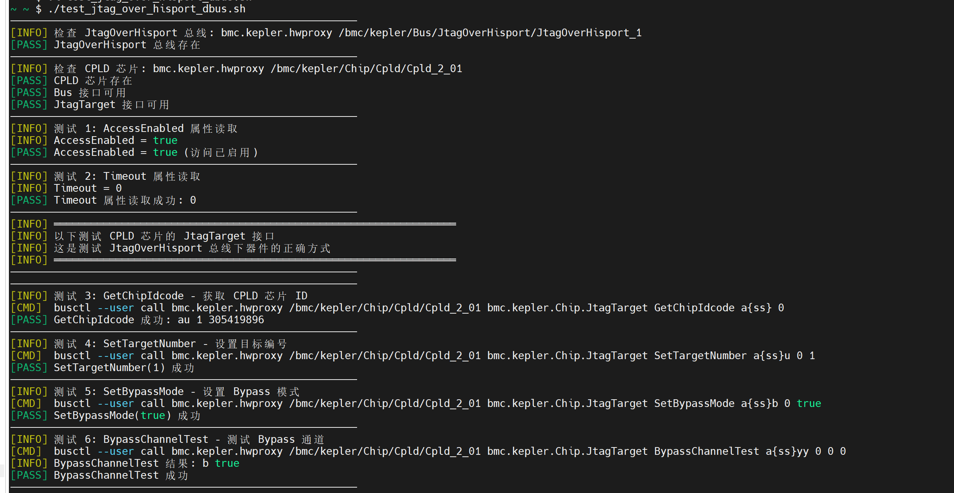

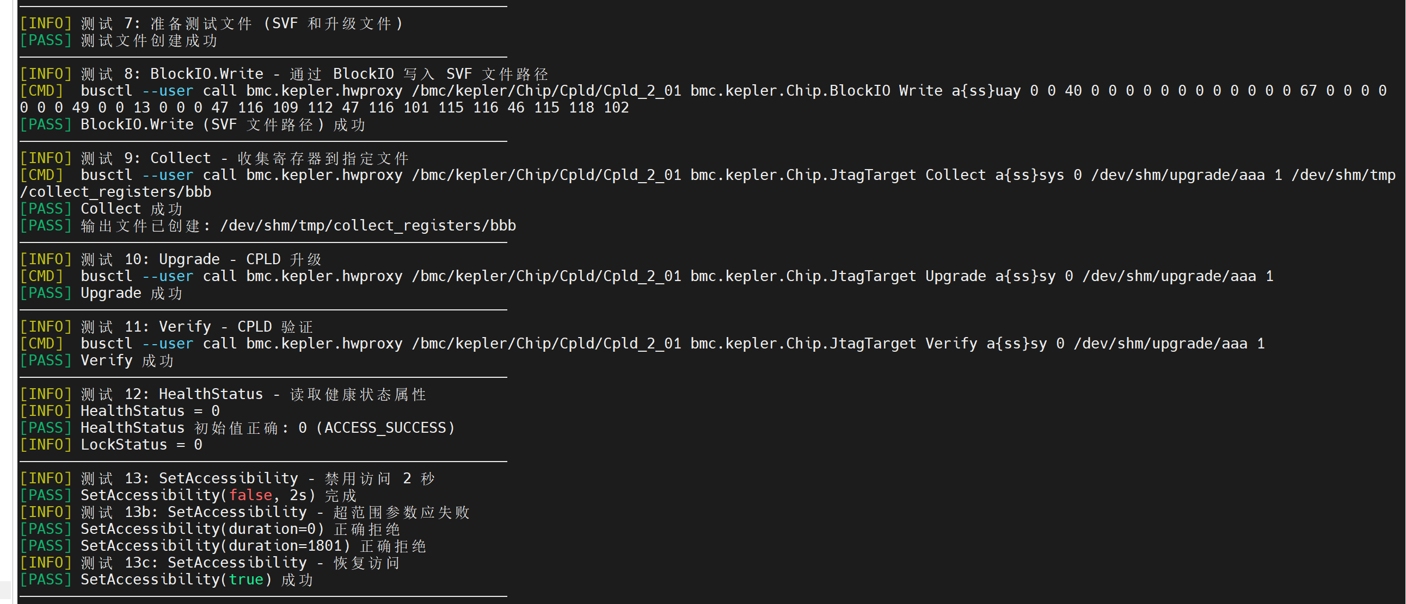
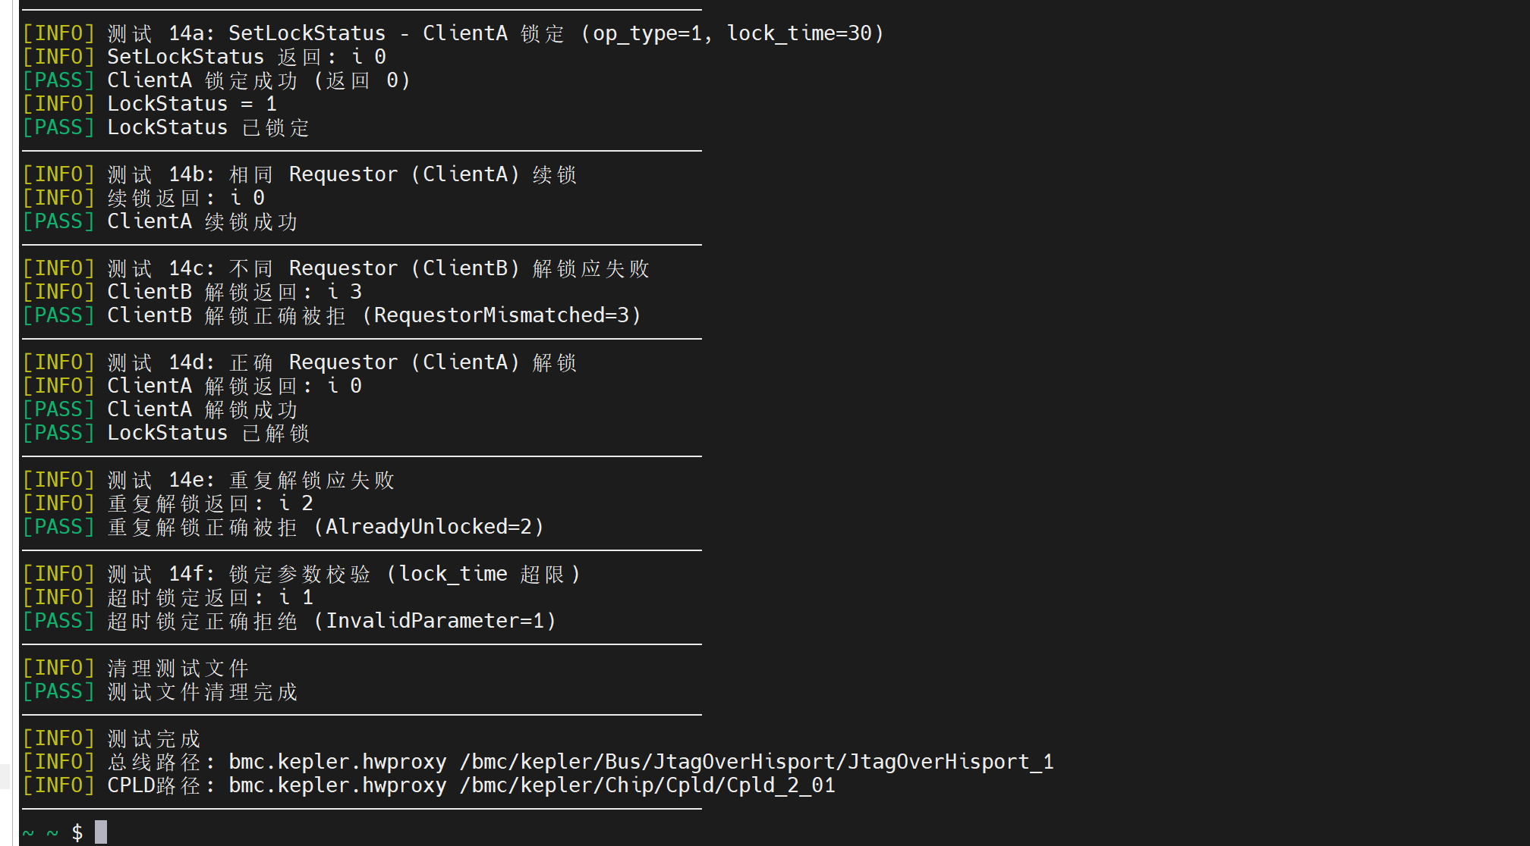

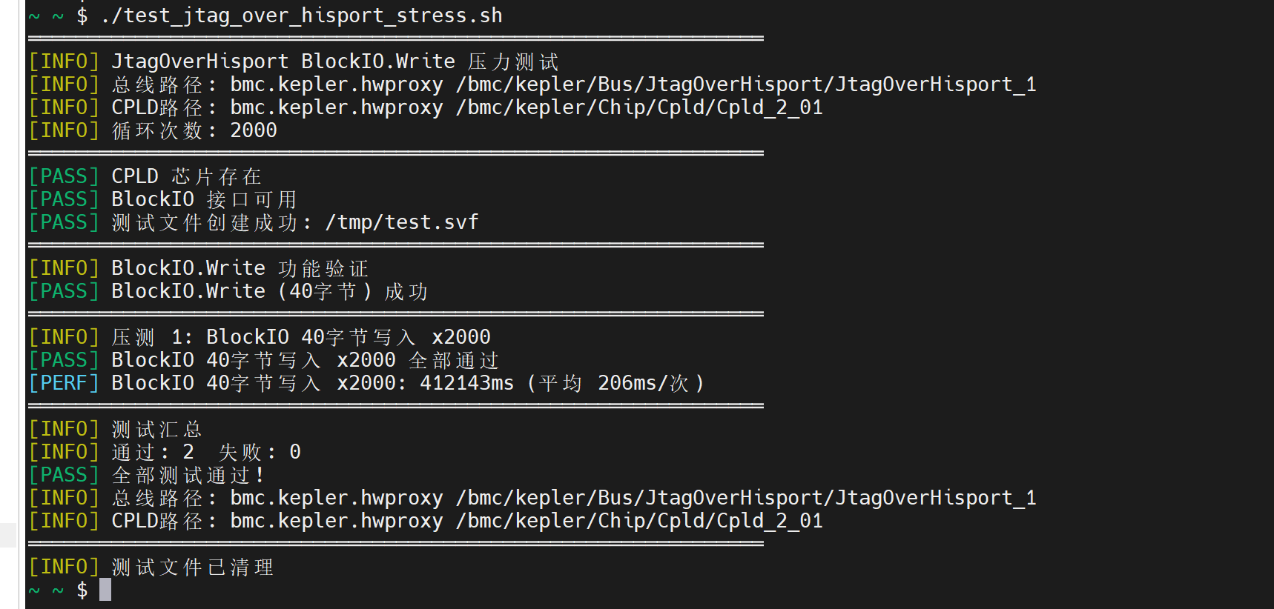

- 黄区lua版本验证

