01 Repair the container image
minikube image build -t my-app:latest .
I get this Error, because the files were created as root, but the app runs as the created user(non root)
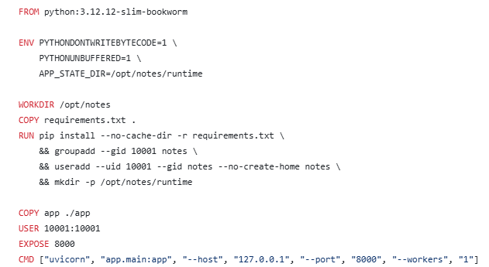
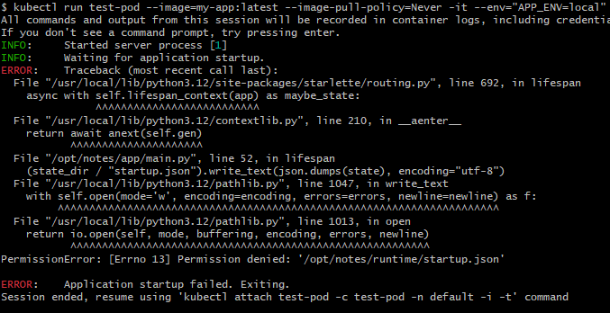
I tried to fix it by creating the user before copying/creating all the files and downloading the requirements specifically for the user with the flag –user. I stopped getting the permission denied error by the build was still incorrect. So I decided the best way is to allow root user to create all the files in the workdir and after creating the user just do a recursive chown for the workdir.
Also in the CMD I didn’t like the “127.0.0.1” because it’s the loopback address of the container so it would prevent communication of that image(service, port-forward) so I changed it to “0.0.0.0”
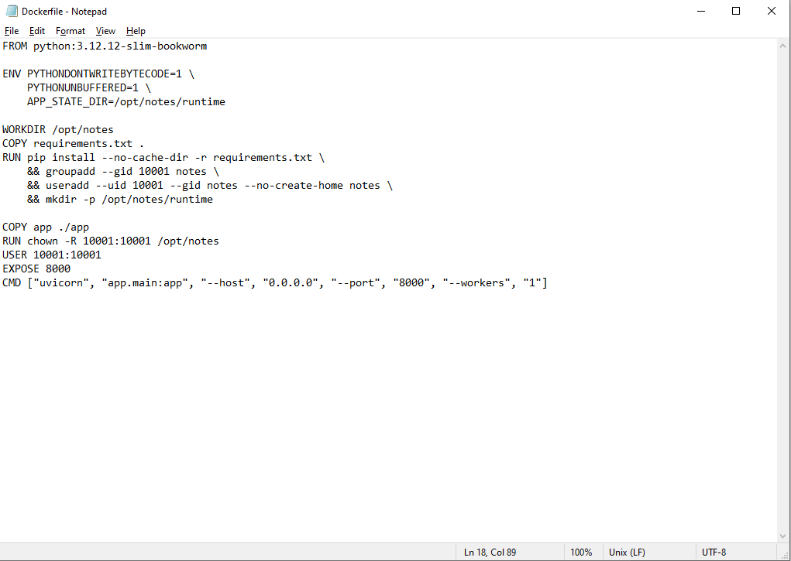
02 Deploy with Helm
Just go over my Helm chart
Installation guide
1 Build from docker file with the command minikube image build -t my-app:latest .
2 Add repo of the postgres with the commands
helm repo add bitnami https://charts.bitnami.com/bitnami
helm repo update
3 Add repo of Prometheus and install it
helm repo add prometheus-community https://prometheus-community.github.io/helm-charts
helm repo update
helm install prometheus prometheus-community/prometheus

4 Add repo of Grafana
helm repo add grafana https://grafana.github.io/helm-charts
helm repo update
helm install grafana grafana/grafana
5 update dependencies with the command helm dependency update
5 Then we will get our password of Grafana with this command (username admin)
kubectl get secret grafana -o jsonpath="{.data.admin-password}" | base64 --decode; echo
6 Then we will do port forwarding so we weill able to open with our browser
kubectl port-forward svc/my-app-service 8000:8000 &
kubectl port-forward svc/grafana 3000:80 &
kubectl port-forward svc/prometheus-server 9090:80 &

7 Then we will install my helm chart with the command helm install my-app ./notes-chart
Upgrade guide
1 Make changes to our helm chart
2 Use the command helm upgrade my-app ./notes-chart
3 Before making the upgrade we can use the command helm upgrade –dry-run to check for errors
4 If we didn’t like the upgrade we can check the history of our verions with the command
helm history my-app
And then rollback to desired version with the command helm rollback my-app <revision/version>

((sum(rate(http_requests_total{status=~"4..|5.."}[5m])) / sum(rate(http_requests_total[5m]))) * 100) or vector(0)

