調整參數:

1. 增加隱藏層數可以讓誤差變小:

* NN=2-2-1時，(epoch=1000) loss=1.573
* NN=2-5-1時，(epoch=1000) loss=1.088

--------------------------------------------------截圖--------------------------------------------------

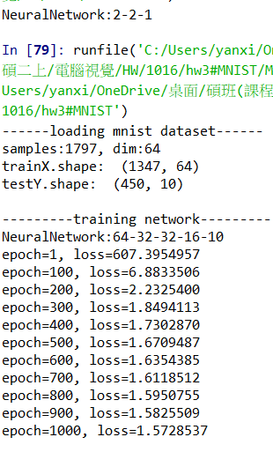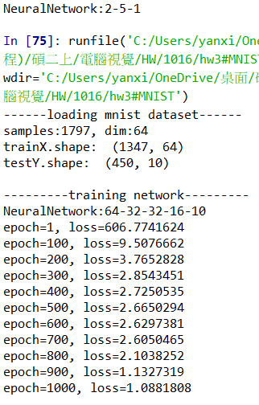

1. 激發函數:

* Relu (0.9898)
* Sigmoid(0.9452)

--------------------------------------------------截圖--------------------------------------------------

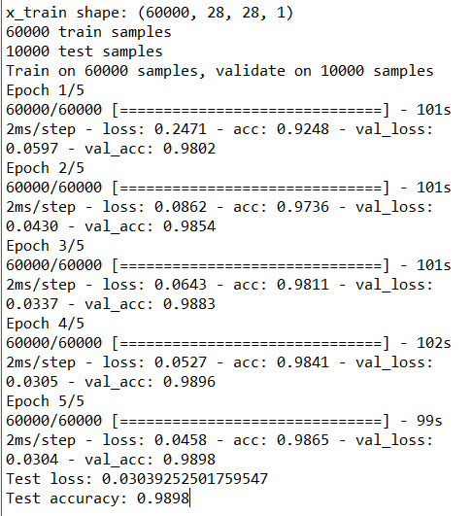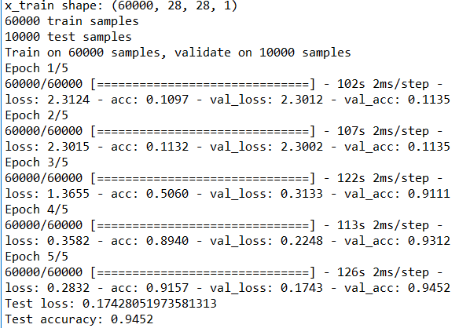

1. 損失函數:

* categorical_crossentropy(0.9904)
* binary_crossentropy(0.9974)

--------------------------------------------------截圖--------------------------------------------------

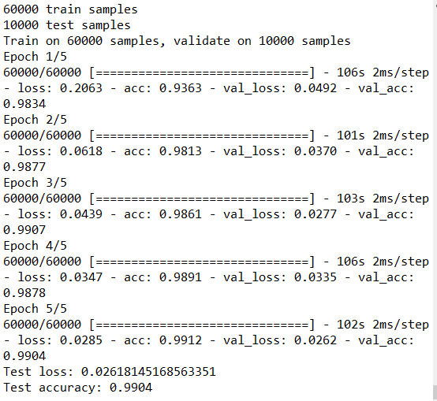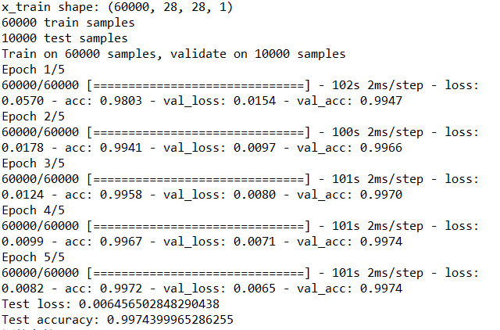

1. 優化方法:

* Adadelta(0.9904)
* SGD (0.9602)

--------------------------------------------------截圖--------------------------------------------------



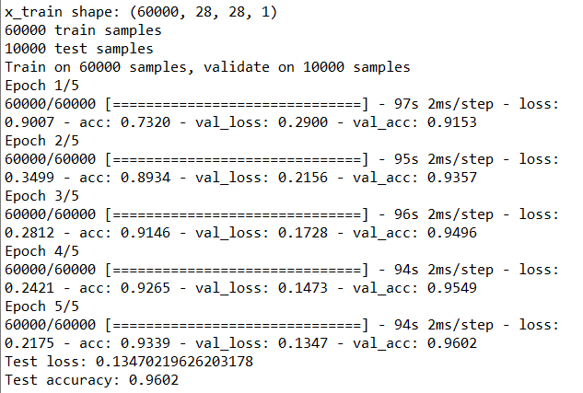

1. dropout:

* 全連接改成 dropout :0.25 (0.9904)
* 全連接改成 dropout :0.5 (0.9975) -->最高

--------------------------------------------------截圖--------------------------------------------------

