## 页表

typedef u32 pteval_t;

typedef u32 pmdval_t;

typedef pmdval_t pmd_t;

typedef pteval_t pte_t;

typedef pmdval_t pgd_t[2];

typedef pteval_t pgprot_t;

#define pgprot_val(x) (x)

#define PTRS_PER_PTE 512

#define PTE_HWTABLE_PTRS (PTRS_PER_PTE)

#define PTE_HWTABLE_OFF (PTE_HWTABLE_PTRS *sizeof(pte_t))

#define PMD_TYPE_TABLE (_AT(pmdval_t, 1) << 0)

#define PMD_BIT4 (_AT(pmdval_t, 1) << 4)

#define PMD_DOMAIN(x) (_AT(pmdval_t, (x)) << 5)

#define _PAGE_KERNEL_TABLE (PMD_TYPE_TABLE | PMD_BIT4 | PMD_DOMAIN(DOMAIN_KERNEL))

static pte_t bm_pte[PTRS_PER_PTE + PTE_HWTABLES_PTRS]

__aligned(PTE_HWTABLE_OFF +PTE_HWTABLE_SIZE)__initdata;

<https://programmer.help/blogs/linux-memory-management-arm-memory-layout-and-mmu-configuration.html>

struct mm_struct {

pgd_t *pgd;

};

mm/init-mm.c

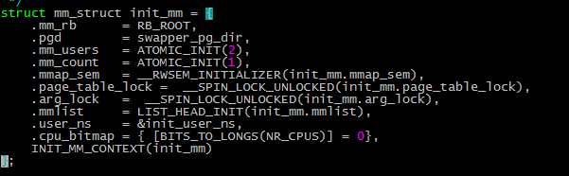

### pgd_offset_k

arch/arm/inclue/asm/pgtable-2level.h

/*

PGDIR_SHIFT 是21，所以一级页表的个数是11，每个页表大小是8字节。

*/

#define PGDIR_SHIFT 21

#define PMD_SHIFT 21

arch/arm/include/asm/pgtable.h

#define pgd_offset_k(addr) pgd_offset(&init_mm,addr) ->

((mm)->pgd + pgd_index(addr))

#define pgd_index(addr) ((addr) >> PGDIR_SHIFT)

### pud_offset

include/asm-generic/pgtable-nopud.h

typedef struct { pgd_t pgd; } p4d_t;



static inline pud_t *pud_offset(p4d_t *p4d,unsigned long address)

{

return (pud_t *)p4d;

}

### pmd_offset

static inline pmd_t *pmd_offset(pud_t *pud,unsigned long addr)

{

return (pmd_t *)pud;

}

### pmd_offset_k

static inline pmd_t *pmd_off_k(unsigned long virt)->

pmd_offset(pud_offset(pgd_offset_k(virt),virt),virt)

### pte_index

#define pte_index(addr)

((addr)>>PAGE_SHIFT)&(PTRS_PER_PTE-1)

### set_pte_at

arch/arm/include/asm/pgtable.h

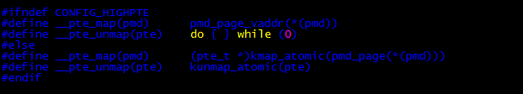

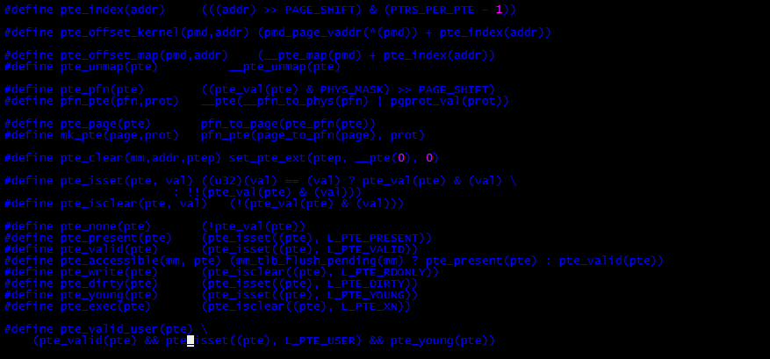

#define (UL(CONFIG_PAGE_OFFSET) – UL(SZ_16M))

void set_pte_at(struct mm_struct *mm,unsigned long addr,pte_t *ptep,pte_t pteval)

{

unsigned long ext =0;

if(addr < TASK_SIZE &&pte_valid_usr(pteval))

{

}

set_pte_ext(ptep,pteval,ext);

}

set_pte_ext(ptep,pteval,ext)->

cpu_set_pte_ext(ptep,pte,ext)->

/*

arch/arm/include/asm/glue-proc.h

比如armv7，在arch/arm/mm/proc-v7-2level.S中定义

cpu_v7_set_pte_ext

*/

__glue(CPU_NAME,_set_pte_ext)

## fixmap

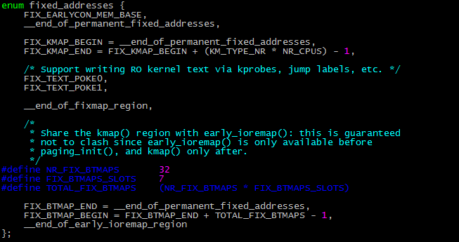

arch/arm/include/asm/fixmap.h



0xff80_0000 - 0xffc0_0000，未知区域

0xffc0_0000 – 0xfff0_0000，是fixmap区域。3M

setup_arch->

early_fixmap_init()

arch/arm/mm/mmu.c

early_fixmap_init()

{

pmd_t *pmd;

pmd = fixmap_pmd(FIXADDR_TOP);

pmd_populate_kernel(&init_mm,pmd,bm_pte);

pte_offset_fixmap = pte_offset_early_fixmap;

}

fixmap_pmd(FIXADDR_TOP)

{

pgd_t *pgd = pgd_offset(addr);

pud_t *pud = pud_offset(pgd,addr);

pmd_t *pmd = pmd_offset(pud,addr);

return pmd;

}

pmd_populate_kernel(&init_mm,pmd,bm_pte)->

__pmd_populate(pmdp,__pa(ptep),_PAGE_KERNEL_TABLE)  
{

pmdval_t pmdval = (pte+ PTE_HWTABLE_OFF) | prot;

pmdp[0] = __pmd(pmdval);

pmdp[1] = __pmd(pmdval+256*sizeof(pte_t);

flush_pmd_entry(pmdp);

}

arch/arm/include/asm/tlbflush.h

pte_offset_early_fixmap(pmd_t *dir,unsigned long addr)

{

return &bm_pte[pte_index(addr)];

}

include/asm-generic/fixmap.h

### earlycon

drivers/tty/serial/earlycon.c

bootargs指定earlycon

early_param(“earlycon”,param_setup_earlycon);

param_setup_earlycon(char *buf)

->setup_earlycon(buf)

->register_earlycon(buf,match)

->earlycon_map(port->mapbase,64)

{

void __iomem *base;

/*

如果CONFIG_FIX_EARLYCON_MEM，则使用fixmap

fixmap的通用定义在include/asm-generic/fixmap.h

*/

set_fixmap_io(FIX_EARLYCON_MEM_BASE,paddr &PAGE_MASK);

base = (void __iomem*)__fix_to_virt(FIX_EARLYCON_MEM_BASE);

base +=paddr &~PAGE_MASK;

return base;

}

set_fixmap_io(FIX_EARLYCON_MEM_BASE,paddr &PAGE_MASK)->

__set_fixmap(FIX_EARLYCON_MEM_BASE,paddr&PAGE_MASK,FIXMAP_PAGE_IO)->

{

/*

__fix_to_virt的含义是按照4KB对齐的。

*/

unsigned long vaddr = __fix_to_virt(idx);

pte_t *pte = pte_offset_fixmap(pmd_off_k(vaddr),vaddr);

if(pgprot_val(prot))

set_pte_at();

else

pte_clear(NULL,vaddr,pte);

local_flush_tlb_kernel_range(vaddr,vaddr+PAGE_SIZE);

}

#define __fix_to_virt(idx)

(FIXADDR_TOP- ((x)<<PAGE_SHIFT))