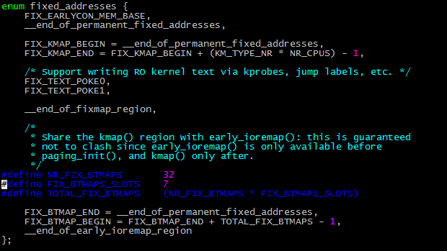

early_ioremap，需要CONFIG_GENERIC_EARLY_IOREMAP宏的定义。

mm/early_ioremap.c

static void __iomem *prev_map[FIX_BTMAPS_SLOTS] __initdata;

static unsigned long prev_size[FIX_BTMAPS_SLOTS] __initdata;

static unsigned long slot_virt[FIX_BITMAPS_SLOTS] __initdata;

setup_arch->

early_ioremap_init->

early_ioremap_setup()

{

int i =0;

for(i=0;i<FIX_BTMAPS_SLOTS;i++)

if(WARN_ON(prev_map[i]))

break;

for(i=0;i<FIX_BTMAPS_SLOTS;i++)

slot_virt[i] = __fix_to_virt(FIX_BTMAP_BEGIN,NR_FIX_BTMAPS*i);

}

/*

*/

setup_arch->

early_ioremap_reset()->

early_ioremap_shutdown()

{

}