**甘肃电信**

**Oracle数据库升级12c技术方案**

云和恩墨(北京)信息技术有限公司

技术顾问 卢立广

http://www.enmotech.com

**文档控制：**

|  |  |  |  |  |
| --- | --- | --- | --- | --- |
| **序** | **版本号** | **更改人** | **日期** | **备注** |
| 1 | 1.0版 | 卢立广 | 2018-04-14 | 初始版本 |
| 2 |  |  |  |  |
|  |  |  |  |  |

|  |  |  |  |  |
| --- | --- | --- | --- | --- |
| **编制** | 卢立广 | （签字） | 日期 | 2018-04-14 |
| **校对** |  | （签字） | 日期 |  |
| **审核** |  | （签字） | 日期 |  |
| **批准** |  | （签字） | 日期 |  |

**目录**

1. 概述 - 6 -

2. DG同步检查 - 6 -

3. 停止对外服务 - 6 -

4. DG切换 - 9 -

4.1 Failover切换 - 9 -

4.1.1 备库状态检查 - 9 -

4.1.2 取消备库日志同步 - 9 -

4.1.3 取消自动恢复 - 9 -

4.1.4 将备库切换为主库 - 9 -

4.1.5 切换后状态检查 - 10 -

4.1.6 重启数据至mount状态 - 10 -

4.1.7 清除dg配置参数 - 10 -

4.1.8 启动数据库至open - 10 -

4.2 Switchover切换 - 11 -

4.2.1 备库状态检查 - 11 -

4.2.2 主库切换为备库 - 11 -

4.2.3 原主库启动到mount状态 - 11 -

4.2.4 原备库切换为主库 - 11 -

4.2.5 切换后状态核对 - 11 -

4.2.6 清除主备DG参数 - 11 -

5. 升级前检查 - 12 -

5.1 检查无效对象 - 12 -

5.2 检查物化视图 - 12 -

5.3 检查数据文件 - 12 -

5.4 检查分布式事务 - 12 -

5.5 删除DBconsole - 13 -

5.6 检查用户密码version - 13 -

5.7 删除审计用户和角色 - 14 -

5.8 删除olap组件 - 14 -

5.9 备份数据库 - 14 -

5.10 创建12c参数文件 - 14 -

5.11 Sqlnet.ora调整 - 15 -

5.12 创建闪回点 - 15 -

6. 升级数据库 - 15 -

6.1 升级前脚本检查 - 16 -

6.2 DBUA方式升级数据库 - 16 -

6.2.1 选择需升级的数据库 - 17 -

6.2.2 升级前系统自检 - 17 -

6.2.3 选择升级内容 - 18 -

6.2.4 选择是否进行备份 - 19 -

6.2.5 确认监听信息 - 19 -

6.2.6 配置EM EXPRESS - 20 -

6.2.7 浏览升级概要 - 20 -

6.2.8 开始升级操作 - 21 -

6.2.9 确认升级结果 - 21 -

6.2.10 删除闪回点 - 22 -

6.3 脚本方式升级数据库 - 22 -

6.3.1 启动至upgrade状态 - 22 -

6.3.2 执行升级脚本 - 22 -

6.3.3 执行升级后脚本 - 30 -

6.3.4 检查组件状态 - 30 -

6.3.5 删除闪回点 - 31 -

7. NO-CDB插入CDB - 31 -

7.1 启动至read only - 31 -

7.2 创建元数据 - 31 -

7.3 检查兼容性 - 32 -

7.4 Nocopy方式插入CDB - 32 -

7.5 同步pdb信息 - 33 -

7.6 执行nocdb_to_pdb脚本 - 33 -

7.7 数据校验 - 33 -

8. 12c适应性调整 - 33 -

9. 备份工程师全备 - 35 -

**摘要**: 本报告为我司向贵方提供数据库服务的工作记录，同时作为档案留存，为贵方数据库运行提供历史数据。本文档可能涉及系统重要信息，仅供用户参考。同时在传阅过程中应注意安全保密事宜，杜绝防止不必要的泄密事件发生。

# 停止对外服务

* 停止应用
* 停止数据库job

alter system set job_queue_processes=0 scope=both;

* 关闭监听

首先执行 ps –ef|grep lsnr确定已开启的监听；

集群所有节点都要检查

srvctl stop 监听名称

* 禁用scan

srvctl stop scan_listener

srvctl disable scan_listener

srvctl disable scan

* 停止crontab
* 杀会话

首先执行ps -ef |grep lgwr确认服务器已开启的实例；

集群所有节点都要做检查。

ps -ef|grep LOCAL=NO|grep XX|grep -v grep|awk '{print $2}'|xargs kill -9

杀完后，ps -ef|grep LOCAL再进行一次检查。

* 清空回收站

purge dba_recyclebin

* 清除分布式事务

set line 200

set pagesize 99999

select ' exec DBMS_TRANSACTION.PURGE_LOST_DB_ENTRY('||chr(39)||LOCAL_TRAN_ID||chr(39)||');'||chr(10)||'commit;' from dba_2pc_pending;

* 创建用户表

CREATE TABLE SYSTEM.migrate_username

AS

SELECT username

FROM dba_users

WHERE username NOT IN ('ANONYMOUS',

'APEX_030200',

'APEX_PUBLIC_USER',

'APPQOSSYS',

'CTXSYS',

'DBSNMP',

'DIP',

'EXFSYS',

'FLOWS_FILES',

'MDDATA',

'MDSYS',

'MGMT_VIEW',

'OLAPSYS',

'ORACLE_OCM',

'ORDDATA',

'ORDPLUGINS',

'ORDSYS',

'OUTLN',

'OWBSYS',

'OWBSYS_AUDIT',

'SCOTT',

'SI_INFORMTN_SCHEMA',

'SPATIAL_CSW_ADMIN_USR',

'SPATIAL_WFS_ADMIN_USR',

'SYS',

'SYSMAN',

'SYSTEM',

'WMSYS',

'XDB',

'XS$NULL')

* 创建测试表

create table system.tabcheck as select * from dba_tables where rownum<3 ;

多次switch logfile

停止过后再次进行日志同步检查。

# 升级12.2 grid

## 解压安装包

同之前的版本不一样，12.2的grid安装包要是一个gridhome打包，要直接解压到grid home下，换句话说，这个安装包解压到哪儿，哪儿就是gridhome，改不了

mkdir –p /u02/app/12.2.0/grid

cd /u02/app/12.2.0/grid

unzip linuxx64_12201_grid_home.zip

rm –f linuxx64_12201_grid_home.zip

## 运行gridSetup.sh

[oracle@rac3 ~]$ ll /u02/app/12.2.0/grid/gridSetup.sh

-rwxr-x--- 1 grid oinstall 5395 Jul 21 2016 /u02/app/12.2.0/grid/gridSetup.sh

## 升级过程

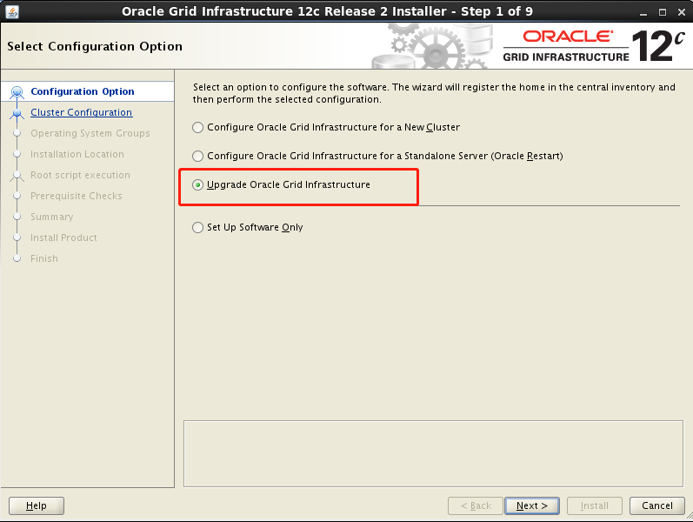

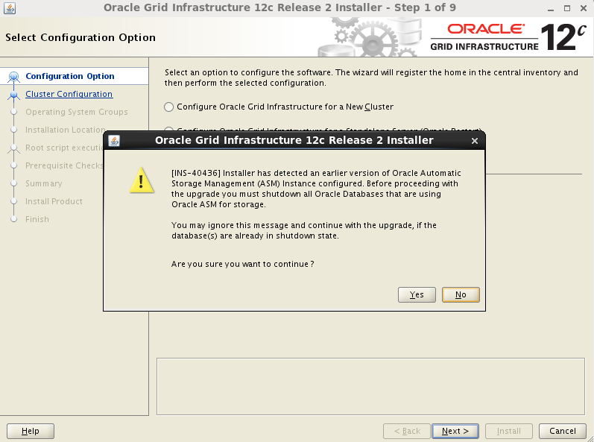

意思想升级grid，得先把用asm磁盘的数据库都停了。

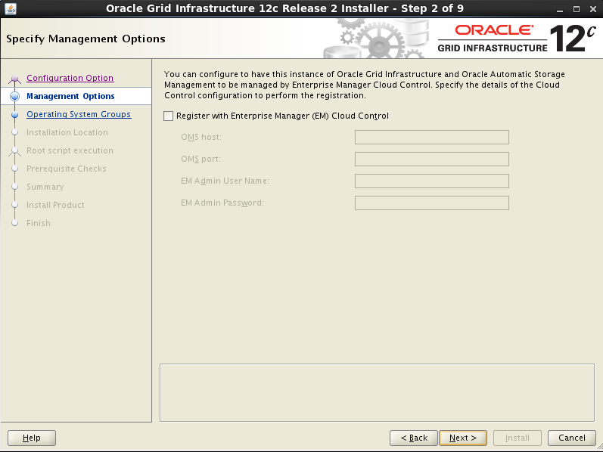

配置EMCC，我不配。

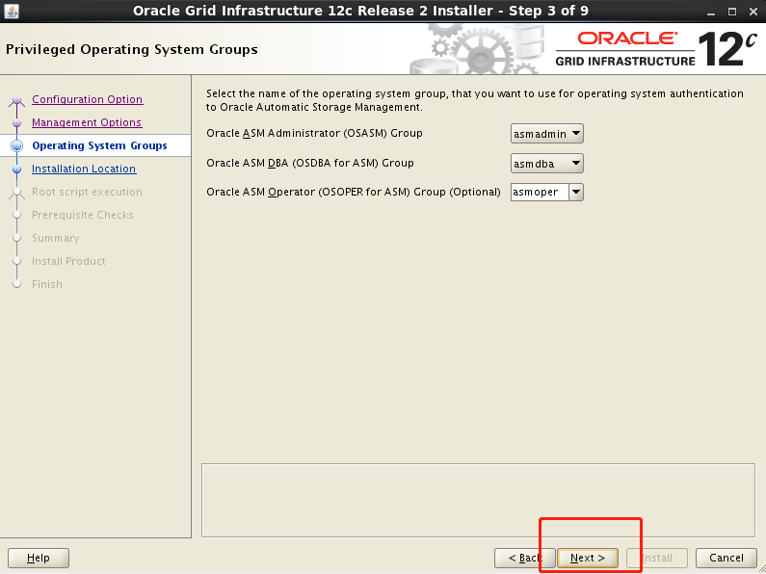

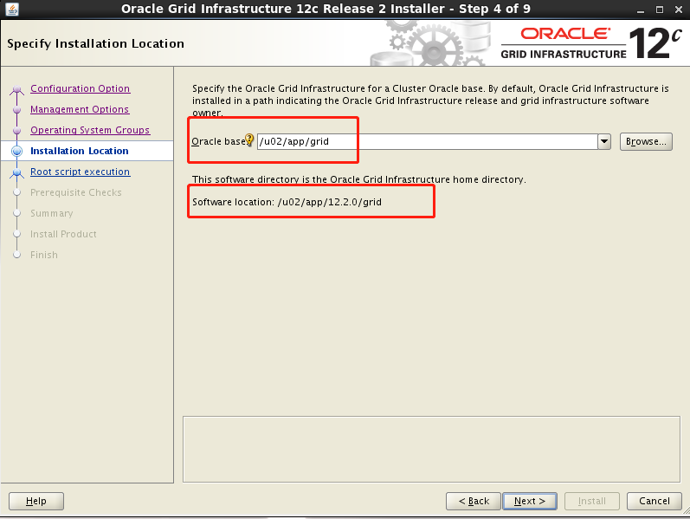

这里grid home是写死的，就是你之前解压的路径。能改的只有oracle base。

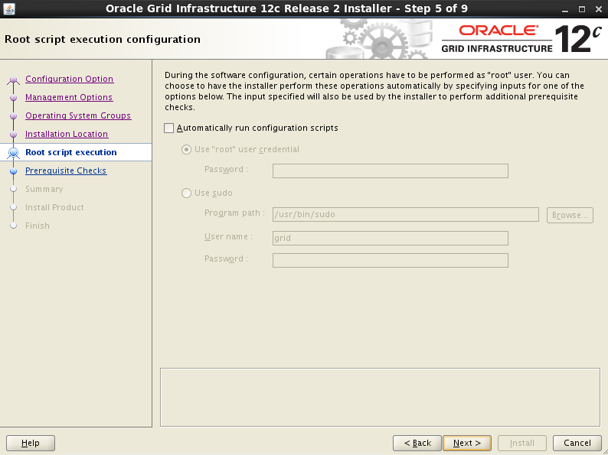

不管，还是手动跑root.sh

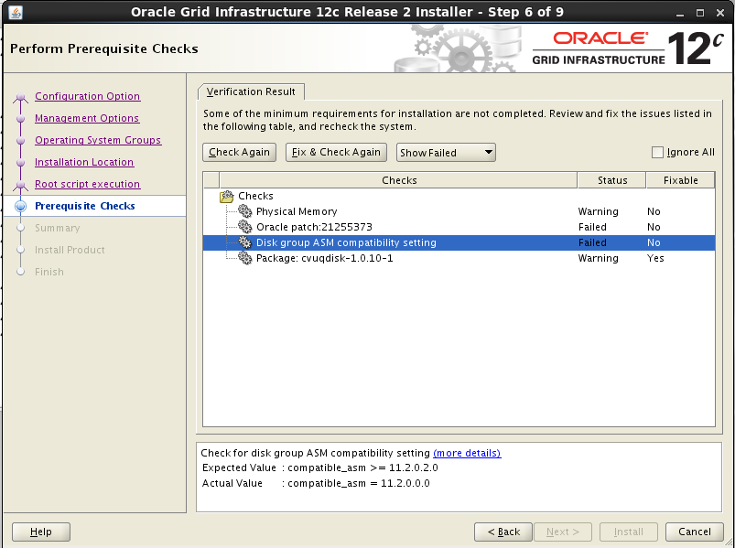

一个一个解决：

第一个：Physical memory不足，意思RAM不够，12.2最少要求8G RAM，所以这里把虚拟机的4G RAM调到8G；

第二个：asm的兼容性问题，下面要求很明确，所以我们这样来做：

[grid@rac3 ~]$ sqlplus / as sysasm

SQL> alter diskgroup data SET ATTRIBUTE 'compatible.asm' = '11.2.0.3.0';

Diskgroup altered.

SQL> alter diskgroup fra SET ATTRIBUTE 'compatible.asm' = '11.2.0.3.0';

Diskgroup altered.

SQL> alter diskgroup data SET ATTRIBUTE 'compatible.rdbms' = '11.2';

Diskgroup altered.

SQL> alter diskgroup fra SET ATTRIBUTE 'compatible.rdbms' = '11.2';

Diskgroup altered.

这里必须用sysasm用户登录，否则权限不足。

第三个：点fix&check again，root执行脚本

第四个：打补丁

专门打对应数据版本的21255373补丁，比如我这次倒腾了半天把grid弄到11.2.0.3.9，那就下载这个版本的21255373补丁，只打grid就行。mos补丁搜索搜21255373。

但是，如果还是报找不到这个补丁的错：

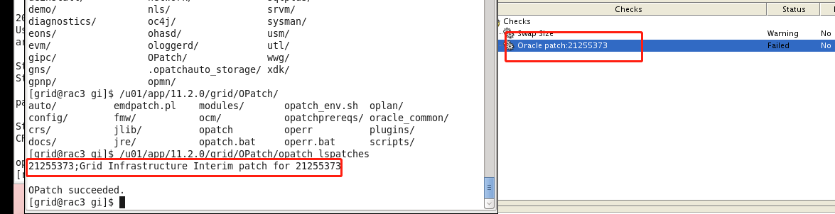

那就只能：

./ gridSetup.sh –skipPrereqs

跳过预检查，这个前提是，其他错误都修复了，就这个装了补丁也没办法修复，这是个bug。***（文档 ID 2280843.1）***

接下来顺利开始安装，安装过程中会提示用root用户执行rootupgrade.sh脚本

/u02/app/12.2.0/grid/rootupgrade.sh

检查一下：

[grid@rac3 ~]$ /u02/app/12.2.0/grid/OPatch/opatch lsinventory

Oracle Interim Patch Installer version 12.2.0.1.6

Copyright (c) 2018, Oracle Corporation. All rights reserved.

Oracle Home : /u02/app/12.2.0/grid

Central Inventory : /u01/app/oraInventory

from : /u02/app/12.2.0/grid/oraInst.loc

OPatch version : 12.2.0.1.6

OUI version : 12.2.0.1.4

Log file location : /u02/app/12.2.0/grid/cfgtoollogs/opatch/opatch2018-05-21_09-14-04AM_1.log

Lsinventory Output file location : /u02/app/12.2.0/grid/cfgtoollogs/opatch/lsinv/lsinventory2018-05-21_09-14-04AM.txt

--------------------------------------------------------------------------------

Local Machine Information::

Hostname: rac3

ARU platform id: 226

ARU platform description:: Linux x86-64

Installed Top-level Products (1):

Oracle Grid Infrastructure 12c 12.2.0.1.0

There are 1 products installed in this Oracle Home.

There are no Interim patches installed in this Oracle Home.

--------------------------------------------------------------------------------

OPatch succeeded.

[grid@rac3 ~]$ sqlplus / as sysasm

SQL*Plus: Release 12.2.0.1.0 Production on Mon May 21 09:17:49 2018

Copyright (c) 1982, 2016, Oracle. All rights reserved.

Connected to:

Oracle Database 12c Enterprise Edition Release 12.2.0.1.0 - 64bit Production

[grid@rac3 ~]$ crsctl status res -t

--------------------------------------------------------------------------------

Name Target State Server State details

--------------------------------------------------------------------------------

Local Resources

--------------------------------------------------------------------------------

ora.DATA.dg

ONLINE ONLINE rac3 STABLE

ora.FRA.dg

ONLINE ONLINE rac3 STABLE

ora.LISTENER.lsnr

ONLINE ONLINE rac3 STABLE

ora.asm

ONLINE ONLINE rac3 Started,STABLE

ora.ons

OFFLINE OFFLINE rac3 STABLE

--------------------------------------------------------------------------------

Cluster Resources

--------------------------------------------------------------------------------

ora.cssd

1 ONLINE ONLINE rac3 STABLE

ora.diskmon

1 OFFLINE OFFLINE STABLE

ora.evmd

1 ONLINE ONLINE rac3 STABLE

ora.prod1.db

1 OFFLINE OFFLINE Instance Shutdown,ST

ABLE

## 启动数据库（遇到memory target不足的问题）

WARNING: You are trying to use the MEMORY_TARGET feature. This feature requires the /dev/shm file system to be mounted for at least 1660944384 bytes. /dev/shm is either not mounted or is mounted with available space less than this size. Please fix this so that MEMORY_TARGET can work as expected. Current available is 1393491968 and used is 675512320 bytes. Ensure that the mount point is /dev/shm for this directory.

memory_target needs larger /dev/shm

日志报这个错：

首先：

[root@rac3 ~]# df -h

Filesystem Size Used Avail Use% Mounted on

/dev/mapper/VolGroup-lv_root 36G 24G 9.7G 72% /

tmpfs 2.0G 645M 1.3G 33% /dev/shm

/dev/sda1 485M 68M 392M 15% /boot

/dev/sr0 3.7G 3.7G 0 100% /media/OL6.5 x86_64 Disc 1 20131125

/dev/sda3 60G 20G 37G 35% /u02

要求是1.7G，现在只有1.3G可用。

然后：

[root@rac3 ~]# lsof /dev/shm

COMMAND PID USER FD TYPE DEVICE SIZE/OFF NODE NAME

gnome-set 2171 root mem REG 0,16 67108904 18394 /dev/shm/pulse-shm-1885580290

metacity 2195 root mem REG 0,16 67108904 23355 /dev/shm/pulse-shm-1762436992

gnome-vol 2223 root mem REG 0,16 67108904 19207 /dev/shm/pulse-shm-1152612685

pulseaudi 2254 root mem REG 0,16 67108904 19353 /dev/shm/pulse-shm-2044153394

asm_pmon_ 32382 grid mem REG 0,16 4194304 797337 /dev/shm/ora_+ASM_177733645_0

asm_pmon_ 32382 grid mem REG 0,16 4194304 797338 /dev/shm/ora_+ASM_177733645_1

asm_pmon_ 32382 grid mem REG 0,16 4194304 797339 /dev/shm/ora_+ASM_177733645_2

asm_pmon_ 32382 grid mem REG 0,16 4194304 797342 /dev/shm/ora_+ASM_177766414_0

asm_pmon_ 32382 grid mem REG 0,16 4194304 797343 /dev/shm/ora_+ASM_177766414_1

asm_pmon_ 32382 grid mem REG 0,16 4194304 797344 /dev/shm/ora_+ASM_177766414_2

asm_pmon_ 32382 grid mem REG 0,16 4194304 797345 /dev/shm/ora_+ASM_177766414_3

asm_pmon_ 32382 grid mem REG 0,16 4194304 797346 /dev/shm/ora_+ASM_177766414_4

asm_pmon_ 32382 grid mem REG 0,16 4194304 797347 /dev/shm/ora_+ASM_177766414_5

asm_pmon_ 32382 grid mem REG 0,16 4194304 797348 /dev/shm/ora_+ASM_177766414_6

asm_pmon_ 32382 grid mem REG 0,16 4194304 797349 /dev/shm/ora_+ASM_177766414_7

后面还有很多很多，看来要先停掉asm实例。

接着：

[grid@rac3 ~]$ sqlplus / as sysasm

SQL*Plus: Release 12.2.0.1.0 Production on Mon May 21 09:33:09 2018

Copyright (c) 1982, 2016, Oracle. All rights reserved.

Connected to:

Oracle Database 12c Enterprise Edition Release 12.2.0.1.0 - 64bit Production

SQL> shutdown immediate

ASM diskgroups volume disabled

ASM diskgroups dismounted

ASM instance shutdown

SQL> exit

再接着：

[root@rac3 ~]# lsof /dev/shm

COMMAND PID USER FD TYPE DEVICE SIZE/OFF NODE NAME

gnome-set 2171 root mem REG 0,16 67108904 18394 /dev/shm/pulse-shm-1885580290

metacity 2195 root mem REG 0,16 67108904 23355 /dev/shm/pulse-shm-1762436992

gnome-vol 2223 root mem REG 0,16 67108904 19207 /dev/shm/pulse-shm-1152612685

pulseaudi 2254 root mem REG 0,16 67108904 19353 /dev/shm/pulse-shm-2044153394

[root@rac3 ~]# kill -9 2171 2195 2223 2254

[root@rac3 ~]# umount /dev/shm

卸载掉/dev/shm才能修改其大小：

[root@rac3 ~]# cat /etc/fstab

#

# /etc/fstab

# Created by anaconda on Thu Nov 23 01:59:38 2017

#

# Accessible filesystems, by reference, are maintained under '/dev/disk'

# See man pages fstab(5), findfs(8), mount(8) and/or blkid(8) for more info

#

/dev/mapper/VolGroup-lv_root / ext4 defaults 1 1

UUID=ccd9e924-6759-4111-801f-ed1463d6e1c2 /boot ext4 defaults 1 2

/dev/mapper/VolGroup-lv_swap swap swap defaults 0 0

tmpfs /dev/shm tmpfs defaults,size=5g 0 0

devpts /dev/pts devpts gid=5,mode=620 0 0

sysfs /sys sysfs defaults 0 0

proc /proc proc defaults 0 0

高亮部分是我加入的添加的内容。

最后：

[oracle@rac3 ~]$ sqlplus / as sysdba

SQL*Plus: Release 11.2.0.3.0 Production on Mon May 21 09:48:49 2018

Copyright (c) 1982, 2011, Oracle. All rights reserved.

Connected to an idle instance.

SQL> startup

ORACLE instance started.

Total System Global Area 1653518336 bytes

Fixed Size 2228904 bytes

Variable Size 1006636376 bytes

Database Buffers 637534208 bytes

Redo Buffers 7118848 bytes

Database mounted.

Database opened.

成功启动了。

# 升级前检查

## 检查无效对象

SQL> @?/rdbms/admin/utlrp

SQL> create table invalid_obj2 as select * from dba_objects where status='INVALID';

## 检查物化视图

SQL> select s.obj#,o.obj#,s.containerobj#,lastrefreshdate,pflags,xpflags,o.name,o.owner#,

bitand(s.mflags, 8) from obj$ o, sum$ s

where o.obj# = s.obj# and o.type# = 42 AND bitand(s.mflags, 8) = 8;

## 检查数据文件

SQL> SELECT * FROM v$recover_file;

SQL> SELECT * FROM v$backup WHERE status != 'NOT ACTIVE';

## 检查分布式事务

set line 200

set pagesize 99999

select ' exec DBMS_TRANSACTION.PURGE_LOST_DB_ENTRY('||chr(39)||LOCAL_TRAN_ID||chr(39)||');'||chr(10)||'commit;' from dba_2pc_pending;

## 确认参数FRA和compatible和sec_case_sensitive_logon的配置

SQL> show parameter compatible

NAME TYPE VALUE

------------------------------------ ----------- ------------------------------

compatible string 11.2.0.0.0

SQL> show parameter recovery

NAME TYPE VALUE

------------------------------------ ----------- ------------------------------

db_recovery_file_dest string +FRA

db_recovery_file_dest_size big integer 4122M

recovery_parallelism integer 0

SQL> show parameter sec_case_sensitive_logon

NAME TYPE VALUE

------------------------------------ ----------- ------------------------------

sec_case_sensitive_logon boolean TRUE

确保FRA配置，因为要开闪回，创建还原点。密码大小写敏感要置为true，即敏感。

## 删除DBconsole

cp /u02/app/oracle/product/12.2.0/dbhome_1/rdbms/admin/emremove.sql /tmp

emctl stop dbconsole

SQL> set echo on

SQL> set serveroutput on

SQL> @/tmp/emremove.sql —11g环境下执行Starting phase 6 : Dropping Oracle Enterprise Manager related other roles ...

Process DBSNMP user

User DBSNMP is locked

Done processing DBSNMP user

Finished phase 6

The Oracle Enterprise Manager related schemas and objects are dropped.

Do the manual steps to studown the DB Control if not done before running this

script and then delete the DB Control configuration files

PL/SQL procedure successfully completed.

SQL> drop user DBSNMP cascade;

User dropped.

SQL> exit

$ cd $ORACLE_HOME

[oracle@rac3 dbhome_1]$ rm -rf rac3_PROD1

[oracle@rac3 dbhome_1]$ cd oc4j/j2ee/

[oracle@rac3 j2ee]$ rm -rf OC4J_DBConsole_rac3_PROD1

这样清除是真的彻底，把dbsnmp删了，我想也是因为12c已经没有这个用户的原因。反正不需要了。

## 检查用户密码version

select username,password , PASSWORD_versions from dba_users;

select USERNAME from DBA_USERS

where ( PASSWORD_VERSIONS = '10G ' or PASSWORD_VERSIONS = '10G HTTP ')

and USERNAME <> 'ANONYMOUS';

新环境，修改sqlnet.ora

SQLNET.ALLOWED_LOGON_VERSION_SERVER=11

## 删除审计用户和角色

SQL> startup migrate

ORACLE instance started.

SQL> drop user audsys cascade;

User dropped.

SQL> DROP USER AUDSYS CASCADE;

SQL> DROP ROLE AUDIT_ADMIN;

SQL> DROP ROLE AUDIT_VIEWER;

## 删除olap组件

SQL> @?/olap/admin/catnoamd.sql

删了一组同义词，删除olapsys用户，删除olap_dba角色。

## 清空回收站

sqlplus "/ as sysdba"<<EOF

purge dba_recyclebin;

exit;

EOF

## 备份数据库

rman target /<<EOF

run{

allocate channel ch01 type disk;

allocate channel ch02 type disk;

backup database format '/home/oracle/bak/%d_%U.full' tag before_upgrade;

backup current controlfile format '/home/oracle/bak/%d_%U.ctl';

}

exit;

EOF

## 创建12c参数文件

# su - oracle

$ . .bash_profile11g

$ sqlplus / as sysdba

SQL> create pfile='/tmp/initorcl.ora' from spfile;

File created.

$ . .bash_profile12c

$ cp /tmp/initorcl.ora $ORACLE_HOME/dbs

删除废弃参数sec_case_sensitive_logon；

compatible参数要保持为11.2.0.4

## Sqlnet.ora调整

Grid用户及oracle下均调整

sqlnet.ora中增加

SQLNET.OUTBOUND_CONNECT_TIMEOUT=2

## 创建闪回点

11g环境

SQL> alter database archive log current;

SQL> create restore point prod1_20180520_12c guarantee flashback database;

Restore point created.

SQL> select name,guarantee_flashback_database,to_char(scn) from v$restore_point;

NAME GUA TO_CHAR(SCN)

------------ ---- ------------------------

PROD1_20180520_12C YES 1207338

没开闪回要开闪回，直接alter database flashback on就可以，11g不用非得mount开。

## 收集统计信息

sqlplus "/ as sysdba"<<EOF

EXECUTE DBMS_STATS.GATHER_FIXED_OBJECTS_STATS;

EXECUTE DBMS_STATS.GATHER_DICTIONARY_STATS;

exit;

EOF

# 升级数据库

DBUA升级和脚本升级二选一，俩种方式均可。

## 升级前脚本检查

拷贝12c的jar到/tmp

cp /u02/app/oracle/product/12.2.0/dbhome_1/rdbms/admin/preupgrade.jar /tmp

11g环境下执行

mkdir -p /home/oracle/enmo/log && $ORACLE_HOME/jdk/bin/java -jar /tmp/preupgrade.jar FILE TEXT DIR /home/oracle/enmo/log

Preupgrade generated files:

/home/oracle/enmo/log/preupgrade.log

/home/oracle/enmo/log/preupgrade_fixups.sql

/home/oracle/enmo/log/postupgrade_fixups.sql

该检查会生成3个文件

这里我把log贴出来看一下：

[oracle@rac3 ~]$ cat /home/oracle/enmo/log/preupgrade.log

Report generated by Oracle Database Pre-Upgrade Information Tool Version

12.2.0.1.0

Upgrade-To version: 12.2.0.1.0

=======================================

Status of the database prior to upgrade

=======================================

Database Name: PROD1

Container Name: Not Applicable in Pre-12.1 database

Container ID: Not Applicable in Pre-12.1 database

Version: 11.2.0.3.0

Compatible: 11.2.0.0.0

Blocksize: 8192

Platform: Linux x86 64-bit

Timezone File: 14

Database log mode: ARCHIVELOG

Readonly: FALSE

Edition: EE

Oracle Component Upgrade Action Current Status

---------------- -------------- --------------

Oracle Server [to be upgraded] VALID

JServer JAVA Virtual Machine [to be upgraded] VALID

Oracle XDK for Java [to be upgraded] VALID

Oracle Workspace Manager [to be upgraded] VALID

OLAP Analytic Workspace [to be upgraded] VALID

Oracle Text [to be upgraded] VALID

Oracle XML Database [to be upgraded] VALID

Oracle Java Packages [to be upgraded] VALID

Oracle Multimedia [to be upgraded] VALID

Oracle Spatial [to be upgraded] VALID

Expression Filter [to be upgraded] VALID

Rule Manager [to be upgraded] VALID

Oracle Application Express [to be upgraded] VALID

Oracle OLAP API [to be upgraded] VALID

==============

BEFORE UPGRADE

==============

Run <preupgradeLogDirPath>/preupgrade_fixups.sql to complete all

of the BEFORE UPGRADE action items below marked with '(AUTOFIXUP)'.

REQUIRED ACTIONS

================

+ Adjust TABLESPACE SIZES as needed.

Auto 12.2.0.1.0

Tablespace Size Extend Min Size Action

---------- ---------- -------- ---------- ------

EXAMPLE 314 MB DISABLED 310 MB None

SYSAUX 570 MB ENABLED 1402 MB None

SYSTEM 720 MB ENABLED 1225 MB None

TEMP 29 MB ENABLED 150 MB None

UNDOTBS1 160 MB ENABLED 400 MB None

Note that 12.2.0.1.0 minimum sizes are estimates.

If you plan to upgrade multiple pluggable databases concurrently,

then you must ensure that the UNDO tablespace size is equal to at least

the number of pluggable databases that you upgrade concurrently,

multiplied by that minimum. Failing to allocate sufficient space can

cause the upgrade to fail.

+ Update NUMERIC INITIALIZATION PARAMETERS to meet estimated minimums.

Parameter 12.2.0.1.0 minimum

--------- ------------------

processes 300

+ (AUTOFIXUP) Empty the RECYCLEBIN immediately before database upgrade.

The database contains 1 objects in the recycle bin.

The recycle bin must be completely empty before database upgrade.

+ Set DB_RECOVERY_FILE_DEST_SIZE initialization parameter to at least 8443

MB. Check alert log during the upgrade to ensure there is remaining

free space available in the recovery area.

DB_RECOVERY_FILE_DEST_SIZE is set at 4122 MB. There is currently 3452

MB of free space remaining, which may not be adequate for the upgrade.

Currently:

Fast recovery area : +FRA

Limit : 4122 MB

Used : 670 MB

Available : 3452 MB

The database has archivelog and flashback enabled, and the upgrade

process will need free space to generate archived and flashback logs to

the recovery area specified by initialization parameter

DB_RECOVERY_FILE_DEST. The logs generated must not overflow the limit

set by DB_RECOVERY_FILE_DEST_SIZE, as the upgrade may not proceed if the

database stops responding.

RECOMMENDED ACTIONS

===================

+ Directly grant ADMINISTER DATABASE TRIGGER privilege to the owner of the

trigger or drop and re-create the trigger with a user that was granted

directly with such. You can list those triggers using "SELECT OWNER,

TRIGGER_NAME FROM DBA_TRIGGERS WHERE BASE_OBJECT_TYPE=''DATABASE'' AND

OWNER NOT IN (SELECT GRANTEE FROM DBA_SYS_PRIVS WHERE

PRIVILEGE=''ADMINISTER DATABASE TRIGGER'')"

There is one or more database triggers whose owner does not have the

right privilege on the database.

The creation of database triggers must be done by users granted with

ADMINISTER DATABASE TRIGGER privilege. Privilege must have been granted

directly.

+ Please make sure that all the MVs are refreshed and sys.sumdelta$

becomes empty before doing upgrade, unless you have strong business

reasons not to do so. You can use dbms_mview.refresh() to refresh the

MVs except those stale ones to be kept due to business need. If there

are any stale MVs depending on changes in sys.sumdelta$, do not truncate

it, because doing so will cause wrong results after refresh.

There is one or more non-fresh MV in the database or sumdelta$ is not

empty.

Oracle recommends that all materialized views (MV's) are refreshed

before upgrading the database because this will clear the MV logs and

the sumdelta$ table, and make the UPGRADE process faster. If you choose

to not refresh some MVs, the change data for those MV's will be carried

through the UPGRADE process. After UPGRADE, you can refresh the MV's and

MV incremental refresh should work in normal cases.

INFORMATION ONLY

================

+ Consider upgrading APEX manually, before the database upgrade.

The database contains APEX version 3.2.1.00.12 and will need to be

upgraded to at least version 5.0.4.00.12.

To reduce database upgrade time, you can upgrade APEX manually before

the database upgrade. Refer to My Oracle Support Note 1088970.1 for

information on APEX installation upgrades.

=============

AFTER UPGRADE

=============

Run <preupgradeLogDirPath>/postupgrade_fixups.sql to complete all

of the AFTER UPGRADE action items below marked with '(AUTOFIXUP)'.

REQUIRED ACTIONS

================

None

RECOMMENDED ACTIONS

===================

+ If you use the -T option for the database upgrade, then run

$ORACLE_HOME/rdbms/admin/utluptabdata.sql after the upgrade is complete,

to VALIDATE and UPGRADE any user tables affected by changes to

Oracle-Maintained types.

There are user tables dependent on Oracle-Maintained object types.

If the -T option is used to set user tablespaces to READ ONLY during the

upgrade, user tables in those tablespaces, that are dependent on

Oracle-Maintained types, will not be automatically upgraded. If a type

is evolved during the upgrade, any dependent tables need to be

re-validated and upgraded to the latest type version AFTER the database

upgrade completes.

+ Upgrade the database time zone version using the DBMS_DST package.

The database is using timezone datafile version 14 and the target

12.2.0.1.0 database ships with timezone datafile version 26.

Oracle recommends using the most recent timezone data. For further

information, refer to My Oracle Support Note 1585343.1.

+ (AUTOFIXUP) Gather dictionary statistics after the upgrade using the

command:

EXECUTE DBMS_STATS.GATHER_DICTIONARY_STATS;

Oracle recommends gathering dictionary statistics after upgrade.

Dictionary statistics provide essential information to the Oracle

optimizer to help it find efficient SQL execution plans. After a

database upgrade, statistics need to be re-gathered as there can now be

tables that have significantly changed during the upgrade or new tables

that do not have statistics gathered yet.

+ Gather statistics on fixed objects two weeks after the upgrade using the

command:

EXECUTE DBMS_STATS.GATHER_FIXED_OBJECTS_STATS;

This recommendation is given for all preupgrade runs.

Fixed object statistics provide essential information to the Oracle

optimizer to help it find efficient SQL execution plans. Those

statistics are specific to the Oracle Database release that generates

them, and can be stale upon database upgrade.

INFORMATION ONLY

================

+ Check the Oracle documentation for the identified components for their

specific upgrade procedure.

The database upgrade script will not upgrade the following Oracle

components: OWB

The Oracle database upgrade script upgrades most, but not all Oracle

Database components that may be installed. Some components that are not

upgraded may have their own upgrade scripts, or they may be deprecated

or obsolete.

从上面的内容我们得知了几点信息：

1. 回收站要提前清空，自己不清，oracle也会帮你清空（这里为了做实验提前drop了一个表）
2. FRA要预留足够的空间，存放升级中产生的归档和闪回日志
3. 确保没有正在刷新的物化视图。升级过程中会清空物化视图日志。
4. 个别组件需要单独升级。
5. 这里mark一下，如果是用dbua的方式升级，job_queue_processes不能为0

执行生成的预升级修复脚本：

@/home/oracle/enmo/log/preupgrade_fixups.sql

Executing Oracle PRE-Upgrade Fixup Script

Auto-Generated by: Oracle Preupgrade Script

Version: 12.2.0.1.0 Build: 1

Generated on: 2018-05-21 03:33:27

For Source Database: PROD1

Source Database Version: 11.2.0.3.0

For Upgrade to Version: 12.2.0.1.0

Fixup

Check Name Status Further DBA Action

---------- ------ ------------------

purge_recyclebin Passed None

min_recovery_area_size Failed Manual fixup required.

trgowner_no_admndbtrg Failed Manual fixup recommended.

mv_refresh Failed Manual fixup recommended.

apex_upgrade_msg Failed Manual fixup recommended.

PL/SQL procedure successfully completed.

## DBUA方式升级数据库

**12c非cdb环境下进行**

### 选择需升级的数据库

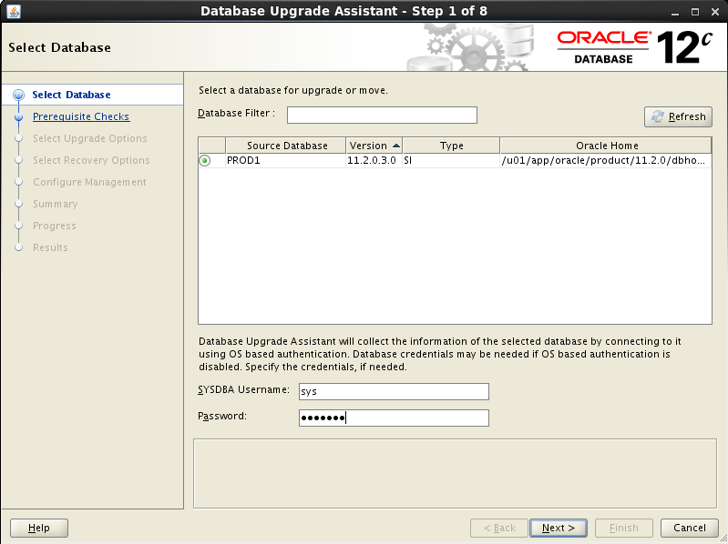

### 升级前系统自检

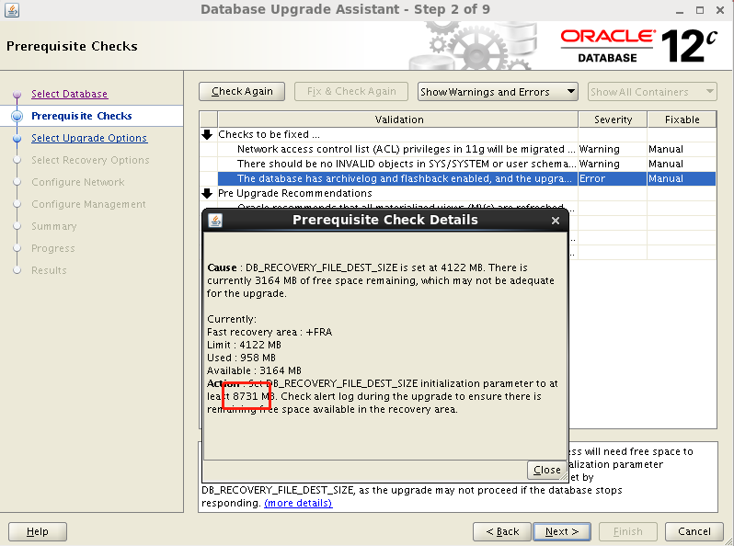

如果采用DBUA方式，需要针对error项进行修复。这里没办法，我虚拟机挂盘失误，所以为了快，我决定先暂时把fast recovery area移到本地。

SQL> drop restore point PROD1_20180520_12C;

Restore point dropped.

SQL> !mkdir /u02/arch

SQL> alter system set db_recovery_file_dest='/u02/arch';

System altered.

SQL> alter system set db_recovery_file_dest_size=9G;

System altered.

SQL> create restore point prod1_20180520_12c guarantee flashback database;

Restore point created.

SQL> show parameter recovery

NAME TYPE VALUE

------------------------------------ ----------- ------------------------------

db_recovery_file_dest string /u02/arch

db_recovery_file_dest_size big integer 9G

修复后效果：

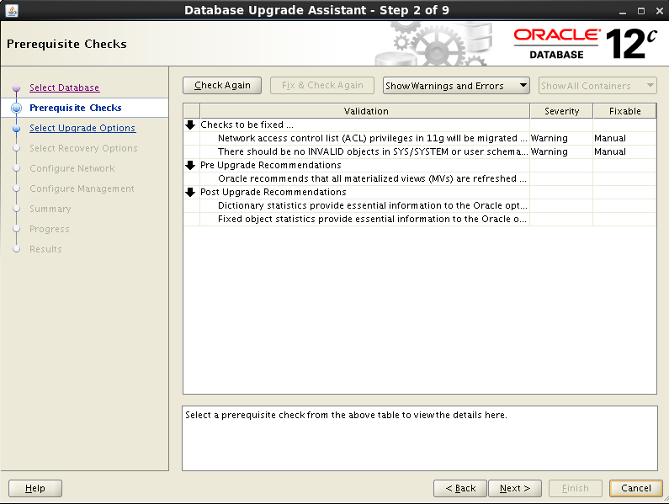

### 选择升级内容

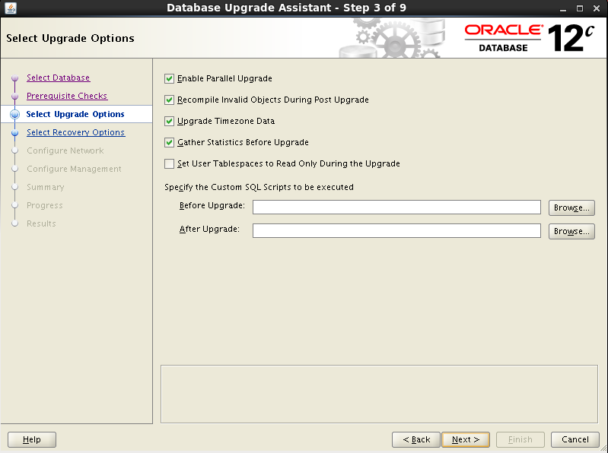

### 选择是否进行备份

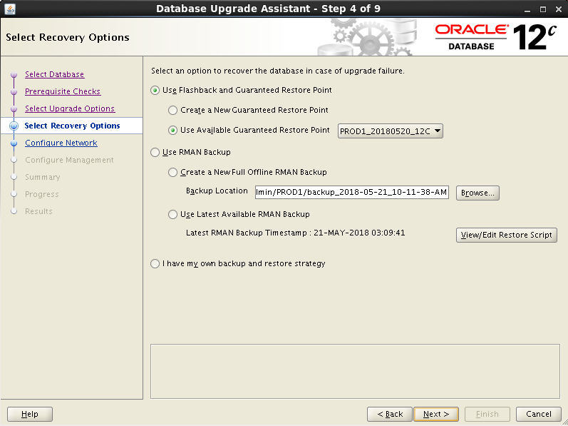

### 确认监听信息

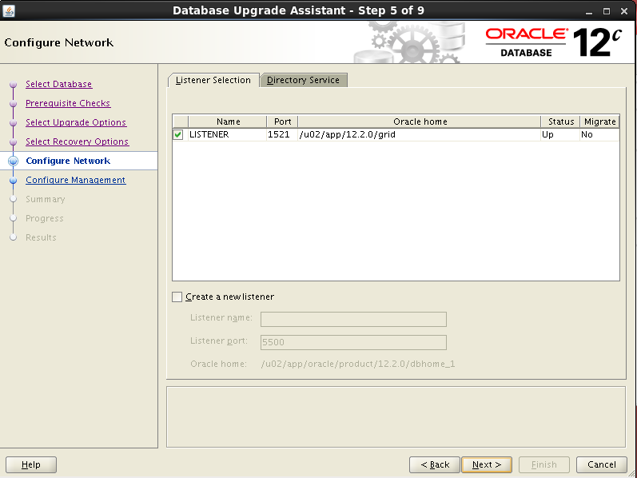

### 配置EM EXPRESS

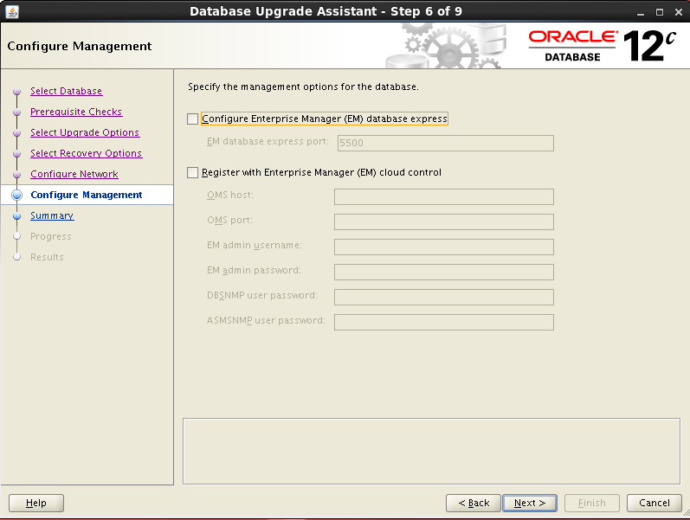

后面需要再配，很简单。

### 浏览升级概要

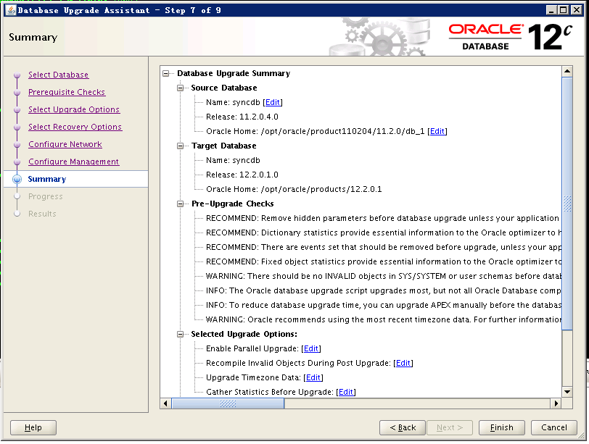

### 开始升级操作

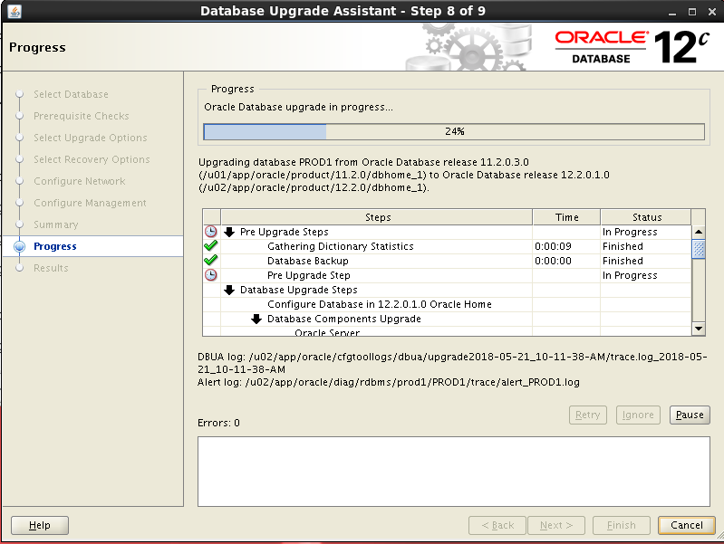

### 确认升级结果

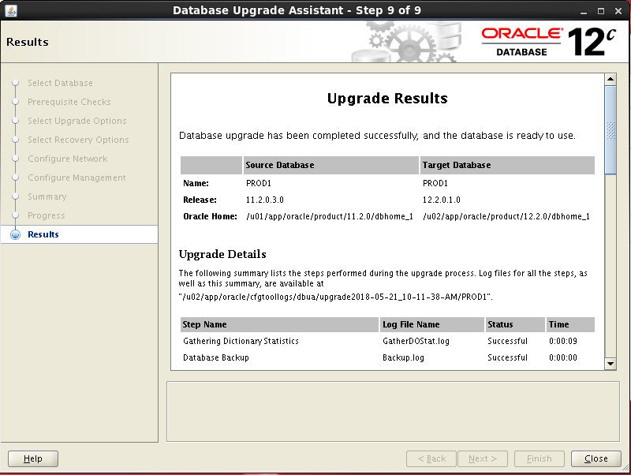

验证一下：

[oracle@rac3 ~]$ . 12c

[oracle@rac3 ~]$ sqlplus / as sysdba

SQL*Plus: Release 12.2.0.1.0 Production on Mon May 21 10:59:43 2018

Copyright (c) 1982, 2016, Oracle. All rights reserved.

Connected to:

Oracle Database 12c Enterprise Edition Release 12.2.0.1.0 - 64bit Production

SQL> show pdbs

SQL> conn scott/tiger

Connected.

SQL> select * from emp;

EMPNO ENAME JOB MGR HIREDATE SAL COMM

---------- ---------- --------- ---------- --------- ---------- ----------

DEPTNO

----------

7369 SMITH CLERK 7902 17-DEC-80 800

20

### 删除闪回点

SQL> drop restore point PROD1_20180520_12C;

## 脚本方式升级数据库

### 启动至upgrade状态

12c非cdb环境

sqlplus / as sysdba

startup upgrade;

### 执行升级脚本

12c环境执行

$ORACLE_HOME/perl/bin/perl -I$ORACLE_HOME/perl/lib $ORACLE_HOME/rdbms/admin/catctl.pl **-n 8**

$ORACLE_HOME/rdbms/admin/catupgrd.sql

升级日志如下：

[oracle@cdrs2 /home/oracle]$ $ORACLE_HOME/perl/bin/perl -I$ORACLE_HOME/perl/lib $ORACLE_HOME/rdbms/admin/catctl.pl -n 8 $ORACLE_HOME/rdbms/admin/catupgrd.sql

Argument list for [/u01/app/oracle/product/12.2.0/dbhome_1/rdbms/admin/catctl.pl]

Run in c = 0

Do not run in C = 0

Input Directory d = 0

Echo OFF e = 1

Simulate E = 0

Forced cleanup F = 0

Log Id i = 0

Child Process I = 0

Log Dir l = 0

Priority List Name L = 0

Upgrade Mode active M = 0

SQL Process Count n = 8

SQL PDB Process Count N = 0

Open Mode Normal o = 0

Start Phase p = 0

End Phase P = 0

Reverse Order r = 0

AutoUpgrade Resume R = 0

Script s = 0

Serial Run S = 0

RO User Tablespaces T = 0

Display Phases y = 0

Debug catcon.pm z = 0

Debug catctl.pl Z = 0

catctl.pl VERSION: [12.2.0.1.0]

STATUS: [production]

BUILD: [RDBMS_12.2.0.1.0_AIX.PPC64_170125.170330]

/u01/app/oracle/product/12.2.0/dbhome_1/rdbms/admin/orahome = [/u01/app/oracle/product/12.2.0/dbhome_1]

/u01/app/oracle/product/12.2.0/dbhome_1/bin/orabasehome = [/u01/app/oracle/product/12.2.0/dbhome_1]

catctlGetOrabase = [/u01/app/oracle/product/12.2.0/dbhome_1]

Analyzing file /u01/app/oracle/product/12.2.0/dbhome_1/rdbms/admin/catupgrd.sql

Log file directory = [/tmp/cfgtoollogs/upgrade20180207002530]

catcon: ALL catcon-related output will be written to [/tmp/cfgtoollogs/upgrade20180207002530/catupgrd_catcon_4522792.lst]

catcon: See [/tmp/cfgtoollogs/upgrade20180207002530/catupgrd*.log] files for output generated by scripts

catcon: See [/tmp/cfgtoollogs/upgrade20180207002530/catupgrd_*.lst] files for spool files, if any

Number of Cpus = 160

Database Name = cdld

DataBase Version = 11.2.0.4.0

catcon: ALL catcon-related output will be written to [/u01/app/oracle/product/12.2.0/dbhome_1/cfgtoollogs/cdld/upgrade20180207002533/catupgrd_catcon_4522792.lst]

catcon: See [/u01/app/oracle/product/12.2.0/dbhome_1/cfgtoollogs/cdld/upgrade20180207002533/catupgrd*.log] files for output generated by scripts

catcon: See [/u01/app/oracle/product/12.2.0/dbhome_1/cfgtoollogs/cdld/upgrade20180207002533/catupgrd_*.lst] files for spool files, if any

Log file directory = [/u01/app/oracle/product/12.2.0/dbhome_1/cfgtoollogs/cdld/upgrade20180207002533]

Parallel SQL Process Count = 8

Components in [cdld]

Installed [CATALOG CATJAVA CATPROC CONTEXT JAVAVM ODM OWM XDB]

Not Installed [APEX APS DV EM MGW OLS ORDIM RAC SDO WK XML XOQ]

------------------------------------------------------

Phases [0-115] Start Time:[2018_02_07 00:25:34]

------------------------------------------------------

*********** Executing Change Scripts ***********

Serial Phase #:0 [cdld] Files:1 Time: 310s

*************** Catalog Core SQL ***************

Serial Phase #:1 [cdld] Files:5 Time: 34s

Restart Phase #:2 [cdld] Files:1 Time: 0s

*********** Catalog Tables and Views ***********

Parallel Phase #:3 [cdld] Files:19 Time: 7s

Restart Phase #:4 [cdld] Files:1 Time: 1s

************* Catalog Final Scripts ************

Serial Phase #:5 [cdld] Files:6 Time: 16s

***************** Catproc Start ****************

Serial Phase #:6 [cdld] Files:1 Time: 13s

***************** Catproc Types ****************

Serial Phase #:7 [cdld] Files:2 Time: 12s

Restart Phase #:8 [cdld] Files:1 Time: 0s

**************** Catproc Tables ****************

Parallel Phase #:9 [cdld] Files:69 Time: 10s

Restart Phase #:10 [cdld] Files:1 Time: 1s

************* Catproc Package Specs ************

Serial Phase #:11 [cdld] Files:1 Time: 31s

Restart Phase #:12 [cdld] Files:1 Time: 0s

************** Catproc Procedures **************

Parallel Phase #:13 [cdld] Files:97 Time: 6s

Restart Phase #:14 [cdld] Files:1 Time: 0s

Parallel Phase #:15 [cdld] Files:118 Time: 9s

Restart Phase #:16 [cdld] Files:1 Time: 1s

Serial Phase #:17 [cdld] Files:13 Time: 3s

Restart Phase #:18 [cdld] Files:1 Time: 1s

***************** Catproc Views ****************

Parallel Phase #:19 [cdld] Files:33 Time: 12s

Restart Phase #:20 [cdld] Files:1 Time: 0s

Serial Phase #:21 [cdld] Files:3 Time: 8s

Restart Phase #:22 [cdld] Files:1 Time: 1s

Parallel Phase #:23 [cdld] Files:24 Time: 67s

Restart Phase #:24 [cdld] Files:1 Time: 0s

Parallel Phase #:25 [cdld] Files:11 Time: 44s

Restart Phase #:26 [cdld] Files:1 Time: 1s

Serial Phase #:27 [cdld] Files:1 Time: 0s

Serial Phase #:28 [cdld] Files:3 Time: 4s

Serial Phase #:29 [cdld] Files:1 Time: 0s

Restart Phase #:30 [cdld] Files:1 Time: 0s

*************** Catproc CDB Views **************

Serial Phase #:31 [cdld] Files:1 Time: 1s

Restart Phase #:32 [cdld] Files:1 Time: 1s

Serial Phase #:34 [cdld] Files:1 Time: 0s

***************** Catproc PLBs *****************

Serial Phase #:35 [cdld] Files:283 Time: 18s

Serial Phase #:36 [cdld] Files:1 Time: 0s

Restart Phase #:37 [cdld] Files:1 Time: 1s

Serial Phase #:38 [cdld] Files:1 Time: 5s

Restart Phase #:39 [cdld] Files:1 Time: 1s

*************** Catproc DataPump ***************

Serial Phase #:40 [cdld] Files:3 Time: 47s

Restart Phase #:41 [cdld] Files:1 Time: 1s

****************** Catproc SQL *****************

Parallel Phase #:42 [cdld] Files:13 Time: 43s

Restart Phase #:43 [cdld] Files:1 Time: 0s

Parallel Phase #:44 [cdld] Files:12 Time: 25s

Restart Phase #:45 [cdld] Files:1 Time: 1s

Parallel Phase #:46 [cdld] Files:2 Time: 1s

Restart Phase #:47 [cdld] Files:1 Time: 1s

************* Final Catproc scripts ************

Serial Phase #:48 [cdld] Files:1 Time: 5s

Restart Phase #:49 [cdld] Files:1 Time: 1s

************** Final RDBMS scripts *************

Serial Phase #:50 [cdld] Files:1 Time: 25s

************ Upgrade Component Start ***********

Serial Phase #:51 [cdld] Files:1 Time: 1s

Restart Phase #:52 [cdld] Files:1 Time: 1s

**************** Upgrading Java ****************

Serial Phase #:53 [cdld] Files:1 Time: 231s

Restart Phase #:54 [cdld] Files:1 Time: 1s

***************** Upgrading XDK ****************

Serial Phase #:55 [cdld] Files:1 Time: 1s

Restart Phase #:56 [cdld] Files:1 Time: 1s

********* Upgrading APS,OLS,DV,CONTEXT *********

Serial Phase #:57 [cdld] Files:1 Time: 46s

***************** Upgrading XDB ****************

Restart Phase #:58 [cdld] Files:1 Time: 1s

Serial Phase #:60 [cdld] Files:3 Time: 19s

Serial Phase #:61 [cdld] Files:3 Time: 8s

Parallel Phase #:62 [cdld] Files:9 Time: 4s

Parallel Phase #:63 [cdld] Files:24 Time: 3s

Serial Phase #:64 [cdld] Files:4 Time: 8s

Serial Phase #:65 [cdld] Files:1 Time: 0s

Serial Phase #:66 [cdld] Files:30 Time: 3s

Serial Phase #:67 [cdld] Files:1 Time: 0s

Parallel Phase #:68 [cdld] Files:6 Time: 3s

Serial Phase #:69 [cdld] Files:2 Time: 20s

Serial Phase #:70 [cdld] Files:3 Time: 87s

Restart Phase #:71 [cdld] Files:1 Time: 1s

********* Upgrading CATJAVA,OWM,MGW,RAC ********

Serial Phase #:72 [cdld] Files:1 Time: 100s

**************** Upgrading ORDIM ***************

Restart Phase #:73 [cdld] Files:1 Time: 0s

Serial Phase #:75 [cdld] Files:1 Time: 2s

Parallel Phase #:76 [cdld] Files:2 Time: 1s

Serial Phase #:77 [cdld] Files:1 Time: 2s

Restart Phase #:78 [cdld] Files:1 Time: 0s

Parallel Phase #:79 [cdld] Files:2 Time: 2s

Serial Phase #:80 [cdld] Files:2 Time: 1s

***************** Upgrading SDO ****************

Restart Phase #:81 [cdld] Files:1 Time: 1s

Serial Phase #:83 [cdld] Files:1 Time: 1s

Serial Phase #:84 [cdld] Files:1 Time: 2s

Restart Phase #:85 [cdld] Files:1 Time: 0s

Serial Phase #:86 [cdld] Files:1 Time: 2s

Restart Phase #:87 [cdld] Files:1 Time: 1s

Parallel Phase #:88 [cdld] Files:3 Time: 1s

Restart Phase #:89 [cdld] Files:1 Time: 1s

Serial Phase #:90 [cdld] Files:1 Time: 1s

Restart Phase #:91 [cdld] Files:1 Time: 1s

Serial Phase #:92 [cdld] Files:1 Time: 1s

Restart Phase #:93 [cdld] Files:1 Time: 1s

Parallel Phase #:94 [cdld] Files:4 Time: 1s

Restart Phase #:95 [cdld] Files:1 Time: 1s

Serial Phase #:96 [cdld] Files:1 Time: 2s

Restart Phase #:97 [cdld] Files:1 Time: 0s

Serial Phase #:98 [cdld] Files:2 Time: 2s

Restart Phase #:99 [cdld] Files:1 Time: 0s

Serial Phase #:100 [cdld] Files:1 Time: 2s

Restart Phase #:101 [cdld] Files:1 Time: 0s

*********** Upgrading Misc. ODM, OLAP **********

Serial Phase #:102 [cdld] Files:1 Time: 6s

**************** Upgrading APEX ****************

Restart Phase #:103 [cdld] Files:1 Time: 1s

Serial Phase #:104 [cdld] Files:1 Time: 1s

Restart Phase #:105 [cdld] Files:1 Time: 1s

*********** Final Component scripts ***********

Serial Phase #:106 [cdld] Files:1 Time: 1s

************* Final Upgrade scripts ************

Serial Phase #:107 [cdld] Files:1 Time: 84s

********** End PDB Application Upgrade *********

Serial Phase #:108 [cdld] Files:1 Time: 2s

******************* Migration ******************

Serial Phase #:109 [cdld] Files:1 Time: 161s

Serial Phase #:110 [cdld] Files:1 Time: 0s

Serial Phase #:111 [cdld] Files:1 Time: 170s

***************** Post Upgrade *****************

Serial Phase #:112 [cdld] Files:1 Time: 148s

**************** Summary report ****************

Serial Phase #:113 [cdld] Files:1 Time: 2s

Serial Phase #:114 [cdld] Files:1 Time: 0s

Serial Phase #:115 [cdld] Files:1 Time: 33s

------------------------------------------------------

Phases [0-115] End Time:[2018_02_07 00:58:01]

------------------------------------------------------

Grand Total Time: 1950s

LOG FILES: (/u01/app/oracle/product/12.2.0/dbhome_1/cfgtoollogs/cdld/upgrade20180207002533/catupgrd*.log)

Upgrade Summary Report Located in:

/u01/app/oracle/product/12.2.0/dbhome_1/cfgtoollogs/cdld/upgrade20180207002533/upg_summary.log

Grand Total Upgrade Time: [0d:0h:32m:30s]

### 执行升级后脚本

startup

@/home/oracle/shell/log/postupgrade_fixups.sql

### 检查组件状态

set line 200

col COMP_NAME for a40

select comp_name,VERSION,STATUS from dba_registry

如果遇到组件状态为upgrade，则执行如下操作

@?/rdbms/admin/catuptabdata.sql

@?/rdbms/admin/utluptabdata.sql

@?/rdbms/admin/utlrp.sql

### 删除闪回点

drop restore point cdld_20180214_12c

# NO-CDB插入CDB

## 启动至read only

12c 非CDB环境

SQL> startup mount exclusive

ORACLE instance started.

Total System Global Area 1027604480 bytes

Fixed Size 8628400 bytes

Variable Size 964691792 bytes

Database Buffers 50331648 bytes

Redo Buffers 3952640 bytes

Database mounted.

SQL> alter database open read only;

Database altered.

## 创建元数据

SQL> BEGIN

DBMS_PDB.DESCRIBE

(

pdb_descr_file => '/tmp/noncdb12c.xml'

);

END;

/

PL/SQL procedure successfully completed.

SQL>

## 检查兼容性

12c cdb环境下：

DECLARE

compatible CONSTANT VARCHAR2(3) := CASE DBMS_PDB.CHECK_PLUG_COMPATIBILITY(pdb_descr_file => '/tmp/noncdb12c.xml',pdb_name => 'syncdb')

WHEN TRUE THEN 'YES'

ELSE 'NO'

END;

BEGIN

DBMS_OUTPUT.PUT_LINE(compatible);

END;

/

## Nocopy方式插入CDB

CREATE PLUGGABLE DATABASE syncdb USING '/tmp/PDBCDRS.xml' NOCOPY;

## 同步pdb信息

exec dbms_pdb.sync_pdb();

## 执行nocdb_to_pdb脚本

alter session set container= pdbcdrs;

alter pluggable database pdbcdrs open;

shutdown immediate ；

@$ORACLE_HOME/rdbms/admin/noncdb_to_pdb.sql

## 数据校验

* 源库启动1个节点至readonly
* 目标库创建到老库的dblink

create public database link to_old connect to ggmgr identified by oracle using ‘to_old'

* 执行对比

@/home/oracle/shell/checkobject.sql

* 对比结果

# 12c适应性调整

* 调整undo；

SET SERVEROUTPUT ON LINES 2000 PAGES 10000 ECHO ON

set lines 200

col file_name for a60

select file_name,file_id,tablespace_name,bytes/1024/1024/1024,AUTOEXTENSIBLE from dba_data_files where tablespace_name like 'UNDOTBS%';

create UNDO tablespace UNDOTBS3 datafile '+DG_DATA01' size 32766m autoextend off;

alter tablespace undotbs3 add datafile '+DG_DATA01' size 32766m autoextend off;

alter tablespace undotbs3 add datafile '+DG_DATA01' size 32766m autoextend off;

create UNDO tablespace UNDOTBS4 datafile '+DG_DATA01' size 32766m autoextend off;

alter tablespace undotbs4 add datafile '+DG_DATA01' size 32766m autoextend off;

alter tablespace undotbs4 add datafile '+DG_DATA01' size 32766m autoextend off;

alter tablespace undotbs2 add datafile '+DG_DATA01' size 32766m autoextend off;

alter system set undo_tablespace=undotbs1 scope=spfile sid='cdbcdrs1';

alter system set undo_tablespace=undotbs2 scope=spfile sid='cdbcdrs2';

alter system set undo_tablespace=undotbs3 scope=spfile sid='cdbcdrs3';

alter system set undo_tablespace=undotbs4 scope=spfile sid='cdbcdrs4';

set lines 200

col file_name for a60

select file_name,file_id,tablespace_name,bytes/1024/1024/1024,AUTOEXTENSIBLE from dba_data_files where tablespace_name like 'UNDOTBS%';

* 调整tmpfile；
* 保存pdb随cdb一起启动

alter pluggable database pdbcdrs save state

* 正式对外提供服务时，再恢复job参数

alter system set job_queue_processes=1000 scope =both;

* 统计信息收集

nohup sh /home/oracle/shell/gather_stat.sh &