Book Name :- MIddleware Troubleshooting Use Cases: A Traditional Approach with AI Assist

Introduction: (This will cover the challenges of manual troubleshooting, the value of LLMs, and the concept of a secure, self-hosted AI engine for log analysis - Diagnostic Excellence with AI-Powered Log Analysis)
Chapter 1: Foundations - Intelligent Log Analysis
- Description: Establishing the rationale for leveraging AI in middleware troubleshooting, focusing on skill gaps, creating knowledgebase, and introducing the architecture of our AI-powered diagnostic tools. We’ll explore the core principles of RAG (Retrieval-Augmented Generation) and how it’s optimized for enterprise operational data. Introduces the two custom tools and their high-level approach.
- Screenshot Focus: Architectural diagram of the RAG pipeline, conceptual visualization of the LLM integration.

Chapter 2: – ByteBite Restaurant Application - Overview
- Description: A deep dive into custom application infrastructure architecture overview with underlying end to end application flow details.
- Screenshot Focus: Tool interface screenshots, workflow diagrams illustrating log generation, and sample log outputs.
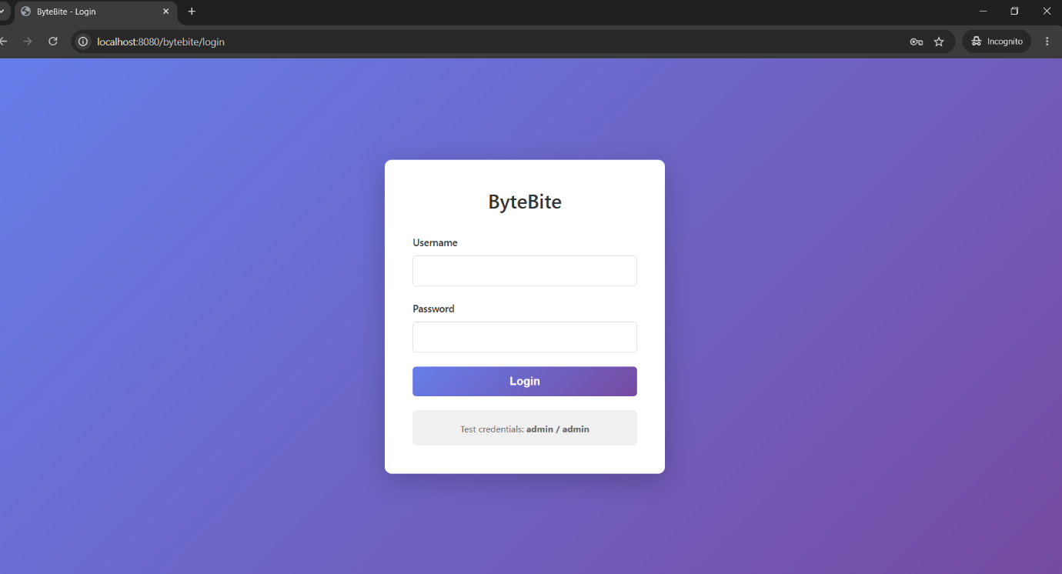
Chapter 3: The Log Analyzer AI Tool – Real-Time Log Investigation
- Description: A detailed exploration of the AI-powered tool, including its architecture, environment setup, and the utilization of Ollama and LangChain for secure LLM integration. Focuses on securing the data flow and anonymization techniques.
- Screenshot Focus: Tool interface screenshots, system architecture diagram, visualization of the RAG pipeline.
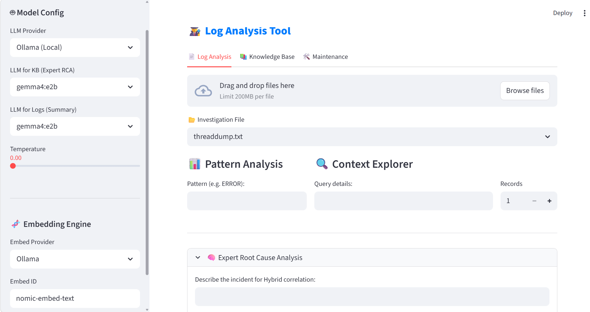
Chapter 4: User Login issues – Addressing LDAP Authentication issues
- Description: Diagnosing authentication failures and Timeouts
- Use Cases Demo: (Detailed walkthroughs of showcasing the issue production screenshots and then a write up for traditional way of resolution followed by showcase of use AI tool for two different LLMs, with screenshot of flow)

LDAP Timeout (automatic with FAILURE_INJECTION_ENABLED=true)
curl -X POST http://localhost:8080/bytebite/login -d "username=admin&password=admin"
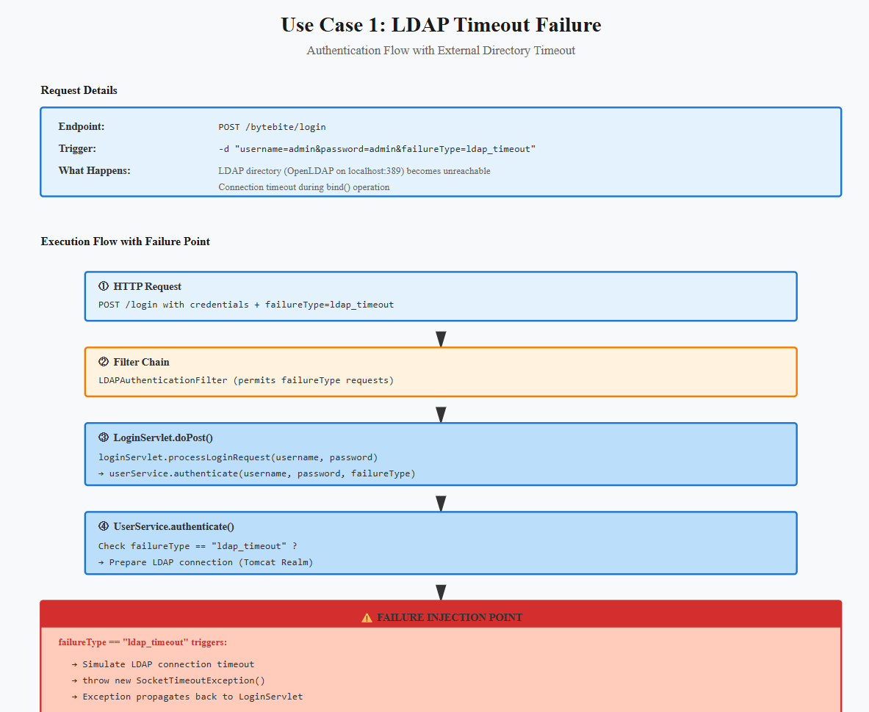

Chapter 5: Database Connection pool issues– Optimizing HikariCP Pool Utilization
- Description: Analyzing and resolving database connection leak scenarios using HikariCP. Focuses on how to identify and correct pool size issues.
- Use Cases Demo: (Detailed walkthroughs, same as above)
6.1 database connection leak
6.2 Connection pool exhaust

DB Leak (20+ requests to exhaust pool)
for i in {1..30}; do curl http://localhost:8080/bytebite/menu/api; done
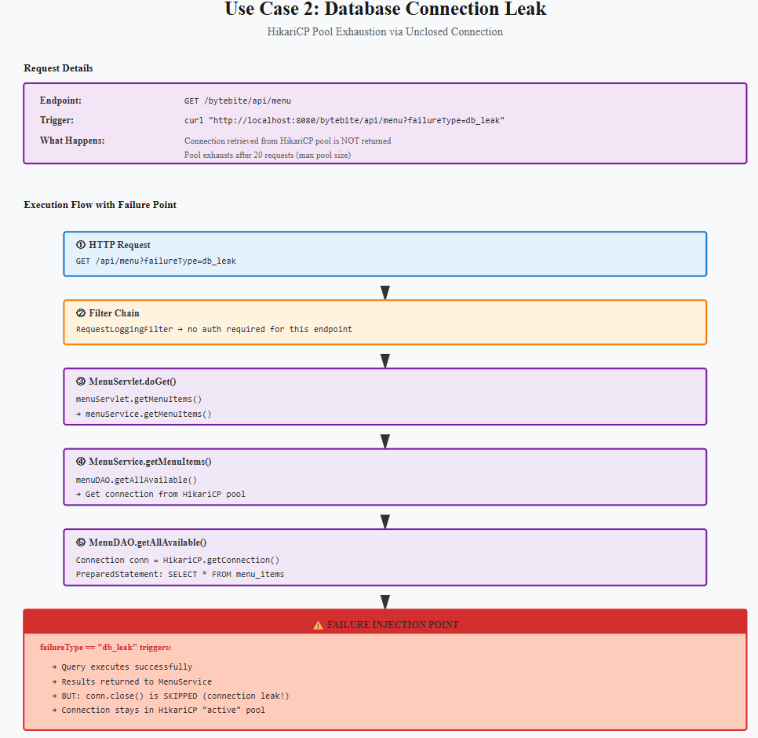
Chapter 4: Memory Management – Identifying JVM OOM
- Description: Analyzing memory-related issues in middleware environments. We explore the identification of JVM Out of Memory (OOM) errors and thread leaks.
- Use Cases Demo: (This chapter would contain the detailed walkthroughs – using both the traditional and AI-powered tools to diagnose and resolve these issues. Screenshots are critical here.)
  - 4.1.1 Heap Space OOM
  - 4.1.2 Stack Overflow
- Screenshot Focus: Traditional log analysis views alongside AI-powered analysis output (highlighting key differences and insights).
OOM (triggers with action=all-time-report)
curl "http://localhost:8080/bytebite/analytics/api?action=all-time-report"

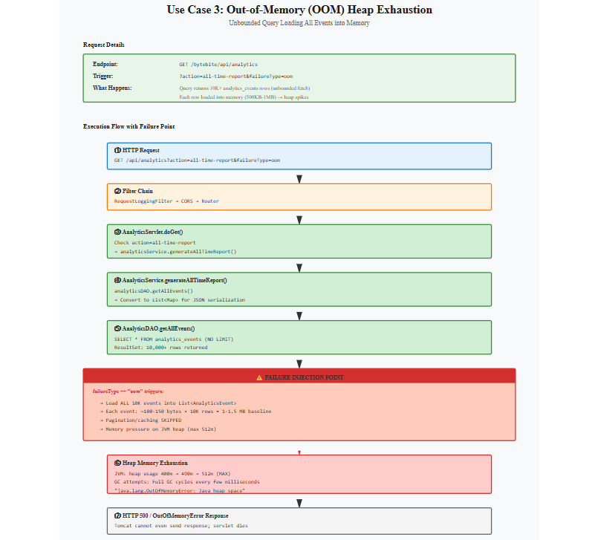
Chapter 5: Thread Analysis – Detecting and Resolving Thread Issues
- Description: Investigating thread-related problems, including blocked threads, thread pool exhaustion, and zombie threads.
- Use Cases Demo: (Detailed walkthroughs, same as above, showcasing both tools)
  - 5.1.1 HTTP Thread Pool Exhaustion
  - 5.1.2 Block HTTP Request Thread
  - 5.1.3 Stuck Thread Detection
Deadlock (specific parameter)
curl -X POST http://localhost:8080/bytebite/kds -H "Content-Type: application/json" \
-d '{"orderId":"ORD1","status":"IN"}' -G --data-urlencode "injectDeadlock=true"

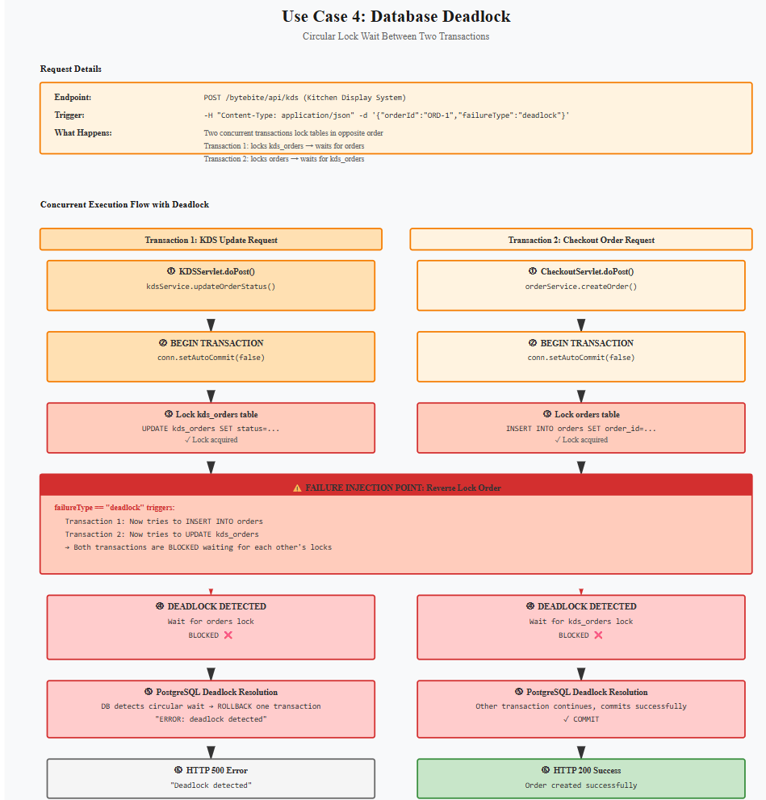
Chapter 8: SSL Issues - Tracing Issues
- Description: Understanding ssl specific use cases of handshake and truststore failure , how to utilize Wireshark to pinpoint handshaking issues etc.
- Use Cases Demo: (Detailed walkthroughs, focusing on practical Wireshark techniques).
Handshake failure
Truststore Failure
SSL Failure (specific parameter)
curl -X POST http://localhost:8080/bytebite/checkout/api \
-G --data-urlencode "injectSSLFailure=true" -H "Content-Type: application/json" \
-d '{"totalAmount":99}'
TCPDUMP to be taken and analyse the same using wireshark
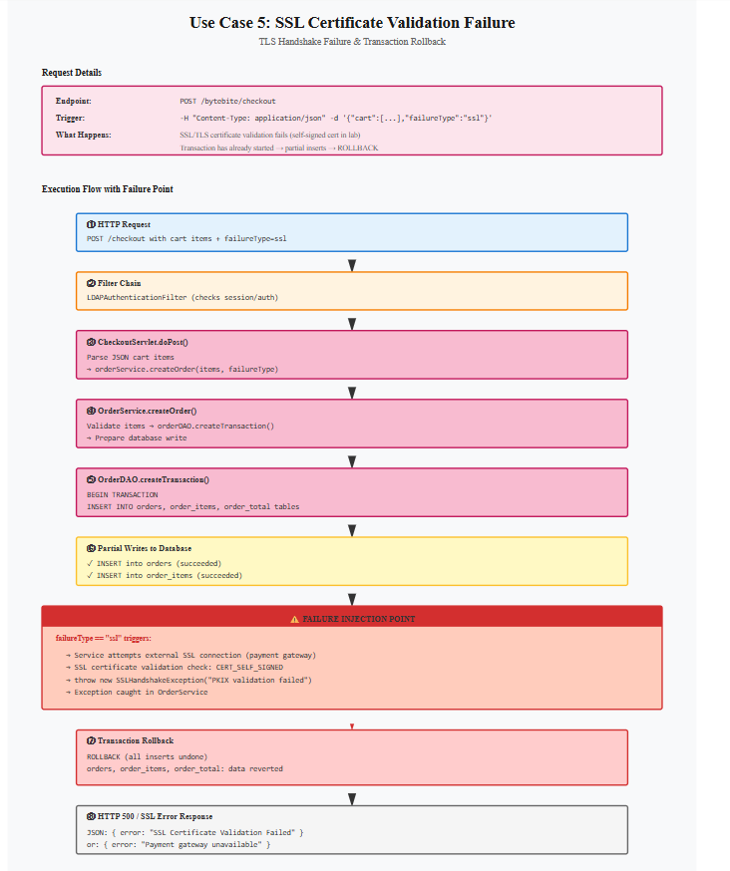
Chapter 9: Conclusion – Embracing AI for Log Analysis
- Description: Summarizing the key takeaways and highlighting the benefits of integrating AI-powered log analysis into your middleware troubleshooting workflow.

Appendix 1 Database schema details
(Link to Chapter -2)
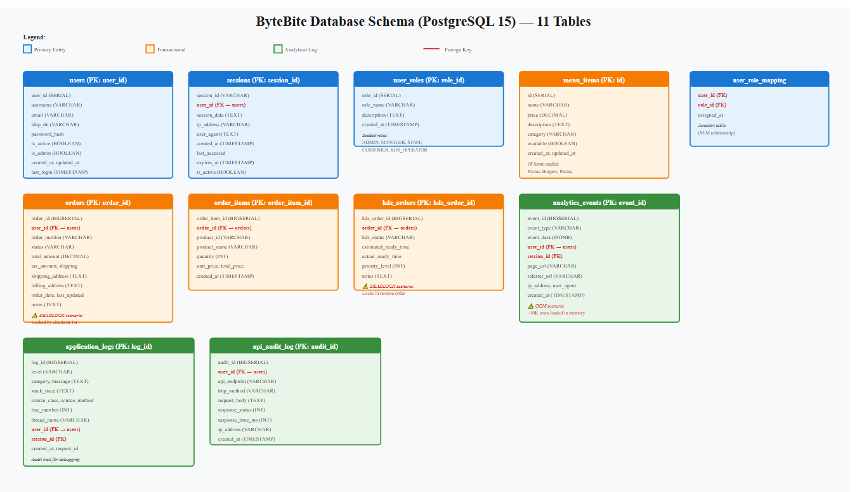
Database Table Structure Diagram
║ BYTEBITE DATABASE SCHEMA (PostgreSQL 15) ║
║ SCHEMA: bytebite ║
┌─────────────────────────────────────────────────────────────────────────┐
│ TABLE: users (PK: user_id SERIAL) │
├─────────────────────────────────────────────────────────────────────────┤
│ user_id (INT) │ Primary Key, Auto-increment │
│ username (VARCHAR 255) │ Unique, NOT NULL — linked to LDAP DN │
│ email (VARCHAR 255) │ Unique, nullable │
│ ldap_dn (VARCHAR 512) │ OpenLDAP Distinguished Name │
│ password_hash (VARCHAR) │ Never used; LDAP auth takes precedence │
│ is_active (BOOLEAN) │ Account activation flag │
│ is_admin (BOOLEAN) │ Admin role flag (also in user_roles) │
│ created_at (TIMESTAMP) │ Account creation timestamp │
│ updated_at (TIMESTAMP) │ Last profile update │
│ last_login (TIMESTAMP) │ Updated on successful login │
├─────────────────────────────────────────────────────────────────────────┤
│ Indices: idx_users_username, idx_users_email │
│ Relationships: ◄── user_roles (M:M), ◄── sessions, ◄── orders │
└─────────────────────────────────────────────────────────────────────────┘
┌─────────────────────────────────────────────────────────────────────────┐
│ TABLE: sessions (PK: session_id VARCHAR 128) │
├─────────────────────────────────────────────────────────────────────────┤
│ session_id (VARCHAR 128) │ Primary Key, JSESSIONID │
│ user_id (INT) │ FK → users.user_id (CASCADE) │
│ session_data (TEXT) │ Serialized session attributes │
│ ip_address (VARCHAR 45) │ IPv4/IPv6 client IP │
│ user_agent (TEXT) │ Browser info │
│ created_at (TIMESTAMP) │ Session creation time │
│ last_accessed (TIMESTAMP)│ Last activity timestamp │
│ expires_at (TIMESTAMP) │ Expiration time (typically +30 min) │
│ is_active (BOOLEAN) │ Session validity flag │
├─────────────────────────────────────────────────────────────────────────┤
│ Indices: idx_sessions_user_id, idx_sessions_expires_at │
│ Relationships: ► users (N:1), ◄── analytics_events │
└─────────────────────────────────────────────────────────────────────────┘
┌─────────────────────────────────────────────────────────────────────────┐
│ TABLE: menu_items (PK: id SERIAL) │
├─────────────────────────────────────────────────────────────────────────┤
│ id (SERIAL) │ Primary Key, Auto-increment │
│ name (VARCHAR 255) │ Menu item name — NOT NULL │
│ price (DECIMAL 10,2) │ Unit price — NOT NULL │
│ description (TEXT) │ Item description │
│ category (VARCHAR 100) │ Category: Pizza, Burgers, Pasta, etc. │
│ available (BOOLEAN) │ Availability flag (default true) │
│ created_at (TIMESTAMP) │ Item added timestamp │
│ updated_at (TIMESTAMP) │ Last modification timestamp │
├─────────────────────────────────────────────────────────────────────────┤
│ Indices: idx_menu_items_category, idx_menu_items_available │
│ Sample Data: 16 items seeded (3 pizzas, 3 burgers, 3 pastas, etc.) │
│ Relationships: ◄── order_items (1:M) │
└─────────────────────────────────────────────────────────────────────────┘
┌─────────────────────────────────────────────────────────────────────────┐
│ TABLE: orders (PK: order_id BIGSERIAL) │
├─────────────────────────────────────────────────────────────────────────┤
│ order_id (BIGSERIAL) │ Primary Key, Auto-increment │
│ user_id (INT) │ FK → users.user_id (RESTRICT) │
│ order_number (VARCHAR 50)│ Unique order reference │
│ status (VARCHAR 50) │ PENDING, IN_PROGRESS, READY, COMPLETED │
│ total_amount (DECIMAL) │ Order total (without tax/shipping) │
│ tax_amount (DECIMAL) │ Calculated tax (8% default) │
│ shipping_amount (DECIMAL)│ Shipping cost │
│ shipping_address (TEXT) │ Delivery address │
│ billing_address (TEXT) │ Billing address │
│ order_date (TIMESTAMP) │ Order creation timestamp │
│ last_updated (TIMESTAMP) │ Last status update timestamp │
│ notes (TEXT) │ Special instructions │
├─────────────────────────────────────────────────────────────────────────┤
│ Indices: idx_orders_user_id, idx_orders_status, idx_orders_order_date │
│ Relationships: ► users (N:1), ◄── order_items, ◄── kds_orders │
│ Failure Injection: DEADLOCK scenario (lock contention with KDS) │
└─────────────────────────────────────────────────────────────────────────┘
┌─────────────────────────────────────────────────────────────────────────┐
│ TABLE: order_items (PK: order_item_id BIGSERIAL) │
├─────────────────────────────────────────────────────────────────────────┤
│ order_item_id (BIGSERIAL)│ Primary Key, Auto-increment │
│ order_id (BIGINT) │ FK → orders.order_id (CASCADE) │
│ product_id (VARCHAR 100) │ Menu item reference │
│ product_name (VARCHAR) │ Item name at purchase time │
│ quantity (INT) │ Number of items │
│ unit_price (DECIMAL) │ Price per unit │
│ total_price (DECIMAL) │ quantity × unit_price │
│ created_at (TIMESTAMP) │ Item addition timestamp │
├─────────────────────────────────────────────────────────────────────────┤
│ Indices: idx_order_items_order_id │
│ Relationships: ► orders (N:1), ► menu_items │
└─────────────────────────────────────────────────────────────────────────┘

┌─────────────────────────────────────────────────────────────────────────┐
│ TABLE: kds_orders (PK: kds_order_id BIGSERIAL) │
├─────────────────────────────────────────────────────────────────────────┤
│ kds_order_id (BIGSERIAL) │ Primary Key, Auto-increment │
│ order_id (BIGINT) │ FK → orders.order_id (CASCADE) │
│ kds_status (VARCHAR 50) │ NEW, IN_PROGRESS, READY, COMPLETED │
│ estimated_ready_time │ Expected completion (kitchen estimate) │
│ actual_ready_time │ Actual completion timestamp │
│ priority_level (INT) │ 0=normal, >0 = expedited │
│ notes (TEXT) │ Preparation instructions │
│ created_at (TIMESTAMP) │ Order sent to kitchen timestamp │
│ updated_at (TIMESTAMP) │ Last status change timestamp │
├─────────────────────────────────────────────────────────────────────────┤
│ Indices: idx_kds_orders_status, idx_kds_orders_priority │
│ Relationships: ► orders (N:1) │
│ Failure Injection: DEADLOCK scenario (opposite lock order from orders) │
└─────────────────────────────────────────────────────────────────────────┘

┌─────────────────────────────────────────────────────────────────────────┐
│ TABLE: analytics_events (PK: event_id BIGSERIAL) │
├─────────────────────────────────────────────────────────────────────────┤
│ event_id (BIGSERIAL) │ Primary Key, Auto-increment │
│ event_type (VARCHAR 100) │ PAGE_VIEW, PURCHASE, CHECKOUT, etc. │
│ event_data (JSONB) │ Flexible event attributes (100KB avg) │
│ user_id (INT) │ FK → users.user_id (SET NULL on delete) │
│ session_id (VARCHAR 128) │ FK → sessions.session_id (SET NULL) │
│ page_url (VARCHAR 512) │ URL visited │
│ referrer_url (VARCHAR) │ Previous page │
│ ip_address (VARCHAR 45) │ Client IP │
│ user_agent (TEXT) │ Browser info │
│ created_at (TIMESTAMP) │ Event timestamp │
├─────────────────────────────────────────────────────────────────────────┤
│ Indices: idx_analytics_event_type, idx_analytics_created_at, │
│ idx_analytics_user_id │
│ Sample Data: ~10,000 rows seeded for testing (OOM failure injection) │
│ Relationships: ► users, ► sessions │
│ Failure Injection: OOM scenario (unbounded query on all-time-report) │
└─────────────────────────────────────────────────────────────────────────┘

┌─────────────────────────────────────────────────────────────────────────┐
│ TABLE: user_roles (PK: role_id SERIAL) │
├─────────────────────────────────────────────────────────────────────────┤
│ role_id (SERIAL) │ Primary Key, Auto-increment │
│ role_name (VARCHAR 100) │ ADMIN, MANAGER, STAFF, CUSTOMER, etc. │
│ description (TEXT) │ Role purpose │
│ created_at (TIMESTAMP) │ Creation timestamp │
├─────────────────────────────────────────────────────────────────────────┤
│ Seeded Roles: ADMIN, MANAGER, STAFF, CUSTOMER, KDS_OPERATOR │
│ Relationships: ◄── user_role_mapping (1:M) │
└─────────────────────────────────────────────────────────────────────────┘

┌─────────────────────────────────────────────────────────────────────────┐
│ TABLE: user_role_mapping (PK: user_id, role_id) │
├─────────────────────────────────────────────────────────────────────────┤
│ user_id (INT) │ FK → users.user_id (CASCADE) │
│ role_id (INT) │ FK → user_roles.role_id (CASCADE) │
│ assigned_at (TIMESTAMP) │ Role assignment timestamp │
├─────────────────────────────────────────────────────────────────────────┤
│ Composite Primary Key: (user_id, role_id) │
│ Relationships: ► users, ► user_roles (M:M junction table) │
└─────────────────────────────────────────────────────────────────────────┘

┌─────────────────────────────────────────────────────────────────────────┐
│ TABLE: application_logs (PK: log_id BIGSERIAL) │
├─────────────────────────────────────────────────────────────────────────┤
│ log_id (BIGSERIAL) │ Primary Key, Auto-increment │
│ level (VARCHAR 20) │ INFO, WARN, ERROR, DEBUG │
│ category (VARCHAR 255) │ Logger category (e.g., com.bytebite.*) │
│ message (TEXT) │ Log message │
│ stack_trace (TEXT) │ Exception stack trace (if error) │
│ source_class (VARCHAR) │ Calling class │
│ source_method (VARCHAR) │ Calling method │
│ line_number (INT) │ Source line number │
│ thread_name (VARCHAR) │ Thread name │
│ user_id (INT) │ FK → users.user_id (SET NULL) │
│ session_id (VARCHAR 128) │ FK → sessions.session_id (SET NULL) │
│ created_at (TIMESTAMP) │ Log timestamp │
│ request_id (VARCHAR 128) │ Correlation ID for request tracing │
├─────────────────────────────────────────────────────────────────────────┤
│ Indices: idx_logs_level, idx_logs_category, idx_logs_created_at, │
│ idx_logs_user_id │
│ Purpose: Audit trail for debugging and compliance │
└─────────────────────────────────────────────────────────────────────────┘

┌─────────────────────────────────────────────────────────────────────────┐
│ TABLE: api_audit_log (PK: audit_id BIGSERIAL) │
├─────────────────────────────────────────────────────────────────────────┤
│ audit_id (BIGSERIAL) │ Primary Key, Auto-increment │
│ user_id (INT) │ FK → users.user_id (SET NULL) │
│ api_endpoint (VARCHAR) │ URL path (e.g., /bytebite/api/menu) │
│ http_method (VARCHAR 10) │ GET, POST, PUT, DELETE │
│ request_body (TEXT) │ Request payload (if POST/PUT) │
│ response_status (INT) │ HTTP status code (200, 500, etc.) │
│ response_time_ms (INT) │ Request duration in milliseconds │
│ ip_address (VARCHAR 45) │ Client IP │
│ created_at (TIMESTAMP) │ Request timestamp │
├─────────────────────────────────────────────────────────────────────────┤
│ Indices: idx_audit_log_user_id, idx_audit_log_created_at │
│ Purpose: API usage audit and performance tracking │
└─────────────────────────────────────────────────────────────────────────┘
Appendix 2 ByteBite Application project structure
(Link to chapter -2)
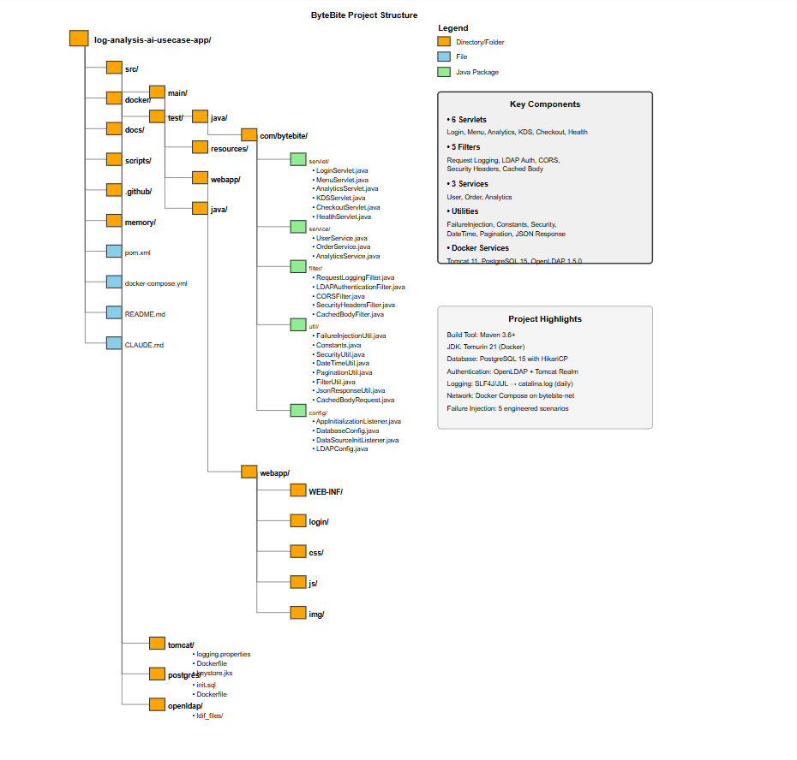
Appendix 3 AI Log Analyzer AI Tool kit project structure
