|  |
| --- |
| dANIEL gameS corporation  L:\SIXTHS~1\COMP30~1\ASSIGN~1\Logo\Logo.jpg |
| Slot Machine |
| **CreateJS web game** |
| Version 2.0  All work Copyright © 2015 by Daniel Games.  All rights reserved. |
| **Zhe Yan 300706310** |
|  |

|  |
| --- |
| February 27, 2015 |

**Table of Contents**

Table of Contents

Version History 3

Game Design 4

I. Detailed Game Description 4

II. Game Play Mechanics 4

III. Controls 5

IV. Interface Sketch 6

V. Screen Descriptions 6

VI. Scoring 7

VII. Art / Multimedia Index 8

# Version History

* Version 1.0: slotmachine template game;

<https://github.com/tsiliopoulos/slotmachine>

* Version 2.0 : slotmachine web game;

<https://github.com/yanzhe19/COMP-397-Assignment2>

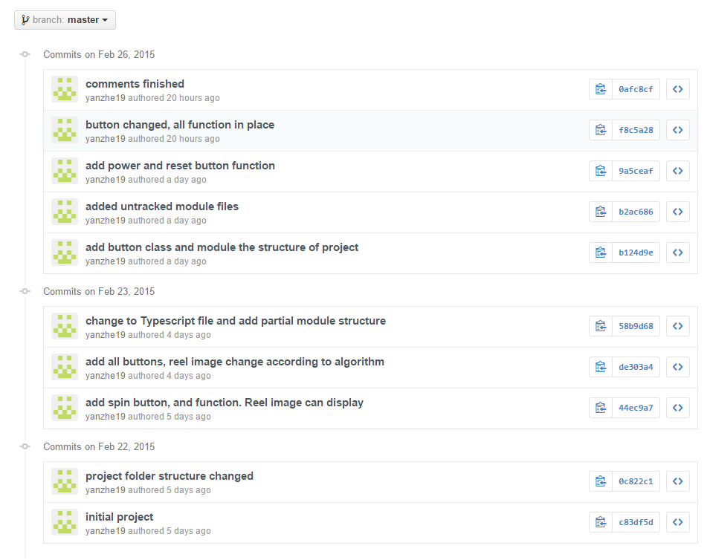The following diagram shows the version control using GitHub.

# Game Design

## Detailed Game Description

*The goal of the slot machine game for a player is to win as much money as possible, Player set his bet for each spin using bet button. Click the spin button, and program will generate three reels according to algorithm predefined. Three reels image will showed in the three tiles on the interface so player know spin result.*

*When player start play the game, initial status is three blanks in reels. Player has 1000 credits, 5 for bet and jackpot is 5000.In order to win, there should be no blank.*

*Rewards for different items and different number of same items will differ.*

*Player can even win a jackpot in the game, after user win the game, program will check if he or she also win the jackpot. The initial money for jackpot is 5000, and a message will pop up remind the player win the jackpot. And player’s credit will increase according to the amount of jackpot.*

*Player can use four bet buttons to increase their bet amount. However, players cannot bet more money than they have. If they put more bet than their credits, the spin button will gray out and not clickable. Player can use reset button to reset the game to initial status which is 5000 for jackpot, 0 for bet and 1000 for credits. Player can also quit the game by click quit button.*

## Game Play Mechanics

This game is based on creatjs, Html and typescript. Player has credit and bet.

Reels will be generated using random number to set the possibility. The possibility of blank is the highest. So player will not always win. Rather there are more possibility for player to lose.

As what stated in the description part, player will win only if there is no blank. Again the chances for win is relatively low according to the algorithm.

Player can even win the jackpot after a winning, and the current algorithm of generate a jackpot is also based on random numbers. When two random number range from 0 to 52 are equal, the player win jackpot. So the possibility of win a jackpot is 1/ 2809.

When player click the reset button, program will reset all the numbers for this player to the initial status. And when the player click quit button, a dialog will pop up to ask player really want to quit or not. If yes, the current web page will close.

*When player click any of the bet button, bet amount will change accordingly. When player click bet one, five or ten button. Bet will increase every time player click it. But for the bet max button, player click the button, bet will simply set to the current credit and if player click again, bet will not increase since it has already been set to maximum.*

*Every time credit, bet or jackpot changed, the number will updated to labels in the interface. The same to the reels, after spin button clicked, reels image will updated to the according space in the interface using createjs bitmap object.*

## Controls

*Game Screen Capture:*

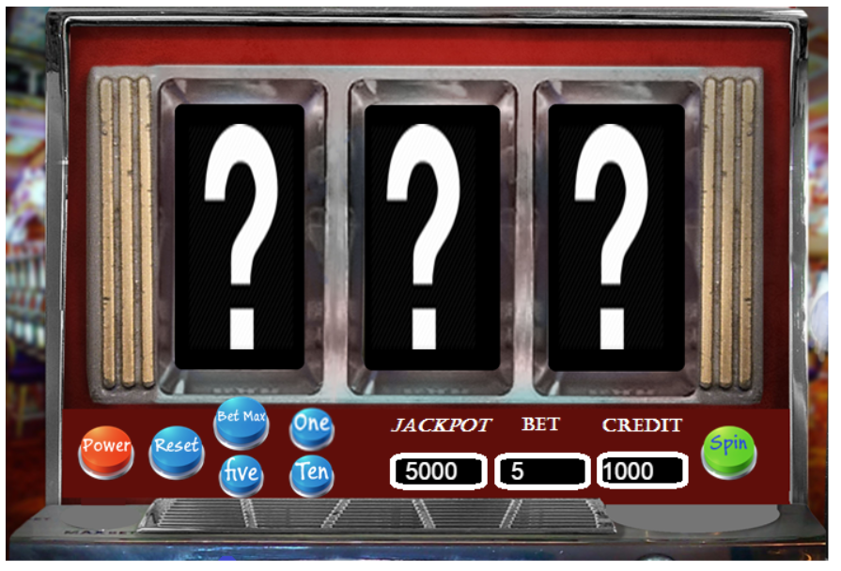

*The diagram above shows interface of the slot machine game.*

*There are three reels, seven buttons and three labels in the screen.*

*Three reel is the bitmap object I will position in the interface, update with the reel result.*

*Seven buttons are power button which used to quit the game and close windows.*

*Reset button, reset the game to initial status. And Bet max, one, five, ten buttons which used to change the bet amount. The green button on right side is spin button which used to spin the reel.*

*Three labels are jackpot, bet and credit respectively. The amount of each one will be placed in the label.*

## Interface Sketch

*The following picture shows the game interface.*

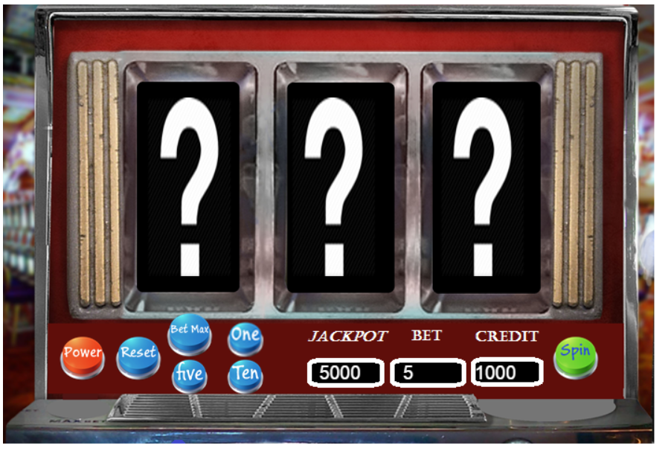

## Screen Descriptions



*The interface has a slot machine picture in canvas to give player a look and feel of playing a real slot machine. There are seven buttons in the interface to interact with player click event. Three labels shows current statistics of the playing.*

*The three reel are changed according to reel result. It will show player result of each reel. Initial status of reels are three blank items.*

## Scoring

|  |  |
| --- | --- |
| Reel result | Score |
| Any blank | Fail, lose bet |
| 3 grapes | Win, bet*10 |
| 3 bananas | Win, bet*20 |
| 3 oranges | Win, bet*30 |
| 3 cherries | Win, bet*40 |
| 3 bars | Win, bet*50 |
| 3 bells | Win, bet*75 |
| 3 sevens | Win, bet*100 |
| 2 grapes | Win, bet*2 |
| 2 bananas | Win, bet*2 |
| 2 oranges | Win, bet*3 |
| 2 cherries | Win, bet*4 |
| 2 bars | Win, bet*5 |
| 2 bells | Win, bet*10 |
| 2 sevens | Win, bet*20 |
| 1 seven | Win, bet*5 |
| three different item without seven | Win, bet*1 |

**Reel possibilities**

|  |  |
| --- | --- |
| Reel | Possibility |
| blank | 41.5% |
| grapes | 15.4% |
| bananas | 13.8% |
| oranges | 12.3% |
| cherries | 7.7% |
| bars | 4.6% |
| bells | 3.1% |
| sevens | 1.5% |

## Art / Multimedia Index

Reels:



Buttons:



Main interface:

