An exploration into what can be done to increase composting rates in Massachusetts.
Composting Rates in Massachusetts

Heidi Buser and Vijay Nagaraj
May 5, 2012

Contents

Executive Summary ................................................................................................................... 2

Section 1 ‐ Introduction ............................................................................................................. 3

Section 2 ‐ Data Characteristics .............................................................................................. 4

Section 3.1 ‐ Model Selection………………………..................................................................... 6

Section 3.2 – Recommended Model........................................................................................... 8

Section 3.3 - Model Interpretation……………………………………………………………………9

Section 3.4 – Justification of Model ………………………………………………………………….9

Section 4 ‐ Summary and Concluding Remarks ..................................................................... 11

Section 5 – Works Cited..............................................................................................................12

Appendices ..................................................................................................................................13

Appendix 1 – Full list of variables …………………………………...............................................14

Appendix 2 – Scatterplot of Recycling Rate and Composting ................................................15

Appendix 3 – Histogram of Composting versus PAYT ...........................................................16

Appendix 4 – Scatterplot of Bachelor’s Degree versus composting .....................................16

Appendix 5 –Reduced (Nested) Model ......................................................................................17

Appendix 6 – LOGNORMAL residual without interaction..........................................................18

Appendix 7 - Residual without interaction.................................................................................18

Appendix 8 – Complete Model ………………………………………………………………………...19
Appendix 9 – Comparison of Complete vs Nested Model ………………………………………...20

Appendix 10 – Review of data that would improve reliability of model ……………….……..…21

Appendix 11 – VIF without interaction or quadratic term……………………………………….…22

Executive Summary

With growing concern over the state of the environment and local government budgets, more and more cities and towns are trying to both increase composting and recycling and decrease waste disposal costs. This report investigates which characteristics are important factors influencing why cities and towns have no or low levels of composting. By applying linear regression models, this report illustrates the quantitative role that these important characteristics play in predicting whether or not a city or town will compost. The results indicate that the factors with the most influence include the amount of waste generated, overall recycling rate, waste services (i.e. Pay-As-You-Through- PAYT) and income per capita. The data suggest that composting rates are higher in towns that have implemented PAYT. The recycling rates also have a positive effect on a town’s municipal composting rate. This analysis is believed to be valuable to local governments as it enables them to better understand how to increase composting rates and in turn reduce waste disposal costs. Furthermore, it is also believed to be valuable to companies providing “Green” solutions to the market place.

Section 1 – Introduction

“Green” technologies and concerns for the environment are growing across the United States. Massachusetts has programs for recycling but limited programs for composting. Composting is the method of turning organic matter into compost. Items that are collected for composting include yard waste (leaves, grass clipping, branches) and food scraps. Composting food scraps produces little or no methane because there is sufficient oxygen in the process. And using the resulting compost reduces greenhouse gases by returning carbon to the soil, increasing plant growth, and reducing emissions associated with chemical fertilizers, pesticides and irrigation.

A waste-stream analysis discovered that about two thirds of the garbage people throw away – half a million tons each year – could have been recycled or turned into compost (decomposed organic matter). When food scraps break down in an oxygen-starved landfill it creates large quantities of methane gas, a greenhouse gas 72 times more potent than carbon dioxide when measured over a 20 year period. It also creates acids that can leach toxins from the landfill.

San Francisco has implemented the first in the country mandatory composting law. A mandatory composting law could help to increase the rate of composting in Massachusetts. San Francisco’s law requires residents and businesses to compost food scraps. San Francisco converts over 400 tons of food scraps and other compostable discards into high-grade organic compost every day. This can be used by farms and vineyards.

Composting also eliminates the waste disposal costs of regular trash. The Case Study of the City of Malden’s PAYT (Pay-As-You-Throw) showed a savings of nearly $2.5 million in solid waste disposal costs and revenue from the sale of PAYT bags. By increasing composting rates, the amount of waste sent to landfills would be reduced, saving money. Composting also benefits “Green” business. For example, UCAN Products, LLC sells biodegradable bags that fit standard-sized kitchen compost bins. “We selected Mirel for our compost bin bags because it’s a superior biobased material that can safely be thrown into an industrial compost pile, eliminating the need for either the consumer or compost facility to remove the waste from the bag. We think it’s the most convenient solution and one that will naturally lead to more people choosing composting.” UCAN states that twenty-eight percent of the content sent to our landfills is organic waste. By separating food waste from other waste disposal the amount of waste in landfills will be reduced.

This paper will examine the relationship between waste services such as PAYT, tons of waste generated, income, education, recycling rates and the amount of composting. This information is useful from an economic standpoint, as the cost of waste disposal is high for most cities/towns in Massachusetts. In addition, there are many business interested in the “Green” market place, which could profit from increased composting.

The analyzed data comes primarily from the Massachusetts Municipal Residential Recycling Rates for 2008, the most recent year with complete data available. Statistical techniques were used to investigate and estimate the relationship between composting and recycling services such as Pay-as- you-throw, total tons generated, recycling rates and income.

The goal of this report is to study municipality characteristics to determine the important factors influencing the rate of composting.

In Section 2, we present and explain the variables used in the analysis, and patterns in the data. In Section 3 we review the model selection, recommended model and interpretation of the model.

Section 2- Data Characteristics

The first objective is to get familiarized with the data. The data was compiled from the Massachusetts Department of Environmental Protection (2008 Municipal Tonnage and Recycling rate summary) describing composting and recycling in Massachusetts municipalities for the year 2008 (latest available year). The data is cross-sectional meaning that the data obtained was for many municipalities at a certain point in time. The appropriate analysis includes comparing various characteristics of the municipalities in the Massachusetts report and looked for trends between the characteristics and composting rates. Additional data regarding per capita income was pulled from U.S. Census Bureau and percent bachelor’s degree per municipality which was found at hometownlocator.com and clrsearch.com.

Variables Explored and Predictions about the chosen Variables

Some of the characteristics explored in this report include recycling rates, income, waste services and amount of waste generated. It is conjectured that towns with higher recycling levels will have higher compost levels. Moreover, towns with higher recycling tend to have systems in place to collect recycling and compost. More importantly, towns with higher recycling rates will tend to be more receptive to changes in the composting programs as they are already actively participating in a waste separation process.

Other predictions include that the participation in Pay-As-You-Throw (PAYT), as a participation in PAYT contributes positively to the rate of composting. Income level also positively impacts the rate of composting. Even further, another variable that will be examined is the amount of total tons of waste generated. With similar reasoning to that involved with recycling rates, a town with a greater amount of total waste, large amount of total waste tends to indicate a larger community, is more likely to have higher composting rates than smaller communities.

Further variables to be considered include a town’s percent of residences with a bachelor’s degree, solid waste flat fee, and waste service (curb-side versus drop-off or subscription). Intuitively, the belief is that a town with high bachelor’s degree rate will have higher compost rates as they are more educated on the environment and the need for composting.

The full data set’s variables were narrowed down to only those of particular interest, excluding those with non-applicable responses (NA’s). The full dataset included a sample of 315 municipalities which were included in the recycling report (fewer than the total 351 municipalities in Massachusetts). After omitting any NA responses, a total sample size of 314 municipalities remained. In this data, there were 300 municipalities which had reportable composting, for a total of 23% composting as a percent of total tons disposed for the state of Massachusetts

The data has been summarized in table 1 to help in understanding the data and relationships between the explanatory variables and the outcome of interest. This table is organized by the top and bottom ten municipalities. Per capita income for ten municipalities with the highest composting rates is an average of $51,890 while the average for the ten municipalities with the lower rates is $30,267. This statistic suggests that a higher composting rate is linked to a municipality's per capita income. Despite this correlation, governments do not direct control over income levels. Income level has been included in the model as a predictor, but towns will need to focus on other strategies to increase composting rates.

Table 1: Summary Statistics
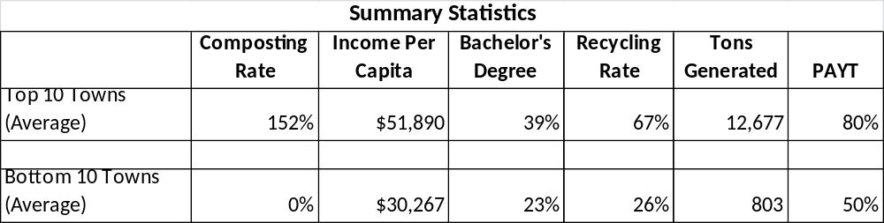

Notes Regarding the Variable Recycling Rates

Recycling Rates is referring to the percentage of waste that is recycled as it relates to the Total Tons Generated. Chart 1 shows the frequency of the recycling rate, that is how many towns are recycling at a particular rate. As the chart shows, most towns are recycling at a rate of 29%. An item of note is an unusually high recycling rate of 91%; this rate was seen in the town of Nantucket, which is a small island. There are laws in place for the disposal of waste in Nantucket. We decided to include the unusual recycling rate for Nantucket in our model.

Chart 1 shows the distribution of the recycling rates per municipality.
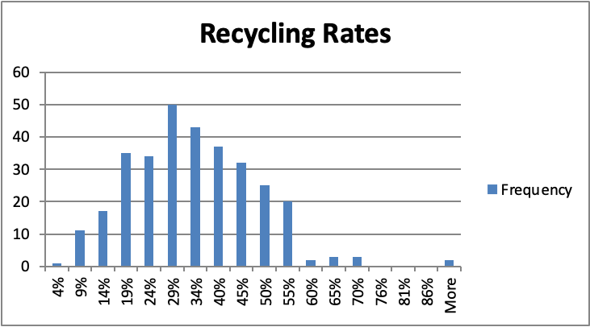

The relationship between Recycling Rate and Composting was plotted and showed. An R squared of 0.642 which shows that composting increase with recycling rates (Appendix 2). Composting and PAYT were also investigated, Appendix 3 shows a histogram showing Composting rate and PAYT which shows that composting rates are higher when PAYT is yes.

The data has been reviewed in detail. Predictions were made and superficially investigated in regards to the affect each variable has on the outcome of the rate of composting. The report will look at the quantitative affect each variable has on predicting the final outcome of what increases the amount of composting. This report will now go into detail on the importance of each explanatory variable has in determining the composting rate utilizing linear regression modeling techniques.

Section 3.1 - Model Selection
Seeing as though the variable of interest is a percentage rate, the analysis will include running linear regression models to predict the rate of composting. The purpose of building a model is to show a measure of association between the predicting variables and the variable of interest. By finding a model that fits the data, the model can be used to predict the percentage of composting given certain characteristics of a city or town. Additionally, the model will provide information about each specific municipality’s characteristics; given a certain characteristic, the model will show the rate of composting compared to a city or town without that characteristic. This section will first look at the process of selecting the model and justification for the model’s use. The following section will interpret the model.

Process that lead up to this model.

A stepwise linear regression was run initial to see the values for each variable (Appendix 1 full list of variables). The summary of the stepwise (table 2) showed that recycling_rate and tl (tons leaves) were significantly significant at P values < .0001. With ttr (total tons recycled), dde (default disposal estimate) and hc (home compost) also showing good P values less than α=.05. Income showed a slightly higher P value at .0792 and rs (recycle service) was .1074. PAYT was not included in the stepwise as the value was too high.
Table 2:
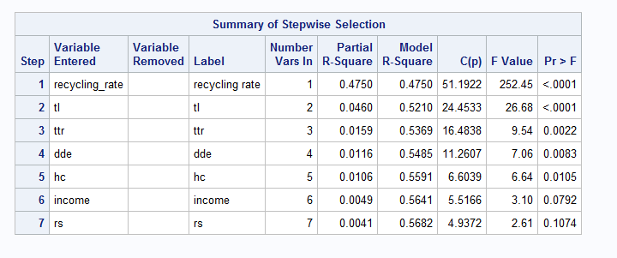
The variables associated with Bachelor’s degree, drop off and curb side were found not to be significant predictors of Composting rate.

The signs of the statistically significant coefficients were not as expected from the preliminary analysis of the data. It had been expected that Bachelor’s degree and PAYT would have an impact on the amount of Composting percent. An Evaluation of Municipal Recycling Programs in Massachusetts suggests that the more educated a town’s residents are, the more material they will recycle. People who have continued their education are more likely to have learned about the environmental and economic benefits of recycling. It was not found that Bachelor’s degree did not haved a statistically significant P value and did not add to the models R squared. A scatterplot of Bachelor’s Degree versus composting (Appendix 4), showed no relationship, thus Bachelor’s degree was excluded.

The stepwise analysis did not show that PAYT as statistically significant. Upon further look at PAYT it was shown that there were 37% of the municipalities participating in PAYT and it was important to the analysis.

The interaction between PAYT and Recycling Rate as a predictor of Composting rate was also analyzed. Since Recycling rate was statistically significant at p < .0001 that an interaction between PAYT and Recycling rate would also add to the overall models prediction. “Pay-as-you-throw (PAYT) programs incentivize people to produce less waste and recycle more, because this means they will pay less.” In the PAYT program residents are charged per bag of trash, but no fee for recycling. The more recycled than the less trash and resulting costs to the resident. “Having costs directly connected to recycling habits leads to a better public understanding of waste management’s costs, because the residents of the town are paying those costs.” ⁷ Composting is linked to recycling and that is why the model includes a relationship between PAYT and Recycling Rate. When PAYT is yes then composting rate is positively increased.

PAYT and Recycling Rate quadratic term was also included as this indicates that there is strong evidence of upward curvature in the rate of composting, that is, composting increases more quickly per unit increase in recycling rate for towns with PAYT than those without PAYT. There is a positive beta for the quadratic term of PAYT and Recycling Rate. This means that after adjusting for the included variables, a municipality with PAYT is more likely to have higher composting percentage than a municipality that does not have PAYT.

Model Selection

The purpose of this paper is to evaluate and estimate the effect of recycle services on composting. Therefore, a proper model would be chosen on this basis that it must predict the percentage of composting in a given municipality. This prediction must be based in part on whether the municipality has PAYT (Pay-As-You-Throw). The model must also be based on the 2008 per capita Income levels of the municipality, tons generated and recycling percentages. The goal is to determine what could be changed to improve composting such as PAYT or recycling services.
In total there were 16 independent variables selected to run against the one dependent variable. After review of the stepwise results, linear regression model was run on Income, PAYT, Recycling Rate and Total Tons Generated independent variables using SAS and SPSS statistical software. Partial SAS output for these models can be found in the appendix.
After further consideration, interaction variables were also deemed necessary. An interaction term between “Recycling percentage” and “PAYT” will investigate the relationship between recycling percentage and Pay-As-You-Throw designation. In addition, an interaction term between “recycling percentage” and “PAYT” squared as a quadratic term was used. Looking at the p-values, the interaction terms appears to be statistically significant in the linear regression model. Comparing the R squared, adding the interaction term increased the R squared value in both cases when compared to the initial full linear model without interaction terms. Additional interaction terms were considered but found to not be statistically significant.
3.2 - Recommended model

Due to the relationships between the data found in Section 2 and the criteria listed above, the chosen model was a linear regression model to predict the value to Compost rate. The full regression equation of the proposed model is:

Compost Rate (%) = βo + β1 (income) + β2 (Recycling_Rate) + β3 (PAYT) + β4 (PAYT*Recycling_Rate) + β5 (PAYT*Recycling_Rate)²

3.3 - Model Interpretation

The complete linear regression model found in Appendix 8 shows an adjusted R squared of 0.8283 which means it is 82.83% of the variation in composting rate is explained by income, PAYT, recycling rate, tons generated and the interaction and quadratic terms. The overall P value of the F statistic is significant at p <.0001. Since the p-value is less than alpha (α=.05), there is sufficient evidence to indicate that the independent variables selected in the model are useful in predicting composting rate. The p-values for the independent variables were also significant at p<.0001 for PAYT, Recycling Rate, PAYT_Recycling and PAYT_Recyclingsquare. It was also significant for Tons Generated at 0.0195 which is less than alpha α=.05. The only non-significant independent variable was income at p=0.1990.

The quadratic term PAYT_Recyclingsquare beta was 10.2586 which is positive, as we expected. As recycling rate increases along with PAYT, there is a concave upward curve of composting rate.

The model was reviewed for multicollinearity, which is when there are significant correlations between pairs of independent variables. The variance inflation factor (VIF) is a comprehensive test for multicollinearity (table 3). The VIF of the model variables is severe for the PAYT_Recycling interaction variable at 87.03725 and strong for PAYT_RecyclingSquared at 34.47839. It is also strong for PAYT at 19.99444. The VIF of 19.99 says that the other predictors “explain” ~80% of the variation in predictor PAYT. This indicates that predictor PAYT is strongly related to the other predictors. The VIF was also run without the interaction and quadratic terms; it was thought the complete model had multicollinearity because of the interaction and quadratic terms. The results of the reduced VIF (appendix 11) showed very low multicollinearity.

Table 3 VIF output from SAS
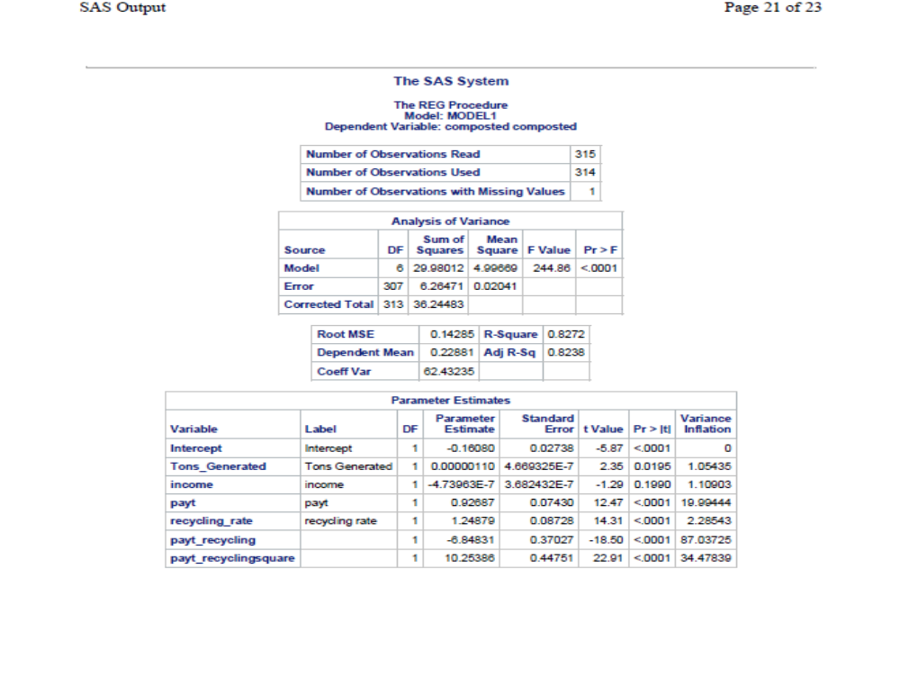
3.4 -Justifications of the model

Regression plot output for residual without interaction showed data that was in a non-random upward curvature pattern. The regression plot was further analyzed in the SAS software using LOGNORMAL residual without interaction and the data points were shown to have more of a random pattern than the regression residual without interaction. (Appendix 6 and 7) This random pattern indicates that the linear model provides a good fit to the data.

Comparison of Complete versus Reduced Model:

To determine which model would be best, a reduced model, a model without the two interaction variables showed an adjusted R-Square of 0.4798. (See Appendix 5 for output of Reduced Model). To test whether or not the complete model with two additional interaction variables is significant versus the reduced model, an F-test for comparing nested models is run. (See Appendix 9 for complete F-Test). The test showed that the interaction terms had an impact and should be included. The complete model was better than the reduced model as a predictor of composting rate.

Validation of Model:
To validate the model, a Durbin-Watson d statistic was used to test the presence of residual correlation. The SAS system produced a d statistic of 1.993 (see output below). This tells us that the residuals are uncorrelated, d~2.
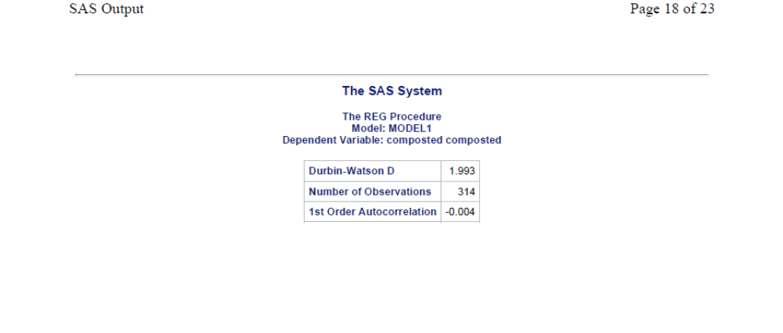
Test Data:
To further validate the model a test of mock data was run. The full model was testing with the following inputs: Income = 53,000, PAYT = 0 (YES), Tons Generated = 5,000 and Recycling Rate = .30 (30%). The resulting composting percent was 0.19 or 19%. The test was rerun with an increase in the Recycling rate 0.60, holding all other variables constant, the composting percentage increased to 0.57 or 57%. The test shows that recycling rate has a positive impact on composting rate.
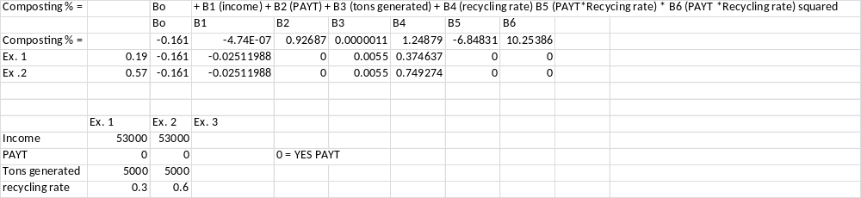

4 - Summary and Concluding Remarks
In conclusion, the proposed complete model, using one interaction term and one quadratic term with a confidence level of 95%, we can conclude with enough evidence that the complete model will predict composting rates within two standard deviations or 0.2857. This model shows that the variables selected primarily Pay-As-You-Throw (PAYT) and recycling rates act as predictors of the rate of composting in a given city or town. Towns that implement PAYT can expect an increase in composting rates. The model is not to be used to predicted precise composting rates, but to indicate what will increase the rates.
The main predictors of composting rate are the income per capita, PAYT program, recycling rate and tons generated. Increases in income, recycling rate and tons generated showed an increase in composting rate, as did the requirement of PAYT.
Results of this study can be used by cities and towns to make choices to implement programs to increase composting. As seen in the City of Malden PAYT program, the results of implementing PAYT in the first year showed a compliance rate of over 98 percent, recycling rate up 74 percent and solid waste tonnage down 49 percent. The composting rate would also have increased due to the increase in recycling; households that recycle are more willing to compost. Cities can expect positive financial results, as waste disposal costs go down with less waste. Again as seen in the Malden case study, this showed nearly $2.5 million in savings to the city. Likewise, the San Francisco case showed implementing a composting law shows improvements in composting and can save the cities money in waste removal. In addition, these programs will positively impact “Green” business such as UCAN and suppliers such as Metabolix with the sale of biodegradable materials for compost bags.
Finally, there is a low level of composting in Massachusetts. The state has a need to reduce waste disposal costs and increase environmental responsibility which increased composting can address. Part of the solution will be government funded PAYT programs to increase recycling and as a result composting. Furthermore, implementing composting programs similar to San Francisco’s program or similar programs will increase the rates of composting. Governments could also work with “Green” companies in a partnership to implement these new programs. Results of this report can be applied to local governments for the purpose of implementing composting programs.
Beyond the scope of this data and this report, it would be worth studying the details of communities with low or high composting rates to further determine what detail impacts the composting rate. The type of government, size of the town and laws regarding recycling along with the method of collection and frequency of waste collection would help to further define an appropriate model to predict composting rates. The current cost of waste disposal and government budget for recycling education would help to determine the financial impact of a composting program.
Works Cited

1. Waste Characterization Studies and Initial MassDEP Analysis. SWAC Meeting, June 23, 2011. Jordan Macy, MassDEP
2. An Evaluation of Municipal Recycling Programs in Massachusetts, Lauren Russell

3. Massachusetts Municipal Residential Recycling Rates; Massachusetts Department of Environmental Protection (MassDEP); Fiscal Years 1997-2001 and Calendar Years 2002-2008

4. “Massachusetts” State & County Quick Facts. U.S. Census Bureau, http://quickfacts.census.gov/qfd/states/25/25001.html(Bachelors degree or higher and median house hold income)

5. http://www.mass.gov/dep/recycle/priorities/wrr.htm (recycling tonnage for 2008)

6. http://www.massachusetts.hometownlocator.com/census(2008 population countywise)

7. http://www.clrsearch.com – Demographic search for Bachelor’s degree percent by municipality

8. San Francisco composting law :source (http://greenopolis.com)
http://greenopolis.com/goblog/gavin-newsom/san-francisco-home-to-first-mandatory-composting-law

9. UCAN - business which has biodegradable compost bags using Mirel (Metabolix's material)
http://www.businesswire.com/news/home/20110426007181/en/UCAN-Products-Selects-Telles%E2%80%99-Mirel-Bioplastic-Line

10. Web site: www.cityofmalden.org Case Study: City of Malden Pay-As-You-Throw (PAYT) Program

11. San Francisco’s Food Composting Program: http://www.epa.gov/reg3wcmd/composting/AlexaKielty.pdf

12. Uninsured in the Modern Day: Missy Pinney and Yang Liu, May 11, 2008

13. Report Writing: Communicating Data Analysis Results

Appendix

Appendix 1 – Full list of variables used from the Massachusetts Municipal Residential Recycling Rates; Massachusetts Department of Environmental Protection (MassDEP) ............ .... 14

Appendix 2 – Scatterplot of Recycling Rate and Composting ...................................................................15

Appendix 3 – Histogram of Composting versus PAYT ..................................... ........................................ 16

Appendix 4 – Scatterplot of Bachelor’s Degree versus composting........................................................ 16

Appendix 5 – Reduced (Nested) Model………………………… ...................................................................... 17

Appendix 6 – LOGNORMAL residual without interaction ...................................................................... 18

Appendix 7 – Residual without interaction.............................................................................................18

Appendix 8 – Complete Model ……………………………………………………………………………………………………………19

Appendix 9 – Comparison of Complete vs Reduced (Nested) Model ………………………………………………….20

Appendix 10 – Review of data that would improve reliability of model ………………………………………..……21

Appendix 11: VIF without interaction or quadratic term…………………………………………………………………….22

Appendix 1: Full list of Variables:

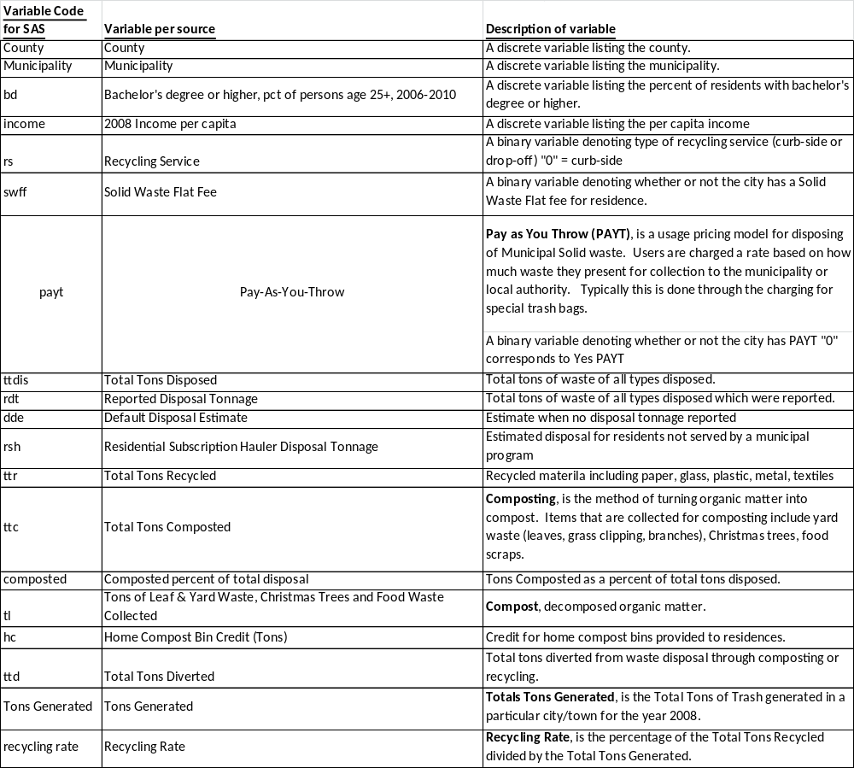

Appendix 2 :

Scatterplot of Recycling Rate and Composting: Showing that composting increases with recycling rates.

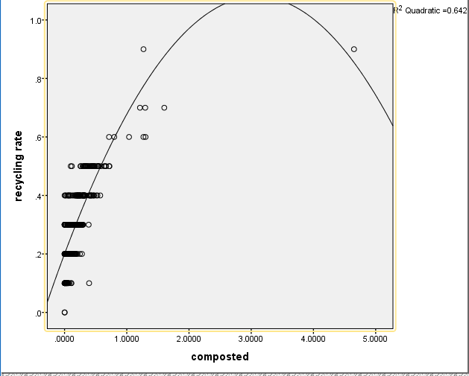

Appendix 3: Histogram of Composting versus PAYT. This shows that Composting is higher with PAYT than without.
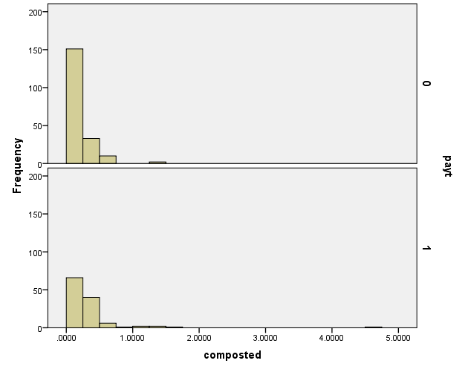

Appendix 4: Scatterplot of Bachelor’s Degree versus composting. This showed no relationship and we thus excluded it.

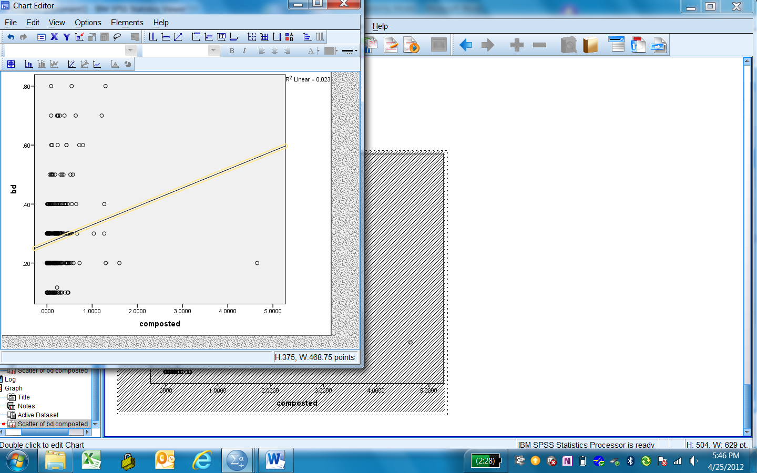

Appendix 5:
Reduced (Nested) Model R squared .4798
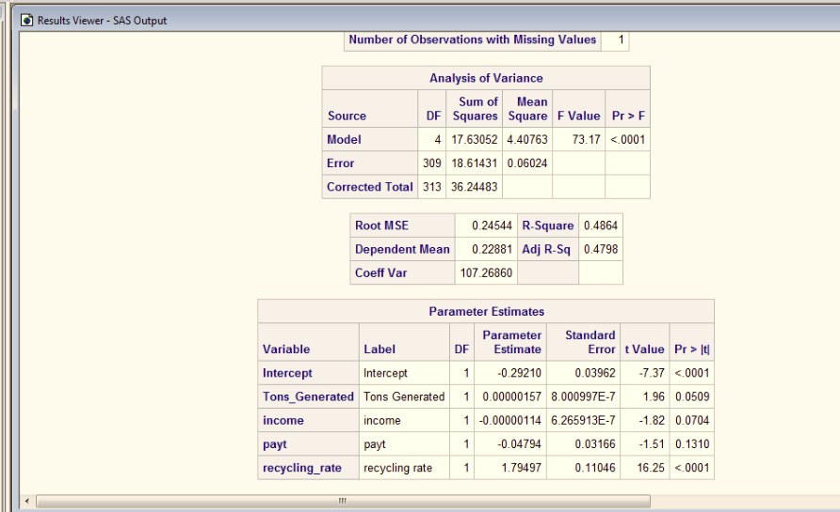

Appendix 6: LOGNORMAL residual without interaction
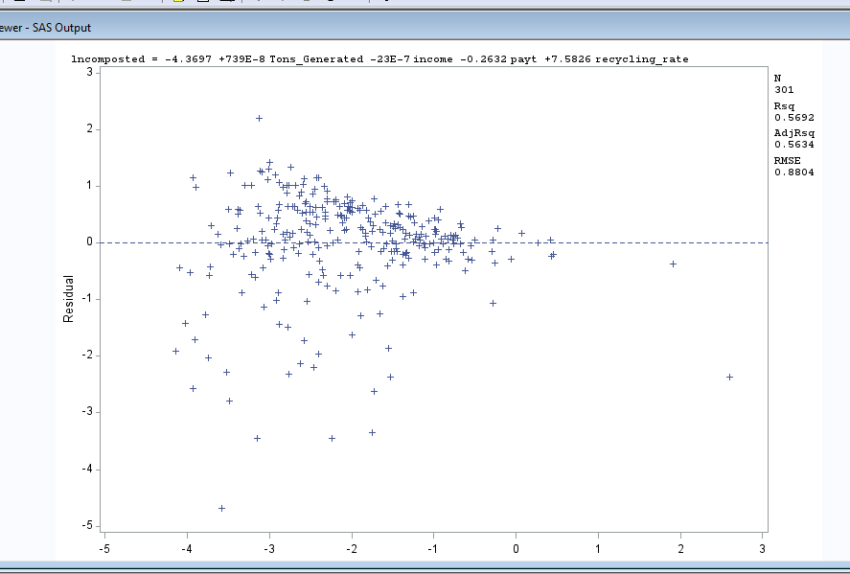
Appendix 7: Residual without interaction
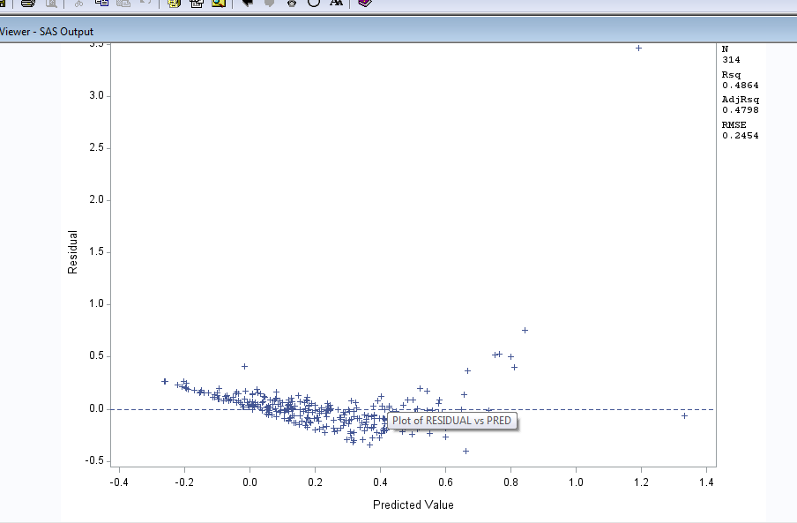

Appendix 8: Complete Model
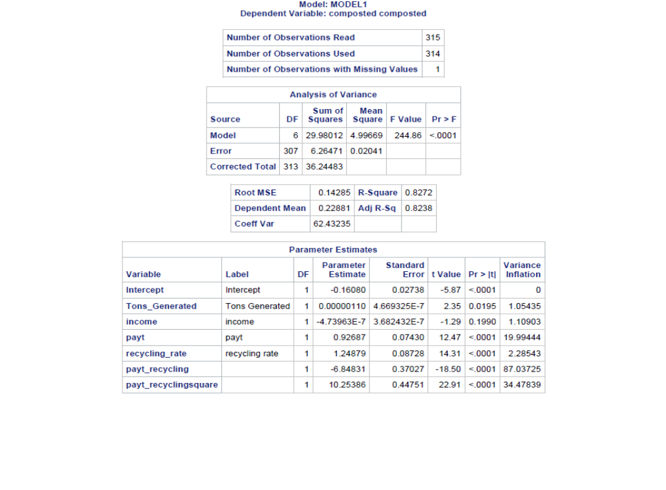

Appendix 9: Comparing Complete vs Nested Model

Complete Model: y=βo+β₁x₁ +β₂x₂+β₃x₃+β₄x₄+β₅x₃x₄+β6(x3x4)²
Reduced Model: y=βo+β₁x₁ +β₂x₂+β₃x₃+β₄x₄

Ho: B5 = B6= 0
H1: At least one of the betas is non-zero

F-Test:
F= SSE(reduced) – SSE(complete)/(k-g)
SSE(Complete)/n-k-1

= (18.61431 – 6.26471)/2
6.26471/307

=6.1748/.0204 = 302.5940
F* (2, 307) = 3.03
F>F* α=0.05 v1 =2 v2 = 307
F
3.03 302.594

Reject null hypothesis: We have enough evidence to conclude that the complete model is better than the reduced model.

Appendix 10: Review of data that would improve the reliability of the model:
Food Waste: Composting data was primarily for organic yard waste. Massachusetts communities are not specifically composting food waste. Having data which breaks down the composting further would be helpful.
Cost of Waste Removal: Data on the cost of waste removal and savings per city or town would help to associate the results with a financial impact to the local government.
Home Composting: Data on home composting would also assist in the analysis. Municipalities report the amount of collected home compost with a credit for home composting bins, but a survey of local residents on home composting could add to the depth of the study.
Test of Composting Programs: For future investigations, test of composting programs implemented in communities similar to the Malden case study and San Francisco program would prove the validity of such programs. Government funding to start the composting programs would also add to the success.
Additional Statistical Analysis: Additional time to analyze the data would help to fine tune the report. In addition, additional statistical tools and training would help to determine which model is best to predict composting rates given other independent variables.

Appendix 11: VIF without interaction and quadratic terms
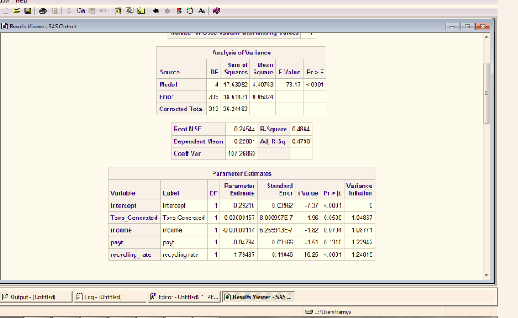

San Francisco mandatory composting law
Case Study: City of Malden Pay-As-You-Throw
www.businesswire.com/news/home/20110426007181/en/UCAN
Massachusetts Department of Environmental Protection
Variable definitions can be found in the appendix
Evaluation of Municipal Recycling Programs in Massachusetts
Evaluation of Municipal Recycling Programs in Massachusetts
Additional SAS Statistical Software output for each model mentioned can be found in the appendix
City of Malden Pay-As-You-Throw (PAYT) Case Study

