Problem 12:

**Plot of batch size:**

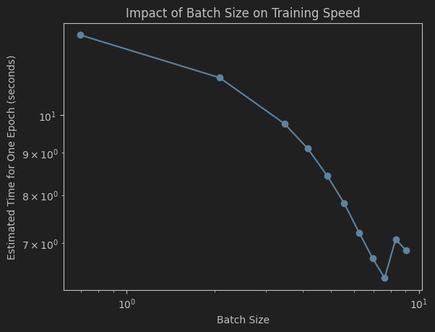

Description of what I see: Before batch size reaches 2048, as the batch size doubles, the estimated time will approximately become half. However, after that the time will not become less and fluctuate within a small range. I think the reason might be that 4096 is larger than my computer’s max handling ability at the same time.

What batch size would I choose: 2048

Problem 13:

Plot of wandb:

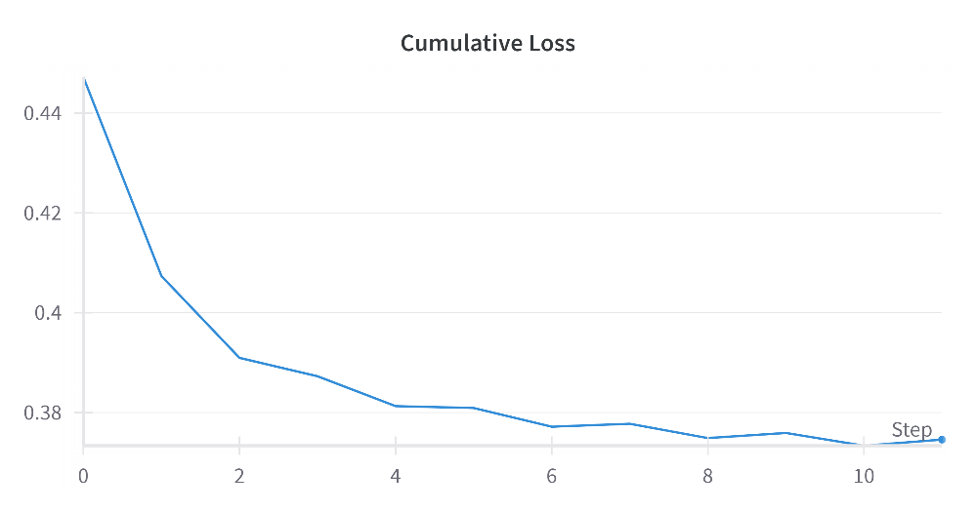

Problem 15:

**Results:**

Most similar words to 'books': [('novels', 0.772312581539154), ('ione', 0.7335072159767151), ('trigiani', 0.7068877220153809), ('rosato', 0.6997941136360168), ('trilogys', 0.6966578960418701), ('thors', 0.6965705156326294), ('trilogies', 0.6898884177207947), ('patricelli', 0.6856436729431152), ('sandra', 0.6826285719871521), ('fossum', 0.6789857149124146)]

Most similar words to 'photos': [('photographs', 0.8947330713272095), ('pictures', 0.8914361000061035), ('pics', 0.8500222563743591), ('drawings', 0.8424339890480042), ('reproductions', 0.8058515191078186), ('illustrations', 0.7983523011207581), ('designs', 0.7664406895637512), ('paintings', 0.7623581290245056), ('photo', 0.744396984577179), ('stitching', 0.7426446080207825)]

Most similar words to 'man': [('woman', 0.9297835230827332), ('lady', 0.764117419719696), ('girl', 0.747891366481781), ('boy', 0.7254368662834167), ('widow', 0.7097799181938171), ('biologically', 0.7035444974899292), ('warrior', 0.6889328956604004), ('guy', 0.6875222325325012), ('men', 0.6839041709899902), ('murderous', 0.6816152930259705)]

Most similar words to 'football': [('baseball', 0.7944216728210449), ('hockey', 0.720067024230957), ('soccer', 0.7171085476875305), ('bachelor', 0.696029543876648), ('basketball', 0.6940032243728638), ('commando', 0.6905590891838074), ('tennis', 0.6902896761894226), ('sports', 0.6650619506835938), ('filmmaker', 0.6444071531295776), ('csi', 0.6343899965286255)]

Most similar words to 'son': [('daughter', 0.9354985952377319), ('grandson', 0.881630003452301), ('granddaughter', 0.8378354907035828), ('niece', 0.8368213176727295), ('yr', 0.7918955683708191), ('neice', 0.7663732767105103), ('sister', 0.7555080652236938), ('nephew', 0.7518795728683472), ('youngest', 0.7482140064239502), ('mom', 0.7328506708145142)]

Most similar words to 'fantasy': [('sci', 0.883333146572113), ('fi', 0.8693403601646423), ('dystopian', 0.8524616956710815), ('genre', 0.8329605460166931), ('scifi', 0.818652331829071), ('romance', 0.8167240619659424), ('horror', 0.8118466734886169), ('steampunk', 0.8045616149902344), ('fiction', 0.7922078371047974), ('paranormal', 0.7827293872833252)]

Most similar words to 'magnificent': [('stunning', 0.7854254841804504), ('geoff', 0.7655529379844666), ('incredible', 0.7541369199752808), ('superb', 0.751526415348053), ('beautiful', 0.7426850199699402), ('amazing', 0.7088311314582825), ('fantastic', 0.7027348279953003), ('marvelous', 0.6956594586372375), ('outstanding', 0.6938199996948242), ('masterful', 0.692801296710968)]

Most similar words to 'active': [('compliance', 0.6461794376373291), ('participation', 0.642973005771637), ('ensuring', 0.6320324540138245), ('surge', 0.6155261993408203), ('tcm', 0.6027130484580994), ('entering', 0.5971044898033142), ('aviator', 0.5960518717765808), ('computerized', 0.5945338010787964), ('gymnast', 0.5927485823631287), ('navy', 0.5896925926208496)]

Most similar words to 'insight': [('insights', 0.8578913807868958), ('insite', 0.7659927606582642), ('glimpse', 0.7376072406768799), ('incite', 0.7328647971153259), ('penetrating', 0.6904246211051941), ('perspective', 0.687146008014679), ('understanding', 0.6617640852928162), ('wisdom', 0.6392198801040649), ('guidence', 0.6340915560722351), ('background', 0.6208731532096863)]

Most similar words to 'super': [('very', 0.6358646154403687), ('pretty', 0.6333441734313965), ('extremely', 0.6208550333976746), ('ridiculously', 0.5822411775588989), ('eater', 0.5794768333435059), ('incredibly', 0.5789140462875366), ('duper', 0.5772424936294556), ('alphas', 0.5744730234146118), ('unbelievably', 0.5731501579284668), ('insanely', 0.5690271258354187)]

**Description of my findings:**

The results highlight both the strengths and limitations of the model. While it successfully identifies semantically related words for common terms, showing a good grasp of their meanings and relationships (e.g., 'books' with literary terms, 'man' with human-related terms), it struggles with less frequent words. This may indicate the model's difficulty in finding similarities for words with fewer occurrences in the data, reflecting a limitation in capturing nuances for rarer terms. The findings suggest a balance between effective semantic understanding for common words and challenges in accurately representing less frequent terms.

Problem 16:

**Results:**

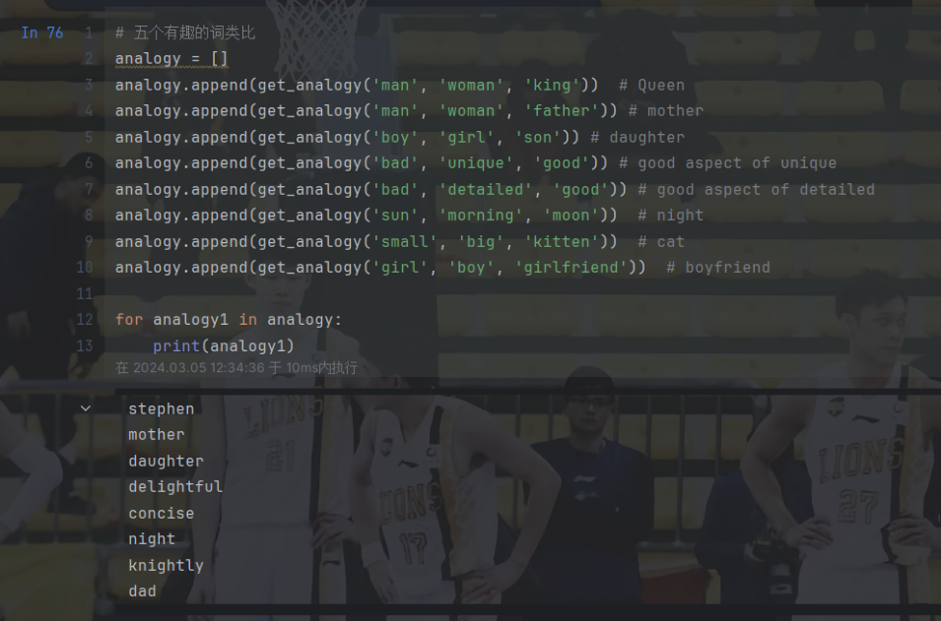

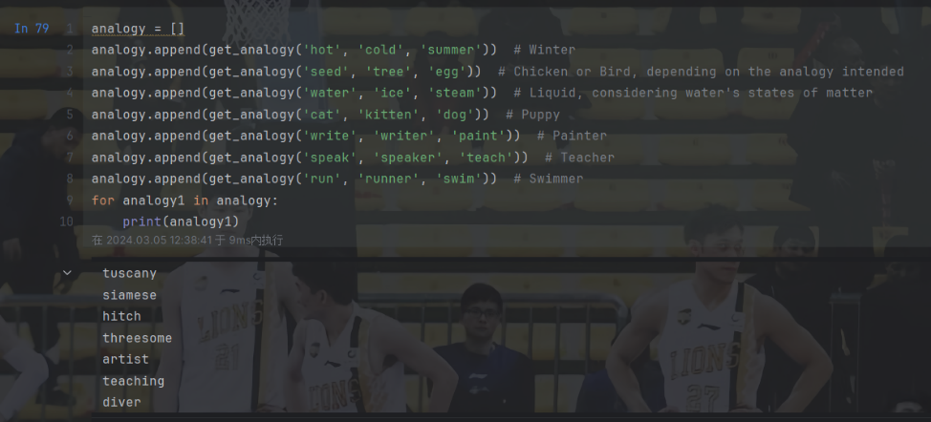

**Description of my findings:**

When dealing with the simple binary problem of things, the model’s results are not bad. However, if we want to use it in more complexed problems, the model is too weak (maybe it’s because I have used large to train it, not huge).

Problem 18:

**Plot of loss:**

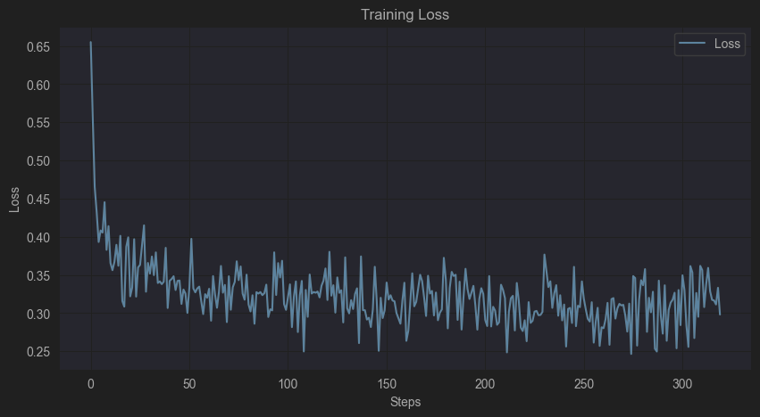

**Plot of F1:**

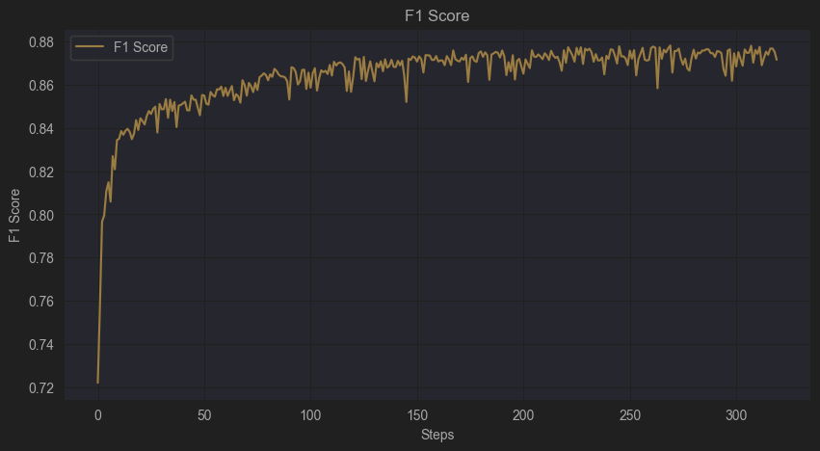

Problem 19:

**Plot of loss:**

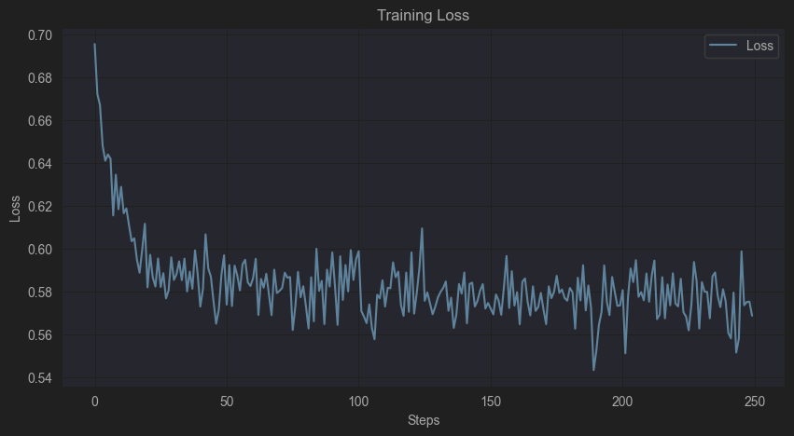

**Plot of performance:**

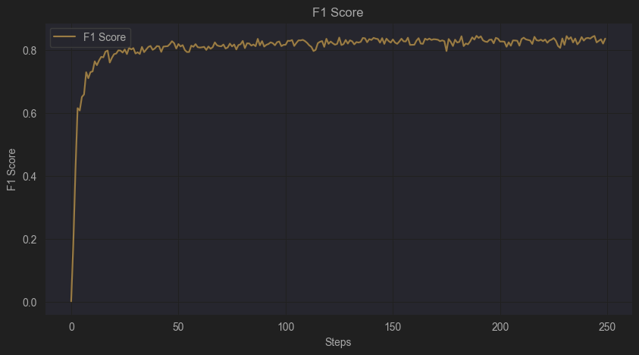

**Describe whether I think we should freeze our word vectors in this setting or not:** Based on the results, the running time of freezing word vectors is much less than that of not freezing (freezing 20min compared to not freezing 50min), while the difference of final performance of model, i.e. F1score, is very small (freezing 0.836 compared to not freezing 0.876). Therefore, I think if we just focus on the accuracy of prediction and don’t care about the running time, then we should not freeze the word vectors. However, since training takes a very long time if we don’t freeze, I still suggest that we should freeze the word vectors when we are not at the final modification of the code. (Freeze to see if the code works and not freeze when submitting the final version of code)

Problem 20:

**Kaggle user name:** Yanzhuo2001

Problem 21.1:

**Four attention plots:**

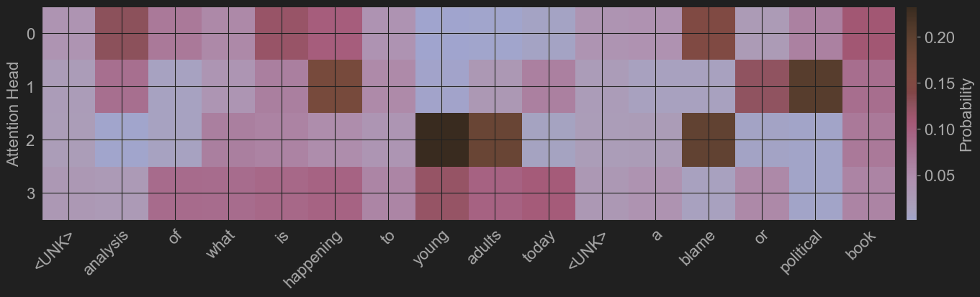

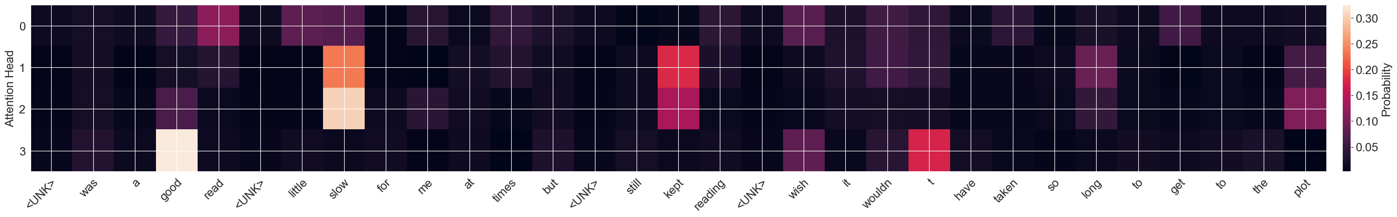



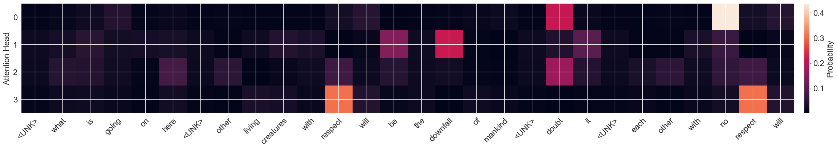

Problem 21.2:

**Paragraph for what the attention heads are looking for:**

**Description for any differences you see between heads and whether there are any patterns in terms of what they focus on:**

Problem 21.3:

**Description for whether the attention is good explanation and looking at the right thing:**

