Title: | Spikezip_model.py
Description | This python script model the high-level behavior of the send-on-delta compression and also provide reconstruction. This scripts also performs RMSE calculation, as explained in more detail below, and also compression ratio estimation.
Authors/ Creators | Pietro Russo, Hua-Peng Liaw, Yao-Hong Liu
Date Created | 30th April 2025
Version | V1

The Python script emulates the hardware (retinomorphic compressive sensing, RCS) behavior and performs reconstruction and performance evaluation. The processing flow is illustrated in Figure 1.
At the beginning of the script, a set of configurable parameters allows the user to select the dataset to run, specifying the file path (line 22) and duration and start of the data cut (lines 25-26). Additional system parameters, such as RCS frequency and resolution, are also configurable (lines 32-48).
The input dataset (raw in-vivo data) is initially prefiltered, with the filter type, order, and bandwidth fully adjustable (Chebyshev filter is set by default). The filtered signal is then upsampled by a factor of 20 to approximate a continuous analog input. This continuous signal is then resampled at the system’s RCS frequency, and delta sampling is applied to extract discrete events.
Input dataset requirements: Neuropixels v1 based recording, binary format
The output of the delta sampling stage is a matrix representing events over time for each channel. At this point, the compression ratio can be calculated by comparing the original data rate with the number of events generated through delta sampling.
Finally, the signal is reconstructed by accumulating the delta events and compensating for the effects of the CLC technique. A post-filter, identical in configuration to the prefilter, is applied to both the reconstructed and the original prefiltered signals. The RMSE is then calculated point-by-point between these two post-filtered signals to evaluate the reconstruction quality.

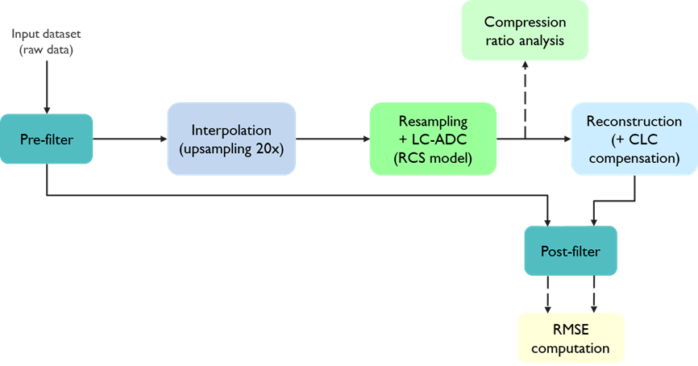
Figure 1: processing flow

