NAME: MARADESA ADELEKE

STUDENT_ID: 20724523

**QUESTION ONE**

**(1a)**

To create data matrix X; we use the below R code to import the data (labelled 09) into R package and then create the matrix X from the data

## R_CODE

x_data <- read.csv("C:/Users/user/Desktop/Batterydata/x_data.txt", header=FALSE)

View(x_data)

X = x_data

**(1b)**

R_code for PCA

library(FactoMineR)

library(factoextra)

pca_X = prcomp(X)

**1(c)**

##Singular Value Decomposition

**SVD =svd(X)**

**1(d)**

**##Plot Top K eigenvalue**

## Obtain eigenvalue

eigen_variance = get_eig(pca_X)

eigen_variance

## Screen-plot

fviz_eig(pca_X, choice = "eigenvalue", addlabels = TRUE)

##use only line bar

fviz_eig(pca_X, geom = "line")

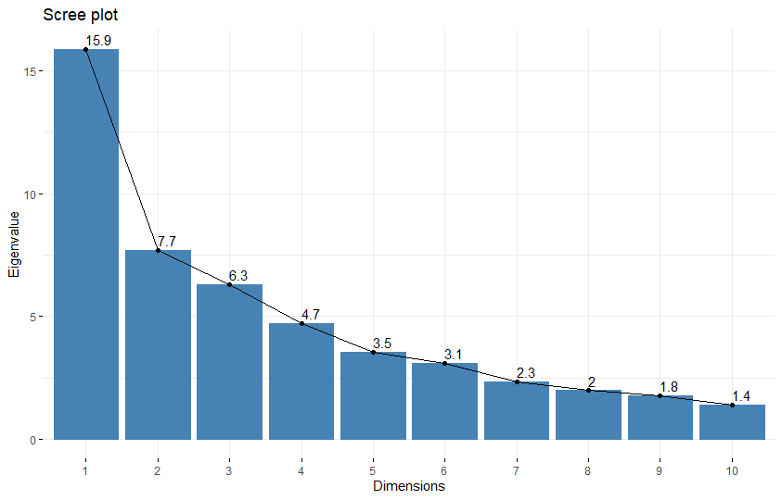

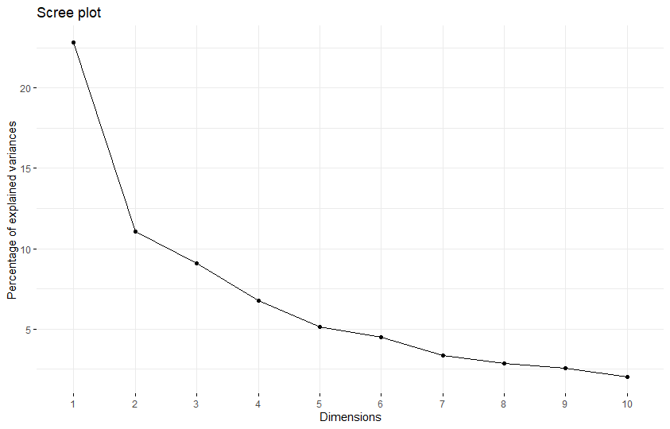

**1(e)**

##TOP k principal component; where k =4

par(mfrow= c(2,2))

pcarot = pca_X$rotation

k1=pcarot[,1:4]

plot(k1)

k2=pcarot[,2:5]

plot(k2)

k3=pcarot[,3:6]

plot(k3)

k4=pcarot[,4:7]

plot(k4)

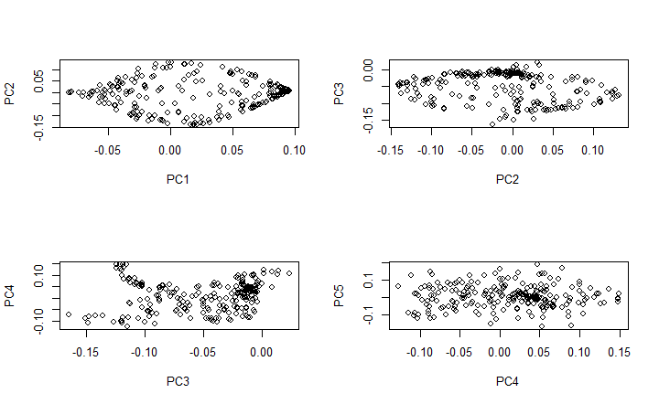

**1(f)**

# ARRANGE PCA1 (v1) in ascending order ; sorted pca1 to obtain v1

pca1=pcarot[,0:1]

ascendingpca1 = sort(pca1)

**1(g)**

# ARRANGE PCA1 (v1) in ascending order

pca1=pcarot[,0:1]

ascendingpca1 = sort(pca1)

## extractt PCA2, *i.e* v2

pca2=pcarot[,2:2]

## plot ascendingpca1 VS pca2

pcadrame= data.frame(pca2, sortedpca1 = ascendingpca1)

plot(pcadrame, panel.first = grid(3, lty = 2, lwd = 2))

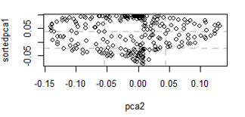

**QUESTION TWO**

**2(a)**

**Data matrix D is represented by the table (matrix) below**

|  |  |  |  |  |  |  |  |
| --- | --- | --- | --- | --- | --- | --- | --- |
| Cities | Beijing | Shanghai | Nanjing | Tiajing | Dalian | Macau | HongKong |
| Beijing | 0 | 1075 | 897 | 108 | 463 | 1986 | 1970 |
| Shanghai | 1075 | 0 | 267 | 969 | 869 | 1258 | 1214 |
| Nanjing | 897 | 969 | 0 | 799 | 805 | 1212 | 1179 |
| Tiajing | 108 | 969 | 799 | 0 | 385 | 1914 | 1896 |
| Dalian | 463 | 869 | 805 | 385 | 0 | 2012 | 1982 |
| Macau | 1986 | 1258 | 1212 | 1924 | 1924 | 0 | 62 |
| HongKong | 1970 | 1214 | 1179 | 1896 | 1982 | 62 | 0 |

**2(b)**

**Code for Multidimensional Scaling**

library(vegan)

Beijing = CITY$Beijing

Shanghai =CITY$Shanghai

Nanjing = CITY$Nanjing

Tiajing = CITY$Tiajing

Dalian = CITY$Dalian

Macau = CITY$Macau

HongKong = CITY$HongKong

data = data.frame(Beijing,Shanghai,Nanjing,Tiajing,Dalian,Macau,HongKong)

row.names(data)=c("Beijing","Shanghai","Nanjing","Tiajing","Dalian","Macau","HongKong")

data

mds <- cmdscale(data, k = 2, eig = TRUE)

y=mds$eig

# EIGENVALUES

|  |
| --- |
| mds$eig  [1] 4569515.420 341855.466 11486.356 200.894 -186.100 -1668.400 -9134.493  ## SCATTER PLOT OF SELECTED CITIES  x <- mds$points[,1]  y <- mds$points[,2]  plot(x, y, xlab = "Coordinate 1", ylab = "Coordinate 2",xlim = range(x)*1.2, type = "n", main = "Multidimensional Scaling for Some Selected Cities in China", col = "blue", panel.first = grid(lty = 3, lwd = 2, col = "blue"))  text(x, y, labels = colnames(data)) |

**2(c)**

**The normalized eigenvalues**

## The code below normalizes the eigenvalue

mds <- cmdscale(data, k = 2, eig = TRUE)

y=mds$eig

for (s in y) {

print(s / sum(y))

}

[1] 0.9302628

[1] 0.069595

[1] 0.002338395

[1] 4.089805e-05

[1] -3.788628e-05

[1] -0.0003396533

[1] -0.001859602

plot(y, xlab = 'Eigenvalue Number', ylab = 'Eigenvalue Size', main = 'Scree Graph', col = "red")

lines(y, col = "green")

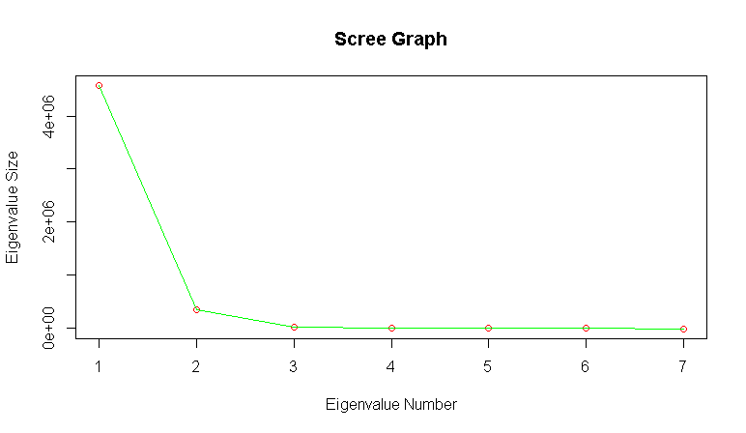

# EIGENVALUES

|  |
| --- |
| mds$eig  [1] 4569515.420 341855.466 11486.356 200.894 -186.100 -1668.400 -9134.493 |

NOTE: There are some negative values in the eigenvalue: when the observed matrix is not Euclidean, then the matrix K = V∑ $V^{T}$ will be negative, as a result, some of its eigenvalue will have negative value. That is, negative eigenvalue is as a result of non- Euclidean distance.

**2(d)**

# **Scatter Plot of Cities for top two eigenvalue**

x <- mds$points[,1]

y <- mds$points[,2]

plot(x, y, xlab = "Coordinate 1", ylab = "Coordinate 2",xlim = range(x)*1.2, type = "n", main = "Multidimensional Scaling for Some Selected Cities in China", col = "blue", panel.first = grid(lty = 3, lwd = 2, col = "blue"))

text(x, y, labels = colnames(data))

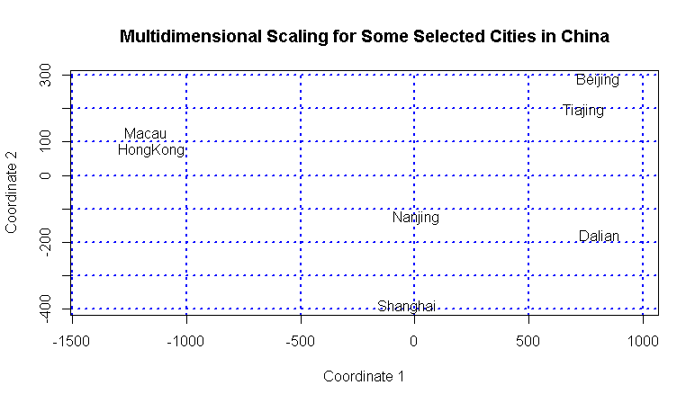

**QUESTION 3**

**(3a)**

$K_{n x n}$ is called positive semidefinite (K $⪰$ 0) if and only if , for $x ϵ R^{n}$, we have: $x^{T}Kx ⪰$ 0.

*i.e.*, its eigenvalues are all nonnegative.

We represent $x$ vector as ${\left(0…0 1 0…0\right)}^{T}$, where the element of the vector is equals to one is represented as $n^{th}$ position, then it follows that:

$x^{T}Kx= K_{n x n}$ (1)

It follows from positive semidefinite that, let $K be a N x N$ matrix, then $K$ is said to be positive semidefinite if $x^{T}Kx ⪰$ 0.

And if $x^{T}Kx>0, K$ is positive definite.

From (1), if $K_{n x n}$ $⪰$ 0, the $K$ is positive semidefinite, and it is positive definite if $K_{n x n}>0$

**(3b)**

We are to show that $d_{ij}= K_{ii}+K_{jj}-2K_{ij}$ is a square distance function, if there exist $u_{i}$, $v_{j}ϵ R^{n}$: $d_{ij}= {||u_{i}-v_{j}||}^{2}$

$d_{ij}= {||u_{i}-v_{j}||}^{2}$ = $\sqrt{\sum_{i=1}^{n}{{|u_{i}-v_{j}|}^{2}}}$ (2)

Let $Ω$ be a set and $d :Ω x Ω →R$ be a function, then, $d is said to be a distance function on Ω$ if:

1. for $\left(u,v\right) ϵ Ω x Ω$, $d\left(u,v\right)>0$
2. for $\left(u,v\right) ϵ Ω x Ω$, $d\left(u,v\right) =0; ⇔u=v$
3. for $\left(u,v\right) ϵ Ω x Ω, d\left(u,v\right)= d\left(u,v\right)$

we need to verify that the function $d_{ij}$ satisfies the three axioms above. From (i), $d_{ij}$ is nonnegative for all value of $u_{i} and v_{j}$, then (i) has been satisfied. From (ii), $d_{ij}=0$ only if $u_{i}= v_{j}$, then the second axiom has been satisfied. From all $u_{i} and v_{j}$, we have:

$\sqrt{\sum_{i=1}^{n}{{|u_{i}-v_{j}|}^{2}}}$ = $\sqrt{\sum_{i=1}^{n}{{|v_{i}-u_{j}|}^{2}}}$ (3)

From (3), we observed that the (ii) has been satisfied. Since all the three axioms have been satisfied, we conclude that $d_{ij}$ is a distance function and square of $d_{ij}$ is also a distance function.

**3(c)**

We define the following relations

X = $\left\{X_{1}, X_{2}…, X_{n}\right\}$ ϵ $R^{p x n}$, Y = $\left\{Y_{1}, Y_{2}…, Y_{n}\right\}$ ϵ $R^{p x n}$ and D = $\left[d_{ij}^{2}\right]$; $d_{ij}^{2} = {||X_{i}-X_{J}||}^{2}$

$d_{ij}^{2}$ = $X_{i}^{T}X_{i}+ X_{j}^{T}X_{j}-2X_{i}X_{j}$; $K_{ij}= X_{i}^{T}X_{j}$

Since ${\hat{K}}_{ij} = Y_{i}^{T}Y_{j}$ and $Y_{i}= X_{i}-\hat{μ}$

We define H = $I- \frac{1}{n}1.1^{T}$ and $Y=XH$ (4)

${\hat{K}}_{ij} = Y_{i}^{T}Y_{j}$ = $K_{n x n} = Y^{T}Y= {\left(XH\right)}^{T}\left(XH\right)= H^{T}X^{T}XH$ (5)

Substitute for H in (5) and note that $X^{T}X=K$, it follows that:

= $\left(I- \frac{1}{n}1.1^{T}\right) K\left(I- \frac{1}{n}1.1^{T}\right)$ = $K-$ $\frac{1}{n}1.1^{T}K- \frac{1}{n}K1.1^{T}+\frac{1}{n^{2}}1.1^{T}K.1.1^{T}$ (6)

It follows from (6) $B_{α}= -\frac{1}{2}H_{α}DH_{α}^{T}$ = (7)

We can now establish that the matrix $B_{α}= -\frac{1}{2}H_{α}DH_{α}^{T} ⪰0$ is positive semidefinite

We also represent $H_{α}$ vector as ${\left(0…0 1 0…0\right)}^{T}$, where the element of the vector is equals to one is represented as $n^{th}$ position such that:

$H_{α}DH_{α}^{T}= D_{nn}$ (8)

It follows (8), let $D be a N x N$ matrix, then $D$ is said to be positive semidefinite if $H_{α}DH_{α}^{T} ⪰$ 0.

And if $H_{α}DH_{α}^{T}>0, K$ is positive definite.

**3(d)**

If $A ⪰0$ and $B ⪰0$ ($A,B ϵ R^{n x m}$), our interest is to show that A+B is positive semidefinite

From the definition: $A$ is positive semidefinite if and only if , for x ϵ $R^{n}$, we have $x^{T}Ax ⪰$ 0, then A is positive semidefinite.

Also, $B$ is positive semidefinite if and only if, for x ϵ $R^{n}$, we have $x^{T}Bx ⪰$ 0, then B is positive semidefinite.

It follows from the definition above that A and B are positive semidefinite. If A is symmetry, then:

$x^{T}(A+B)x$ = $x^{T}Ax+ x^{T}Bx ⪰$ 0 (9)

It follows directly from (9) that (A+B) = ($A_{ij}+B_{ij}$) is positive semidefinite

Also, if $A and B$ are of order $N x N$ (square matrix) and A = B, then:

$x^{T}A^{T}.Bx$ = ${\left(xA\right)}^{T}Bx ⪰$ 0 (10)

From (9), [ $A_{ij}B_{ij}]$ is positive semidefinite

**QUESATION 4**

**4(a)**

Suppose d: $R^{p} x R^{p} →R$ is a distance function, we are required to show that $d^{2} and \sqrt{d}$ are distance function.

We define a distance function as follow:

Let $D$ be a set and $d :D x D →R$ be a function, then, $d is said to be a distance function on D$ if:

1. for $\left(x,y\right) ϵ D x D$, $d\left(x,y\right)>0$
2. for $\left(x,y\right) ϵ D x D$, $d\left(x,y\right) =0; ⇔x=y$
3. for $\left(x,y\right) ϵ D x D, d\left(x,y\right)= d\left(y,x\right)$

now we use the above axioms to prove (4a) and (4b)

from (4a), our interest is to show that $d^{2}$ is a distance function.

Let $d_{p}\left(X,Y\right)= \sqrt[p]{\sum_{i=1}^{n}{{|X_{i}-Y_{i}|}^{p}}}$ (11)

For $p=4$, we have $d^{2} = d_{4}\left(X,Y\right)= {\left(\sum_{i=1}^{n}{{|X_{i}-Y_{i}|}^{p}}\right)}^{\frac{p}{2}}= {\left(\sum_{i=1}^{n}{{|X_{i}-Y_{i}|}^{4}}\right)}^{2}$ (12)

From the axioms above, we deduce that $d^{2}$ cannot be negative for any value of $X_{i}$ and $Y_{i}$. This implies that the axiom of nonnegativity has be satisfied. $d^{2}$ can only be zero if and only if all $X_{i}$ are equals to $Y_{i}$; this implies that second axiom has been satisfied. Also, for all $X_{i}$ and $Y_{i}$,

${\left(\sum_{i=1}^{n}{{|X_{i}-Y_{i}|}^{4}}\right)}^{2}= {\left(\sum_{i=1}^{n}{{|Y_{i}-X_{i}|}^{4}}\right)}^{2}$ (13)

This also showed that the third axiom has been satisfied. Since all the three axioms are satisfied, the $d^{2}$ is a distance function.

**4(b)**

Our interest is to show that $\sqrt{d}$ is a distance function. This can be proved using the axioms above.

For p = 1, we define $\sqrt{d}= d_{1}\left(X,Y\right) = \sqrt{\sum_{i=1}^{n}{|X_{i}-Y_{i}|}}$ (14)

Since $d_{1}\left(X,Y\right)$ can never be negative at any value of $X_{i}$ and $Y_{i}$, then first axiom has been satisfied. Also $d_{1}\left(X,Y\right)$ can only be zero if and only if $X_{i}=Y_{i}$, then the second axiom has been satisfied. Lastly, for all $X_{i}$ and $Y_{i}$, we have:

$\sqrt{\sum_{i=1}^{n}{|X_{i}-Y_{i}|}}$ = $\sqrt{\sum_{i=1}^{n}{|Y_{i}-X_{i}|}}$ (15)

From (15), the symmetry axiom has been satisfied (third axiom). Since all the three axioms have been verified, then we say that $\sqrt{d}= d_{1}\left(X,Y\right)$ is a distance function.

$d^{2}$ and $\sqrt{d}$ are both distance function.