

**Peer review sheet**

MAFS6010Z, 2021 fall, Project 2

Your name: Zhang Quandi

Student ID: 20749999

Group that you review: Group 3

|  |  |  |  |  |
| --- | --- | --- | --- | --- |
|  | Confidence on your assessment (1-3) | Clarity and quality of writing (1-5) | Technical quality  (1-5) | Overall rating  (1-5) |
| Score | 3 | 4 | 4 | 4 |

**Summary:**

This report contain six parts: introduction, data description, methodology, prediction, extension-Interpretation.

* In data description, the report used first seven-year sample data as training and validation data,in which 70% for training and 30% for validation.
* In methodology, they saved the csv file in feather format and judged whether the number of images and labels are equal. Classifying the stock returns into two categories: positive and negative. They reshape the image ,build neural network, and use Conv2d, BatchNorm2d, LeakyReLU and MaxPool2d four functions.
* In prediction, the report use Baseline, GELU, GELU+LN, LN four CNN models to prediction and calculate the loss value, accuracy rate, sharpe ratio and correlation to evaluate and compare the performance.
* In extension-interpretation, there are four pictures show the original and the first derivative. Lastly, they use Grad-CAM approach to visualization.

**Strengths:**

The content of the report is readable, it’s easy to understand what they did. the claims are supported by theoretical analysis and experimental results.

**Weaknesses:**

The authors didn't give self-reflection and future work. Some formulas are written dislocation, making the report looks unity.

**Clarity and writing:**

The content of the report is readable, it’s easy to understand what they did. But some formulas are written dislocation, making the report looks unity, for example:

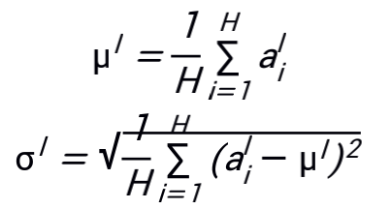

**Technical quality:**

The results are technically sound, there are no obvious flaws in the reasoning and the claims are supported by theoretical analysis and experimental results.