2)

(a) 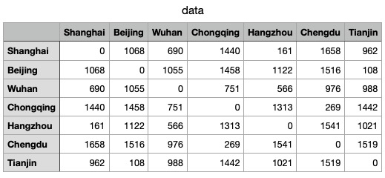

(b) Please see the attached .py file.

(c) All are positive. In the MDS algorithm, the presence of negative eigenvalues may lead to errors or instability in the algorithm, indicating the possible presence of data noise. We need to ensure that the centralized distance matrix B is a semi-positive definite matrix.



(d) 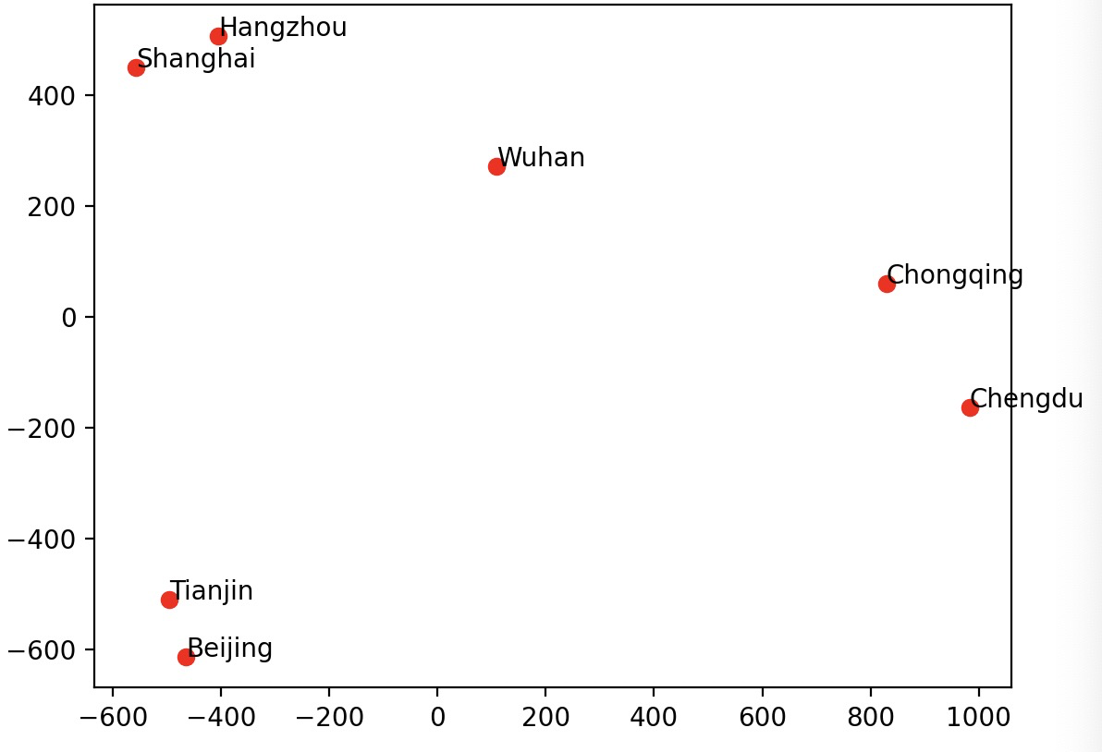

I found that the original distance and the transformed distance of these points are very positively correlated. For example, Shanghai and Hangzhou are very close (161 km), and the distance remains very close after will dimension.

