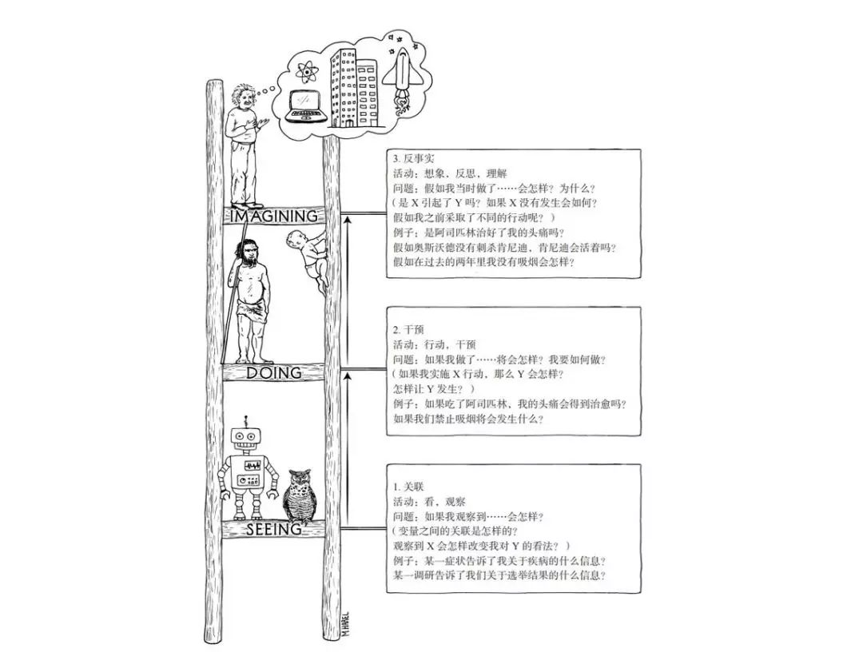
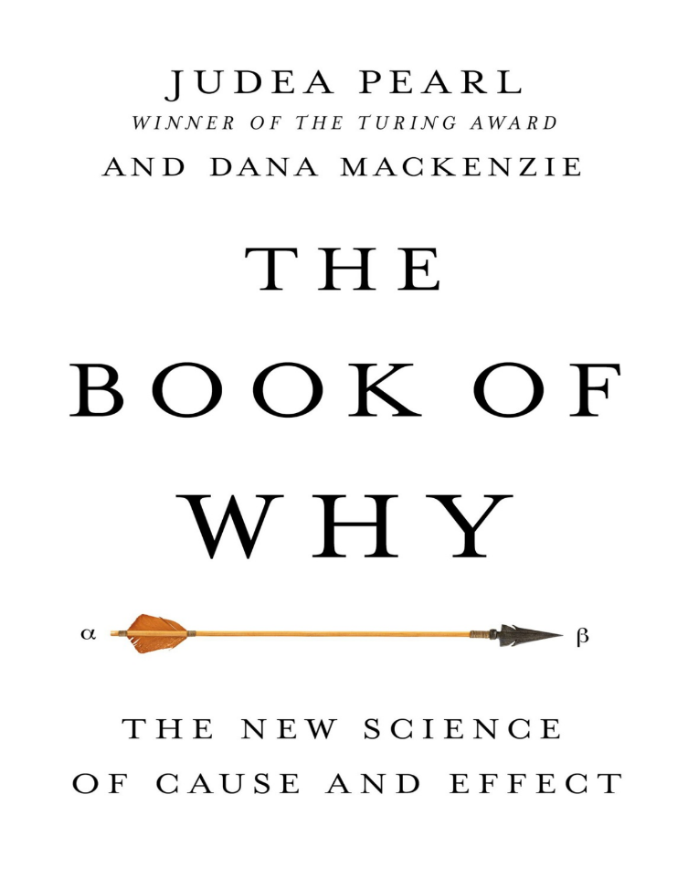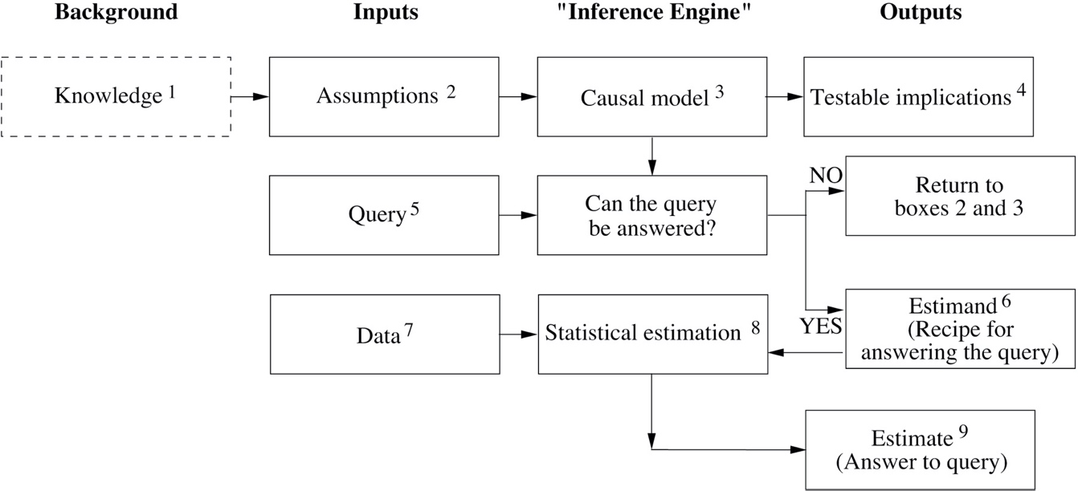

Introduction

Causation versus Association
Consider a dichotomous treatment variable $A$ (1: treated, 0: untreated) and a dichotomous outcome variable $Y$ (1: death, 0: survival), both of which are random variables. Let $Y^{a=1}$ be the outcome variable that would have been observed under the treatment value $a = 1$, and $Y^{a=0}$ the outcome variable that would have been observed under the treatment value $a = 0$, which are also random variables and referred to as potential outcomes or counterfactual outcomes.
We can now provide a formal definition of a causal effect for an individual: The treatment A has a causal effect on an individual’s outcome Y if $Y^{a=1}≠Y^{a=0}$ for the individual. Therefore, we are now ready to provide a formal definition of the average causal effect in the population: An average causal effect of treatment $A$ on outcome $Y$ is present if $\operatorname{Pr}\left[Y^{a=1}=1\right]≠\operatorname{Pr}{{[Y}^{a=0}=1]}$ (dichotomous outcomes) or $E\left[Y^{a=1}=1\right]≠E{{[Y}^{a=0}=1]}$ (non-dichotomous outcomes) in the population of interest.
Under this definition, treatment $A$ does not have an average causal effect on outcome $Y$ in our population because both the risk of death under treatment $\operatorname{Pr}\left[Y^{a=1}=1\right]$ and the risk of death under no treatment $\operatorname{Pr}\left[Y^{a=0}=1\right]$ are 0.5.
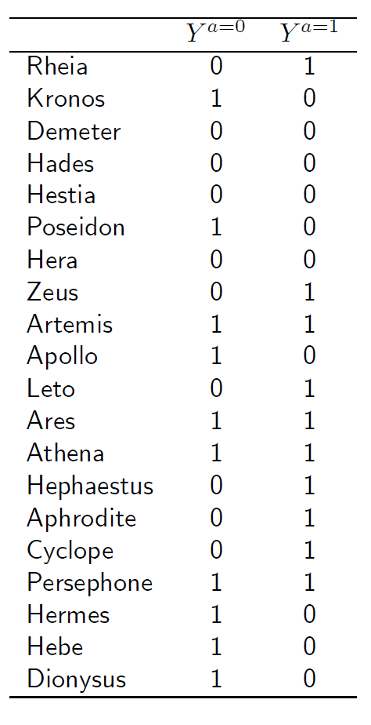
Obviously, the data available from actual studies look different from those shown in the table above. For example, we would not usually expect to learn Zeus’s outcome if treated $Y^{a=1}=1$ and also Zeus’s outcome if untreated $Y^{a=0}=0$. In the real world, we only get to observe one of those outcomes because Zeus is either treated or untreated. We referred to the observed outcome as $Y$. Thus, for each individual, we know the observed treatment level $A$ and the outcome $Y$ as in the table below.
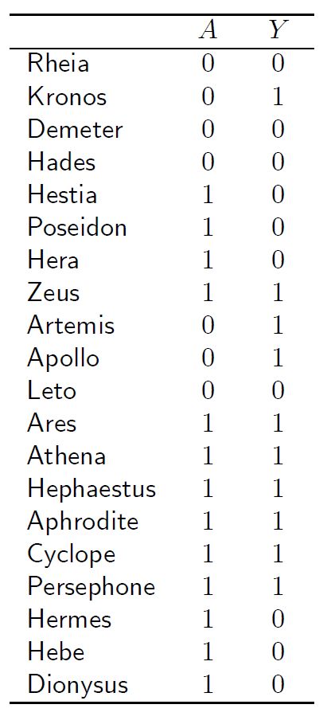
When the proportion of individuals who develop the outcome in the treated $\operatorname{Pr}{[Y=1|A=1]}$ equals the proportion of individuals who develop the outcome in the untreated $\operatorname{Pr}{[Y=1|A=0]}$, we say that treatment $A$ and outcome $Y$ are independent, that $A$ is not associated with $Y$, or that $A$ does not predict $Y$. We say that treatment $A$ and outcome $Y$ are dependent or associated when $\operatorname{Pr}{[Y=1|A=1]}≠\operatorname{Pr}{[Y=1|A=0]}$. In our population, treatment and outcome are indeed associated because $\operatorname{Pr}{[Y=1|A=1]}=7/13$ and $\operatorname{Pr}\left[Y=1 | A=0\right]=3/7$.
For dichotomous outcomes, we can therefore rewrite the definition of association in the population as $E{[Y=1|A=1]}≠E{[Y=1|A=0]}$.
The figure below depicts the causation-association difference. The population (represented by a diamond) is divided into a white area (the treated) and a smaller grey area (the untreated). The definition of causation implies a contrast between the whole white diamond (all individuals treated) and the whole grey diamond (all individuals untreated), whereas association implies a contrast between the white (the treated) and the grey (the untreated) areas of the original diamond. That is, inferences about causation are concerned with what if questions in counterfactual worlds, such as “what would be the risk if everybody had been treated?” and “what would be the risk if everybody had been untreated?”, whereas inferences about association are concerned with questions in the actual world, such as “what is the risk in the treated?” and “what is the risk in the untreated?”
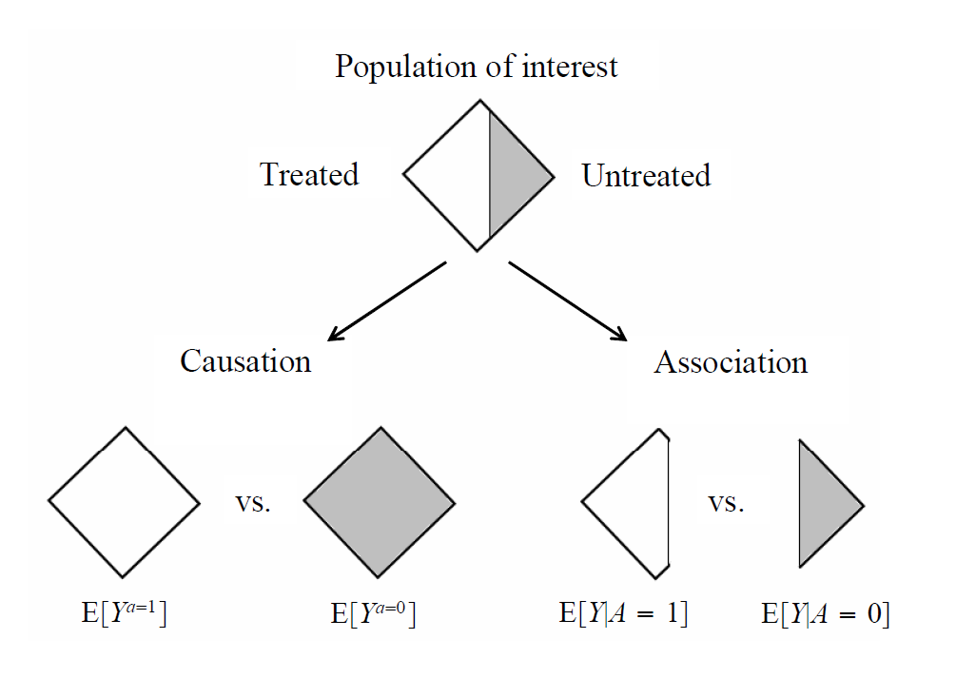

Why Study Causation?
The questions that motivate most studies in the health, social and behavioral sciences are not associational but causal in nature. For example,
- What is the efficacy of a given drug in a given population?
- Whether data can prove an employer guilty of hiring discrimination?
- What fraction of past crimes could have been avoided by a given policy?
- What was the cause of death of a given individual, in a specific incident?
These are causal questions because they require some knowledge of the data-generating process; they cannot be computed from the data alone, nor from the distributions that govern the data.

The Ladder of Causation

Structural Causal Models
Structural causal models (SCMs) provide a comprehensive theory of causality.

Causal Graph
A causal graph $G = \left(V, E\right)$ is a directed graph that describes the causal effects between variables, where $V$ is the node set and $E$ the edge set. In a causal graph, each node represents a random variable including the treatment, the outcome, other observed and unobserved variables. A directed edge $x → y$ denotes a causal effect of $x$ on $y.$
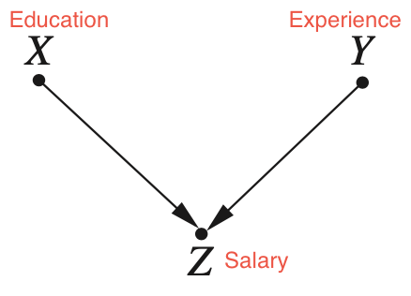

Product Decomposition
For any model whose graph is acyclic, the joint distribution of the variables in the model is given by the product of the conditional distributions $P\left(child | parents\right)$ over all the “families” in the graph. Formally, we write this rule as
$$P\left(x_{1},x_{2},…, x_{n}\right)=\prod_{i}{P\left(x_{i} | pa_{i}\right)}$$
where $pa_{i}$ stands for the values of the parents of variable $X_{i}$.
For example, in a simple chain graph $X → Y → Z$, we can write directly:
$$P\left(X=x, Y=y, Z=z\right)=P\left(X=x\right)P\left(Y=y | X=x\right)P\left(Z=z | Y=y\right)$$
This knowledge allows us to save an enormous amount of space when laying out a joint distribution. To estimate the joint distribution from a data set generated by the above model, we need not count the frequency of every triple $(x, y, z)$; we can instead count the frequencies of each $x$, $(y|x)$, and $(z|y)$ and multiply.
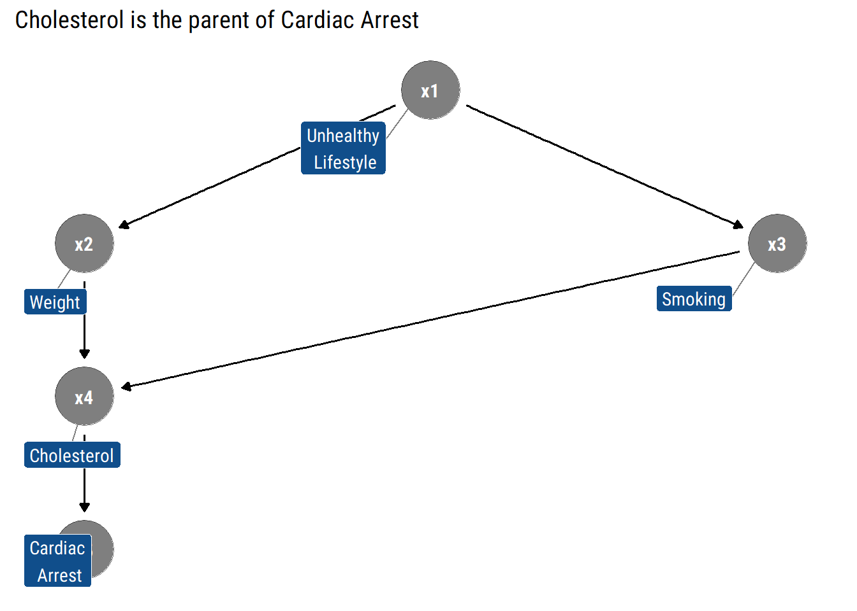
$$P\left(x_{1}, x_{2}, x_{3}, x_{4}, x_{5}\right) = P\left(x_{1}\right)P\left(x_{2}\right|x_{1})P\left(x_{3} | x_{1}\right)P\left(x_{4}\right|x_{2}, x_{3})P\left(x_{5}\right|x_{4})$$

$d$-Separation
Given a SCM, the conditional independence embedded in its causal graph provides sufficient information to confirm whether it satisfies the criteria such that we can apply certain causal inference methods. To understand the conditional independence, we need the concept of dependency-separation ($d$-separation) based on the definition of blocked path.
Two events $A$ and $B$ are conditionally independent given a third event $C$ if $P\left(A | B,C\right)=P(A|C)$ and $P\left(B | A,C\right)=P(B|C)$.
The probabilistic implications of the $d$-separation criterion:
- If $X$ and $Y$ are $d$-separated by $Z$ in causal graph $G$, then $X$ is independent of $Y$ conditional on $Z$ in every distribution compatible with $G$
- Conversely, if $X$ and $Y$ are not $d$-separated by $Z$ in causal graph $G$, then $X$and$Y$ are dependent conditional on $Z$
There are three typical DAGs for conditional independence:
- Chain: $x$ causally affects $y$ through its influence on $z$
- Fork: $z$ is the common cause of both $x$ and $y$, that is, $x$ is associated with $y$ but there is no causation between them
- Collider: both $x$ and $y$ cause $z$ but there is no causal effect or association between $x$ and $y$
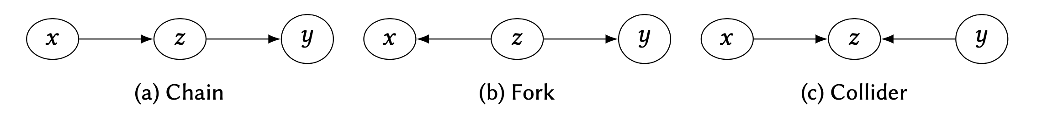
In the chain and fork, the path between $x$ and $y$ is blocked, that is, the variables become independent, if we condition on $z$. Contrarily, in a collider, conditioning on $z$ introduces an association between $x$ and $y$. Generally, we say conditioning on a set of nodes $Z$ blocks a path $p$ iff there exists at least one node $z∈Z$ in the path $p$.

Definition 1 ($d$-Separation)
A path $p$ is blocked (or $d$-separated) by a set of nodes $Z$ if and only if
- $p$ contains a chain of nodes $A→B→C$ or a fork $A←B→C$ such that the middle node $B$ is in $Z$ (i.e., $B$ is conditioned on), or
- $p$ contains a collider $A←B→C$ such that the collision node $B$ is not in $Z$, and no descendant of $B$ is in $Z$.

Chain

Rule 1 (Conditional Independence in Chains)
Two variables, $X$ and $Y$, are conditionally independent given $Z$, if there is only one unidirectional path between $X$and $Y$, and $Z$ is any set of variables that intercepts that path.
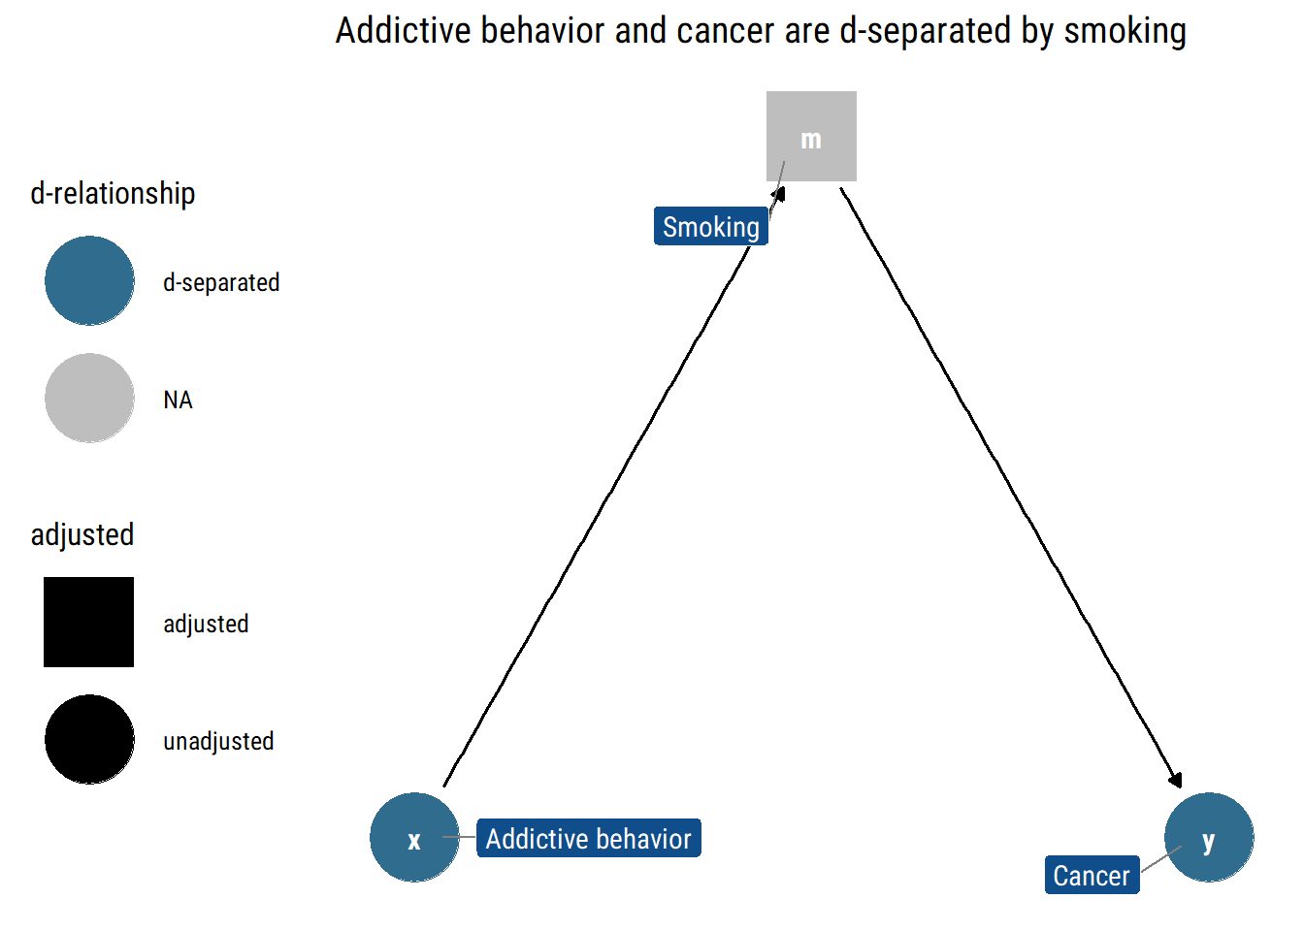

Fork

Rule 2 (Conditional Independence in Forks)
If a variable $X$ is a common cause of variables $Y$ and $Z$, and there is only one path between $Y$ and $Z$, then $Y$ and $Z$ are independent conditional on $X$.
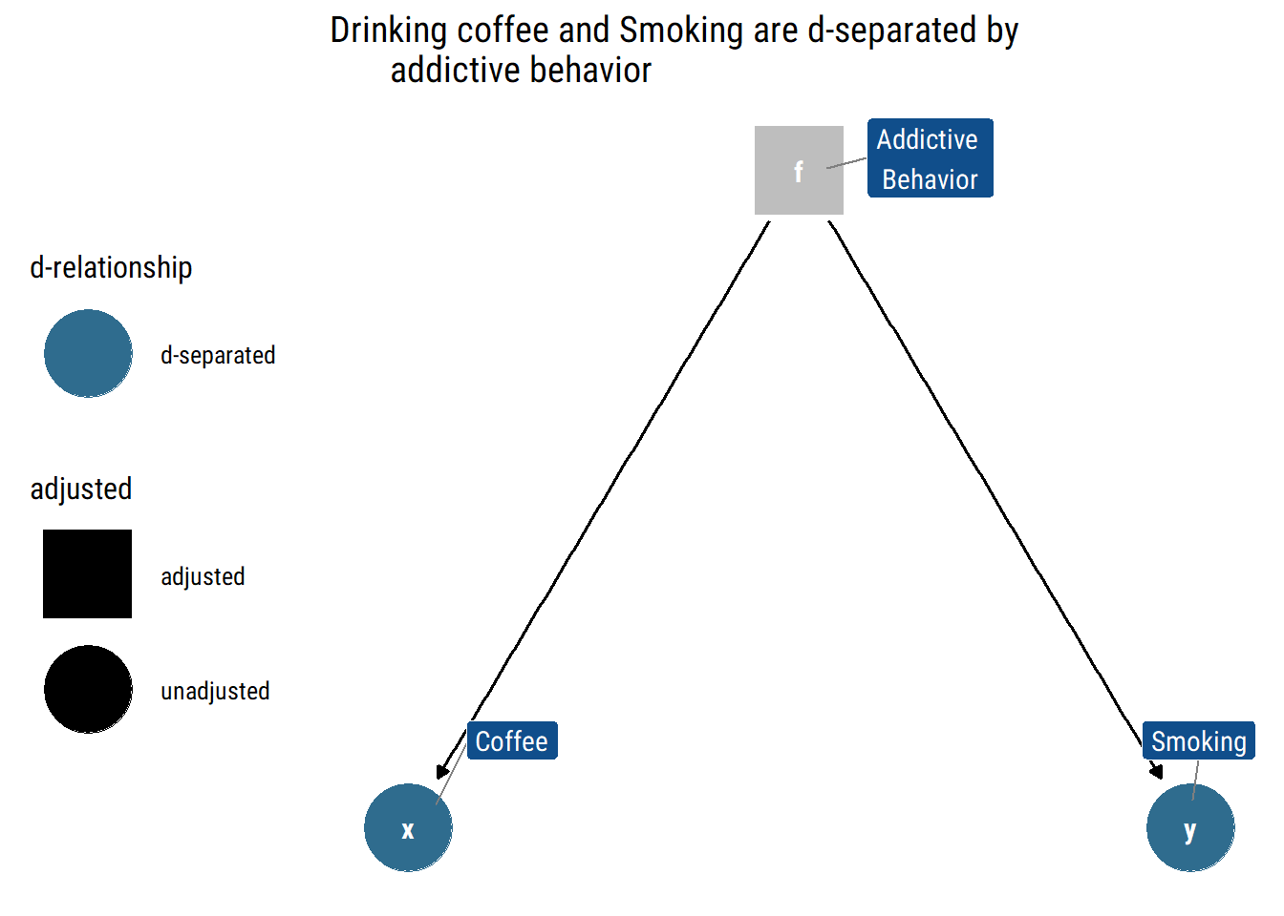

Collider

Rule 3 (Conditional Independence in Colliders)
If a variable $Z$ is the collision node between two variables $X$ and $Y$, and there is only one path between $X$and $Y$, then $X$and $Y$ are unconditionally independent but are dependent conditional on $Z$and any descendants of $Z$.
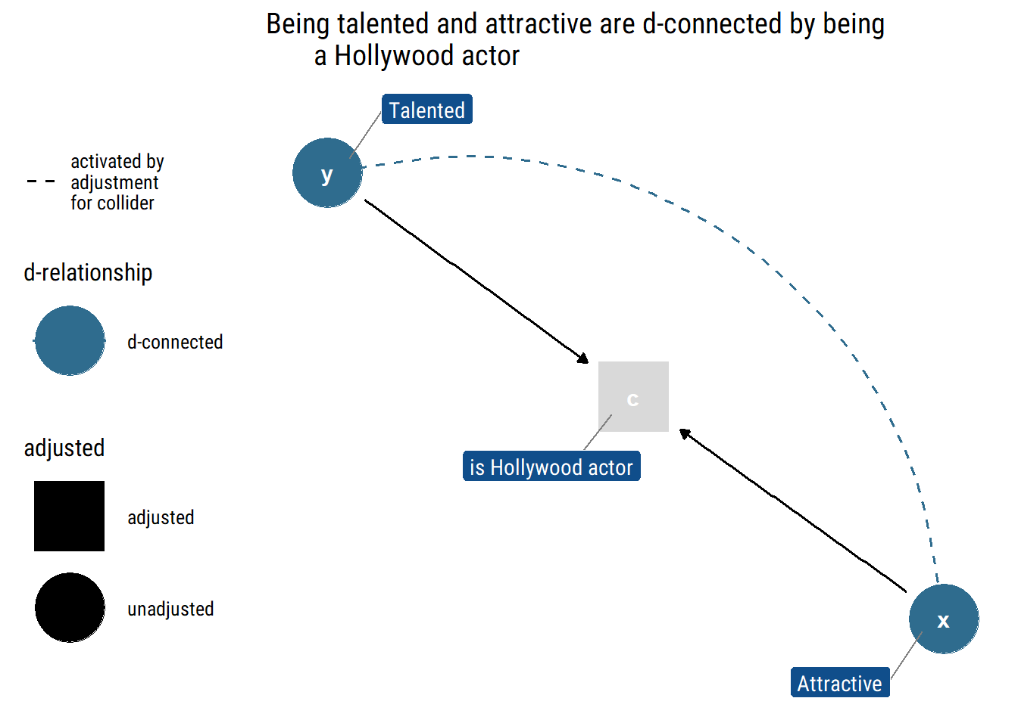

Example
Armed with the tool of $d$-separation, we can now look at some more complex graphical models and determine which variables in them are independent and dependent, both marginally and conditional on other variables.
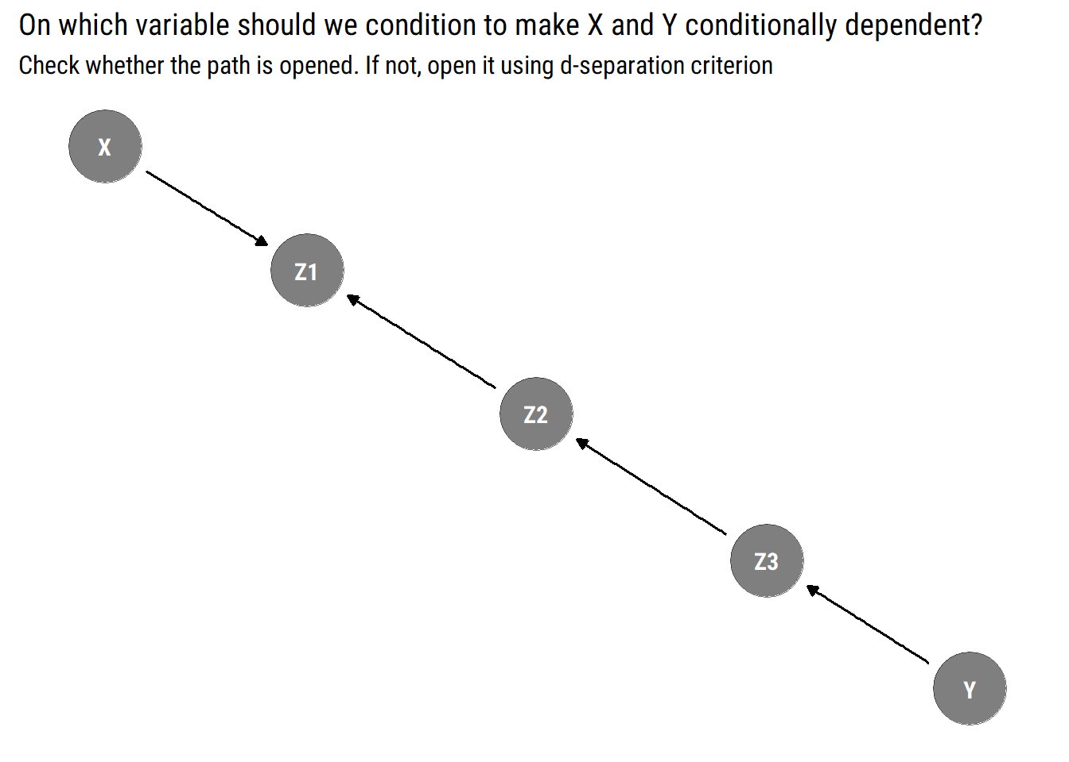

Can we distinguish models from data alone?
The preceding sections demonstrate that causal models have testable implications in the data sets they generate. For instance, if we have a graph $G$ that we believe might have generated a data set $S$, $d$-separation will tell us which variables in $G$ must be independent conditional on which other variables. Conditional independence is something we can test for using a data set. Suppose we list the $d$-separation conditions in $G$, and note that variables $A$ and $B$ must be independent conditional on $C$. Then, suppose we estimate the probabilities based on $S$, and discover that the data suggests that $A$ and $B$ are not independent conditional on $C$. We can then reject $G$as a possible causal model for $S$.
But there are other models that imply the same conditional independencies. Two graphical models $G_{1}$ and $G_{2}$ are observationally equivalent when they imply the same conditional independencies. The set of all the models with indistinguishable implications is called an equivalence class.
If two models are observationally equivalent, we cannot use data alone to distinguish from them. We must use our structural knowledge about the problem at hand to decide which model is the right one.
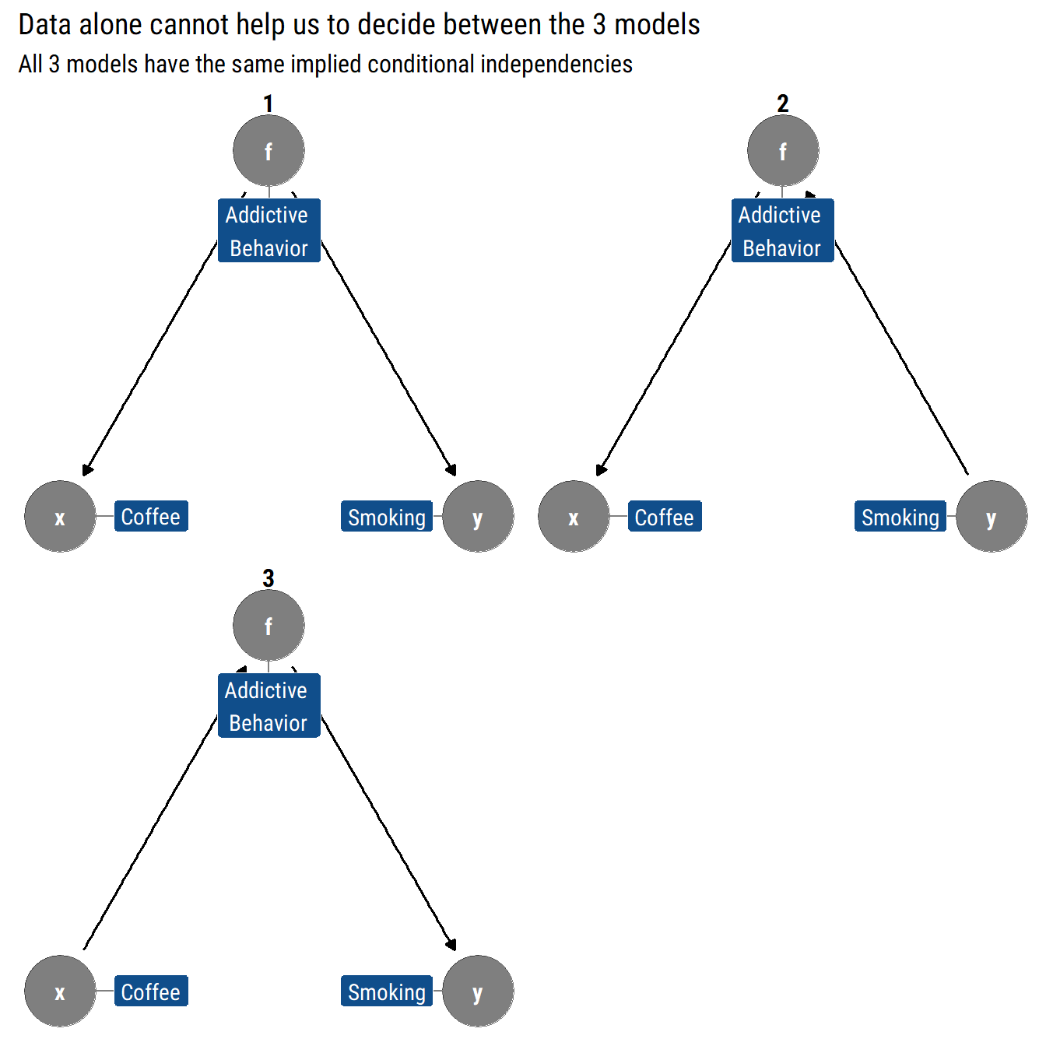
As Pearl says, data are fundamentally dumb: if we rely only in data to inform our models, we are extremely limited on what we can learn from them. We cannot predict the consequences of intervening (i.e., causal effects) in one of the variables with only observational data. Therefore, we must extend our theory beyond conditional probabilities gain causal understanding with only observational data.

The Effects of Interventions
Causal effects cannot be estimated from the data itself without a causal story, but this dost not mean that we cannot gain any causal understanding, far from which it just means that we must have a causal model. With the combination of causal models and observational data, causal effects can be estimated by leveraging the invariant information from the pre-intervention distribution.

Interventions
The do-calculus of Pearl was proposed to define intervention in SCMs. Specifically, the do-calculus introduces a new operator $do(t)$, which denotes the intervention of setting the value of the variable $t$ to $t'$. The notation of $do(t)$ leads to a formal expression of the interventional distributions:

Definition 2 (Interventional Distribution)
The interventional distribution $P(y|do(x'))$ denotes the distribution of the variable $y$ when we rerun the modified data-generation process where the value of variable $x$ is set to $x'$.
Consider a study of how Yelp ratings influence potential restaurant customers. Below are SCMs without and under intervention $do(t')$ for the study, where $x$, $t$and $y$ denote restaurant category, Yelp rating and customer flow. For the causal graph, the interventional distribution $P(y|do(t'))$ refers to the distribution of variable $y$ as if the rating $t$ is set to $t'$ by intervention, where all the arrows into $t$ are removed.
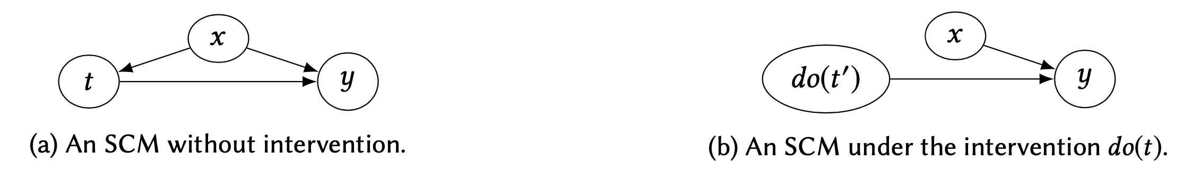
The difference between intervening on a variable and conditioning on that variable should, hopefully, be obvious. When we intervene on a variable in a model, we fix its value. We change the system, and the values of other variables often change as a result. When we condition on a variable, we change nothing; we merely narrow our focus to the subset of cases in which the variable takes the value we are interested in. What changes, then, is our perception about the world, not the world itself.
In notation, we distinguish between cases where a variable $X$ takes a value $x$ naturally and cases where we fix $X = x$by denoting the latter $do(X = x)$. So $P(Y = y|X = x)$ is the probability that $Y = y$ conditional on finding $X = x$, while $P(Y = y|do(X = x))$ is the probability that $Y = y$when we intervene to make $X = x$. In the distributional terminology, $P(Y = y|X = x)$ reflects the population distribution of $Y$ among individuals whose $X$ value is $x$. On the other hand, $P(Y = y|do(X = x))$ represents the population distribution of $Y$if everyone in the population had their $X$ value fixed at $x$. We similarly write $P(Y = y|do(X = x), Z = z)$ to denote the conditional probability of $Y = y$, given $Z = z$, in the distribution created by the intervention $do(X = x)$.

The Adjustment Formula
In the classical example of Simpson’s paradox, where $X$ stands for drug usage, $Y$ stands for recovery, and $Z$ stands for gender. To find out how effective the drug is in the population, we imagine a hypothetical intervention by which we administer the drug uniformly to the entire population and compare the recovery rate to what would obtain under the complementary intervention, where we prevent everyone from using the drug. Denoting the first intervention by $do(X = 1)$ and the second by $do(X = 0)$, our task is to estimate the difference
$$P\left(Y = 1 | do\left(X = 1\right)\right) - P\left(Y = 1 | do\left(X = 0\right)\right)$$
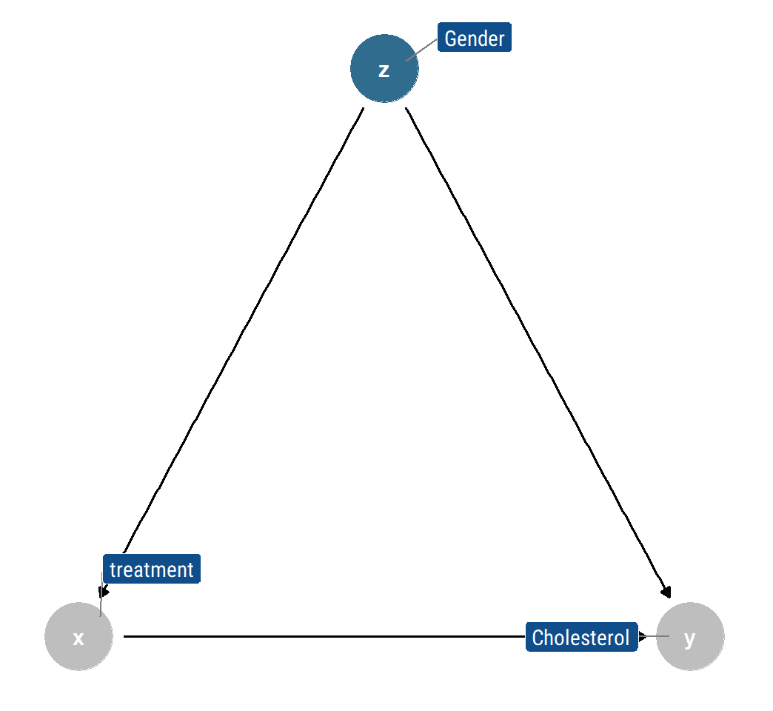
We know from first principles that causal effects cannot be estimated from the data set itself without a causal story. That was the lesson of Simpson’s paradox: The data itself was not sufficient even for determining whether the effect of the drug was positive or negative. But with the aid of the graph $G$ above, we can compute the magnitude of the causal effect from the data. To do so, we simulate the intervention in the form of a graph surgery (showed in the graph $G_{m}$ below), then the causal effect $P\left(Y = y | do\left(X = x\right)\right)$ is equal to the conditional probability $P_{m}\left(Y = y | X = x\right)$ that prevails in the manipulated model, where $P$ is the pre-intervention distribution probability and $P_{m}$ is the post-intervention distribution probability.
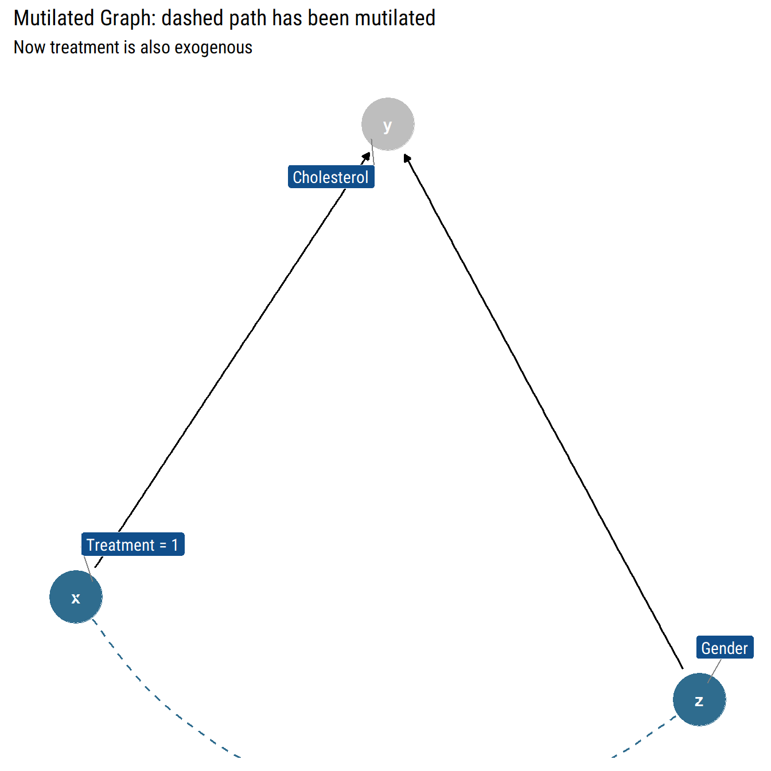
The key to computing the causal effect lies in the observation that $P_{m}$, the manipulated probability, shares two essential properties with $P$ (the original probability function that prevails in the pre-intervention model):
- First, the marginal probability $P(Z=z)$ is invariant under the intervention, because the process determining $Z$ is not affected by removing the arrow from $Z$ to $X$
- Second, the conditional probability $P(Y=y|Z=z, X=x)$ is invariant, because the process by which $Y$ responds to $X$ and $Z$ remains the same, regardless of whether $X$ changes spontaneously or by deliberate manipulation
Therefore, two of the equations of invariance are $P_{m}\left(Y=y|Z=z, X=x\right)=P(Y=y|Z=z, X=x)$ and $P_{m}\left(Z=z\right)=P(Z=z)$.
We can also use the fact that Z and X are d-separated in the modified model and are, therefore, independent under the intervention distribution, which tells us that $P_{m}\left(Z=z | X=x\right)=P_{m}\left(Z=z\right)=P(Z=z)$. Putting these considerations together, we have
$$P\left(Y = y ∣ do\left(X=x\right)\right)= P_{m}\left(Y=y ∣ X=x\right) \left(by definition\right)=\sum_{z}{P_{m}\left(Y=y ∣ X=x, Z=z\right)}P_{m}\left(Z=z ∣ X=x\right)=\sum_{z}{P_{m}\left(Y=y ∣ X=x, Z=z\right)}P_{m}\left(Z=z\right)$$
Finally, using the invariance relations, we obtain a formula for the causal effect, in terms of pre-intervention probabilities:
$$P\left(Y = y ∣ do\left(X=x\right)\right)=\sum_{z}{P_{m}\left(Y=y ∣ X=x, Z=z\right)}P_{m}\left(Z=z\right)$$which is called adjustment formula, and it computes the association between $X$ and $Y$ for each value $z$ of $Z$, then averages over those values. This procedure is referred as “adjusting for $Z$” or “controlling for $Z$.”

