一、Software download

<https://github.com/NTSC-GASV>

二、Environment setup

* **Anaconda install**

<https://www.anaconda.com/download/>

* **Anaconda create environment**

conda create –name myenv python=3.8

Where 'myenv' represents the environment name (user-defined), and 'python=3.8' specifies the Python version.

conda activate myenv

enter to 'myenv' environment；

conda deactivate

exit current environment

conda env list

list all environment

conda remove –name myenv –all

delete 'myenv' environment

* **Install required packages**

First, enter to 'myenv' environment, then:

conda install numpy

conda install matplotlib

conda install scipy

conda install -c conda-forge netcdf4

conda install pip

pip install jplephem

pip install pyside2

* Run

cd to software path, and in terminal enter：

python GASV_GUI.py”

三、**Initial Configuration**

Clicked File-Preference, set the path and click save button。

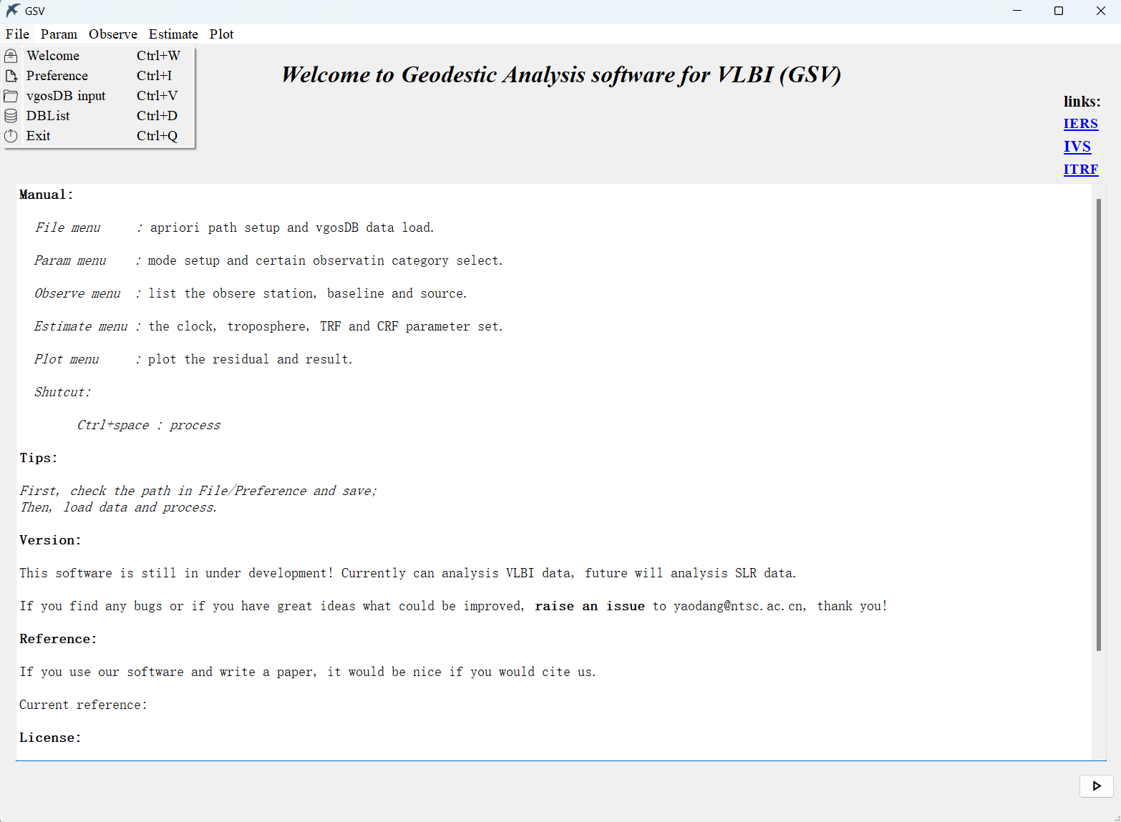

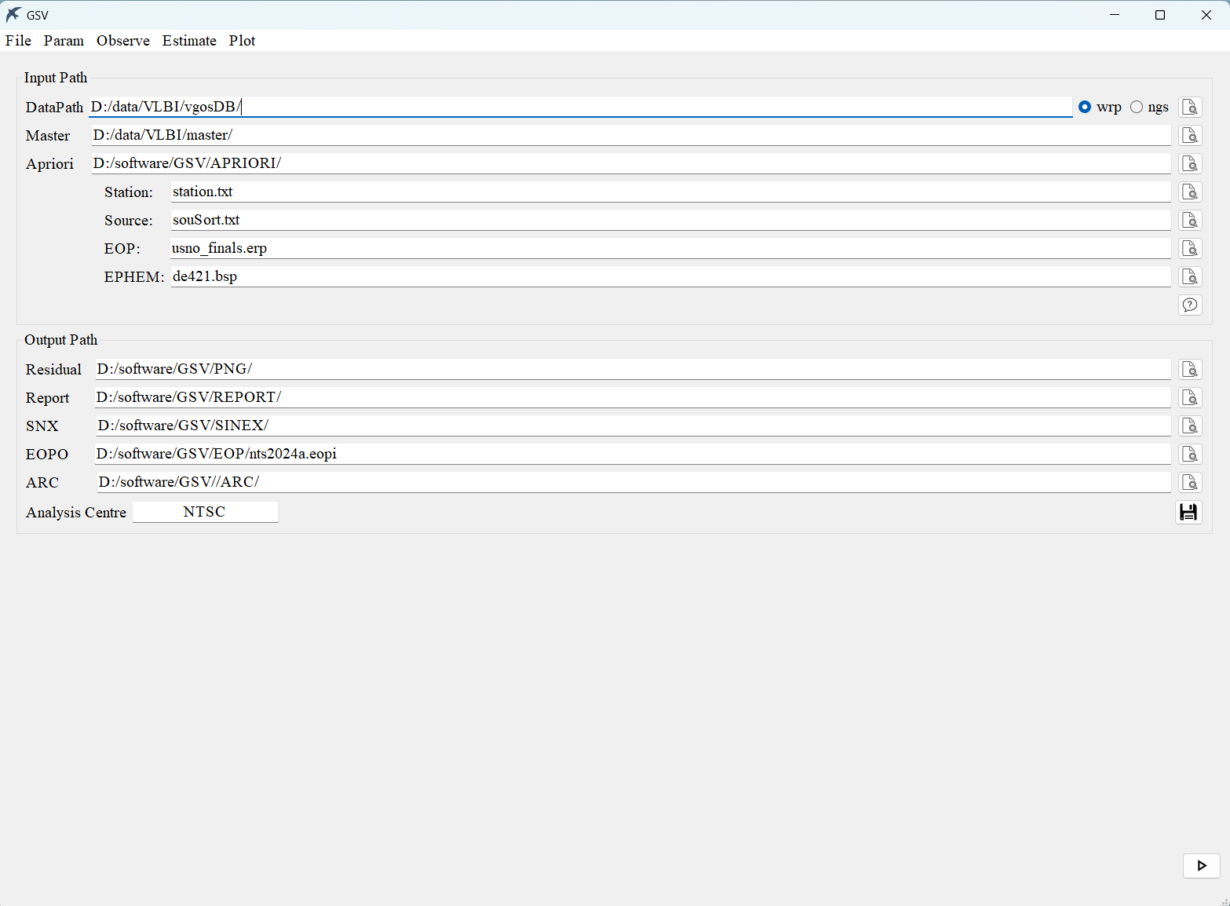

Clicked File-vgosDB_input to load data, and clicked bottom-right button to process data.

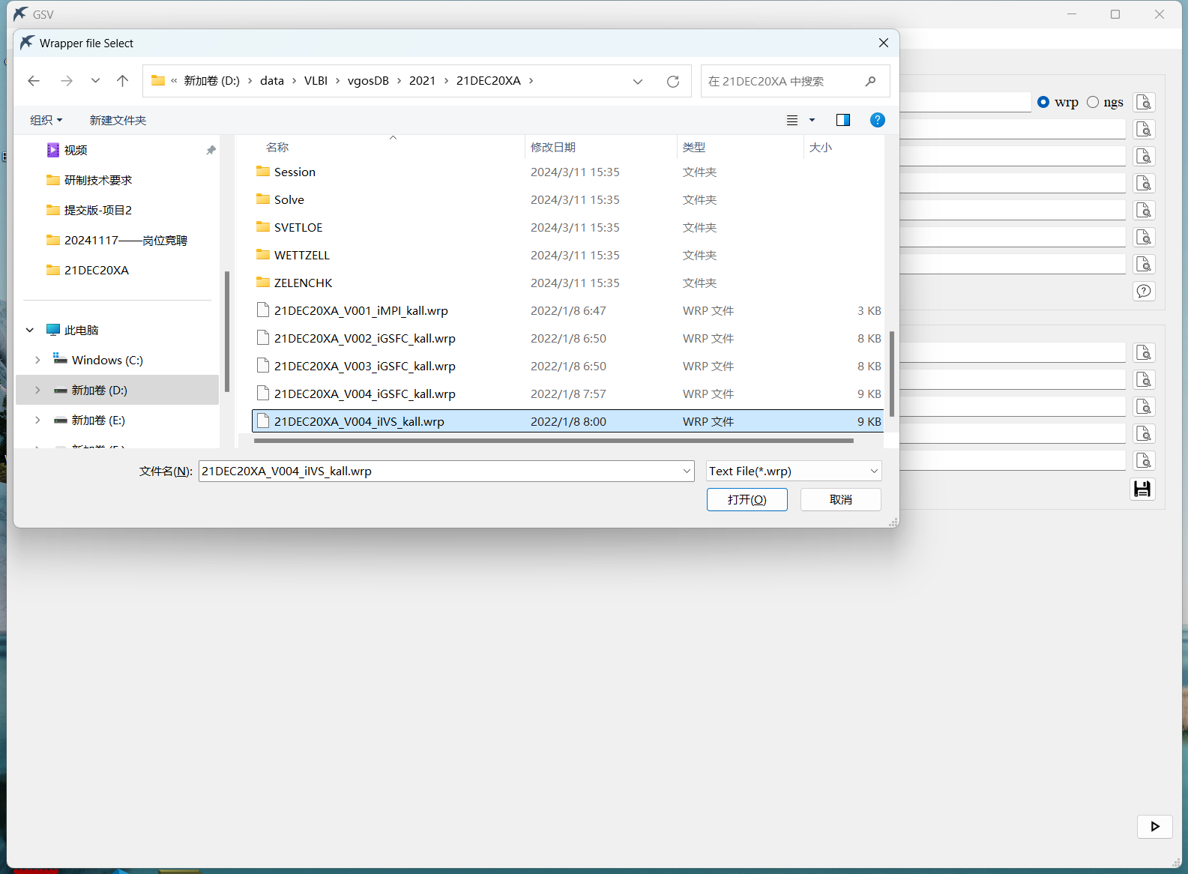

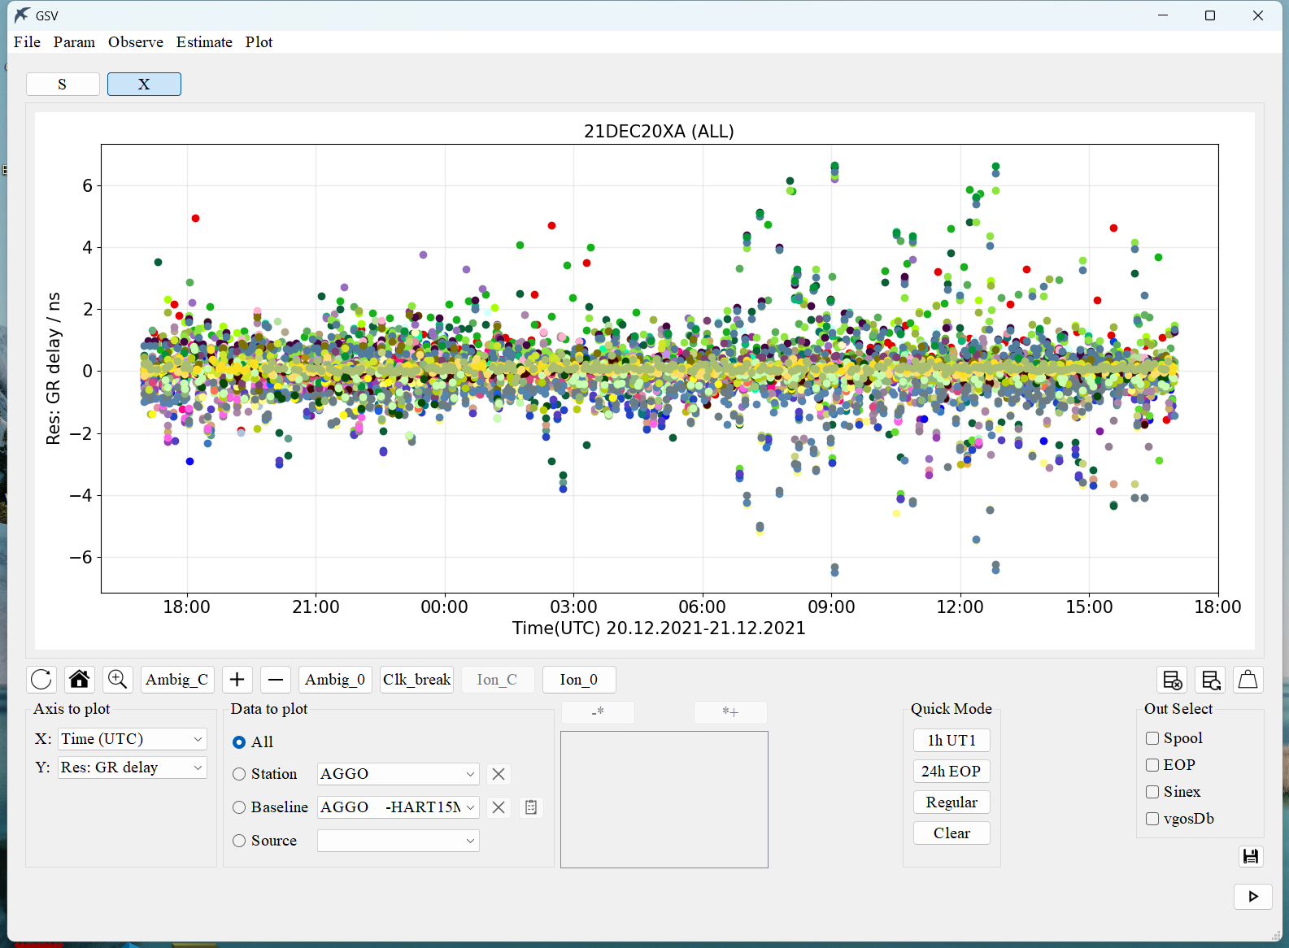

After processing, you can:

1. **View residuals** by clicking **Plot → Residual** in the menu bar.
2. **Set up EOP estimation automatically** by clicking the **"24h EOP"** button in the *Quick Mode* section.
3. **Reprocess** by clicking bottom-right button.

*Note: This process may take some time to complete.*

**Save:**

Check the 'Sinex' option and click 'Save'. The SINEX file will be stored in the directory specified in the Preference settings.

