Nginx教程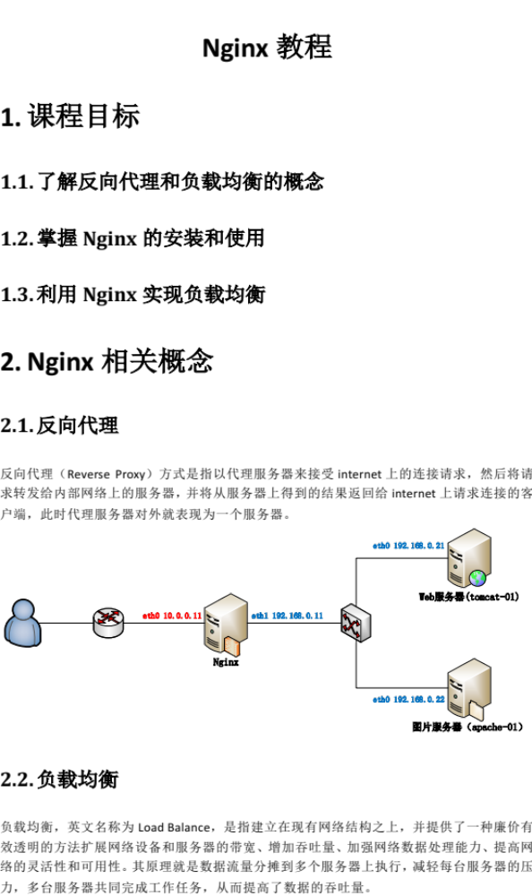

课程目标

了解反向代理和负载均衡的概念

掌握Nginx的安装和使用

利用Nginx实现负载均衡

Nginx相关概念

反向代理
反向代理（Reverse Proxy）方式是指以代理服务器来接受internet上的连接请求，然后将请求转发给内部网络上的服务器，并将从服务器上得到的结果返回给internet上请求连接的客户端，此时代理服务器对外就表现为一个服务器。
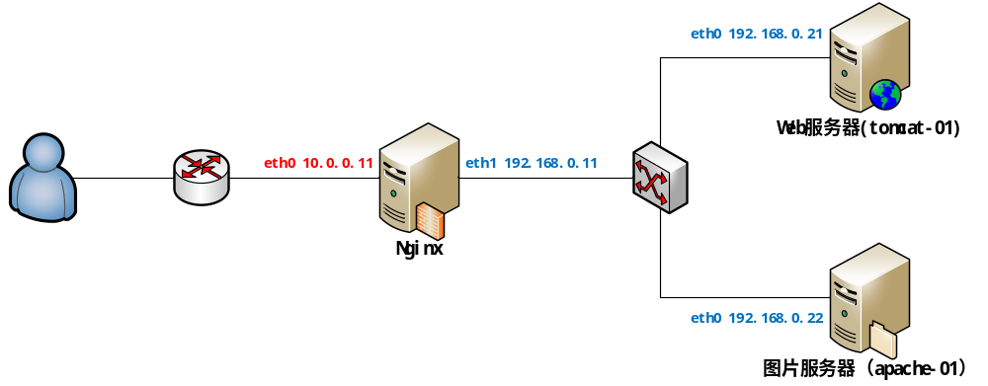

负载均衡
负载均衡，英文名称为Load Balance，是指建立在现有网络结构之上，并提供了一种廉价有效透明的方法扩展网络设备和服务器的带宽、增加吞吐量、加强网络数据处理能力、提高网络的灵活性和可用性。其原理就是数据流量分摊到多个服务器上执行，减轻每台服务器的压力，多台服务器共同完成工作任务，从而提高了数据的吞吐量。
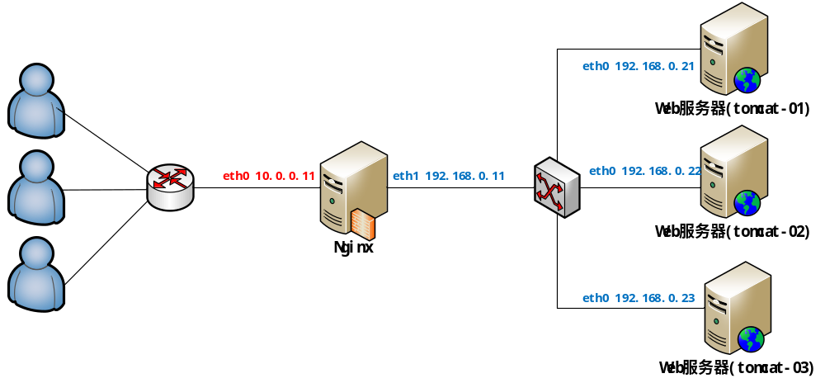

Nginx的安装

下载nginx
官网：http://nginx.org/

上传并解压nginx
tar -zxvf nginx-1.8.1.tar.gz -C /usr/local/src

编译nginx
#进入到nginx源码目录
cd /usr/local/src nginx-1.8.1

#检查安装环境
./configure --prefix=/usr/local/nginx

#缺包报错 ./configure: error: C compiler cc is not found

#使用YUM安装缺少的包
yum -y install gcc pcre-devel openssl openssl-devel

#编译安装
make && make install

配置nginx

配置反向代理
- 修改nginx配置文件
server {
listen 80;
server_name nginx-01.xiaoniu.cn;
#172.16.203.101/hello.html
location / {
root html;
proxy_pass http://192.168.0.21:8080;
}
}
- 启动tomcat-01上的tomcat

3.启动nginx-01上的nginx
./nginx

动静分离
#动态资源 index.jsp
location ~ .*\.(jsp|do|action)$ {
proxy_pass http://tomcat-01.xiaoniu.cn:8080;
}

#静态资源
location ~ .*\.(html|js|css|gif|jpg|jpeg|png)$ {
expires 3d;
}

负载均衡
在http这个节下面配置一个叫upstream的，后面的名字可以随意取，但是要和location下的proxy_pass http://后的保持一致。
http {
upstream tomcats {
server 172.16.203.20:8080 weight=1;
server tomcat-02.xiaoniu.cn:8080 weight=1;
server tomcat-02.xiaoniu.cn:8080 weight=1;
}
location ~ .*\.(jsp|do|action) {
proxy_pass http://tomcats;
}
}

利用keepalived实现高可靠（HA）

高可靠概念
HA(High Available), 高可用性集群，是保证业务连续性的有效解决方案，一般有两个或两个以上的节点，且分为活动节点及备用节点。
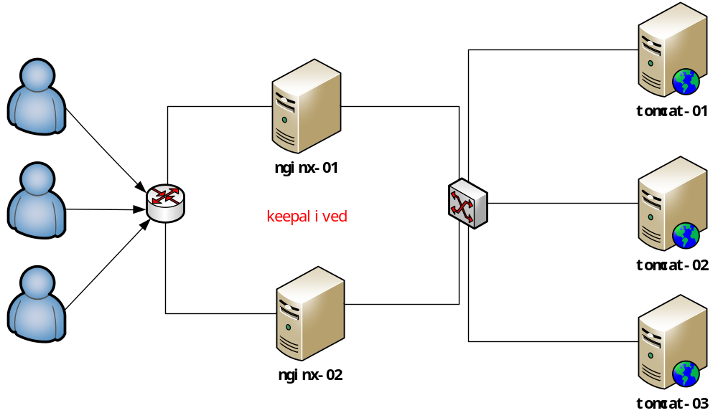

高可靠软件keepalived
keepalive是一款可以实现高可靠的软件，通常部署在2台服务器上，分为一主一备。Keepalived可以对本机上的进程进行检测，一旦Master检测出某个进程出现问题，将自己切换成Backup状态，然后通知另外一个节点切换成Master状态。

keepalived安装
下载keepalived官网:http://keepalived.org

将keepalived解压到/usr/local/src目录下
tar -zxvf keepalived-1.3.6.tar.gz -C /usr/local/src

进入到/usr/local/src/keepalived-1.3.6目录
cd /usr/local/src/keepalived-1.3.6

开始configure
./configure

#编译并安装
make && make install

将keepalived添加到系统服务中
拷贝执行文件
cp /usr/local/sbin/keepalived /usr/sbin/
将init.d文件拷贝到etc下,加入开机启动项
cp /usr/local/src/keepalived-1.3.6/keepalived/etc/init.d/keepalived /etc/init.d/keepalived
将keepalived文件拷贝到etc下
cp /usr/local/src/keepalived-1.3.6/keepalived/etc/sysconfig/keepalived /etc/sysconfig/
创建keepalived文件夹
mkdir -p /etc/keepalived
将keepalived配置文件拷贝到etc下
cp /usr/local/src/keepalived-1.3.6/keepalived/etc/keepalived/keepalived.conf /etc/keepalived/keepalived.conf
添加可执行权限
chmod +x /etc/init.d/keepalived

添加keepalived到开机启动
chkconfig --add keepalived
chkconfig keepalived on

配置keepalived虚拟IP

#MASTER节点
global_defs {
}
vrrp_instance VI_1 {
state MASTER
interface eth0
virtual_router_id 51
priority 100
advert_int 1
authentication {
auth_type PASS
auth_pass 1111
}
virtual_ipaddress {
10.0.0.10/24
}
}

#BACKUP节点
global_defs {
}
vrrp_instance VI_1 {
state BACKUP
interface eth0
virtual_router_id 51
priority 99
advert_int 1
authentication {
auth_type PASS
auth_pass 1111
}
virtual_ipaddress {
10.0.0.10/24
}
}

#分别启动两台机器上的keepalived
service keepalived start

配置keepalived心跳检查
#MASTER节点
global_defs {
}

vrrp_script chk_health {
script "[[ `ps -ef | grep nginx | grep -v grep | wc -l` -ge 2 ]] && exit 0 || exit 1"
interval 1
weight -2
}

vrrp_instance VI_1 {
state MASTER
interface eth0
virtual_router_id 1
priority 100
advert_int 2
authentication {
auth_type PASS
auth_pass 1111
}

track_script {
chk_health
}

virtual_ipaddress {
10.0.0.10/24
}

notify_master "/usr/local/keepalived/sbin/notify.sh master"
notify_backup "/usr/local/keepalived/sbin/notify.sh backup"
notify_fault "/usr/local/keepalived/sbin/notify.sh fault"
}

#添加切换通知脚本
vi /usr/local/keepalived/sbin/notify.sh
#!/bin/bash

case "$1" in
master)
/usr/local/nginx/sbin/nginx
exit 0
;;
backup)
/usr/local/nginx/sbin/nginx -s stop
/usr/local/nginx/sbin/nginx
exit 0
;;
fault)
/usr/local/nginx/sbin/nginx -s stop
exit 0
;;
*)
echo 'Usage: notify.sh {master|backup|fault}'
exit 1
;;
esac

#添加执行权限
chmod +x /usr/local/keepalived/sbin/notify.sh
global_defs {
}

vrrp_script chk_health {
script "[[ `ps -ef | grep nginx | grep -v grep | wc -l` -ge 2 ]] && exit 0 || exit 1"
interval 1
weight -2
}

vrrp_instance VI_1 {
state BACKUP
interface eth0
virtual_router_id 1
priority 99
advert_int 1
authentication {
auth_type PASS
auth_pass 1111
}

track_script {
chk_health
}

virtual_ipaddress {
10.0.0.10/24
}

notify_master "/usr/local/keepalived/sbin/notify.sh master"
notify_backup "/usr/local/keepalived/sbin/notify.sh backup"
notify_fault "/usr/local/keepalived/sbin/notify.sh fault"
}

#在第二台机器上添加notify.sh脚本
#分别在两台机器上启动keepalived
service keepalived start
chkconfig keepalived on

