Research on Mechanical Sensitivity Response Prediction of Explosives Based on Machine Learning

Authors Name/s per 1st Affiliation (Author)
line 1 (of Affiliation): dept. name of organization
line 2: name of organization, acronyms acceptable
line 3: City, Country
line 4: e-mail address if desired

Authors Name/s per 3rd Affiliation (Author)*
line 1 (of Affiliation): dept. name of organization
line 2: name of organization, acronyms acceptable
line 3: City, Country
* Corresponding author: e-mail address if desired
Authors Name/s per 2nd Affiliation (Author)
line 1 (of Affiliation): dept. name of organization
line 2: name of organization, acronyms acceptable
line 3: City, Country
line 4: e-mail address if desired

Authors Name/s per 4th Affiliation (Author)
line 1 (of Affiliation): dept. name of organization
line 2: name of organization, acronyms acceptable
line 3: City, Country
line 4: e-mail address if desired

Abstract—In order to reduce the workload and uncertainty of conventional mechanical sensitivity tests, and to obtain the performance parameters of explosives more quickly and accurately, machine learning methods to predict the response value of explosives mechanical sensitivity is proposed. The dataset is constructed by real test, finite element simulation and Monte Carlo data enhancement. By training and hyperparameter tuning for different classification models, we conclude that BP neural network is the best. The model is tested with real test data, and the results show that it is effective and feasible to predict the response value of mechanical sensitivity using machine learning methods. It also provides a good reference for multiple QMU reliability evaluation of explosives.
Keywords-machine learning; explosive; safety; QMU evaluation

Introduction
The degree of explosion of explosives under mechanical action is called mechanical sensitivity, including impact sensitivity and friction sensitivity. Bruceton up-down method is widely used in the sensitivity test of products. Due to the limitations of the development period and cost of this method, and the insufficient experimental samples and data required, the results are highly stochastic. [1] Traditional methods cannot achieve accurate predictions. Machine learning is uniquely superior in solving nonlinear problems with uncertain inference rules. [2] As no published reports on the prediction of the response value of explosives mechanical sensitivity have been seen, this paper combines real test, finite element simulation and Monte Carlo data enhancement [3], builds a suitable machine learning model. The ultimate goal is to input the stimulus amount of impact and friction sensitivities that can quickly and accurately predict the response outcome. This method reduces the amount and consumption of tests, provides a basis for QMU reliability evaluation of explosives, and is an important reference for the safety of the production, transportation and use of explosives.

Mechanical Sensitivity Response Prediction Model

Source and construction of the dataset
Experimental data: According to the national military standard in "GJB772A-1997"(601.2 characteristic drop height method, 602.1 explosion probability method) [4], the determination of the impact and friction sensitivity of some kind of explosives are carried out. The impact sensitivity and the logarithmic value of stimulus (drop height) satisfy a normal distribution. Giving initial stimulus and step size, and five groups (25 shots per group) of Bruceton up-down method experiments were performed with falling hammer. The swing hammer of pendulum friction instrument hits the sample of explosives to be measured with the standard pendulum angle, gauge pressure and the amount of gunpower. Two groups (25 shots per group) of tests were conducted. If the sample is found to be audible, glowing, decomposing and smoking in the above tests, we can judge it as an explosion, i.e. response. The experimental apparatus are shown in Figure 1.
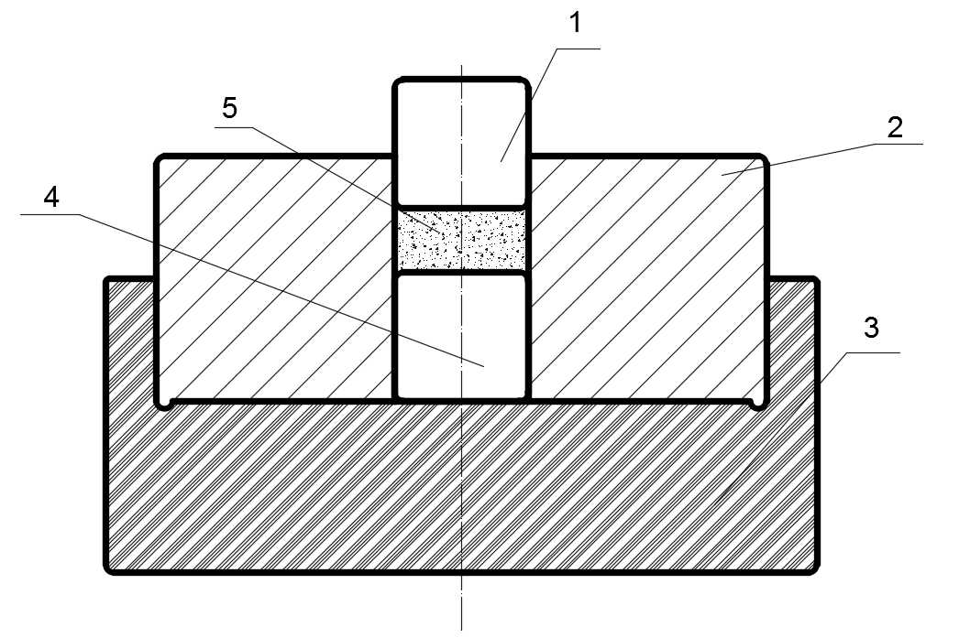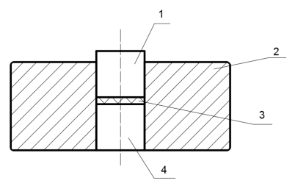
Figure1. The equipment for impact sensitivity test (left): 1-Upstroke column, 2-Strike sleeve, 3-Base, 4-Downstroke column, 5-Sample. The equipment for friction sensitivity test(right): 1-Upslide column, 2-Sliding sleeve, 3- Sample, 4-Downslide column.
Finite element simulation: ANSYS AUTODYN software was used to simulate the mechanical sensitivity tests of explosive particles. Models of drop hammer impacting HMX explosive particles and pendulum impacting slide column were established. Subsequently, we successfully simulated the characteristic drop height method and explosion probability method introduced above. The particle diameters used for the simulation were mixed from 200 to 400 μm. Simulations of the impact sensitivity tests were performed at drop heights (logarithmic value with base 10) of 1.2 to 1.6 to observe the response results at different stimulus amounts. Simulations of the friction sensitivity tests were conducted with samples actually subjected to pressures of 85-480 MPa and pendulum swing angles of 30-90° to observe the reaction degree at different pressures and swing angles. The simulation results are shown in Figure 2.
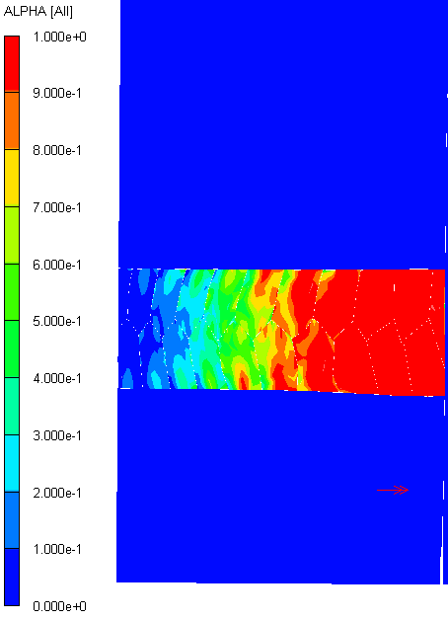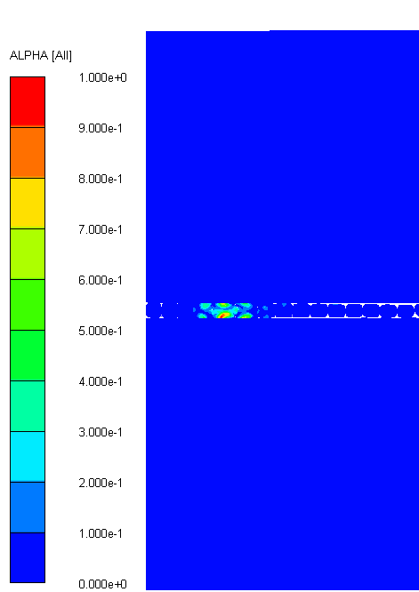
Figure 2. Impact (left) and friction (right) sensitivity simulations
Monte Carlo simulation data enhancement: The program flow is shown in Figure 3. The principle of the computer simulation of sensitivity tests is that the program randomly generates a critical stimulus amount and compares it with another group of stimuli generated according to the standard to obtain the response results [3],[5]. In order to expand the dataset of explosive sensitivity tests, Monte Carlo program is written to simulate Bruceton up-down method. μ and σ of the critical stimulus quantities obtained from real tests and simulations as a priori knowledge [6]. Determine the initial stimulus amount x1 as μ step size d as σ. Based on Box-Muller transform [7] to generate long-period normal random numbers _{xci}~(μ, σ). Compare the simulated stimulus x_{i} with _{xci}. If x_{i} is less than _{x}ci , response y_{i} is noted as 0, x_{i+1} is added to xi with step d. Conversely, y_{i} is noted as 1, x_{i+1} is subtracted from xi by step d. In this way, it stops until the sampling number reaches N.
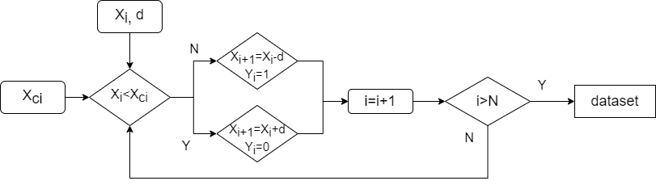
Figure 3. Algorithm of computer simulation up-down method
Make the dataset: The two parts of the data generated by finite element and Monte Carlo simulation are combined, randomly disrupted and divided into training, validation and test sets in appropriate proportions. The real sensitivity test data are retained for the final prediction. The composition of the dataset required to train the model is shown in Table I.
- Composition of The Dataset

Build model
Type | Number of each type |  |  | Input | Output
Type | Real test | Finite element | Monte Carlo | Input | Output
Impact | 125 | 250 | 450 | Particle diameter, Drop height | Stimulus  (0 or 1)
Friction | 50 | 64 | 190 | Particle diameter, Pressure, Pendulum angle | Stimulus  (0 or 1)

Model training
There are two phenomena in the mechanical sensitivity tests of explosives, that is, explosive (noted as 1) and inexplosive (noted as 0). Therefore, the prediction of response value can be considered as the binary classification problem.The following classification models and features of machine learning methods are commonly used:
          - Decision tree. Highly explanatory, but sensitive to data noise, improve learning efficiency by decision tree pruning.
          - Logistic regression. Non-linear transformations, simple to use and highly interpretative.
          - Naive bayes. The generalization effect of limited data is good, but the input variables should be assumed to be independent of each other.
          - Support vector machine (SVM). Searching for the maximum margin hyperplane to partition dataset.
          - K nearest neighbor (KNN). According to the majority classification of nearest K samples, avoid the problem of sample imbalance.
          - Random forest. One of ensemble learning methods, the calculation speed is slow, but the performance of processing unbalanced data is relatively robust.[8]
          - BP neural network. Composed of input layer, hidden layer and output layer, optimize the model based on the principle of back propagation, runs fastest and has high accuracy.
With reference to the above models, eight specific models are selected, including fine decision tree (A), logistic regression (B), kernel naive bayes (C), quadratic SVM (D), cosine KNN (E), weighted KNN (F), integrated RUS-Boosted tree (G) and BP neural network (H). The training model adopts 10-fold cross validation. After several hyper-parameter tuning, the training results and model information are obtained as shown in Table II and Table III. The results show that the BP neural network has the best performance.

- Model of Impact Experiment
Model | Accuracy (%) | Precision (%) | Recall (%) | AUC | Training time(s) | Details
A | 71.9 | 72.6 | 68.6 | 0.79 | 1.49 | Maximum split: 100; Principle of division: Gini impurity
B | 71.4 | 67.9 | 73.7 | 0.80 | 11.21 | Loss function: binary cross entropy
C | 71.4 | 70.3 | 73.7 | 0.78 | 9.34 | Gaussian kernel
D | 71.4 | 70.3 | 73.7 | 0.79 | 21.48 | Quadratic kernel function
E | 72.7 | 77.3 | 64.5 | 0.79 | 0.95 | Number of neighbors K=19; Metric: cosine distance
F | 73.8 | 74.5 | 72.5 | 0.81 | 0.73 | Number of neighbors K=27; Metric: Euclidean distance
G | 72.7 | 69.8 | 78.6 | 0.81 | 5.69 | Maximum split: 100; Learning rate:0.1
H | 88.0 | 84.6 | 91.7 | 0.90 | 0.07 | Hidden layers:10; Sigmoid; MSE; Epochs:14; Bayesian regularization
- Model of Friction Experiment
Model | Accuracy (%) | Precision (%) | Recall (%) | AUC | Training time(s) | Details
A | 83.9 | 83.2 | 88.4 | 0.88 | 1.85 | Maximum split: 100; Principle of division: Gini impurity
B | 71.7 | 81.8 | 72.9 | 0.78 | 4.10 | Loss function: binary cross entropy
C | 67.7 | 86.5 | 67.4 | 0.75 | 5.35 | Gaussian kernel
D | 80.7 | 79.7 | 86.1 | 0.89 | 43.26 | Quadratic kernel function
E | 83.1 | 87.2 | 83.1 | 0.87 | 46.74 | Number of neighbors K=10; Metric: cosine distance
F | 84.6 | 89.8 | 83.1 | 0.91 | 1.05 | Number of neighbors K=14; Metric: Euclidean distance
G | 85.0 | 89.9 | 83.8 | 0.91 | 5.51 | Maximum split: 40; Learning rate:0.1
H | 88.2 | 91.4 | 91.4 | 0.92 | 0.31 | Hidden layers:30; Sigmoid; MSE; Epochs:62; Bayesian regularization

Prediction of model
- Predict Results
Type | Number of data | Model | Accuracy (%) | Precision (%) | Recall (%) | Binary cross entropy
Impact | 125 | BP neural network | 88.0 | 90.5 | 89.3 | 0.0490
Friction | 50 | BP neural network | 86.0 | 92.5 | 90.2 | 0.0446

Two BP neural network models trained above are selected to predict the response value of the real sensitivity test. Table IV. show that our attempt is effective.

Application Of Model In QMU Evaluation

The definition of QMU
Quantification of margins and uncertainties (QMU) [9] method was presented by LNNL and LANL as a creditability evaluation method which can also be used in reliability certification of systems such as high-tech weapons. The mathematical formula of QMU [10] is：
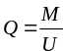 (1)
 (2)
M is the best estimate of the margin of the performance parameter and is the subtraction of the worst-case estimate for explosives and the estimate for the lowest requirement (failure criterion). U is the uncertainty of M. The calculation methods for M and U are based on specific tests. Q is the confidence coefficient, which is used to characterize whether the explosive meets the reliability requirements. The key elements of QMU are shown in Figure 4.
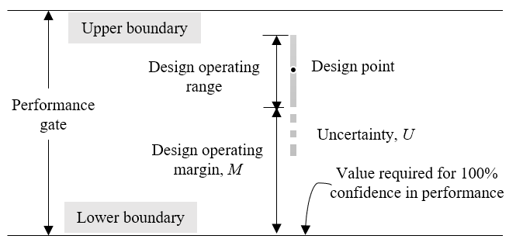
Figure 4. Key elements of QMU

Model prediction and the multiple QMU evaluation
The QMU method shown above is for single performance parameter. However, the QMU evaluation of mechanical sensitivity of explosives is composed of two parameters (impact & friction). We proposed a new multiple QMU evaluation methods based on Euclidean distance of projection curve. The performance curve is shown in Fig. 5.
According to the trained classification model, the response values of sensitivity tests are predicted. The model of sensitivity and critical stimulus is established from a large number of predicted values as the observation list and performance gate in QMU evaluation system. X_{th} is the performance threshold. X_{PL} is the lower limit of the uncertainty of the performance threshold obtained according to the one-sided confidence interval. X₀ is the safety design value. The Euclidean distance between curves is calculated as the interval of margin M and uncertainty U.
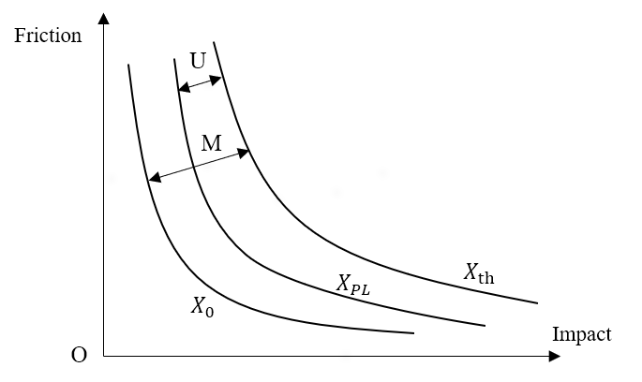
Figure 5. Performance curve of the multiple QMU evaluation
Assume that under the given condition, the safety design value of impact sensitivity is x₁, the one-sided confidence limit is x₂, the critical stimulus is x₃. The safety design value of friction sensitivity is y₁, the one-sided confidence limit is y₂, the critical explosion probability is y₃. This leads to the following equations for the margin and uncertainty in the multiple QMU evaluation method:
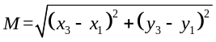 (3)
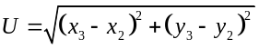 (4)
M is divided by U as the interval range of Q. If Q>1, the uncertainty is included in the margin of performance. We believe that under the given confidence level, the explosive satisfies the reliability requirement that the probability of response does not exceed the safety design value. On the contrary, if there is Q<1, the explosive loses its efficiency.
Taking some explosives for example, the above trained BP neural network is used to predict the response values of 25 impact tests and 50 friction tests. According to the statistics method [11],[12], when the confidence level is 0.9999, the critical stimulus (logarithmic) of impact sensitivity is 1.1662, the lower confidence limit is 0.7157, and the given safety value is 0.7. The critical explosion probability of friction sensitivity is 0.6920, the lower confidence limit is 0.6039, and the given safety value is 0.6. Calculated from (3)(4), the results are shown in Table V.
- An Example of Multiple QMU Evaluation
 | X_{th} | X_{PL} | X₀
Impact | 1.1662 | 0.7157 | 0.7
Friction | 0.6920 | 0.6039 | 0.6
Multiple evaluation | 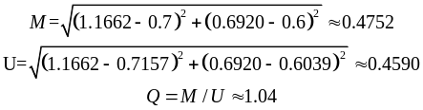Meet reliability requirements.
This multiple QMU evaluation method is extensible. If more sensitivity performance parameters are needed, it can be extended to higher dimensional Euclidean distance, and the evaluation of more sensitivity can be realized.

Counclusion
According to the results of various model training and prediction, we find that it is feasible to predict the response value of mechanical sensitivity of explosive based on machine learning method. Compared with the conventional sensitivity test method, models of machine learning are faster and have higher accuracy, which can effectively reduce the workload and the risk of the test. At the same time, the predicted response values provide an effective reference for the establishment of threshold model of critical explosive sensitivity and multiple QMU evaluation method. This research is also of great significance to the production, transportation and use of explosives. In addition, there are still left to be improved, such as to provide the time-series of system performance data by conditional monitoring and prognostics technology [13]. This is worthy of further exploration and research.
Acknowledgment
The work was supported by the
References
- N. Yan, R. Cai, and Y. Tian, "Monte Carlo simulation method and analysis for sensitivity tests," Initiators & Pyrotechnics, no.4, pp.1-6+33, 1995.
- Z. Yang, Y. Liu, and G. Yu, "Study on evaluation of critical thickness of HMX based on neural network," Initiators & Pyrotechnics, no.3, pp.33-36, 2009.
- R. Cai, and Y. Tian, "Study of computer simulation of sensitivity experiments," Journal of Wuhan University of Technology (Information & Management Engineering), no.3, pp.64-67, 2003.
- Commission of Science, Technology and Industry for National Defense,"GJB772A-97.Explosive test method," Beijing, 1997.
- T. Zhang, R. Cai, H. Dong, and J. Cao, "Study on σestimation in up-down sensitivity test with Monte Carlo method," Initiators & Pyrotechnics, no.2, pp.43-47, 2004.
- D. Fu., et al., "Study on estimation accuracy of the interval estimation method for up-and-down sensitivity test data," in Proceedings of the 6th Symposium on Energetic Materials and Insensitive Munitions, pp.397-400, 2014.
- Lee, D-U., et al. "A hardware Gaussian noise generator using the Box-Muller method and its error analysis," IEEE transactions on computers, vol.55, no.6, pp.659-671, 2006.
- X. Li, "Using random forest for classification and regression," Chinese Journal of Applied Entomology, vol.50, no.4, pp.1190-1197, 2013.
- https://cfwebprod.sandia.gov/cfdocs/CompResearch/docs/SAND2004-2411P.pdf.
- Z. Ma, Y. Ying, and J. Zhu, "QMU certifying method and its implementation," Nuclear Science and Engineering, vol.29, no.1, pp.1-9, 2009.
- Commission of Science, Technology and Industry for National Defense, "GJB8185-2015. Qualification and acceptance of reliability of initiating explosive device by using test information entropy equivalency assessment method," Beijing, 2015.
- C. Hua, S. Zhang, and D. Gao, "QMU evaluation of explosive safety under shock wave effect," Chinese Journal of Explosives & Propellants, vol.38, no.4, pp.31-34+62, 2015.
- Y. Hu, "Dynamic safety margin and uncertainty assessment based on RVM-PF," National University of Defense Technology, Changsha, Hunan, 2012.

