第七章_类人DNA与神经元基于催化算子映射编码方式.

AOPM-VECS-IDUQ 十二元基建模与应用， 文件肽化方式.

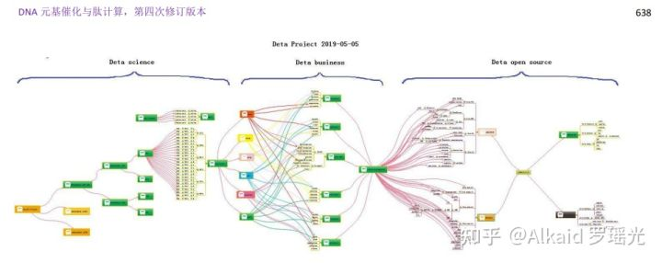

**1 DETA humanoid cognition**

1.1DETA humanoid cognition history, 德塔类人认知历史 refer page 638

1.2DETA humanoid cognition development, 德塔类人认知研发 refer page 638

1.3 DETA humanoid cognition application, 德塔类人认知应用 refer page 639

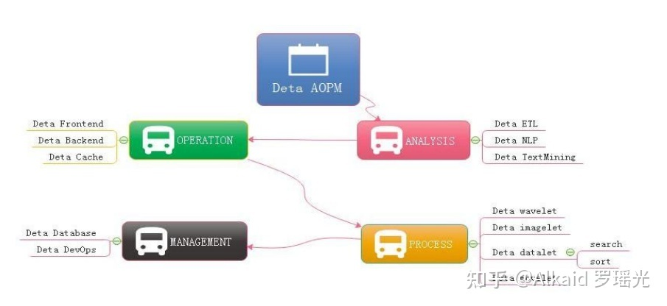

1.3.1 AOPM Open Source System On SDLC Theory refer page 640

1.3.1.1 Cathedral and the Bazaar, refer page 642

1.3.1.2 DETA WEB Projects System refer page 643

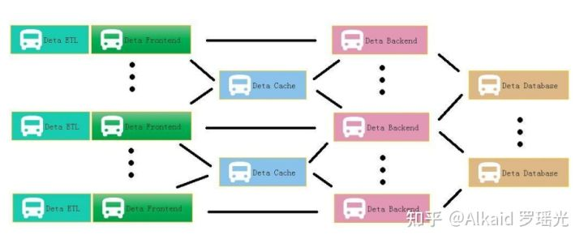

1.3.1.3 DETA DevOps Projects System refer page 644

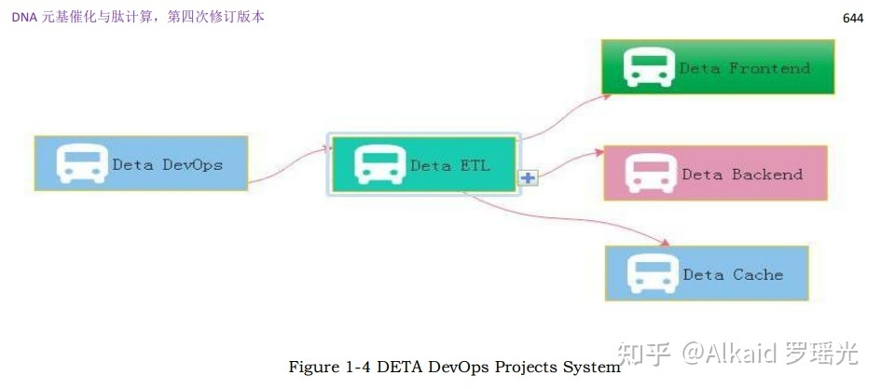

**2 DETA Business back end logic**

2.1DETA Business backend logic history, 德塔商业后端逻辑历史 refer page 644

2.2DETA Business backend logic development, 德塔商业后端逻辑发展 refer page 645

2.3DETA Business backend logic application, 德塔商业后端逻辑应用 refer page 645

2.3.1 VPCS Backend Theory And Its Application refer page 646

2.3.1.1 VPCS STAR MODEL refer page 647

2.3.1.2 VPCS BACKEND MODEL refer page 648

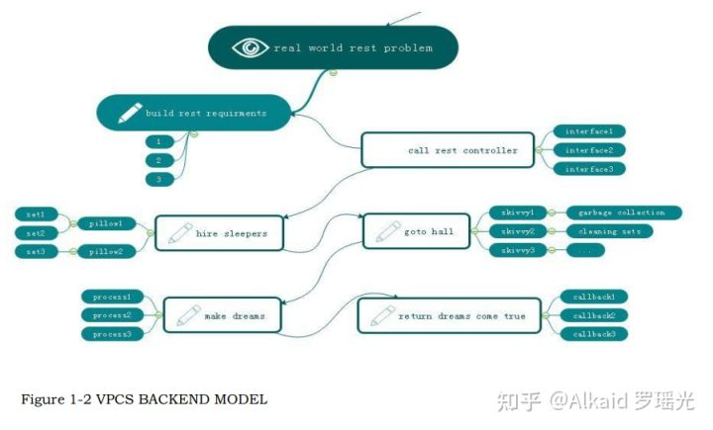

2.3.1.3 VPCS WORK WITH FRONTEND refer page 649

2.3.1.4 VPCS FOR DATABASE SYSTEM refer page 650

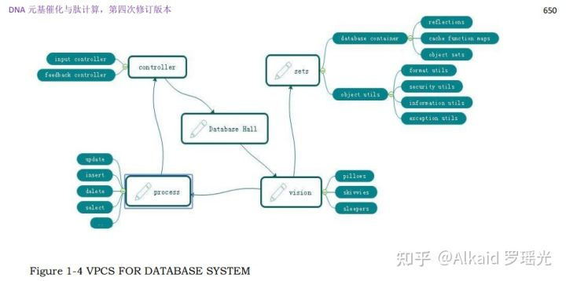

2.3.1.5 VPCS KERNEL refer page 651， 653

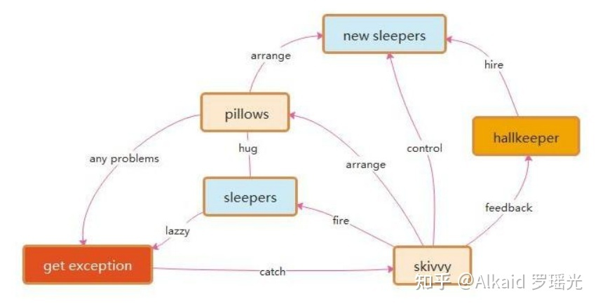

**3 DETA Catalytic computing**

3.1DETA Catalytic computing history, 德塔催化计算历史 refer page 655

3.2DETA Catalytic computing development, 德塔催化计算发展 refer page 655

3.2.1 Theory on YAOGUANG's Array Split Peak Defect refer page 656

3.2.1.1 Quicksort Yaoguang.Luo 4D refer page 656

3.2.1.2 DETA parser refer page 659

3.3 DETA Catalytic computing application, 德塔催化计算应用 refer page 661

3.3.1 《微分催化计算作为类人 DNA 进化的唯一途径》 论证

3.3.1.1 DETA 快速分词 POS 流水阀门微分算法 refer page 661

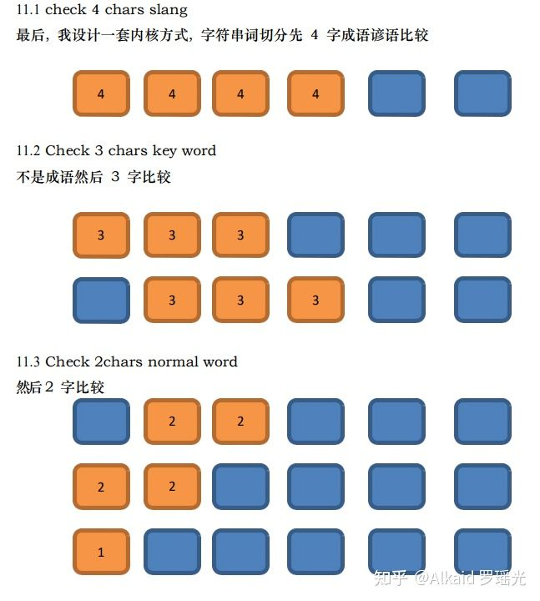分词内核文字匹配方式。

3.3.1.2 罗瑶光小高峰计算过滤排序算法 refer page 662

3.3.1.3 罗瑶光欧拉森林商旅环微分 TSP 算法 refer page 662

3.3.1.4 罗瑶光象契字符串条件微分排序算法 refer page 662

3.3.1.5 DETA Socket 流可编程数据库引擎的 PLSQL 语言微分编译机 refer page 662

**4 DETA Finding initions**

4.1 DETA Finding initions history, 德塔催化计算算子单元寻找历史 refer page 663

4.2 DETA Finding initions development, 德塔催化计算算子单元寻找发展 refer page 664

4.3 DETA Finding initions application, 德塔催化计算算子单元寻找应用 refer page 664

**5 DETA DNA decoding**

5.1DETA DNA decoding history, 德塔催化单元的 DNA 解码历史 refer page 665

5.2DETA DNA decoding development, 德塔催化单元的 DNA 解码发展 refer page 665

5.3DETA DNA decoding application, 德塔催化单元的 DNA 解码应用

5.3.1 元基映射编码 refer page 665

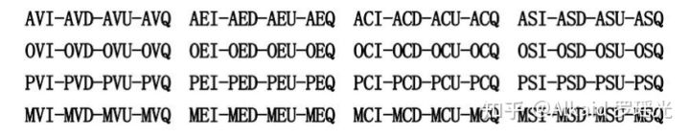

6 IDUC DNA and Its Applications, IDUC DNA 与它的应用 refer page 666

6.1 dna催化矩阵处理 refer page 669

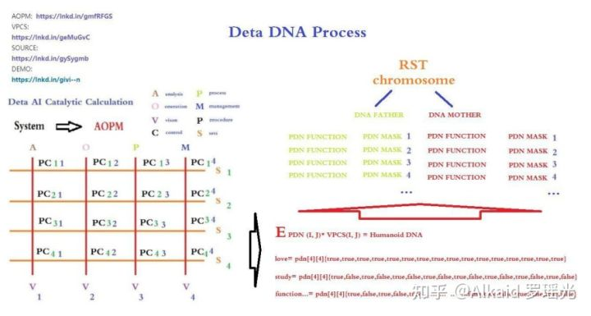

7 7 IDUC VPCS AOPM 3D Nero Cell and Its Applications, 3 维神经建模与应用 refer page 669

文件名肽化 refer page 671

**章节的著作权文件列表：**

1.罗瑶光. 《德塔自然语言图灵系统 V10.6.1》. 中华人民共和国国家版权局，软著登字第3951366号. 2019.

2.罗瑶光. 《Java数据分析算法引擎系统 V1.0.0》. 中华人民共和国国家版权局，软著登字第4584594号. 2014.

3.罗瑶光. 《德塔ETL人工智能可视化数据流分析引擎系统 V1.0.2》. 中华人民共和国国家版权局， 软著登字第4240558号. 2019.

4.罗瑶光. 《德塔 Socket流可编程数据库语言引擎系统 V1.0.0》. 中华人民共和国国家版权局，软著登字第4317518号. 2019.

5.罗瑶光. 《德塔数据结构变量快速转换 V1.0》. 中华人民共和国国家版权局，软著登字第4607950号. 2019.

6.罗瑶光. 《数据预测引擎系统 V1.0.0》. 中华人民共和国国家版权局，软著登字第5447819号. 2020.

7.罗瑶光，罗荣武. 《类人DNA与 神经元基于催化算子映射编码方式 V_1.2.2》. 中华人民共和国国家版权局，国作登字-2021-A-00097017. 2021.

**文件资源**

1 jar： [https://github.com/yaoguangluo/ChromosomeDNA/blob/main/BloomChromosome_V19001_20220108.jar](https://link.zhihu.com/?target=https%3A//github.com/yaoguangluo/ChromosomeDNA/blob/main/BloomChromosome_V19001_20220108.jar)

2 book 《DNA元基催化与肽计算 第四修订版 V00919》上下册

[https://github.com/yaoguangluo/ChromosomeDNA/tree/main/元基催化与肽计算第四修订版本整理](https://link.zhihu.com/?target=https%3A//github.com/yaoguangluo/ChromosomeDNA/tree/main/%25E5%2585%2583%25E5%259F%25BA%25E5%2582%25AC%25E5%258C%2596%25E4%25B8%258E%25E8%2582%25BD%25E8%25AE%25A1%25E7%25AE%2597%25E7%25AC%25AC%25E5%259B%259B%25E4%25BF%25AE%25E8%25AE%25A2%25E7%2589%2588%25E6%259C%25AC%25E6%2595%25B4%25E7%2590%2586)

3 函数在git的存储地址：demos

Github：[https://github.com/yaoguangluo/ChromosomeDNA/](https://link.zhihu.com/?target=https%3A//github.com/yaoguangluo/ChromosomeDNA/)

Coding：[公开仓库](https://link.zhihu.com/?target=https%3A//yaoguangluo.coding.net/public/YangLiaoJingHuaRuiJi/YangliaojingHuaruiji/)

Bitbucket：[Bitbucket](https://link.zhihu.com/?target=https%3A//bitbucket.org/luoyaoguang/yangliaojing/)

Gitee：[浏阳德塔软件开发有限公司GPL2.0开源大数据项目 (DetaChina) - Gitee.com](https://link.zhihu.com/?target=https%3A//gitee.com/DetaChina/)