File: EE599_lab8_Yao_Guo.zip

USCID: 2176023892

Email: yaog@usc.edu

Description:

Task 1:

Add a final two tests to testReadFrom() method that reads the fourth and fifth Members from our input file.

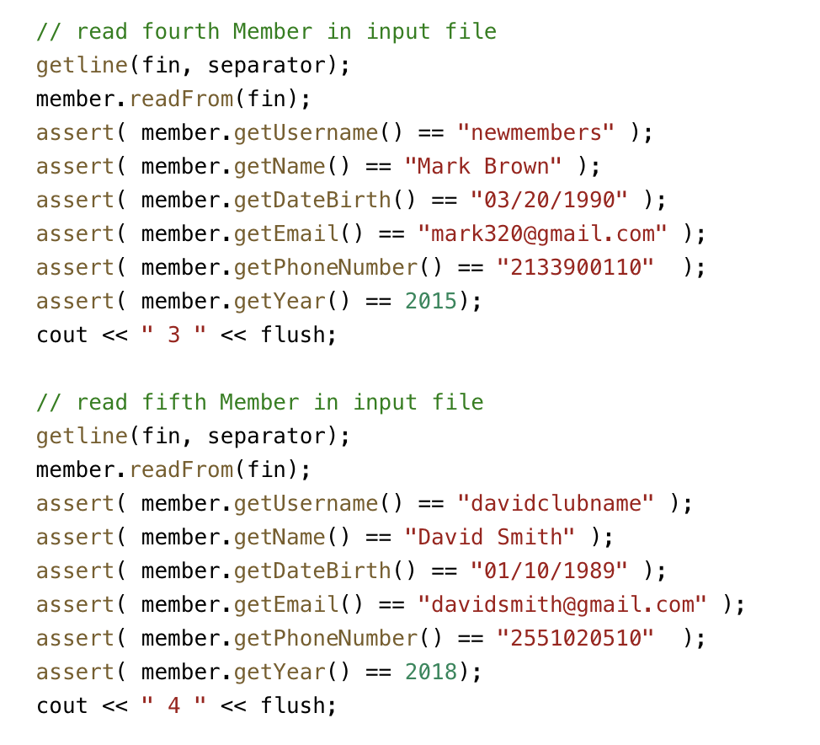

Task 2:

Using this TDD concept and this working model that we have designed to implement three Memberlist’s operations,**implement search by username, search by email and search by registered year.**

First, write the test code prototype:

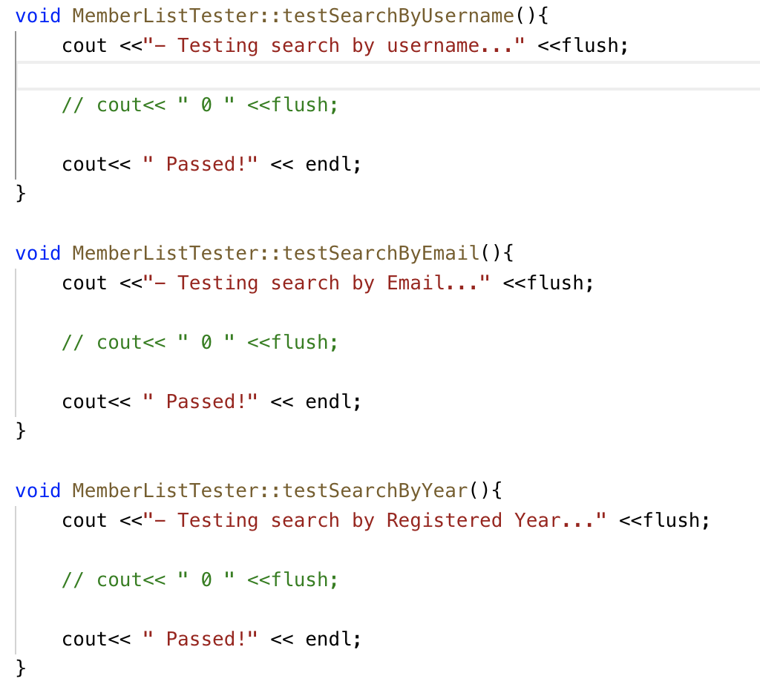

Also, in MemberList.cpp and MemberList.h, we add the corresponding function.

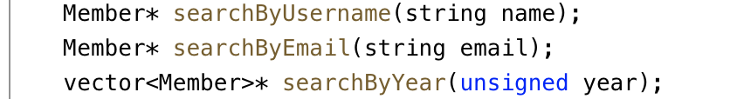

Then, we define our test code;

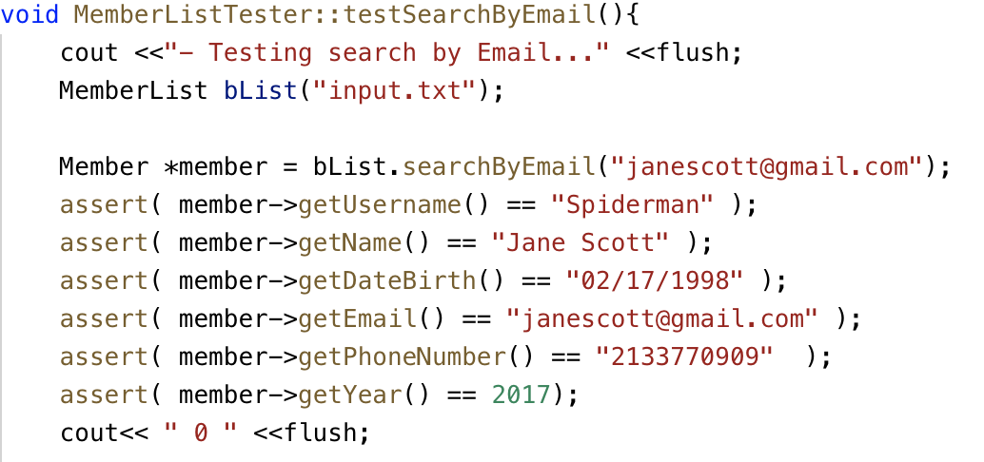

We need the searchByEmail to return a pointer of a member object, if we didn’t find the name, we return NULL.

Same as searchByUsername;

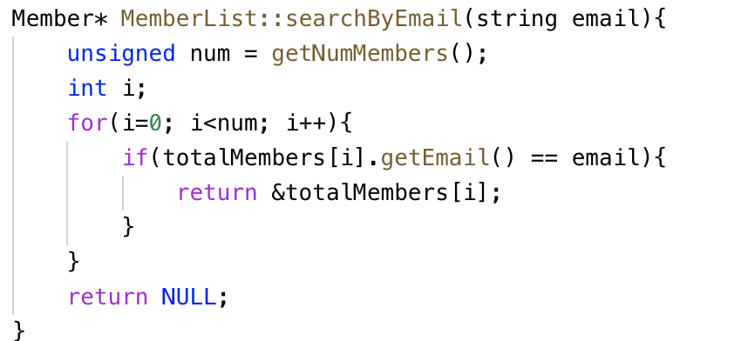

In this search function, if we find the matched object, we return the corresponding member object via pointer. We assume that everyone’s email and username is unique so that we only need to return the pointer of that member object.

However, test searchByYear is different. Because the year is not unique, so we need a container to save the matched year member objects, then we return a C++ reference.

To do so, the following is the test function and searchByYear function.

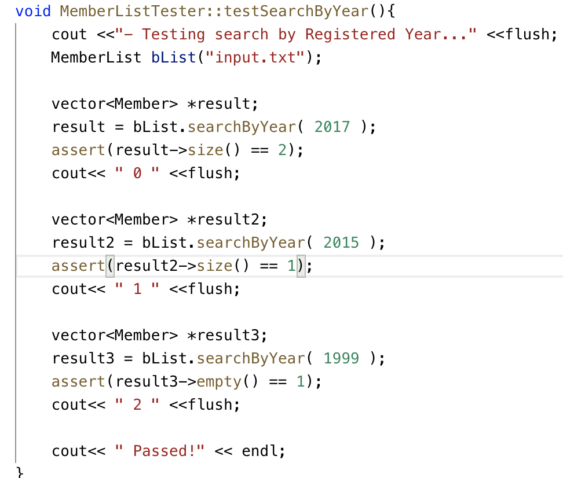

For convenience, we compare the vector size with the correct matched size.

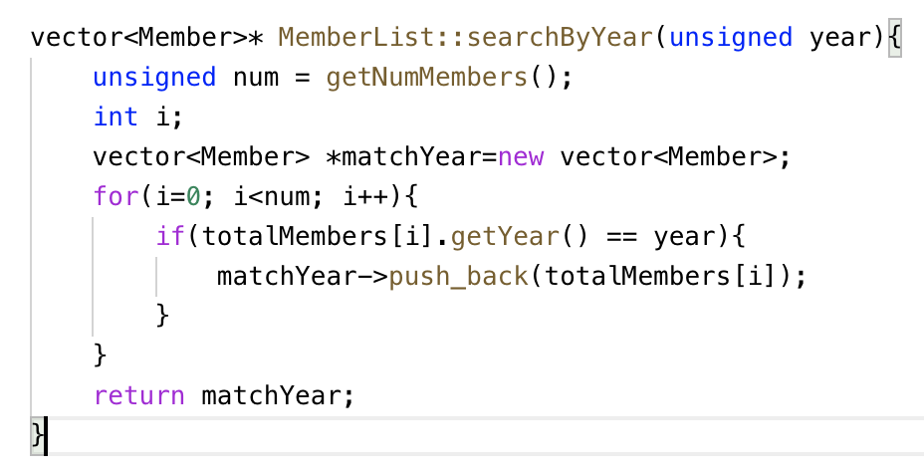

If the vector is empty, which indicate we didn’t find any matched year member objects.

After finishing these, we get our test output:

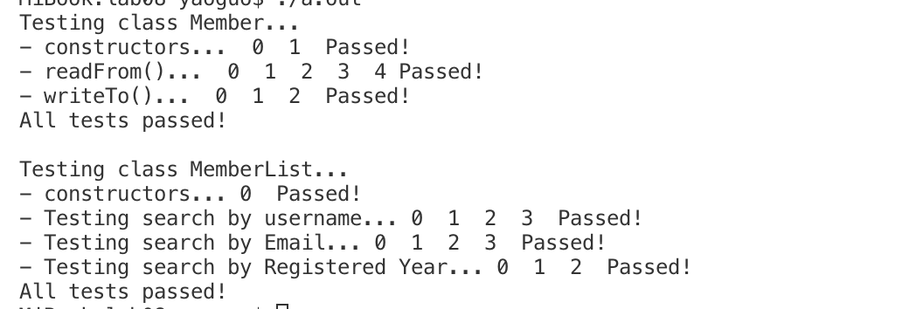

Reference:

This Lab8’s instruction.