# CICS Health check tool Introduction

This is the CICS Health check tool. Owned by IBM CICS China team.

Please keep it as IBM and DLUT confidential, do not share with any others out of this group!

It's written in Python, and as you can see in the folder.

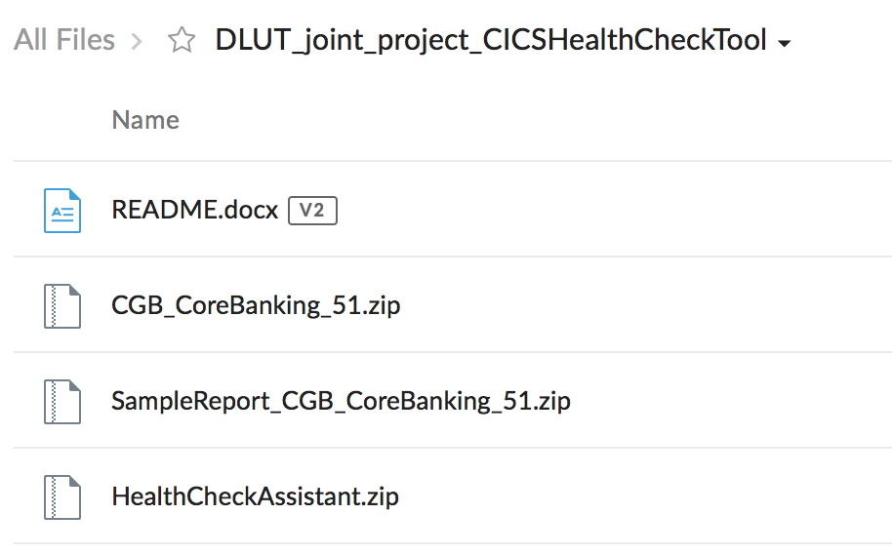

## HealthCheckAssistant.zip

HealthCheckAssistant.zip is the source code, you can unzip it and see below files:

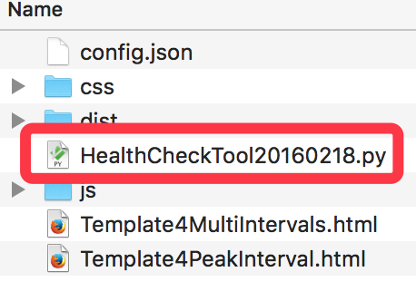

The file highlighted is the main source code.

It is currently works fine in Mac system, if you are using Windows system, there might be some minor changes need to take to build Python.(Good luck~~~)

Open the main source code file, and build it. You'll see a prompted window, and you need to pick up the CICS statistics input file, e.g. CGB_CoreBanking_51. After click "Open", you will need to wait for several minutes, as this file is quite big, around 2.4GB.

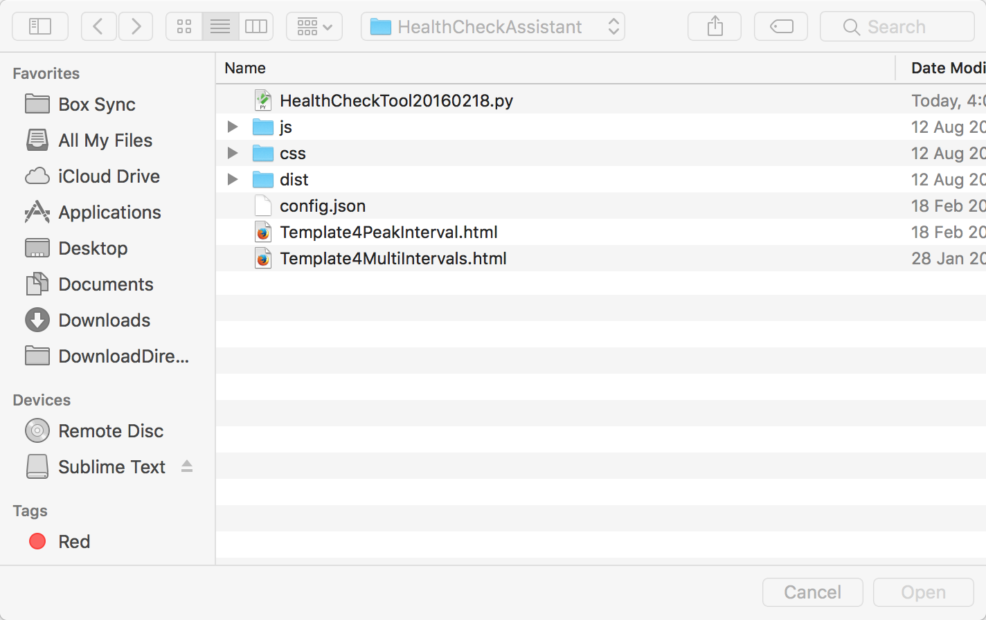

After the report is generated, you will see two html files in your browser, as below:

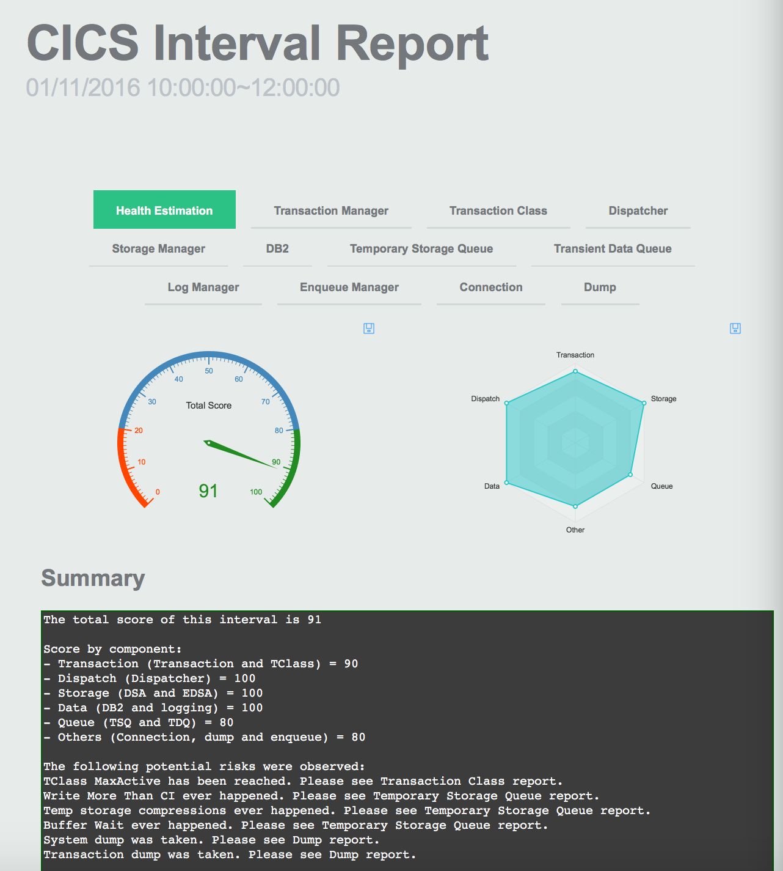

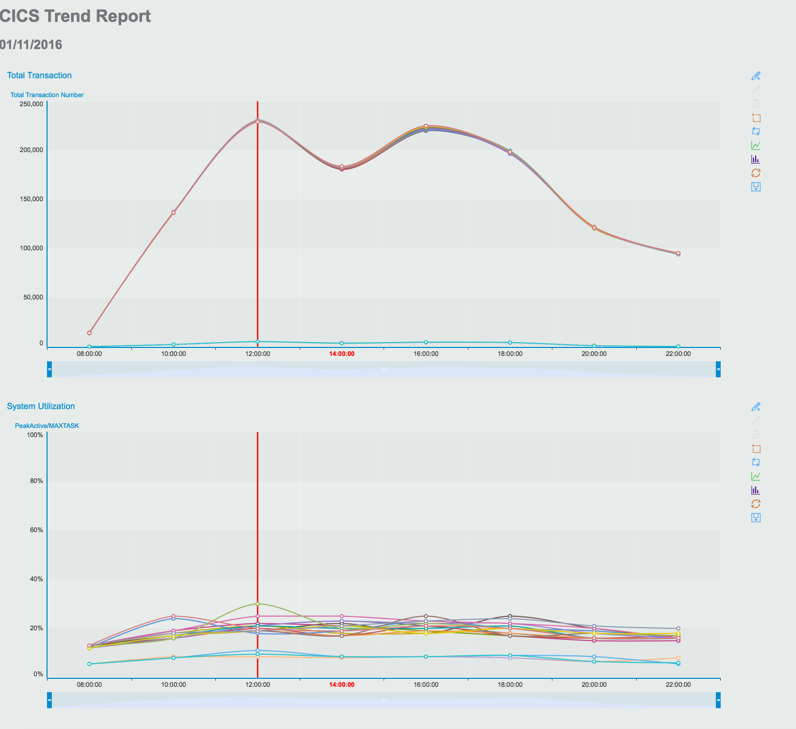

These are the analysis result of the CICS statistics file.

## CGB_CoreBanking_51.zip

This file is the CICS statistics input file. Unzip it and keep it for later usage.

## SampleReport_CGB_CoreBanking_51.zip

This file is the sample report I generated on my laptop, if you have problems to try it by yourself, take a look at the generated one first.

## Reference

浅谈CICS性能分析，两篇文章

<https://www.ibm.com/developerworks/community/blogs/cicschina/entry/%25e6%25b5%2585%25e8%25b0%2588cics%25e6%2580%25a7%25e8%2583%25bd%25e5%2588%2586%25e6%259e%2590_%25e4%25b9%258b_part1?lang=en>

<https://www.ibm.com/developerworks/community/blogs/cicschina/entry/%25e6%25b5%2585%25e8%25b0%2588cics%25e6%2580%25a7%25e8%2583%25bd%25e5%2588%2586%25e6%259e%2590_%25e4%25b9%258b_part_2?lang=en>

Introduction to CICS statistics

<https://www.ibm.com/support/knowledgecenter/SSGMCP_5.3.0/com.ibm.cics.ts.performance.doc/topics/dfht3_stats_intro.html>

不同类型statistics字段解释

https://www.ibm.com/support/knowledgecenter/en/SSGMCP_5.3.0/com.ibm.cics.ts.performance.doc/topics/dfht3_stats_bytype.html