1.设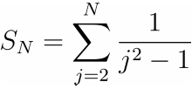, 其精确值为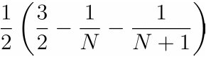.
- 编制按从大到小的顺序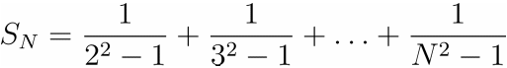, 计算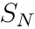的通用程序
- 编制按从小到大的顺序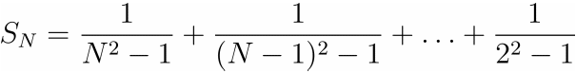, 计算的通用程序
- 按两种顺序分别计算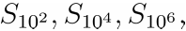并指出有效位数（编制程序时用单精度）
- 通过本上机题，你明白了什么
- 从大到小：
N = input('please input a number(N>=2)')
if(N < 2)
disp('wrong number')
else
S = 0;
for j = N:-1:2
S = S + 1/(j^2 -1);
end
disp('S:')
disp(S)
end
结果：
>>please input a number(N>=2)100
S:
0.7400495
>>please input a number(N>=2)100
S:
0.7498521
>>please input a number(N>=2)100
S:
0.7498521
- 从小到大：
N = input('please input a number(N>=2)')
if(N < 2)
disp('wrong number')
else
S = 0;
for j = 2:1:N
S = S + 1/(j^2 -1);
end
disp('S:')
disp(S)
End
结果：
>>please input a number(N>=2)100
S:
0.74004954
>>please input a number(N>=2)100
S:
0.7499
>>please input a number(N>=2)100
S:
0.74999905
- 有效位数非别为：7，7，7和8，4，8
- 计算顺序不同，结果不同，会出现大数吃小数
2.已知n次多项式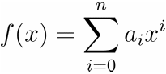，用秦九韶算法编写通用的程序计算函数在点x₀的值，并计算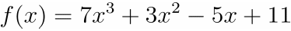在点23的值.
(提示：编写程序时，输入系数向量和点，输出结果，多项式的次数可以通过向量的长度来判断)
QinJiuZhao.m:
function value=QinJiuZhao(A,x)
n=length(A);
F=zeros(n);
F(1)=A(1);
for i=1:n-1
F(i+1)=F(i)*x+A(i+1);
end
value=F(n)
disp('真值')
polyval(A,x)
结果：
>> A=[7,3,-5,11]
>> x=23
>> value=qinjiushao(A,x)
value =
86652
真值
ans =
86652
value =
86652

3.分别用Gauss消元法和列主元消去法编程求解方程组Ax=b，其中
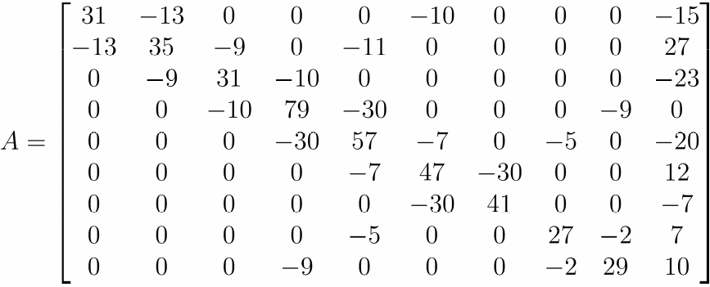，
.
（1）高斯消去法：
Gauss.m
function x=Gauss(A,b)
n=length(b);
l=cell(1,n-1);
l(:)={eye(n)};
U=A;
for i=1:n-1
for j=i+1:n
l{i}(j,i)=-U(j,i)/U(i,i);
end
U=l{i}*U;
end
disp(U);
%计算L和U
L=inv(l{1});
for i=2:n-1
L=L/l{i};
end
disp(L);
x=U\(L\b);
B=L*U;
y=det(B)
>>A=[31,-13,0,0,0,-10,0,0,0;-13,35,-9,0,-11,0,0,0,0;0,-9,31,-10,0,0,0,0,0;0,0,-10,79,-30,0,0,0,-9;0,0,0,-30,57,-7,0,-5,0;0,0,0,0,-7,47,-30,0,0;0,0,0,0,0,-30,41,0,0;0,0,0,0,-5,0,0,27,-2;0,0,0,-9,0,0,0,-2,29,10]
>>b=[-15;27;-23;0;-20;12;-7;7;10]
>>x=GaussMethod(A,b)
x =
-0.2892
0.3454
-0.7128
-0.2206
-0.4304
0.1543
-0.0578
0.2011
0.2902
- 高斯列主元消去法：
MainElementMethod.m:
function x=MainElementMethod(A,b)
n=length(b);
l=cell(1,n-1);
l(:)={eye(n)};
p=cell(1,n-1);
p(:)={eye(n)};
U=A;
for i=1:n-1
[Max,row]=max(U(i:n,i));
row=row+i-1;
mid=p{i}(row,:);
p{i}(row,:)=p{i}(i,:);
p{i}(i,:)=mid;
U=p{i}*U;
for j=i+1:n
l{i}(j,i)=-U(j,i)/Max;
end
U=l{i}*U;
end
disp(U);
L=eye(n);
for i=1:n-2
for j=i+1:n-1
l{i}=p{j}*l{i}/p{j};
end
L=l{i}*L;
end
L=inv(L*l{n-1});
disp(L);
P=eye(n);
for i=1:n-1
P=p{i}*P;
end
disp(P);
x=U\(L\P*b);
>>x=MainElementMethod(A,b)
>>x =
-0.2890
0.3459
-0.7123
-0.2193
-0.4296
0.1545
-0.0577
0.2018
0.2983

4.编程求解题3中矩阵的LU分解及列主元的LU分解（求出L,U和P），并用LU分解的方法求A的逆矩阵及A的行列式

（1）LU分解
L：
1.0000 0 0 0 0 0 0 0 0
-0.4194 1.0000 0 0 0 0 0 0 0
0 -0.3046 1.0000 0 0 0 0 0 0
0 0 -0.3539 1.0000 0 0 0 0 0
0 0 0 -0.3976 1.0000 0 0 0 0
0 0 0 0 -0.1569 1.0000 0 0 0
0 0 0 0 0 -0.6540 1.0000 0 0
0 0 0 0 -0.1121 -0.0175 -0.0246 1.0000 0
0 0 0 -0.1193 -0.0834 -0.0142 -0.0200 -0.0923 1.0000
U：
31.0000 -13.0000 0 0 0 -10.0000 0 0 0
0 29.5484 -9.0000 0 -11.0000 -4.1935 0 0 0
0 0 28.2587 -10.0000 -3.3504 -1.2773 0 0 0
0 0 0 75.4613 -31.1856 -0.4520 0 0 -9.0000
0 0 0 0 44.6020 -7.1797 0 -5.0000 -3.5780
0 0 0 0 0 45.8732 -30.0000 -0.7847 -0.5615
0 0 0 0 0 0 21.3807 -0.5132 -0.3672
0 0 0 0 0 0 0 26.4131 -2.4200
0 0 0 0 0 0 0 0 27.3895
（2）列主元LUP：
L:
1.0000 0 0 0 0 0 0 0 0
-0.4194 1.0000 0 0 0 0 0 0 0
0 -0.3046 1.0000 0 0 0 0 0 0
0 0 -0.3539 1.0000 0 0 0 0 0
0 0 0 -0.3976 1.0000 0 0 0 0
0 0 0 0 -0.1569 1.0000 0 0 0
0 0 0 0 0 -0.6540 1.0000 0 0
0 0 0 0 -0.1121 -0.0175 -0.0246 1.0000 0
0 0 0 -0.1193 -0.0730 -0.0126 -0.0177 -0.0923 1.0000
U：
31.0000 -13.0000 0 0 0 -10.0000 0 0 0
0 29.5484 -9.0000 0 -11.0000 -4.1935 0 0 0
0 0 28.2587 -10.0000 -3.3504 -1.2773 0 0 0
0 0 0 75.4613 -31.1856 -0.4520 0 0 -9.0000
0 0 0 0 44.6020 -7.1797 0 -5.0000 -3.5780
0 0 0 0 0 45.8732 -30.0000 -0.7847 -0.5615
0 0 0 0 0 0 21.3807 -0.5132 -0.3672
0 0 0 0 0 0 0 26.4131 -2.4200
0 0 0 0 0 0 0 0 27.3895
P:
1 0 0 0 0 0 0 0 0
0 1 0 0 0 0 0 0 0
0 0 1 0 0 0 0 0 0
0 0 0 1 0 0 0 0 0
0 0 0 0 1 0 0 0 0
0 0 0 0 0 1 0 0 0
0 0 0 0 0 0 1 0 0
0 0 0 0 0 0 0 1 0
0 0 0 0 0 0 0 0 1
A的逆矩阵：通过LU分解获得LU，LUX =I ，LY = I，UX= Y用高斯下去法解得Y和X
3.8952e-002 1.5961e-002 5.8083e-003 3.6407e-003 7.2823e-003 1.7585e-002 1.2867e-002 1.4396e-003 1.2292e-003
1.5863e-002 3.7828e-002 1.3083e-002 6.5129e-003 1.2133e-002 9.7237e-003 7.1149e-003 2.4090e-003 2.1874e-003
4.8698e-003 1.1613e-002 3.8126e-002 7.7386e-003 6.9188e-003 3.8776e-003 2.8373e-003 1.4666e-003 2.5028e-003
8.1938e-004 1.9539e-003 6.4150e-003 1.8128e-002 1.0528e-002 3.2693e-003 2.3922e-003 2.3786e-003 5.7899e-003
4.5601e-004 1.0874e-003 3.5701e-003 1.0089e-002 2.4339e-002 6.9837e-003 5.1100e-003 4.7635e-003 3.4595e-003
1.2743e-004 3.0388e-004 9.9769e-004 2.8193e-003 6.8017e-003 4.1874e-002 3.0639e-002 1.3312e-003 9.6677e-004
9.3244e-005 2.2235e-004 7.3002e-004 2.0629e-003 4.9768e-003 3.0639e-002 4.6809e-002 9.7403e-004 7.0739e-004
1.0381e-004 2.4755e-004 8.1276e-004 2.2967e-003 4.7736e-003 1.3755e-003 1.0064e-003 3.8169e-002 3.3451e-003
2.6145e-004 6.2346e-004 2.0469e-003 5.7843e-003 3.5966e-003 1.1095e-003 8.1180e-004 3.3705e-003 3.6510e-002
A的行列式：
y =6.1817e+013
5.编制程序求解矩阵A的cholesky分解，并用程序求解方程组Ax=b，其中
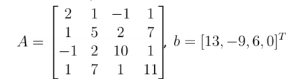,

Cholesky.m：
function [X]=cholesky(A,b)
[N,N]=size(A);
X=zeros(N,1);
Y=zeros(N,1);
for i=1:N
A(i,i)=sqrt(A(i,i)-A(i,1:i-1)*A(i,1:i-1)');
if A(i,i)==0
'A is singular. no unique solution'
break
end
for j=i+1:N
A(j,i)=(A(j,i)-A(j,1:i-1)*A(i,1:i-1)')/A(i,i);
end
end
A
b
for j=1:N
Y(j)=(b(j)-A(j,1:j-1)*Y(1:j-1))/A(j,j);
end
Y
A=A'
for k=N:-1:1
X(k)=(Y(k)-A(k,k+1:N)*X(k+1:N))/A(k,k);
end
>>A=[ 2,1,-1,1;1,5,2,7;-1,2,10,1;1,7,1,11;]
>> b=[13;-9;6;0]
>> [X]=cholesky(A,b)
L =
1.4142 0.7071 -0.7071 0.7071
0 2.1213 1.1785 3.0641
0 0 2.8480 -0.7413
0 0 0 0.7494
X =
26.4146
-65.3902
12.5122
38.0732
6. 用追赶法编制程序求解方程组Ax=b，其中
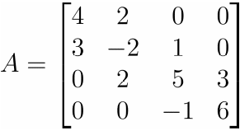，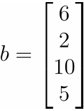
Trim.m
function s=Trim(A,bb)
n=size(A,1);
s=zeros(n,1);
b=diag(A);
a=diag(A,-1);
c=diag(A,1);
d=zeros(n,1);
u=zeros(n-1,1);
for i=1:n-1
d(1)=b(1);
u(i)=c(i)/d(i);
d(i+1)=b(i+1)-a(i)*u(i);
end
y=zeros(n,1);
y(1)=bb(1)/d(1);
for i=2:n
y(i)=(bb(i)-a(i-1)*y(i-1))/d(i);
end
s(n)=y(n);
for i=n-1:-1:1
s(i)=y(i)-u(i)*s(i+1);
end
end
结果：
>>A=[4,2,0,0;3,-2,1,0;0,2,5,3;0,0,-1,6]
>> b=[6;2;10;5]
>> s=Trim(A,b)
s =
1
1
1
1
7.已知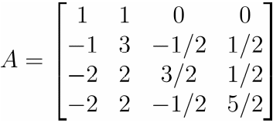.编程求解矩阵A的QR分解；
QRhouseholder.m:
function [Q,R]=QRhouseholder(A)
dim=size(A,1);
R=A;
Q=eye(dim);
for i=1:(dim-1)
x=R(i:dim,i);
y=[1;zeros(dim-i,1)];
Ht=householder(x,y);
H=blkdiag(eye(i-1),Ht);
Q=Q*H;
R=H*R;
end
End
Householder.m:
function [H,rho]=householder(x,y)
x=x(:);
y=y(:);
if length(x)~=length(y)
error('The Column Vectors X and Y Must Have The Same Length!');
end
rho=-sign(x(1))*norm(x)/norm(y);
y=rho*y;
v=(x-y)/norm(x-y);
I=eye(length(x));
H=I-2*v*v';
end
结果：
>>A=[1,1,0,0;-1,3,-0.5,0.5;-2,2,1.5,0.5;-2,2,-0.5,2.5]
>> [Q,R]=QRhouseholder(A)
Q =
-0.3162 -0.7071 -0.2582 0.5774
0.3162 -0.7071 0.2582 -0.5774
0.6325 -0.0000 -0.7746 -0.0000
0.6325 -0.0000 0.5164 0.5774
R =
-3.1623 3.1623 0.4743 2.0555
0.0000 -2.8284 0.3536 -0.3536
0.0000 0.0000 -1.5492 1.0328
-0.0000 -0.0000 -0.0000 1.1547
- 分别应用Jacobi迭代法和Gauss-Seidel迭代法求解如下方程组
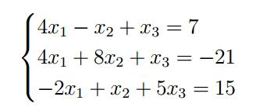
（1）Jacobi迭代法：
A = [4 1 1
4 8 1
2 1 5]
B = [7 21 15];
B = B.';
dim = size(A,1);
x = zeros(1,dim);
px = zeros(1,dim)
disp('x')
disp(x)
%disp('D')
%disp(D)
n = input('请输入迭代次数');
if n >= 1
for i = 1:1:n
for j = 1:1:dim
temp = 1/A(j,j)
px(j) = x(j) +temp *(B(j) -sum(A(j,1:dim).*x(1:dim)));
end
x = px;
end
else
disp('迭代次数不符合规范')
end
disp('x')
disp(x)

请输入迭代次数:10
x
0.6623 1.9949 2.3284
- Gauss-Seidel迭代法
A = [4 1 1
4 8 1
2 1 5]
B = [7 21 15];
B = B.';
dim = size(A,1);
x = zeros(1,dim);
disp('x')
disp(x)
%disp('D')
%disp(D)
n = input('please input number of iterations:');
for i = 1:1:n
for j = 1:1:dim
temp = 1/A(j,j)
x(j) = x(j) +temp *(B(j) -sum(A(j,1:dim).*x(1:dim)));
end
end
disp('x')
disp(x)

结果
x
0.6667 2.0000 2.3333
9分别应用Newton迭代法和割线法计算（1）非线性方程2x³-5x-1=0在[1,2]上的一个根；（2）在[-4,-3]上的一个根。
- Newton迭代法：
Newton1.m
function y=Newton1()
N =1000;
x0=1;
x1=2*x0^3-5*x0-1;
E=1.0e-6;
k=1;
while(norm(x1-x0)>=E&k<N)
x0=x1;
f=2*x0^3-5*x0-1;
f1=6*x0*x0-5;
if(f1~=0)
x1=x0-f/f1;
end
k=k+1;
end
fprintf('迭代的次数：%d\n',k);
fprintf('\n');
fprintf('方程的根：%.7f\n',x1);
结果：
>>y=Newton1()
迭代的次数：5
方程的根：1.5707963

function y=Newton2()
N =1000;
x0=-4;
x1=exp(x0)*sin(x0);
E=1.0e-6;
k=1;
while(k<N&((x1>-3)||(x1<-4)))
x0=x1;
f=exp(x0)*sin(x0);
f1=exp(x0)*sin(x0)+exp(x0)*cos(x0);
if(f1~=0)
x1=x0-f/f1;
end
k=k+1;
end
fprintf('迭代的次数：%d\n',k);
fprintf('\n');
fprintf('方程的根：%.7f\n',x1);
结果：
>> y=Newton2()
迭代的次数:k=8
方程的根:-3.1415926
- 割线法：
Gexian1.m
function x=Gexian1(f,x0,x1,e)
if nargin<4,e=1e-4;end
y=x0;x=x1;
while abs(x-y)>e
z=x-(feval(f,x)*(x-y))/(feval(f,x)-feval(f,y));
y=x;
x=z;
end
结果：
fun=inline('2*x^3-5*x^2-1')
>> Gexian1(fun,1,2,1e-6)
ans =
-3.1416
Gexian2.m
function x=Gexian2(f,x0,x1,e)
if nargin<4,e=1e-4;end
y=x0;x=x1;
while abs(x-y)>e
z=x-(feval(f,x)*(x-y))/(feval(f,x)-feval(f,y));
y=x;
x=z;
end
结果：
fun=inline('exp(x)*sin(x)')
Gexian2(fun,-4,-3,1e-6)
ans =
-3.1416
10采用二分法计算非线性方程xcosx-2=0查找区间为[-4,-2]
Erfen.m:
a = -4;
b = -2;
flag = 1;
accuracy = 0.0005;
while flag
if a >= b
disp('wrong number')
flag = 0;
else
fa = a*cos(a) -2;
fb = b * cos(b) -2;
if fa *fb > 0
disp('there is no adequate conditions to judge')
flag = 0
else
m = (a +b)/2;
if (b-a) < accuracy
flag = 0;
else
fm = m*cos(m) -2;
if fa* fm < 0
b = m;
else
a = m;
end
end

end
end
end
disp('root')
disp(m)
结果：
root
-2.4988e+000
11：已知函数，在[-5,5]上分别取2，1，1/2，为单位长度的等距节点作为插值节点，用Lagrange方法插值，并把原函数图与插值函数图比较，观察插值效果
Lagrange.m：
function y=lagrange(x0,y0,x)
n=length(x0);
m=length(x);
for i=1:m
z=x(i);
s=0.0;
for k=1:n
p=1.0;
for j=1:n
if j~=k
p=p*(z-x0(j))/(x0(k)-x0(j));
end
end
s=p*y0(k)+s;
end
y(i)=s;
end

- 间距为2：
>> x=[-5:2:5];
>> y=1./(1+x.^2);
>> x0=[-5:0.2:5];
>> y0=lagrange(x,y,x0);
>> y1=1./(1+x0.^2);
>> plot(x0,y0,'b')
>> hold on
>> plot(x0,y1,'r')

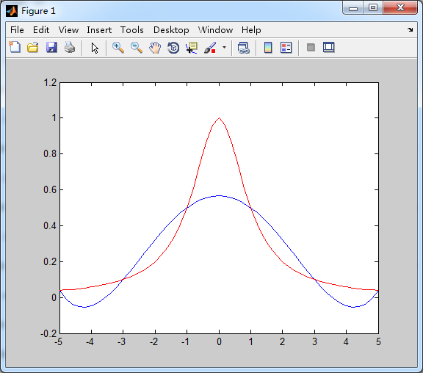
- 间距为1：
>> x=[-5:1:5];
>> y=1./(1+x.^2);
>> x0=[-5:0.1:5];
>> y0=lagrange(x,y,x0);
>> y1=1./(1+x0.^2);
>> plot(x0,y0,'b')
>> hold on
>> plot(x0,y1,'r')
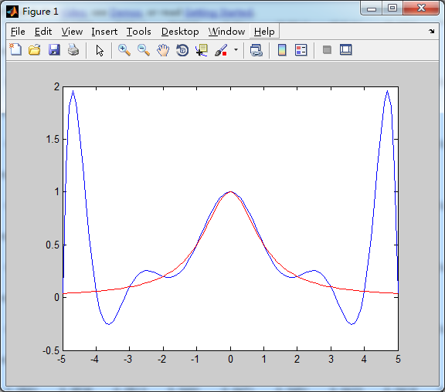

- 间距为0.5：
>> x=[-5:0.5:5];
>> y=1./(1+x.^2);
>> x0=[-5:0.1:5];
>> y0=lagrange(x,y,x0);
>> y1=1./(1+x0.^2);
>> plot(x0,y0,'b')
>> hold on
>> plot(x0,y1,'r')
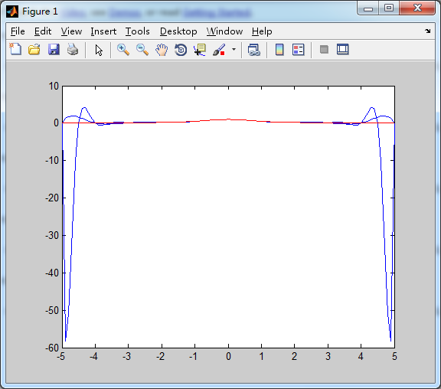

- 用三次样条插值上题中的插值节点，并画图比较插值效果。（提示：原函数在两个端点-5,5的导数值可作为边界条件）
tripleSpindleMethod.m:
function s=tripleSpindleMethod(X,Y,f0,fn,type)
syms x;
n=length(X);
h=[];
l=[];
u=[];
g=[];
m=[];
A1=2*eye(n-2);
A2=2*eye(n);
a11=zeros(1,n-3);
a12=zeros(1,n-3);
a21=zeros(1,n-1);
a22=zeros(1,n-1);
b1=zeros(n-2,1);
b2=zeros(n,1);
for k=1:n-1
h(k)=X(k+1)-X(k);
end
for k=2:n-1
l(k-1)=h(k)/(h(k)+h(k-1));
u(k-1)=h(k-1)/(h(k)+h(k-1));
g(k-1)=3*(u(k-1)*(Y(k+1)-Y(k))/h(k)+l(k-1)*(Y(k)-Y(k-1))/h(k-1));
end
switch type
case 1
for k=1:n-3
a11(k)=u(k);
a12(k)=l(k);
end
A1=A1+diag(a11,1)+diag(a12,-1);
for k=1:n-2
b1(k)=g(k);
end
b1(1)=b1(1)-l(1)*f0;
[L,U,P]=lu(A1);
z=U\(L\P*b1);
m(1)=f0;
m(n)=fn;
for k=1:n-2
m(k+1)=z(k);
end
case 2
a21(1)=1;
a22(n-1)=1;
for k=1:n-2
a21(k+1)=u(k);
a22(k)=l(k);
end
A2=A2+diag(a21,1)+diag(a22,-1);
b2(1)=3*(Y(2)-Y(1))/h(1)-0.5*h(1)*f0;
b2(n)=3*(Y(n)-Y(n-1))/h(n-1)+0.5*h(n-1)*fn;
for k=1:n-2
b2(k+1)=g(k);
end
[L,U,P]=lu(A2);
m=(U\(L\P*b2))';
otherwise
disp('type值只能为1或2');
return
end
p1(1:n-1)=x;
p2(1:n-1)=x;
p3(1:n-1)=x;
p4(1:n-1)=x;
s(1:n-1)=x;
for k=1:n-1
p1(k)=(1+2*(x-X(k))/h(k))*((x-X(k+1))/h(k))^2*Y(k);
p2(k)=(1-2*(x-X(k+1))/h(k))*((x-X(k))/h(k))^2*Y(k+1);
p3(k)=(x-X(k))*((x-X(k+1))/h(k))^2*m(k);
p4(k)=(x-X(k+1))*((x-X(k))/h(k))^2*m(k+1);
s(k)=p1(k)+p2(k)+p3(k)+p4(k);
s(k)=simple(s(k));
End
PiecewiseFunction.m:
function y=PiecewiseFunction(X1,X,s)
y=[];
%计算X,s长度
n=length(X1);
m=length(s);
%计算函数值
for i=1:n
for j=1:m
if (X(j)<=X1(i))&&(X1(i)<=X(j+1))
y(i)=subs(s(j),X1(i));
break
end
end
end

（1）间距为2：
>> x=[-5:2:5];
>> y=1./(1+x.^2)
>> s=tripleSpindleMethod(x,y,0.0000255182,-0.0000255182,1)
>> X=-5:0.1:5;
>> Y=PiecewiseFunction(X,x,s);
>> plot(x,y,'r')
>> hold on
>> plot(X,Y,'*')
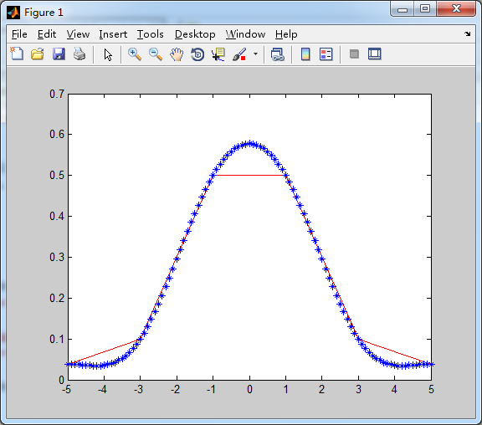
（2）间距为1：
>> x=[-5:1:5];
>> y=1./(1+x.^2)
>> s=tripleSpindleMethod(x,y,0.0000255182,-0.0000255182,1)
>> X=-5:0.1:5;
>> Y=PiecewiseFunction(X,x,s);
>> plot(x,y,'r')
>> hold on
>> plot(X,Y,'*')
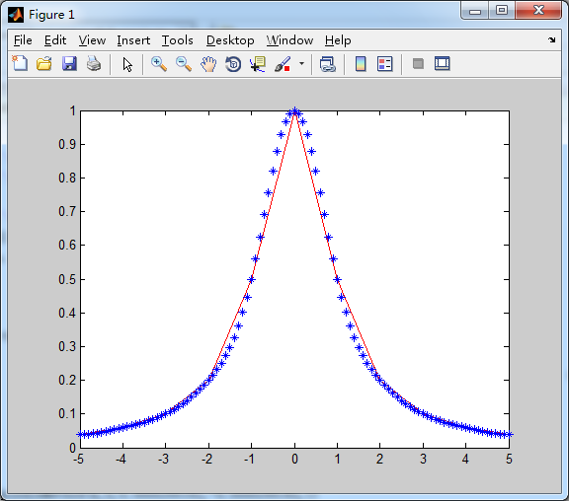
（3）间距为0.5：
>> x=[-5:0.5:5];
>> y=1./(1+x.^2)
>> s=tripleSpindleMethod(x,y,0.0000255182,-0.0000255182,1)
>> X=-5:0.05:5;
>> Y=PiecewiseFunction(X,x,s);
>> plot(x,y,'r')
>> hold on
>> plot(X,Y,'*')
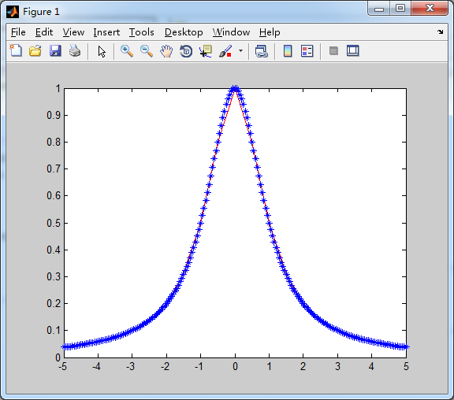
13已知f(x)=x²sinx，分别用复合梯形法和复合Simpson公式计算积分，区间分为20，40，80，200个小区间，并计算其精确值，比较计算精度情况。
#include "stdafx.h"
#include <iostream>
#include <math.h>

#define pai 3.1415926535

double a=-2.0,b=2.0;
double x,h;
double Sim(int n)
{
double s=0.0,x1,x2,x3;
h=(b-a)/n;
for(int i=0;i<n;i++)
{ x1=a+i*h;
x2=a+(i+1)*h;
x3=(x1+x2)/2.0;
s+=h/6.0*(sin(x1)*x1*x1+sin(x2)*x2*x2+4*sin(x3)*x3*x3);
}
return s;
}
double Ti(int n)
{
double f=0.0,x1,x2;
h=(b-a)/n;
for(int i=0;i<n;i++)
{ x1=a+i*h;
x2=a+(i+1)*h;
f+=h/2.0*(sin(x1)*x1*x1+sin(x2)*x2*x2);
}
return f;
}
int main()
{
int n;
double f,s;
cout<<"输入区间数：";
while(cin>>n)
{
s = Sim(n);
f = Ti(n);

cout<<"复化梯形法结果为："<<f<<endl;
cout<<"复化Simpson法近似结果为："<<s<<endl<<"输入区间数：";
}
return 0;
}
实验结果为：
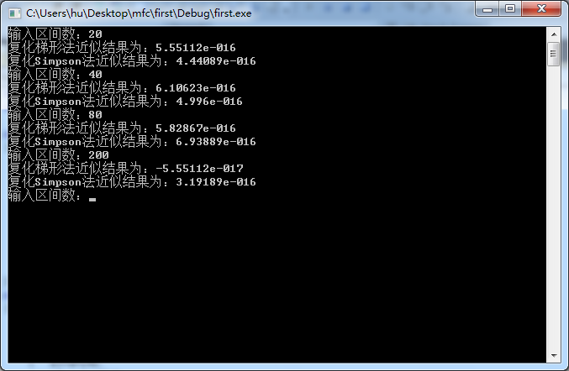

14.用2点，3点和5点Gauss积分法分别计算定积分，并与真值作比较。
guass.m
function [ql,Ak,xk]=guass(fun,a,b,n,tol)
syms x
p=sym2poly(diff((x^2-1)^(n+1),n+1))/(2^n*factorial(n));
tk=roots(p);
Ak=zeros(n+1,1);
for i=1:n+1
xkt=tk;
xkt(i)=[];
pn=poly(xkt);
fp=@(x)polyval(pn,x)/polyval(pn,tk(i));
Ak(i)=quadl(fp,-1,1,tol);
end
xk=(b-a)/2*tk+(b+a)/2;
fun=fcnchk(fun,'vectorize');
fx=fun(xk)*(b-a)/2;
ql=sum(Ak.*fx);
disp('ql')
disp(ql)
end
（1）2点：
>> fun = @(x)(x.^2 .* cos(x));
>> clear
>> fun = @(x)(x.^2 .* cos(x));
>> a = 0;
>> b = pi/2;
>> n = 1;
>> tol = 0.00005;
>> [ql,Ak,xk]=guass(fun,a,b,n,tol);
ql
0.4746
（2）3点
>> fun = @(x)(x.^2 .* cos(x));
>> clear
>> fun = @(x)(x.^2 .* cos(x));
>> a = 0;
>> b = pi/2;
>> n=2
>> tol = 0.00005;
>> [ql,Ak,xk]=guass(fun,a,b,n,tol);
ql
0.4672

（3）5点
>> fun = @(x)(x.^2 .* cos(x));
>> clear
>> fun = @(x)(x.^2 .* cos(x));
>> a = 0;
>> b = pi/2;
>> n=4
>> tol = 0.00005;
>> [ql,Ak,xk]=guass(fun,a,b,n,tol);
ql
0.4674
- 真实值
>> quadl(fun, a,b)

ans =

0.4674

- 已知常微分方程,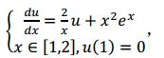分别用Euler法，改进的Euler法，Runge-Kutta法去求解该方程，步长选为0.1,0.05,0.01.画图观察求解效果。
- Euler法：
a = 1;
b = 2;
u(1) = 0;
len = input('length of step')
n = input('please a number')
N = (b-a)/len;
if n < 0 || n > N
disp('wrong number')
else
for j = 1:1:n
x(j) = a + (j-1) * len;
u(j+1) = u(j) + (2/x(j))* u(j) + x(j)^2*exp(x(j));
y(j+1) = u(j+1);
end
end
disp('len(i)')
disp(len)
disp('u')
disp(u(n+1))
plot(x,u(1:n))

>>length of step0.1
>>please a number10
len(i)
1.0000e-001
u
1.2260e+004
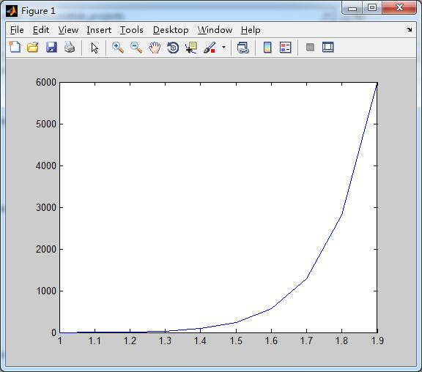

>>length of step0.05
>>please a number20
len(i)
5.0000e-002
u
5.8700e+007

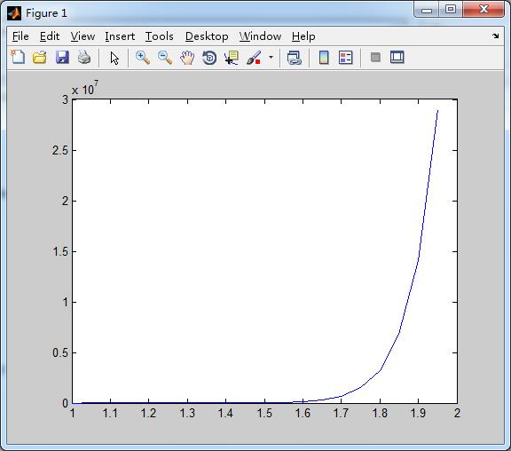

>>length of step0.01
>>please a number100
len(i)
0.9720e-002
u
4.0013e+034
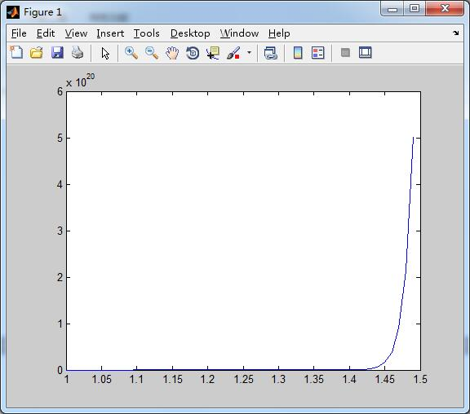

- 改进的Euler法：
a = 1;
b = 2;

u(1) = 0;
len = input('length of step')
n = input('please a number')
N = (b-a)/len;
if n < 0 || n > N
disp('wrong number')
else
for j = 1:1:n
x(j) = a + (j-1) * len;
u_ = u(j) + (2/x(j))* u(j) + x(j)^2*exp(x(j));
u(j+1) = u(j) + (len/2) * ((2/x(j))* u(j) + x(j)^2*exp(x(j)) + (2/(a + j * len))* u_ + (a + j * len)^2*exp((a + j * len)));
y(j+1) = u(j+1);
end
end
disp('len(i)')
disp(len)
disp('u')
disp(u(n+1))
plot(x,u(1:n))

>>length of step0.1
>>please a number10
len(i)
1.0000e-001
u
3.4619e+001
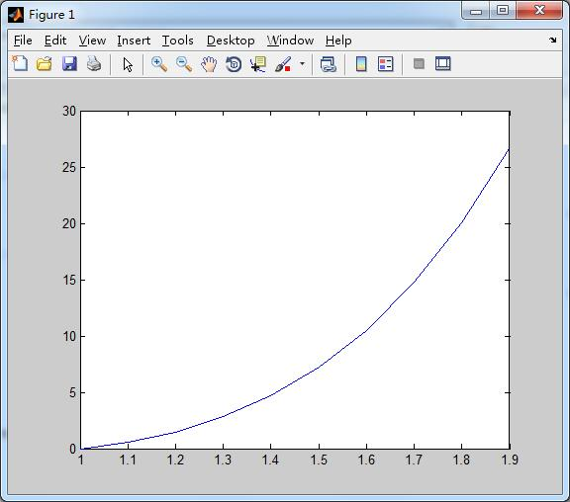

>>length of step0.05
>>please a number20
len(i)
5.0000e-002
u
3.8950e+001
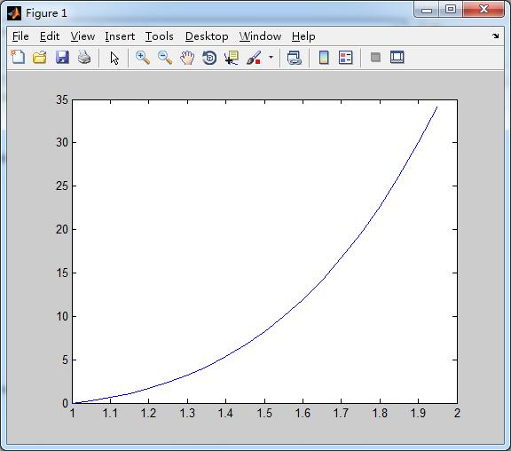

>>length of step0.01
>>please a number100
len(i)
1.0000e-002
u
4.3410e+001
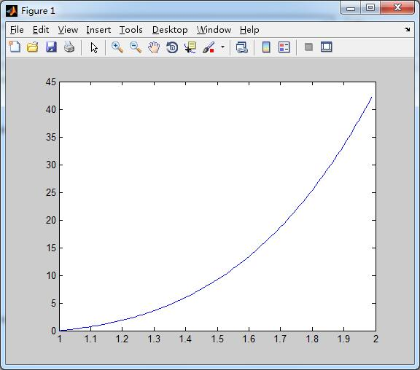

- Runge-Kutta法：
step = input('please input lenght of step')
n= input('please input number of iterations')

a = 1;
b = 2;
N = (b-a)/step;
x = zeros(1,n);
x(1) = a;
u(1) = 0;
if n<0 || n > N
disp('wrong number')
else
for i = 1:1:n
x(i) = a + (i-1) * step;
%tn,un
k1 = (2/x(i))* u(i) + x(i)^2 * exp(x(i));
%tn + (1/2)*h, un + (1/2)*h*k1
k2 = (2/(x(i)+ 1/2 * step))*(u(i) + (1/2)*step*k1) + (x(i)+ 1/2 * step)^2 * exp((x(i)+ 1/2 * step));
%tn+(1/2)*h,un + (1/2)*h*k2
k3 = (2/(x(i)+(1/2)* step))*(u(i) + (1/2)*step*k2) + (x(i)+(1/2)* step)^2 *exp((x(i)+(1/2)* step));
%tn+ h, un + h*k3
k4 = (2/(x(i)+ step))*(u(i)+ step *k3) + (x(i)+ step)^2 * exp((x(i)+ step));
u(i+1) = u(i) + (step/6) * (k1 + 2 *k2 + 2 * k3 + k4);
end
end
disp('u')
disp(u(n+1))
plot(x,u(1:n))
>>
please input lenght of step0.1
please input number of iterations10
u
1.8682e+001
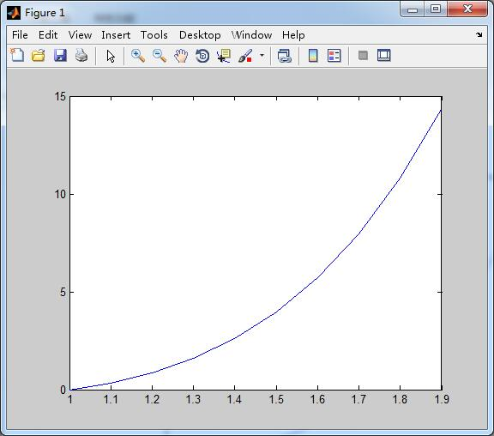

please input lenght of step0.05
please input number of iterations20
u
1.8631e+001
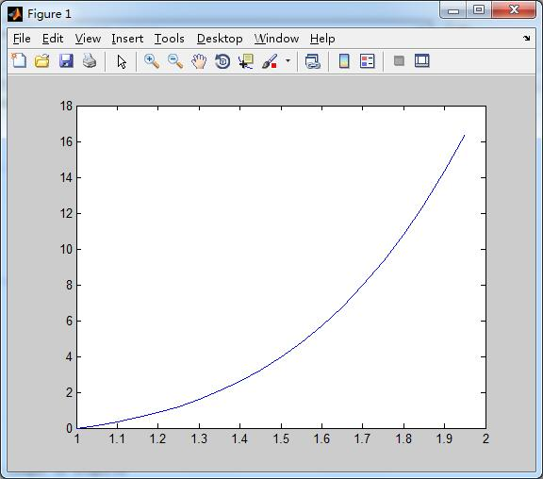

please input lenght of step0.01
please input number of iterations100
u
1.8631e+001
