# Step 1 – Install Sysmon:

Run this command in elevated powershell in the folder where the exe and xml files are:

sysmon.exe -accepteula -i IncludeAllExcludeCommon.xml

Once installed and started, open Windows Event Viewer

Navigate to Applications and Services > Microsoft > Windows > Sysmon

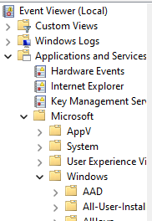

Right-click Operational and select properties

Change default logging to “Archive the log when full, do not overwrite events”

Select ‘OK’ and close the events viewer

# Step 2 – Train machine:

Train the model using the command ‘python RAD.py’. This will take in all Sysmon archive files and run them through the application. Note – The application automatically deletes the files after analyzing them. To avoid this, use the ‘-s’ option.



# Step 3 – Generate a prediction:

Once the model is trained using as many log files as wanted, generate a prediction of which events are anomalies by running the application with the ‘-p’ option.

