**Mr. Drilling Game Development Technical Document**

**Ⅰ The Demand Background**

Detailed requirements for the requirements document refer to Group Projects (1).pdf

**Ⅱ The Development Environment**

**PyCharm——python IDE**

First, PyCharm has the features of a general IDE, such as debugging, syntax highlighting, Project management, code jumping, smart prompting, auto-completion, unit testing, version control.

In addition, PyCharm also provides some great features for Django development, while supporting Google App Engine, and even more cool, PyCharm supports IronPython.

**Ⅲ The Development Background Part**

1. **Image engine——Pygame**

Contains images and sounds. Built on SDL, it allows real-time video game development without being tied to low-level languages such as machine language and assembly language.

* 1. **pygame graphics interface** Images can be read and saved using the pygame.image module. Use pygame.image.load to read the image file.

**Support format：JPEG、PNG、GIF、BMP、PCX、TGA、TIF、LBM,PBM、XPM**

* 1. **pygame** **Drawing** In addition to blit the pre-drawn picture to the Surface, you can also draw some simple graphics on the Surface, such as points, lines, squares, circles, etc. This feature is mainly done by the pygame.draw
* module.surface = pygame.display.set_mode((640, 480))

// Draw the canvas

* pygame.draw.rect(surface, (0,0,255), (100, 200, 100, 100))

//Draw a rectangle

* 1. **pygame Write** Need to import the pygame.font module and initialize it
* import pygame.fontpygame.font.init()

1. **library function**

**2.1 sys：**Sys contains data and methods for interacting with the Python interpreter.

**2.2 pygame**：

* **pygame.locals**

Includes names (variables) used within your own module scope. Includes names for event types, keys, and video modes.

* **pygame.sprite**

Group is used as a container for sprite objects. Calling the update object of the group object will automatically call the update method of all sprite objects.

* **pygame.display**

Includes functions to handle the way pygame is displayed. Includes normal window and full screen mode. Some common methods in pygame.display are as follows:

**flip：**Update the display.

**update：**Use update when part of the update.

**2.3 json**：Json (JavaScript Object Notation) It is a lightweight data exchange format with many advantages such as simple data format, easy to read and write, and so on. Many mainstream programming languages use it for data transmission at the front and back end, greatly simplifying the development workload of the server and client.

* **json.loads**

Used to decode JSON data. This function returns the data type of the Python field.

* **json.dumps**

Used to encode Python objects into JSON strings.

* 1. **random**：This method returns a randomly generated real number.

**Ⅳ Game flow**

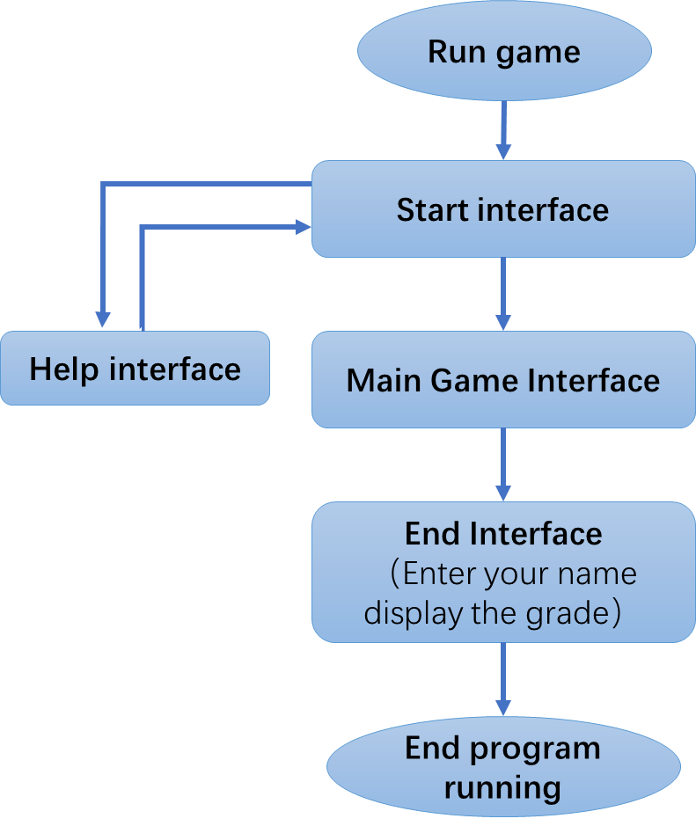

**Ⅴ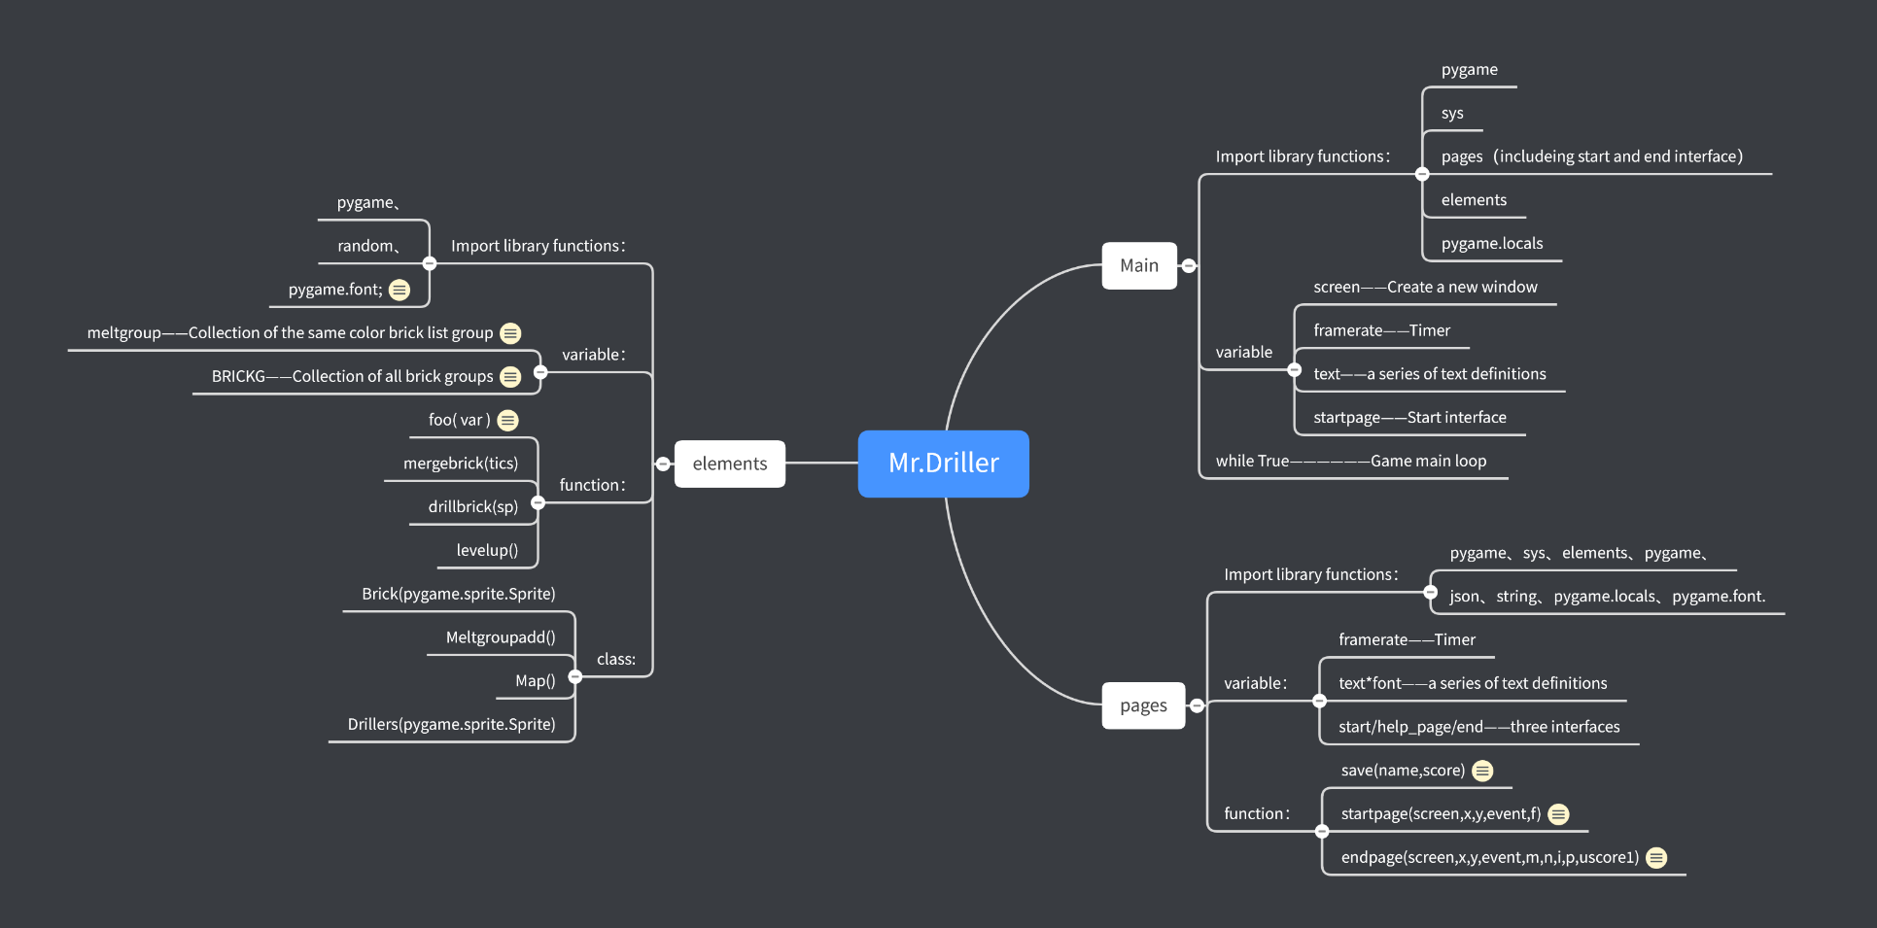 Game code structure framework**

**Ps：There is also an original picture outside the document.**

**Ⅵ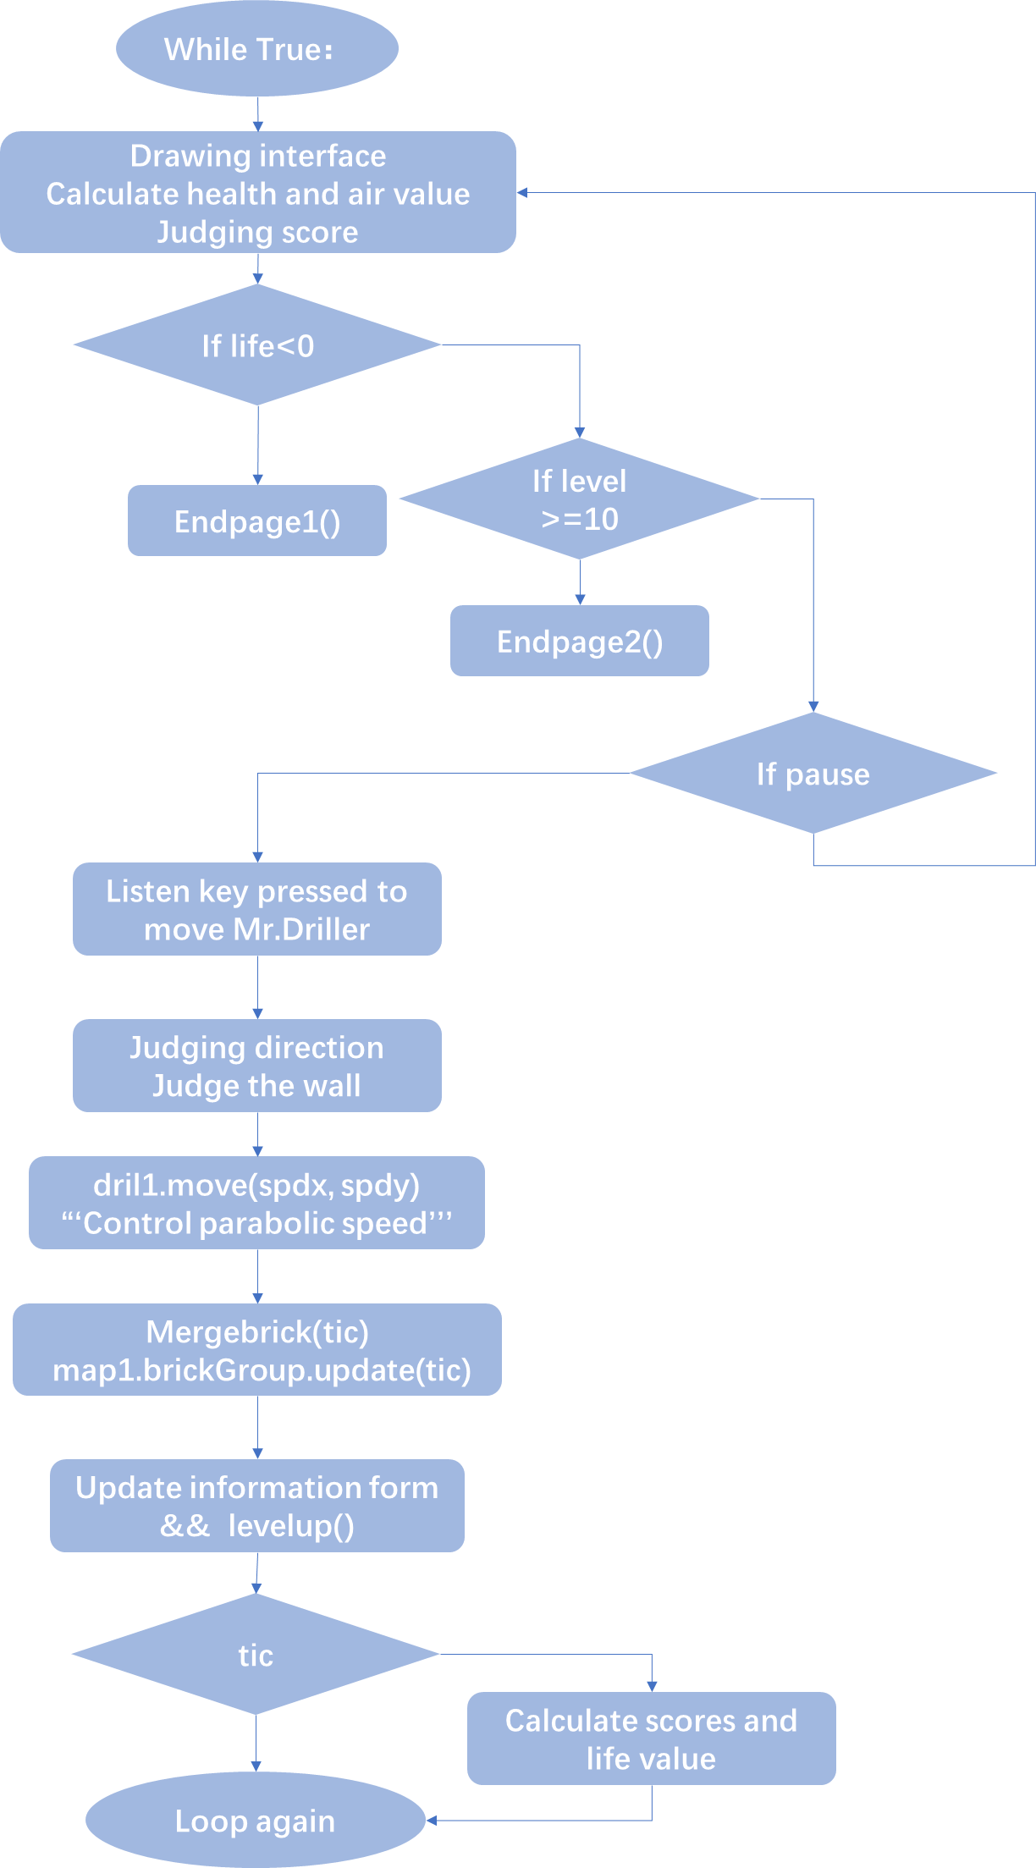 Main function flow chart**

**Ⅶ Important functions introduction**

The following introduction to functions is to classify functions according to different documents.

1. **elements.py**
   1. **save**(name,score)——Save game data (including player name, grade) to a file for storage.
   2. **startpage**(screen,x,y,event,f)——Generate a start interface
   3. **endpage**(screen,x,y,event,m,n,i,p,uscore1)——Receive the score data, apply for the name, complete the grade, and generate the end screen.
2. **pages.py**

2.1 **foo**( var )：​Return the image address according to the var value.

2.2 **Brick:**

* + 1. **Brick.init:** Implement brick initialization
    2. **Brick.fall:** Achieve fall

2.2.3 **Brick.melt:** Grouping adjacent bricks of the same color

* 1. **Meltgroupadd**
     1. **Meltgroupadd.__init__:**  Create a new sprite group

2.3.2 **Meltgroupadd.aadd:** Add a brick to the group

2.4 **Map**

2.4.1 **Map.__init__:**初始化全部图形

2.4.2 **Map.changemap:** 升级换地图

* 1. **Drillers**(pygame.sprite.Sprite)
     1. **Move:** Achieve character movement
     2. **Fall:** Realize the gravity drop of the character
     3. **Updata:** Update character status
  2. **mergebrick**(tics)：Realize the elimination and fusion of brick groups
  3. **drillbrick**(sp)：Remove the bricks that have been dug
  4. **levelup**()：High rise