Team13 Microblog Design Documentation

Team 13

Database Management System
Dr. Weifeng Su
May 24, 2011
Beijing Normal University
Hong Kong Baptist University, United International College

Contents

DOCUMENT MANAGEMENT 3
1.1 The labour of division 3
OVERVIEW 4
2 DEVELOPMENT TECHNOLOGIES AND TOOLS 5
2.1 Technologies 5
2.2 Tools 5
3 SYSTEM ARCHITECTURE 6
4 The details are followed. 6
4.1 Front-end Architecture 6
4.2 Java Server Architecture 7
4.3 Database Relation Scheme 7
DETAILED SYSTEM DESIGN 8
4.4 User Interface 9
4.5 Java Server UML Draft 13
4.6 Database Tables Implementation 13
4.7 SQL commands 14
4.7.1 ICommentDAOImpl 14
4.7.2 ITweetDAOImpl 15
4.7.3 IUserDAOImpl 16
4.7.4 IUserRelatioDAOImpl 16

DOCUMENT MANAGEMENT

The labour of division

Role | Name
UI Designers | 吕耀佳
Java Server Designers | 吕耀佳
Database System Designers | 黎子翔 徐畅
Documentation Writer | 徐畅

OVERVIEW
Microblog is a broadcast medium in the form of blogging. A microblog differs from a traditional blog in that its content is typically much smaller, in both actual size and aggregate file size. A microblog entry could consist of nothing but a short sentence fragment.
This project, which imitates the functions of the famous microblog website www.weibo.com, provides basic functionalities for users such as posting a twitter, reading the twitters from the people who you follow and forwarding some twitters what you are interested in.

DEVELOPMENT TECHNOLOGIES AND TOOLS

Technologies
- HTML
- CSS
- JavaScript
- JSP
- Java Servlets
- SQL

Tools
- Dreamweaver
- Firefox 4 with Firebug
- Eclipse with WPT (Version: Helios, 3.6.2)
- JDK (Version: 6)
- Tomcat (Version: 6.0.32)
- MySQL
- Opensource projects

SYSTEM ARCHITECTURE

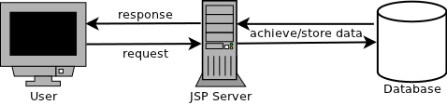
Overview of The Microblog Sytstem

This system is a simple web application using Java Web techniques. Commonly, User do requests to the server through the web site, and the JSP server gains the requests and process it, mainly do interactions such like store and achieve with the database, then responses the result to the user through the web site.
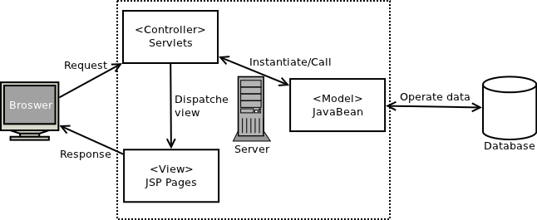
MVC Diagram

More specifically, the system is designed by using the MVC model. In this architecture, the system is divided into 3 parts: Model, View and Controller.
The View consists of JSP pages, which are only provides the UI of front-end of this system. The User send request through the View and the Controller, which is consist of Java Servlets, gain the request and deal with it by instantiate the Model. The Model consists of JavaBeans, provide the function of operating the data and return the result to the Controller. Then the Controller sends response to the View and show the result to the user by JSP pages.

The details are followed.

Front-end Architecture

Site Diagram
Level 1: Consist of index page and sign up page, which is the door of this web site. After login successfully, the user moves to the level 2.

Level 2: Consist of Home page, Profile, My Page, View followers, View people who the user follows, Settings and admin. Pages in this layout provide functions of overview and global setting to the user.

Level 3: Consist of twitters that users post.

Java Server Architecture
Package Dependency Diagram

hk.edu.hk.weibo.model.dao:
Contains interfaces for data operating classes. The methods of each table depend on the design of database.

hk.edu.hk.cosns.model.dao.impl:
Contains the implementation of the interfaces define in the package hk.edu.hk.weibo.model.dao.

hk.edu.hk.cosns.model.dbc:
Contains a database connection class which use to connect the database. This class will be instantiated by the package above and every time when the request needs to operate the database.

hk.edu.hk.weibo.model.vo:
It contains classes which are defined according to entities in Database. Each table in database has one corresponding class in this package. The classes will be instantiated by the classes in the hk.edu.hk.weibo.model.dao.impl and hk.edu.hk.weibos.controller.servlets.

hk.edu.hk.weibo.controller.servlets:
Contains method to deal with user's request and send server's response to user by instantiated corresponding classes in the packaged mentioned above.

Database Relation Scheme
User (UID, Email, Password, UName, Avatar, Gendar, City, FollowingCount, Follo werCount, TweetCount)
UserRelation (UID, FollowingUID)
Tweets (TweetsID, InsertUID, Date, Content, IsRetweet, RetweetID, RetweetCount, CommentCount)
Comments (CommentsID, TweetsID, InsertUID, Date, Content, TweetAuthorUID)

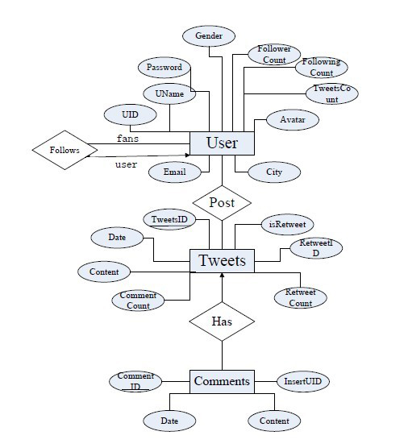

DETAILED SYSTEM DESIGN

User Interface
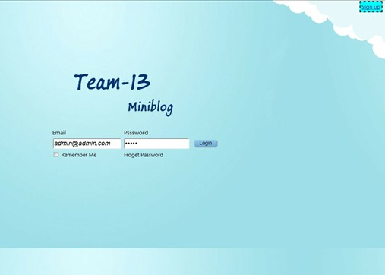
XXX.JSP

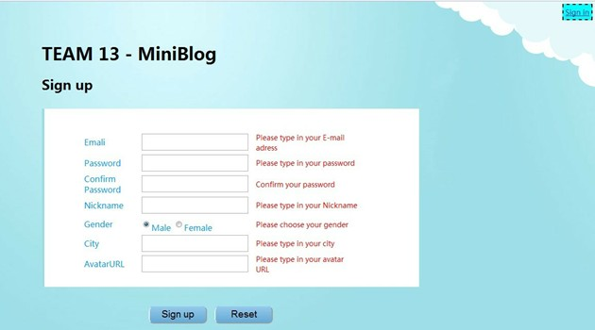
This is the login page of our login page. User need to type in both email and password to login to the system. For those who have not signed in, there is a links to sign up a new account at top right corner.

This is the registration page. The sign up process require user to input information of Email, Password, Name, gender, City and Avatar URL. Email will use as account name which is unique. Other information can be edited after the registration in setting links at user’s own page.
XXX.JSP

What’s more, the data input by user will valid before write to the database by using JS.

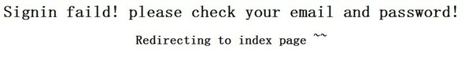

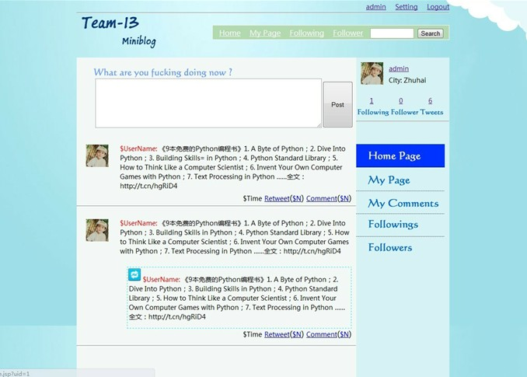
Avatar
XXX.JSP

This is the home page for a user. After login to this system, it will automatically turn to this page. This page contains Menu bar which located in the header of the page and contains links to the other pages.

Home: A link to this page.
My page: A link to see what twitters you have post.
Following: A link to see whom you follow.
Followers: A link to see who follows you.

In the right hand side of the page, there are user's avatar and the city where user lives in. In the middle column, there are twitters what your followings post. And you can post your twitters in the text area in the middle of the page.

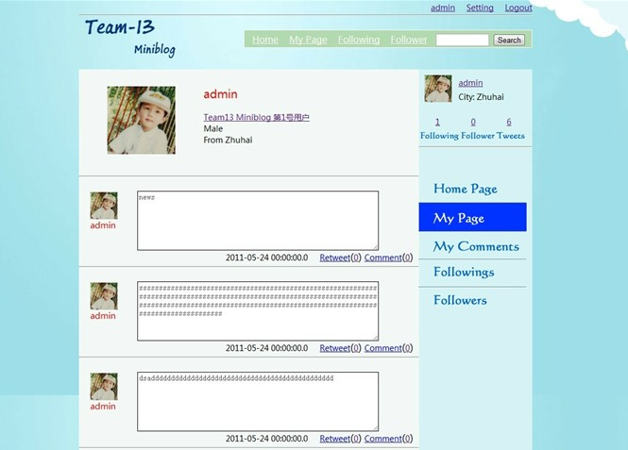

My page: A link to see what twitters you have post.

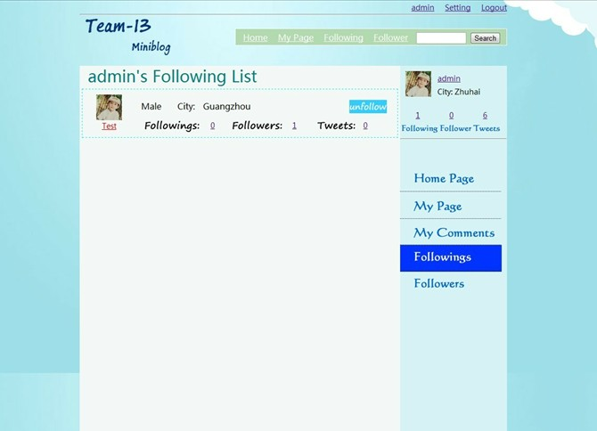

Following List: show users whom you follow

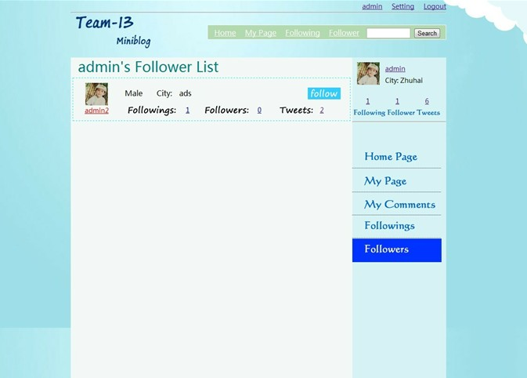
Followers List: show users whom you follow
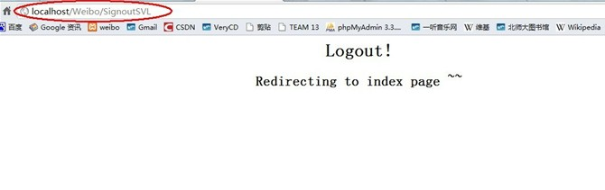

Logout: After press the logout button, the system will lead user to the index page.

Java Server UML Draft

hk.edu.hk.cosns.model.dao
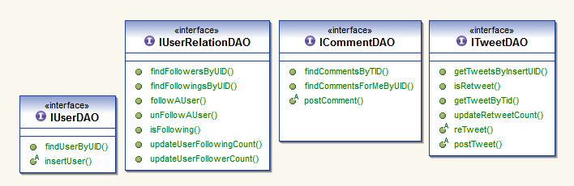

hk.edu.hk.weibo.model.vo
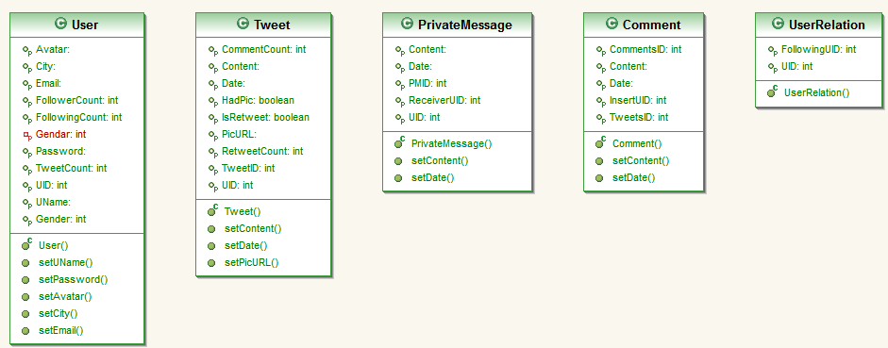

Database Tables Implementation

User
CREATE TABLE IF NOT EXISTS `user` (
`UID` int(10) NOT NULL AUTO_INCREMENT,
`Email` varchar(50) NOT NULL,
`Password` varchar(20) NOT NULL,
`UName` varchar(20) NOT NULL,
`Avatar` varchar(200) NOT NULL DEFAULT '/images/a.jpg',
`Gender` int(1) NOT NULL DEFAULT '0',
`City` varchar(20) DEFAULT NULL,
`FollowingCount` int(10) NOT NULL DEFAULT '0',
`FollowerCount` int(10) NOT NULL DEFAULT '0',
`TweetCount` int(10) NOT NULL DEFAULT '0',
PRIMARY KEY (`UID`),
UNIQUE KEY `Email` (`Email`)
)

UserRelation
CREATE TABLE IF NOT EXISTS `userrelation` (
`UID` int(11) NOT NULL,
`FollowingUID` int(11) NOT NULL,
PRIMARY KEY (`UID`,`FollowingUID`)
)

User Relation
CREATE TABLE IF NOT EXISTS `userrelation` (
`UID` int(11) NOT NULL,
`FollowingUID` int(11) NOT NULL,
PRIMARY KEY (`UID`,`FollowingUID`)
)

Tweets
CREATE TABLE IF NOT EXISTS `tweets` (
`TweetsID` int(10) NOT NULL AUTO_INCREMENT,
`InsertUID` int(10) NOT NULL,
`Date` date NOT NULL,
`Content` varchar(200) NOT NULL DEFAULT '鏃?,
`IsRetweet` int(1) NOT NULL DEFAULT '0',
`RetweetID` int(10) DEFAULT NULL,
`RetweetCount` int(10) NOT NULL DEFAULT '0',
`CommentCount` int(10) NOT NULL,
PRIMARY KEY (`TweetsID`)
)

SQL commands

ICommentDAOImpl

findCommentsByTID

String sql = "select * from Comments where TweetsID = '"+tid+"'";

findCommentsForMeByUID

String sql = "select* from Comments where InsertUID = '"+uid+"'";

postComment

String sql = "insert into Comments(TweetsID,InsertUID,Date,Content,TweetAuthorUID) values('"+tid+"', '"+insertUID+"','"+datetime+"', '"+content+"', '"+tweetAuthorUID+"')";

ITweetDAOImpl

findNewsByUIDs

String query="select user.uid, TweetsID, Avatar, tweets.Date, content, uname, CommentCount, RetweetCount,IsRetweet,RetweetID from user, tweets " +
temp + "and tweets.InsertUID = user.uid order by Date desc";

getTweetByTid

String sql_2 = "select* from Tweets where TweetsID = '"+tid+"'";

getTweetsByInsertUID

String sql_2 = "select* from Tweets where InsertUID = '"+insertUID+"'" +"ORDER BY `TweetsID` DESC";

isRetweet

String sql1="select isretweet from tweets where tweetsid="+TID;

postTweet

String sql_1 = "insert into Tweets(TweetsID,Date,Content,InsertUID,RetweetCount,CommentCount) values (NULL ,'"+datetime+"','"+content+"', '"+insertUID+"','0','0')";

reTweet

String sql = "insert into Tweets(TweetsID,InsertUID, Content,IsRetweet, RetweetID, Date, RetweetCount, CommentCount) values (NUll, '"+insertUID+"', '"+content+"',1, '"+retweetTID+"', '"+datetime+"', '0', '0')";

updateRetweetCount

String sql = "update tweets set ReTweetCount=ReTweetCount+1 where TweetsID="+rtTID;

IUserDAOImpl

findByUserName

String query="select * from user where UName LIKE '%" + username + "%'";

findUserByUID

String sql1="select * from User where UID='"+uid+"'";

insertUser

String query="insert into User (UID, Email, Password, Uname, Avatar, Gender,City,FollowingCount,FollowerCount,TweetCount) " +
"values(Null,?,?,?,?,?,?,0,0,0)";

isUserExisted

String query = "select * from user where email=\'" + email + "\'";

Signin

String query="select * from user where email= ? and password= ?";

updateTweetCount

String sql = "update User set TweetCount=TweetCount+1 where UID='"+uid+"'";

IUserRelatioDAOImpl

findFollowersByUID

String sql = "select * from UserRelation where FollowingUID='"+uid+"'";

findFollowing

String query="select FollowingUID from userrelation where UID=" + uid;

findFollowingsByUID

String sql = "select * from userrelation where UID='"+uid+"'";

followAUser

String sql1="insert into userrelation(uid,followinguid) values("+uidA+","+uidB+")";

isFollowing

String sql1="select * from userrelation where UID="+uidA+" and FollowingUID="+uidB;

unFollowAUser

String sql1="delete from userrelation where UID="+uidA+" and FollowingUID="+uidB;

updateUserFollowerCount

sql = "update User set FollowerCount=FollowerCount+1 where UID='"+uid+"'";

updateUserFollowingCount

sql = "update User set FollowingCount=FollowingCount+1 where UID='"+uid+"'";

