Appendices

Appendix S1
We have referred to official standards and regulations regarding the transmission of safety information for civil aviation engineering projects, as shown in Table S1. The right column (Information Sender) represents the originating party; the left column (Information Receiver) represents the corresponding recipient. Status = 1 indicates an active safety information exchange relationship between the two subjects. CAAC = Civil Aviation Administration of China. Art(s). = Article(s). § = Section. Where a single issuing authority published multiple documents in the same year, suffixes a, b, c are appended in chronological or alphabetical order.
Note: We identify safety information actors and their information flow relationships from safety standards and related documents on construction during airport operations in civil aviation. The URL of the reference regulations and standards is:
https://mp.weixin.qq.com/mp/homepage?__biz=MzU2NDM3NTM0Mg==&hid=3&sn=aa02e71049de58793b1e05c38931d75a&scene=18#wechat_redirect. The full list of documents is provided in Appendix S2.
Table S1 Safety Information Exchange Among Information Subjects in Civil Aviation Engineering Construction
Information Receiver | Status | Regulatory Basis
Information Receiver | Status | Information Sender: Civil Aviation Management Organization
Exploration unit | 1 | CAAC (2022b), Arts. 83, 88, 89
Design unit | 1 | CAAC (2022b), Arts. 83, 88, 89
Building firm | 1 | CAAC (2022b), Arts. 83, 88, 89
Construction unit | 1 | CAAC (2022b), Arts. 83, 88, 89
Supervision unit | 1 | CAAC (2022b), Arts. 83, 88, 89
Airport authority | 1 | CAAC (2023), Arts. 19, 20
Civil aviation quality supervision institution | 1 | CAAC (2022b), Art. 5
Safety information personnel | 1 | CAAC East China (2022c), Arts. 8, 9
Information Receiver | Status | Information Sender: Exploration Unit
Civil aviation management organization | 1 | CAAC (2022b), Arts. 83, 88, 89
Building firm | 1 | CAAC (2022b), Art. 68
Airport authority | 1 | CAAC (2023), Arts. 13, 18
Civil aviation quality supervision institution | 1 | CAAC (2022b), Arts. 83, 88, 89
Information Receiver | Status | Information Sender: Design Unit
Civil aviation management organization | 1 | CAAC (2022b), Arts. 83, 88, 89
Building firm | 1 | State Council (2005), Art. 13
Construction unit | 1 | CAAC (2022b), Art. 68
Airport authority | 1 | CAAC (2023), Arts. 13, 18
Civil aviation quality supervision institution | 1 | CAAC (2022b), Arts. 83, 88, 89
Information Receiver | Status | Information Sender: Building Firm
Civil aviation management organization | 1 | CAAC (2022b), Arts. 83, 88, 89
Exploration unit | 1 | CAAC (2022b), Art. 64
Design unit | 1 | CAAC (2022b), Art. 64
Construction unit | 1 | CAAC (2022b), Art. 64
Supervision unit | 1 | CAAC (2022b), Art. 64
Airport authority | 1 | CAAC (2023), Arts. 13, 18
Air traffic management department | 1 | CAAC (2022a), § 8.5.5.1
Civil aviation quality supervision institution | 1 | CAAC (2018), Art. 46; CAAC (2022b), Arts. 83, 88, 89
Construction personnel | 1 | CAAC (2022a), § 8.5.5.1
Safety management personnel | 1 | CAAC (2021), Arts. 8, 22
Safety information personnel | 1 | CAAC (2018), Art. 62
Information Receiver | Status | Information Sender: Construction Unit
Civil aviation management organization | 1 | CAAC (2022b), Art. 80
Design unit | 1 | CAAC (2022b), Art. 68
Building firm | 1 | CAAC (2020), § 6.5
Supervision unit | 1 | CAAC (2020), § 6.5
Airport authority | 1 | CAAC (2023), Arts. 13, 18
Airport site command department | 1 | CAAC (2023), Art. 14
Civil aviation quality supervision institution | 1 | CAAC (2022b), Art. 80
Construction personnel | 1 | CAAC (2022b), Art. 77; State Council (2005), Arts. 36, 37
Safety management personnel | 1 | CAAC (2022b), Arts. 75, 76; State Council (2005), Art. 23; CAAC (2021), Art. 20
Information Receiver | Status | Information Sender: Supervision Unit
Civil aviation management organization | 1 | CAAC (2022b), Art. 72
Building firm | 1 | CAAC (2022b), Art. 69; CAAC (2020), § 6.3
Construction unit | 1 | CAAC (2022b), Art. 70; CAAC (2020), § 6.3
Airport authority | 1 | CAAC (2023), Arts. 13, 18
Civil aviation quality supervision institution | 1 | CAAC (2022b), Art. 72; CAAC (2020), § 6.3
Construction personnel | 1 | CAAC (2019b), Art. 24
Safety management personnel | 1 | CAAC (2021), Art. 21
Information Receiver | Status | Information Sender: Airport Authority
Civil aviation management organization | 1 | CAAC (2023), Art. 11; CAAC (2018), Art. 47; CAAC (2014), Art. 9
Exploration unit | 1 | CAAC (2023), Arts. 13, 18
Design unit | 1 | CAAC (2023), Arts. 13, 18
Building firm | 1 | CAAC (2023), Arts. 13, 18
Construction unit | 1 | CAAC (2023), Arts. 13, 18
Supervision unit | 1 | CAAC (2023), Arts. 13, 18
Air traffic management department | 1 | CAAC (2023), Arts. 13, 16; State Council (2009), Art. 36
Airport public safety and fire department | 1 | CAAC (2023), Art. 8
Information Receiver | Status | Information Sender: Air Traffic Management Department
Civil aviation management organization | 1 | CAAC (2014), Art. 9
Airport authority | 1 | CAAC (2023), Arts. 13, 16; State Council (2009), Art. 36
Information Receiver | Status | Information Sender: Airport Site Command Department
Construction unit | 1 | CAAC (2023), Art. 14
Information Receiver | Status | Information Sender: Airport Public Safety and Fire Department
Airport authority | 1 | CAAC (2023), Art. 8
Information Receiver | Status | Information Sender: Civil Aviation Quality Supervision Institution
Civil aviation management organization | 1 | CAAC (2022b), Art. 5
Exploration unit | 1 | CAAC (2022b), Arts. 83, 88, 89
Design unit | 1 | CAAC (2022b), Arts. 83, 88, 89
Building firm | 1 | CAAC (2022b), Arts. 83, 88, 89
Construction unit | 1 | CAAC (2022b), Arts. 83, 88, 89
Supervision unit | 1 | CAAC (2022b), Arts. 83, 88, 89
Safety management personnel | 1 | CAAC (2021), Art. 5
Information Receiver | Status | Information Sender: Construction Personnel
Civil aviation management organization | 1 | CAAC (2019a), Art. 7
Information Receiver | Status | Information Sender: Safety Management Personnel
Building firm | 1 | CAAC (2019a), Art. 7
Construction unit | 1 | State Council (2005), Art. 23
Construction personnel | 1 | CAAC (2023), Art. 14
Information Receiver | Status | Information Sender: Safety Information Personnel
Civil aviation management organization | 1 | CAAC (2018), Art. 62

Appendix S2
Abbreviations and original Chinese titles of the corresponding reference texts as following:
- Civil Aviation Administration of China. (2014). Regulations on submission of civil aviation ATC safety information [民航空管安全信息报送规定]. CAAC.
- Civil Aviation Administration of China. (2018). Regulations on civil airport construction management [民用机场建设管理规定]. CAAC.
- Civil Aviation Administration of China. (2019a). Measures for reporting and investigation of construction safety accidents in civil aviation professional projects (Trial) [民航专业工程施工安全事故报告和调查办法（试行）]. CAAC.
- Civil Aviation Administration of China. (2019b). Safety management regulations for high-risk engineering in civil aviation professional projects (Trial) [民航专业工程危险性较大的工程安全管理规定（试行）]. CAAC.
- Civil Aviation Administration of China. (2020). Self-inspection guidelines for work safety of participating units in professional engineering construction of transport airports (Trial) [运输机场专业工程参建单位施工安全自查指南（试行）]. CAAC.
- Civil Aviation Administration of China. (2021). Measures for the administration of safety management personnel of professional engineering contractors at transport airports (Trial) [运输机场专业工程施工单位安全管理人员管理办法（试行）]. CAAC.
- Civil Aviation Administration of China. (2022a). Airport operations manual [机场使用手册]. CAAC.
- Civil Aviation Administration of China. (2022b). Regulations on quality and work safety supervision of professional engineering construction of transport airports [运输机场专业工程建设质量和安全生产监督管理规定]. CAAC.
- Civil Aviation Administration of China. (2023). Measures for the administration of construction during airport operations at transport airports [运输机场不停航施工管理办法]. CAAC.
- Civil Aviation Administration of China, East China Regional Administration. (2022c). Implementation measures for aviation safety information management in the Civil Aviation East China Region [民航华东地区航空安全信息管理实施办法]. CAAC East China.
- State Council of the People's Republic of China. (2005). Regulations on work safety production management of construction projects [建设工程安全生产管理条例] (Decree No. 393). State Council.
- State Council of the People's Republic of China. (2009). Regulations on civil airport management [民用机场管理条例] (Decree No. 553). State Council.

Appendix S3
As described in the main text, we use the IDEF0 method to characterize how safety information flows through the key activities and processes of construction during airport operations, with the main functional modules derived from the relevant safety standards. The modeling process is illustrated through the following four figures.
Fig. S1 presents the top-level structure of the IDEF0 model, which depicts the overall functional modules of the safety information chain in construction during airport operations. The arrows in the model represent the flow of safety information governed by the relevant regulations and operational processes of construction during airport operations. The same conventions apply to Figs. S2-S4. In all four models, policies, laws and regulations, standard specifications, and the safety management system serve as the control components, denoted by "↓". The mechanism guarantees of the safety information chain are provided by the stakeholders involved in construction and the corresponding safety inputs, denoted by "↑". Building on the control and mechanism components defined at the top level, the functional modules of the safety information transmission chain are decomposed into three modules: application and approval, implementation, and acceptance.
The refined results across these three modules enable a more granular examination of safety information flow within each functional module. First, the application and approval module is decomposed into two sub-modules: A (application) and B (approval). The application sub-module relies primarily on the safety responsibility letter and organizational management; through the safety management system, relevant standards, and applicable laws and regulations, it produces the outcome of the construction application. The approval sub-module takes construction safety requirements and other safety assurance information as inputs, generating outputs that include the NOTAM (Notice to Airmen), assigned safety management personnel, safety supervision and inspection records, and safety self-examination reports, as shown in Fig. S2.
Fig. S3 illustrates the refinement of the implementation module, which is decomposed into three sub-modules: C (construction commencement), D (construction area control), and E (construction safety requirements). The inputs of this module include the original NOTAM information, the allocation of safety management personnel, safety supervision and inspection records, safety self-examination reports, and other related information. Beyond the controls imposed by laws and regulations, standards, and management systems, this module is further constrained by safety inputs and the activities of participating parties. The outputs include the special acceptance report on safety and environmental protection, quality qualification documents, and the flight inspection report.
Fig. S4 decomposes the acceptance module into two sub-modules: F (pre-acceptance) and G (completion acceptance). Under the same control conditions (laws and regulations, standards, and management systems) and mechanism conditions (safety inputs and the activities of participating parties), the inputs to this module include quality qualification documents, survey evaluations, and design inspections. The outputs include the special acceptance report on safety and environmental protection and the flight inspection report.

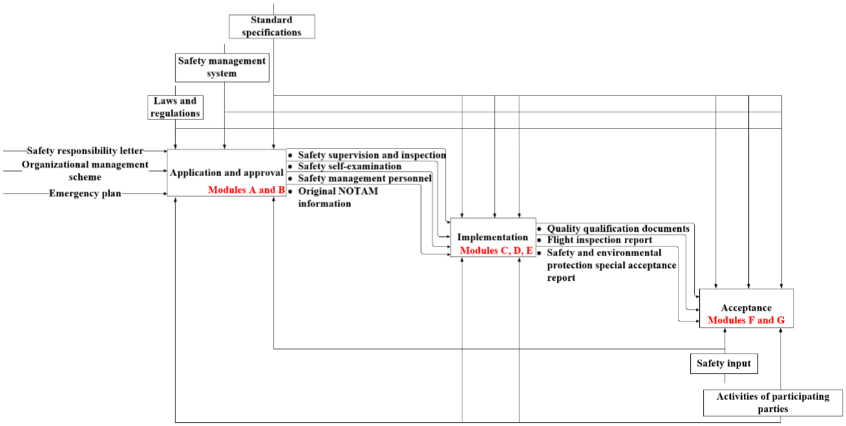
Fig. S1. Safety information chain in construction during airport operations
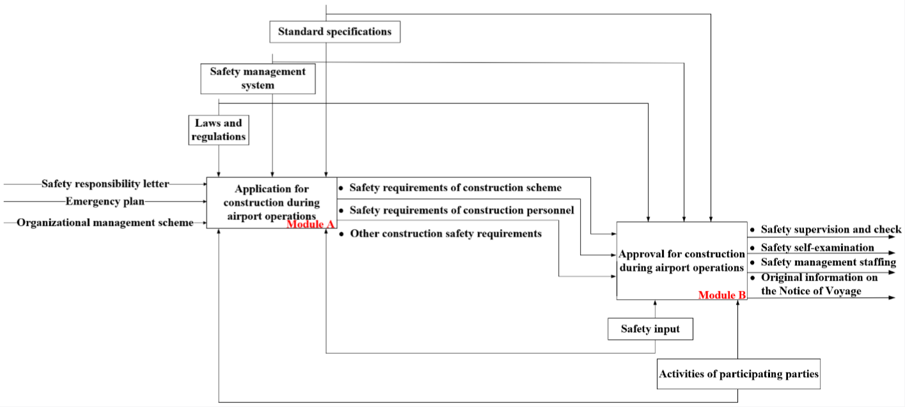
Fig. S2. Application and approval in construction during airport operations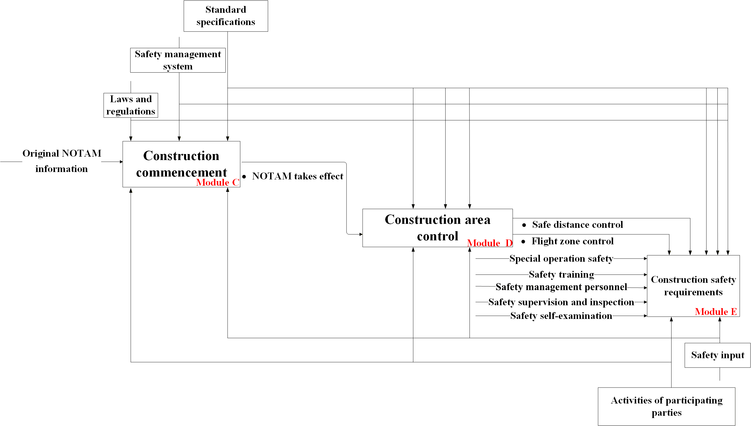
Fig. S3. Implementation in construction during airport operations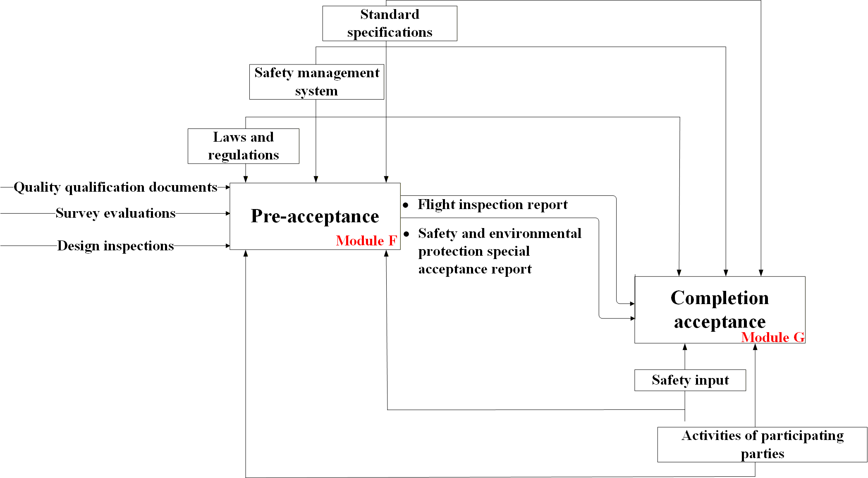
Fig. S4. Acceptance in construction during airport operations

