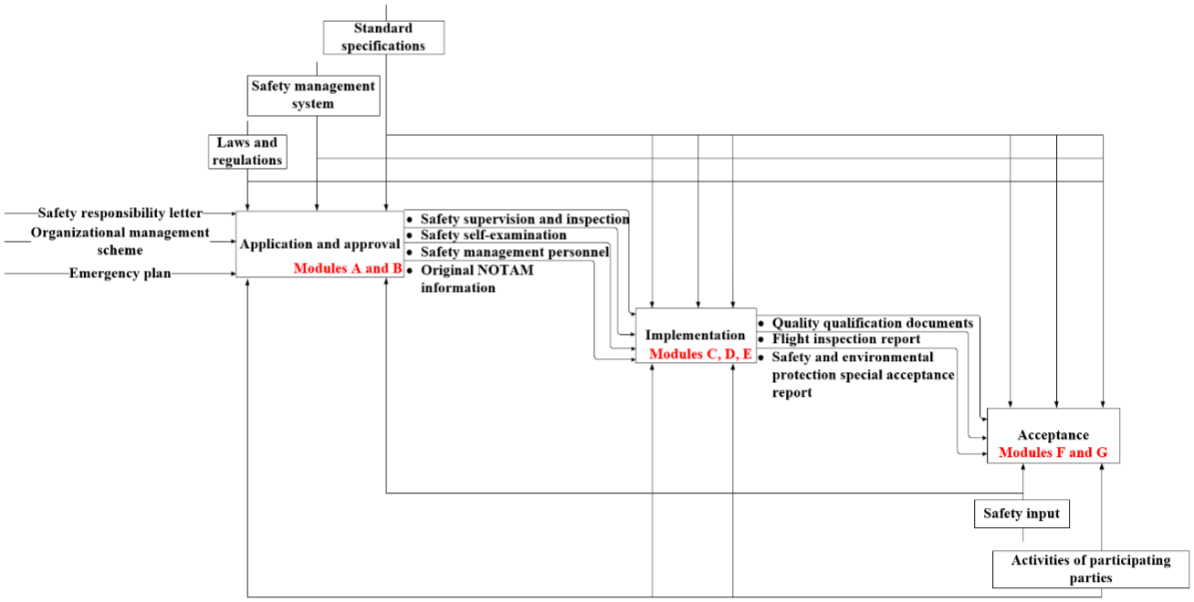
Fig. S1. Safety information chain in construction during airport operations
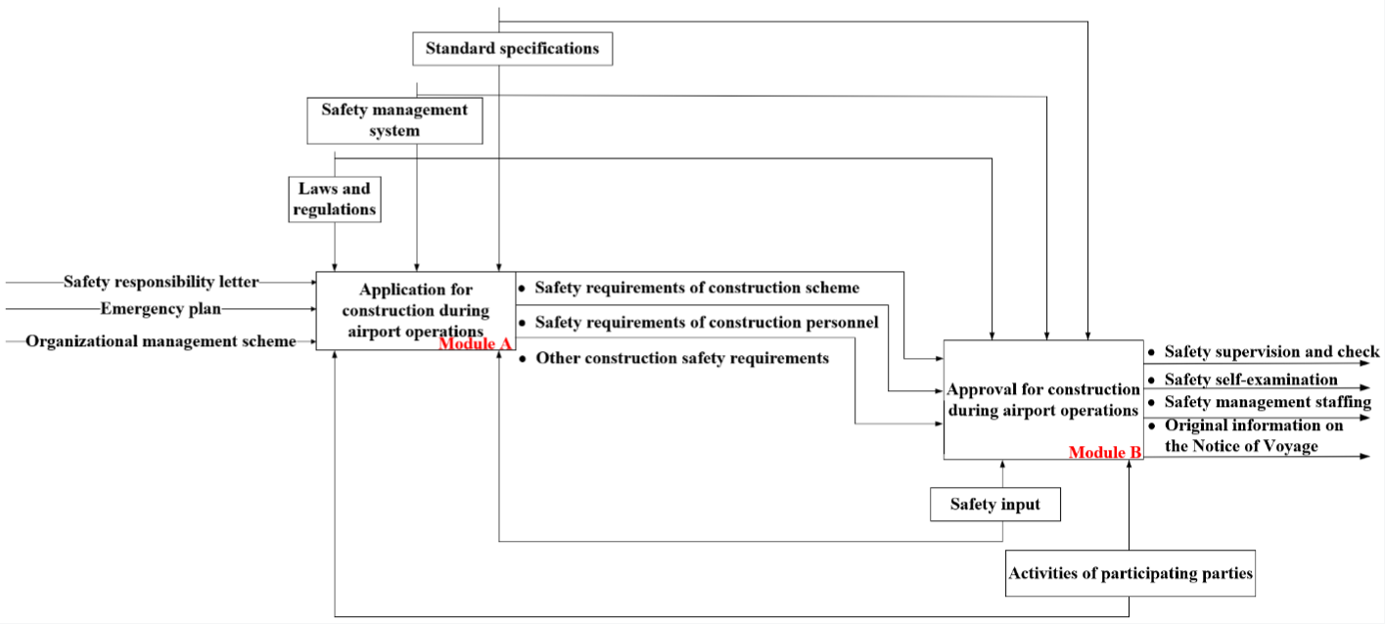
Fig. S2. Application and approval in construction during airport operations
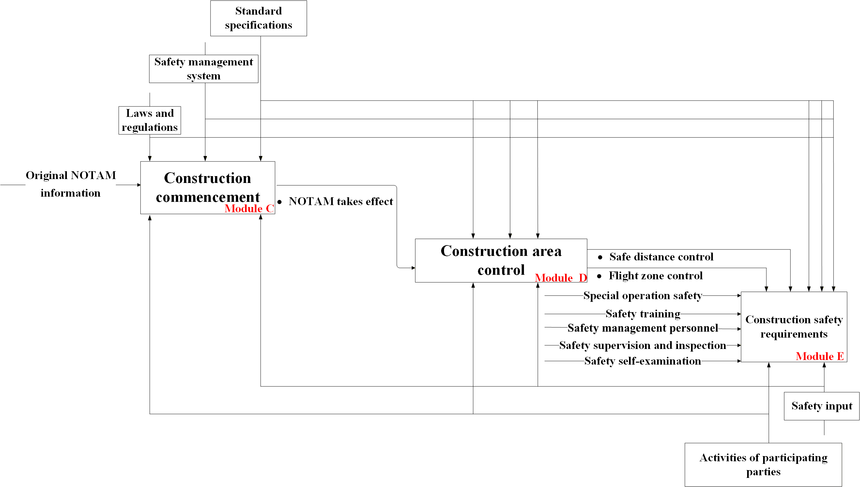
Fig. S3. Implementation in construction during airport operations
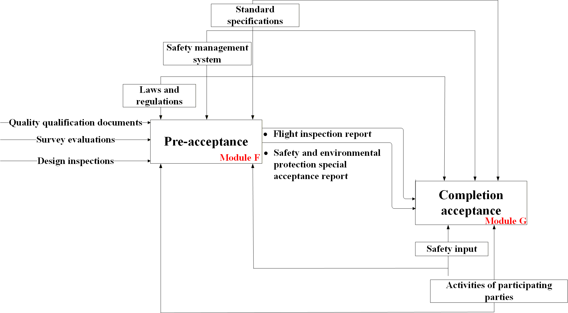
Fig. S4. Acceptance in construction during airport operations

