**HW 2 5333 Fall 20 Answers**

**Ch3.2-Growth functions**

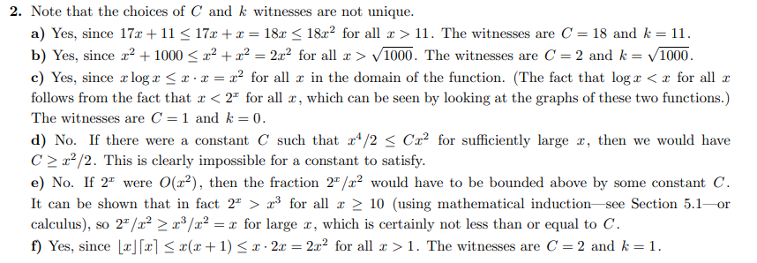

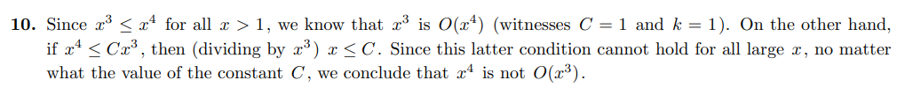



**Ch3.3-Algorithm-complexity**

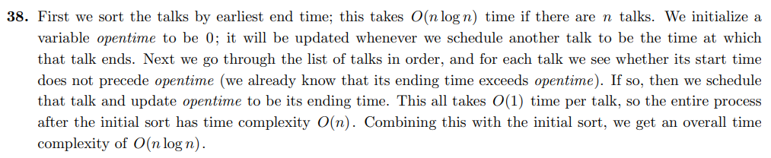

**Ch5.1 Mathematical-Induction**

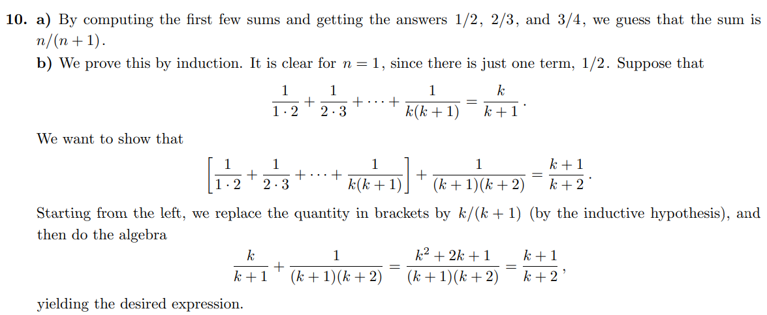

**Ch5.2 Strong Induction**

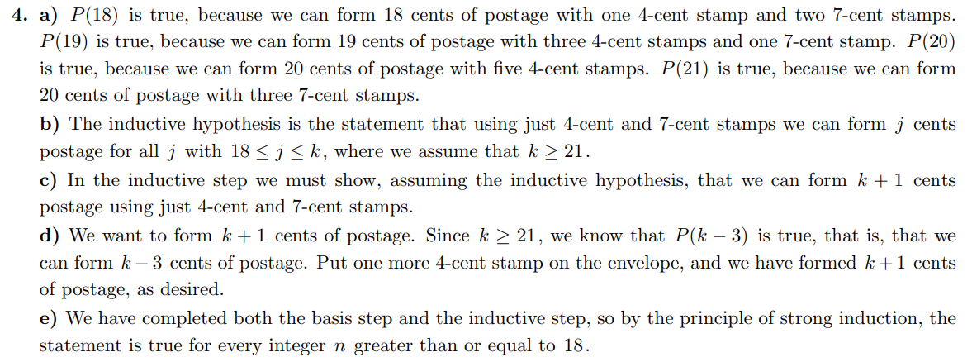

**Ch6.1-Basic-Counting**

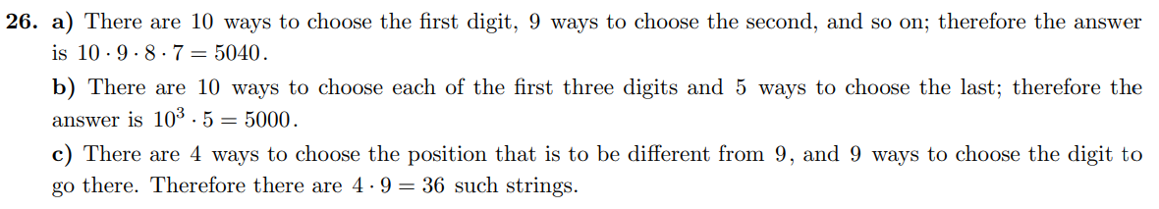

**Ch6.2-Pigeonhole-Principle**

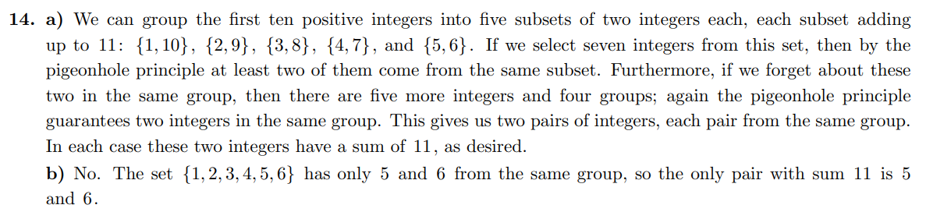

**Ch6.5-Generalized-Permutations-and-Combinations**



