小组成员：1600300228覃文权、1600300237张鹏

单词分类表

|  |  |
| --- | --- |
| 关键字 | 二元式 |
| begin | (1, BEGIN) |
| end | (2, END) |
| var | (3, VAR) |
| integer | (4, INTEGER) |
| while | (5, WHILE) |
| do | (6, DO) |
| then | (7, THEN) |
| if | (8, IF) |
| else | (9, ELSE) |

|  |  |
| --- | --- |
| 算符 | 二元式 |
| = | (10, EQUAL) |
| := | (11,ASSIGNMENT) |
| + | (12,ADD) |
| * | (13,MULTIPLY) |
| < | (14, SMALLER) |
| > | (15,BIGER) |
| <= | (16, SMALLER_EQUAL) |
| >= | (17, BIGER_EQUAL) |
| ( | (18,LEFT_BRACKET) |
| ) | (19,RIGHT_BRACKET) |
| <> | (20,NOT_EQUAL) |

|  |  |
| --- | --- |
| 分割符 | 二元式 |
| . | (21,POINT) |
| , | (22,BEAN) |
| : | (23,BUBBLE) |
| ; | (24,SPLIT) |

设计图

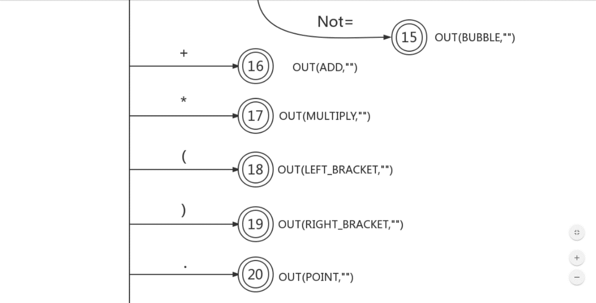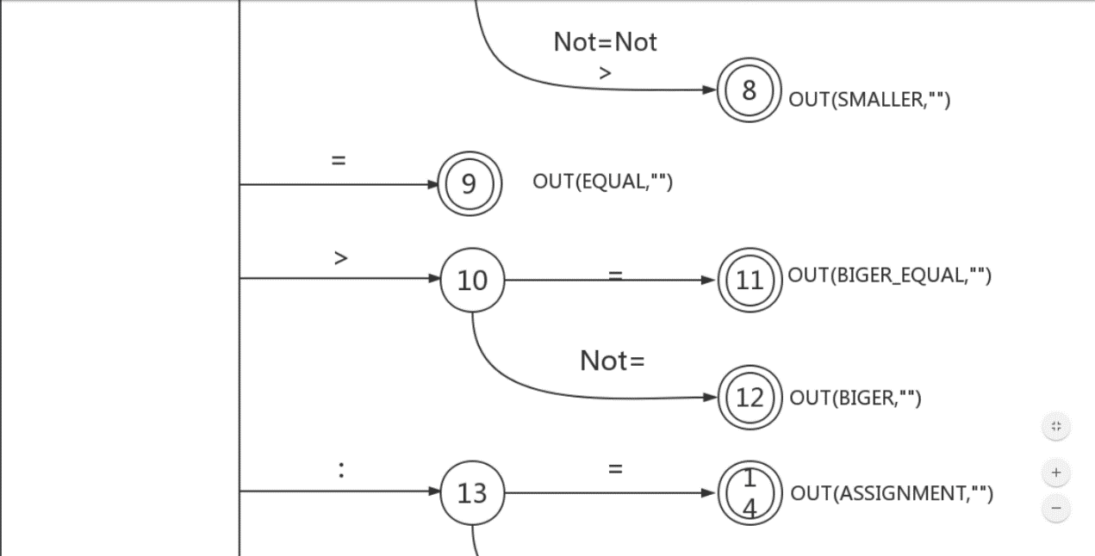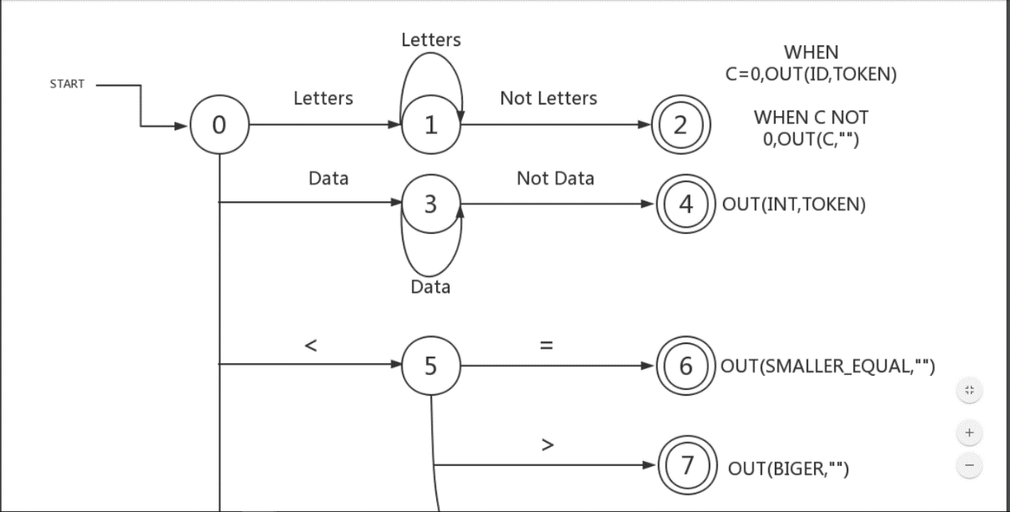

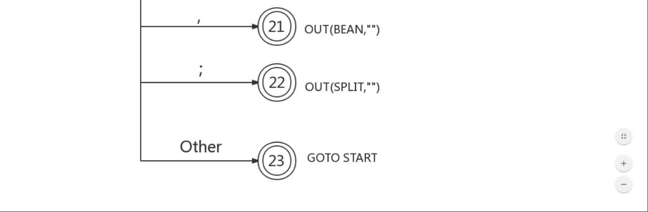

|  |  |  |
| --- | --- | --- |
| #define | BEGIN | 1 |
| #define | END | 2 |
| #define | VAR | 3 |
| #define | INTEGER | 4 |
| #define | WHILE | 5 |
| #define | DO | 6 |
| #define | THEN | 7 |
| #define | IF | 8 |
| #define | ELSE | 9 |
| #define | EQUAL | 10 |
| #define | ASSIGNMENT | 11 |
| #define | ADD | 12 |
| #define | MULTIPLY | 13 |
| #define | SMALLER | 14 |
| #define | BIGER | 15 |
| #define | SMALLER_EQUAL | 16 |
| #define | BIGER_EQUAL | 17 |
| #define | LEFT_BRACKET | 18 |
| #define | RIGHT_BRACKET | 19 |
| #define | NOT_EQUAL | 20 |
| #define | POINT | 21 |
| #define | BEAN | 22 |
| #define | BUBBLE | 23 |
| #define | SPLIT | 24 |