

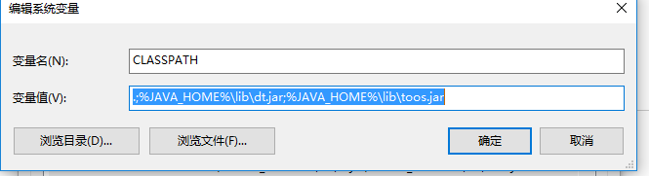

CLASSPATH

.;%JAVA_HOME%\lib\dt.jar;%JAVA_HOME%\lib\toos.jar

JAVA_HOME

F:\Java\jdk1.7.0_80

Path

F:\Java\jdk1.7.0_80\bin

F:\Java\jdk1.7.0_80\jre\bin

E:\app开发\Git\cmd