启动jenkins
service jenkins start

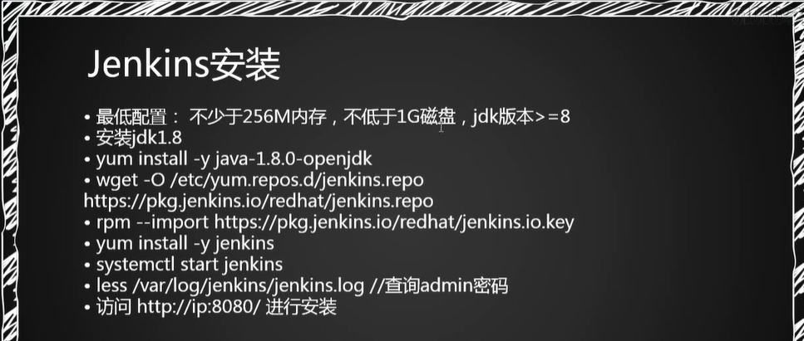

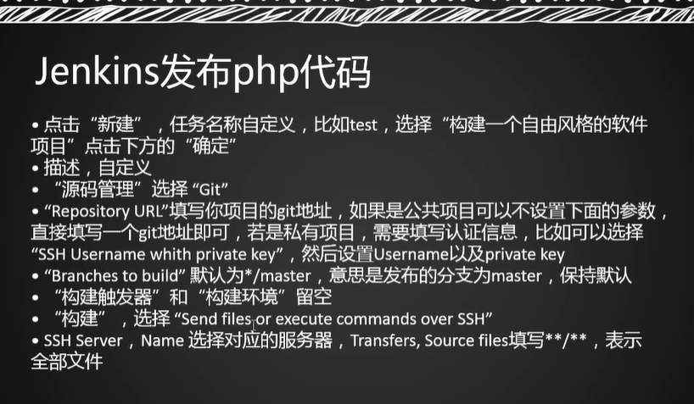

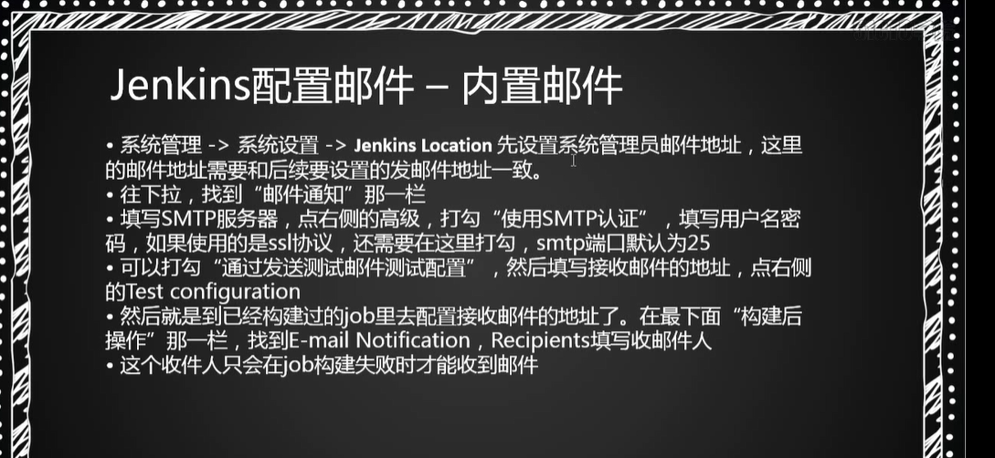

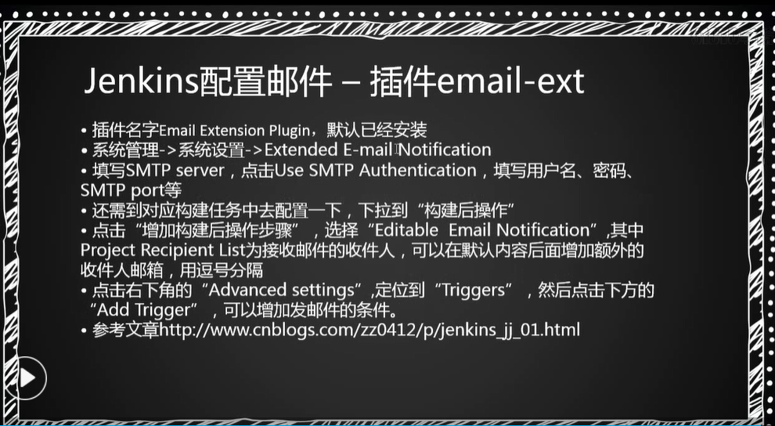

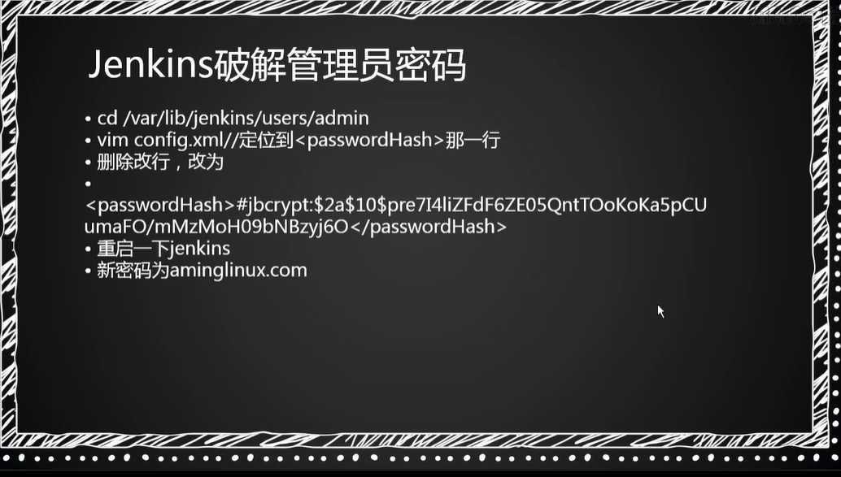
/var/lib/jenkins/users/admin

<passwordHash>#jbcrypt:$2a$10$zgXpVdIPrYx.eQh46VxreudmVjrfun7miRYf6DdLyGbPR3DPwH33G</passwordHash>
123456

