XJTLU MUSIC FESTIVAL

ShanliangYao 1930954

<http://cw1.411.iat.net.cn/>

When I saw this assignment, my first thought was how to integrate a home page, a music OR video player, an image gallery, and a JavaScript app. If each module is made into a single page, the content of this page will be relatively single. Eventually I thought of a music festival as the background inspiration. I could make this assignment into a theme, which just contains music, albums, introduction information and so on.

After determining the theme, I began to think about the layout of the page, combined with my previous work experience as a web engineer, the single-page promotion form can be better liked by people, people can browse the page by sliding up and down, and You can directly click the anchor point in the menu bar to switch directly to the corresponding module. Then I used Axure to design a layout. The layout is as follows:

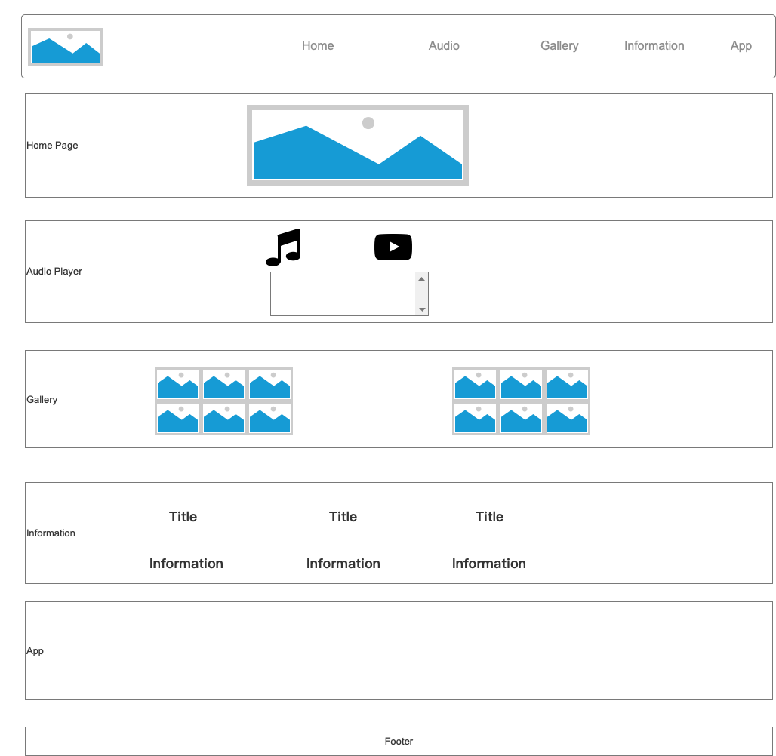

*Figure1:* Rough screen design

I have also been entangled in the color selection of the page for a long time. I have referred to many music festival theme websites and music playback websites, such as QQ Music [1] and Netease Cloud Music [2]. In the end, Netease cloud music with red and white as the main colors was selected as a reference, which can not only show the vitality of the music festival, but also attract users' enthusiasm for listening to music.

The Home Page uses header, nav, ul, li and other tags, and uses anchor method, so that the menu item can be directly switched to the corresponding module. I searched a photo of listening to music from the Internet, and it can bring the user into the situation of the concert. I also downloaded a baloobhaijaan font [3] from the Internet for the title display of the home page. The font was introduced by @font-face in the style.css file, so that the theme and time can be clearly displayed on the web page In the middle. A countdown effect was made at the bottom of the home page, using May 1, 2020 as the concert start time, using the event listener in JS, the countdown effect is displayed, reminding people that the music festival is about to start.

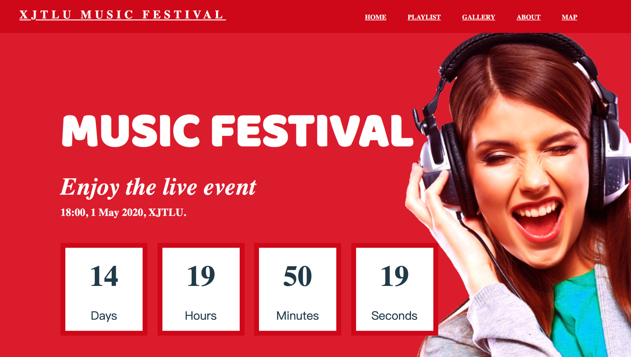

*Figure 2:* Home Page

The Playlist part is used to display the songs that will be sung at this concert. I have separated the song information into a data.js file, so that I can easily add and modify the data. Due to the limitation of file size, only five songs were added as a reference. In terms of music material, I chose QQ Music [1], selected the popular list to download 5 songs, and intercepted the cover art of the album to display in my playlist. The music player refers to a music player demo [4] on the Internet, but the player is based on jQuery, I replaced it with a native JS implementation. I found the corresponding start, pause, volume, etc. icons from Ali icon [5]. The music playback function in the previous assignment was migrated, and the ratio was calculated based on the total time of the song and the current time, and the progress bar was displayed. Increase the display of the volume bar, click the increase and decrease of the volume to see the effect of the volume bar in real time. Click-to-play is implemented in the following playlist, which can play the corresponding song, displaying the song name, artist, album picture, time progress, etc.

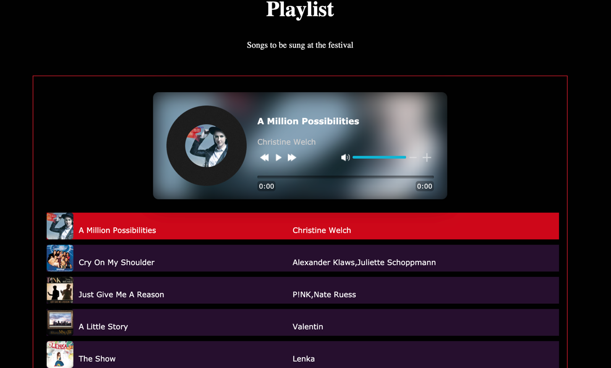

*Figure 3:* Playlist

My assumption in the Gallery section is to display 12 pictures, using a three-row, four-column layout. Initially, a smaller picture is displayed. You can click on the picture to enlarge it. This function refers to the enlargement effect in a demo [6] on the Internet. Based on it, I optimized the display style of the picture and added the rounded corners of the picture to make the overall style look more harmonious. The picture material was found from a music template [7] on the Internet, which just fits the theme of the music festival. After the picture is enlarged, there will be a button to switch back and forth. The button is obtained from the icon, which can realize the switching display of the picture.

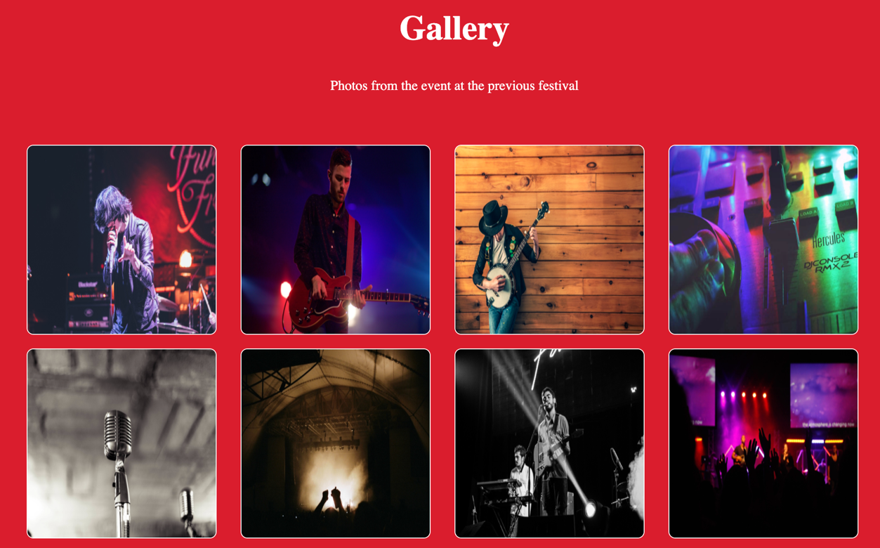

*Figure 4:* Gallery

In the Information section, I changed the title to About, which is more suitable for my theme and displays some information about the concert. I imagined that this concert was held by XJTLU’s Music Lovers Association, so in this section we introduce XJTLU, Music Lovers Association and XJTLU Music Festival. XJTLU ’s introduction is taken from XJTLU’s official website [8], written by the Music Lovers Association and XJTLU Music Festival. The information part is displayed in text. In order to make it not monotonous, I found some icons about music from the Internet, which are displayed above the text, so that it looks more coordinated.

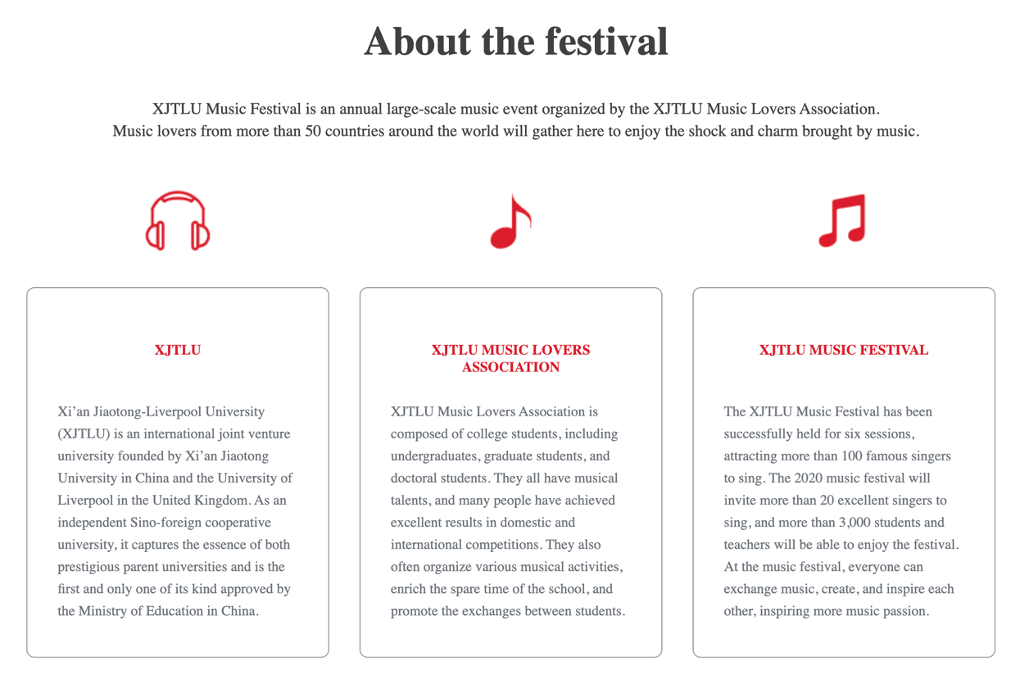

*Figure 5:* About the festival

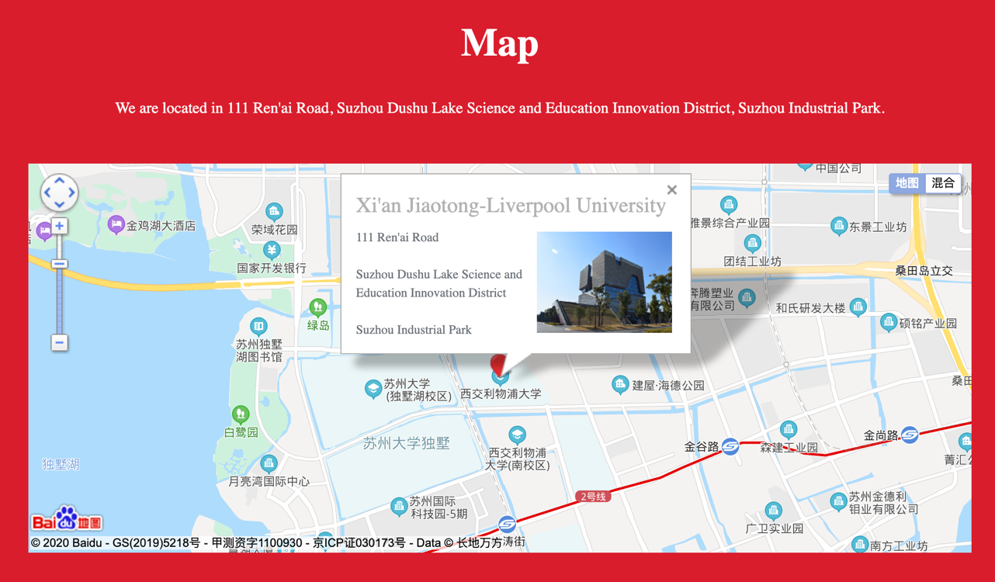

*Figure 6:* Map

The App part has troubled me for a long time. There are many JS special effects and app functions on the Internet, but it is difficult to connect with the theme of my music festival. Fortunately, I have done map development before, so I thought about whether I can make the app a map display of Nishiura. It just introduced the location of the concert to people and fit the theme. I introduced the JS of Baidu map [9], used the appkey I added, and then picked up the GPS coordinates of XJTLU through the coordinate pickup tool, and displayed it through the built-in method of Baidu map. And added XJTLU’s bullet box display, you can expand the name and specific address of XJTLU by default. Later, I felt that this map appeared to be single, so I studied Baidu's panoramic map [10], which can show the school environment, which is more vivid. After referring to the corresponding information, I also displayed this panorama. By default, it is in the gate part of the school, which can be rotated and clicked forward.

In the footer part, I added copyright and my own website for good filing, and posted the coursework on my own server [11], which can be accessed through the domain name [cw1.iat.net.cn](http://cw1.iat.net.cn/) [12].

In terms of code, I adopted strict html, JS, CSS specifications, added key comments, and it is more readable. Place the audio and gallery files in separate folders. I divided the JS file into two parts, one is data.js, which contains audio and gallery data, similar to the configuration file. The other is function.js, which contains some JS functions, such as countdown and player control. I also use advanced methods of CSS, such as hover, focus, etc. These advanced methods not only help me review the relevant knowledge of CSS, but also better show the effect of the web page.

Although I have used jQuery, react, Vue, bootstrap frameworks before, I still know that JS and CSS foundations are very important. Through this homework practice, I reviewed the related operations of JS and CSS more deeply, and learned the advanced features of CSS more deeply.

[1] QQ Music https://y.qq.com/

[2] NetEase Cloud Music https://music.163.com/

[3] baloobhaijaan font: https://fonts.gstatic.com/s/baloobhaijaan/v7/RWmRoKCU5fcqq8fOWNzFLqSjx7EFLGRBCF-U.woff2

[4] Music player http://sc.dede58.com/qitatexiao/37843.html

[5] Ali icon https://www.iconfont.cn/

[6] Photo click to enlarge effect http://sc.dede58.com/demo_mb.php?aid=35008

[7] Music theme template https://demo.demohuo.top/modals/63/6381/demo/#

[8] XJTLU reference: https://www.xjtlu.edu.cn/en/about/

[9] Map reference: http://lbsyun.baidu.com/

[10] Panoramic map http://lbsyun.baidu.com/jsdemo.htm#j1_1

[11] Personal website: https://iat.net.cn

[12] Publishing website: http://cw1.411.iat.net.cn