**Sports Tracker PRO**

**Shanliang Yao 1930954**

**Installation**

* Copy the entire directory to the server directory.
* Import the *sports.sql* file in the root directory to the database.
* Modify the link information of the database in the *common/dbHelper.php* file.

**Demonstration**

* Some pages in the project are listed below. I also deployed this project on the server at <http://cw2.411.iat.net.cn/>. You can access it easily and conveniently.
* The account used for demonstration is **ShanliangYao** and the password is **123456**. You can also re-register a new account for access.

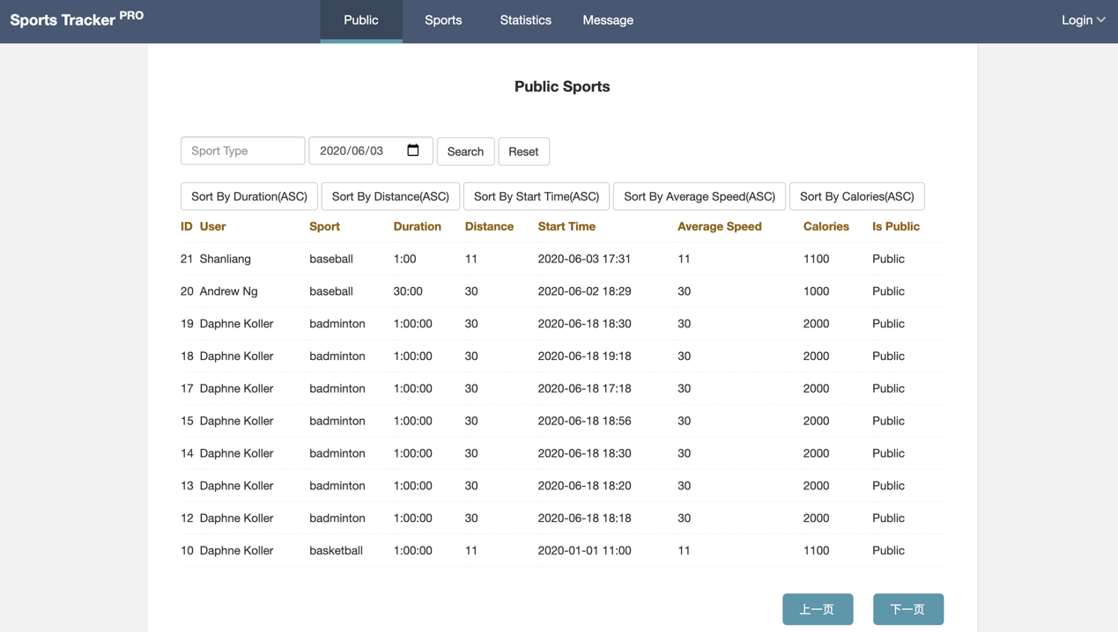

Figure 1. Public sports

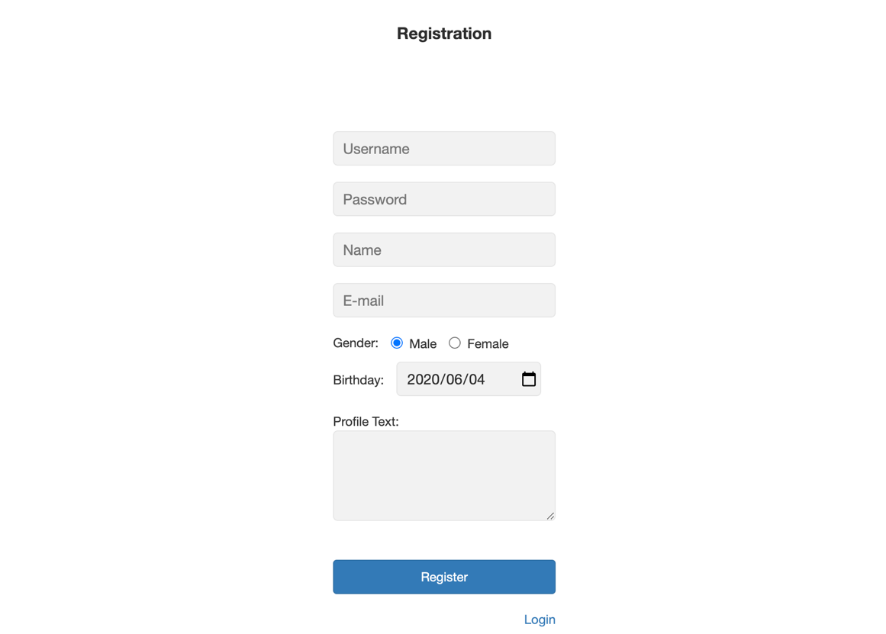

Figure 2. Page of registration

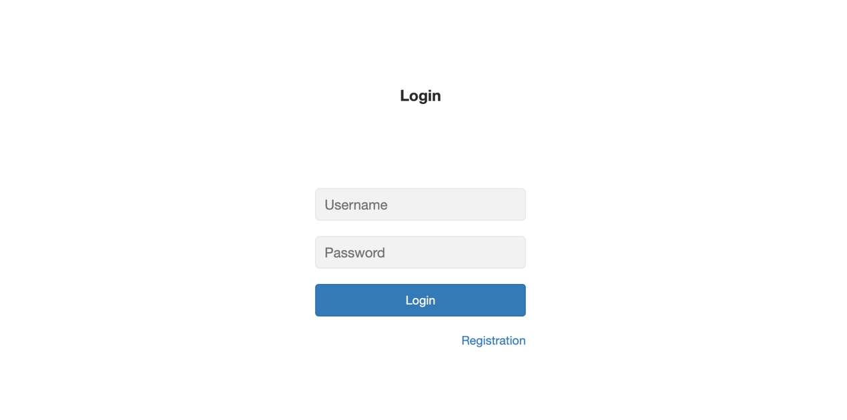

Figure 3. Page of login

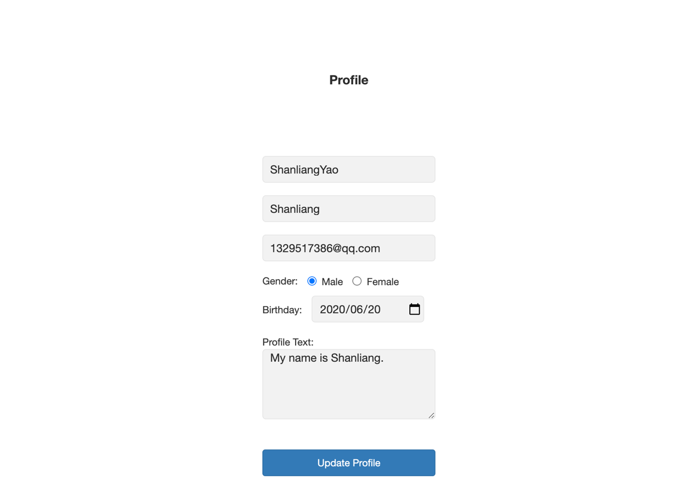

Figure 4. Page of profile

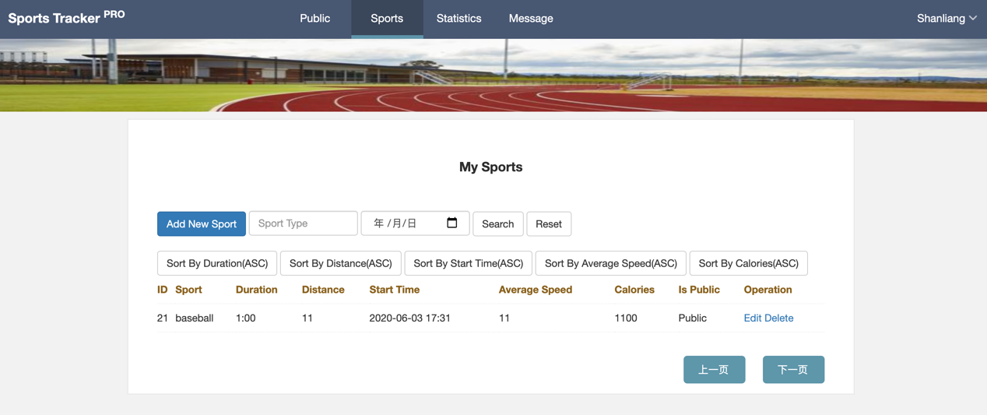

Figure 5. Page of my sports

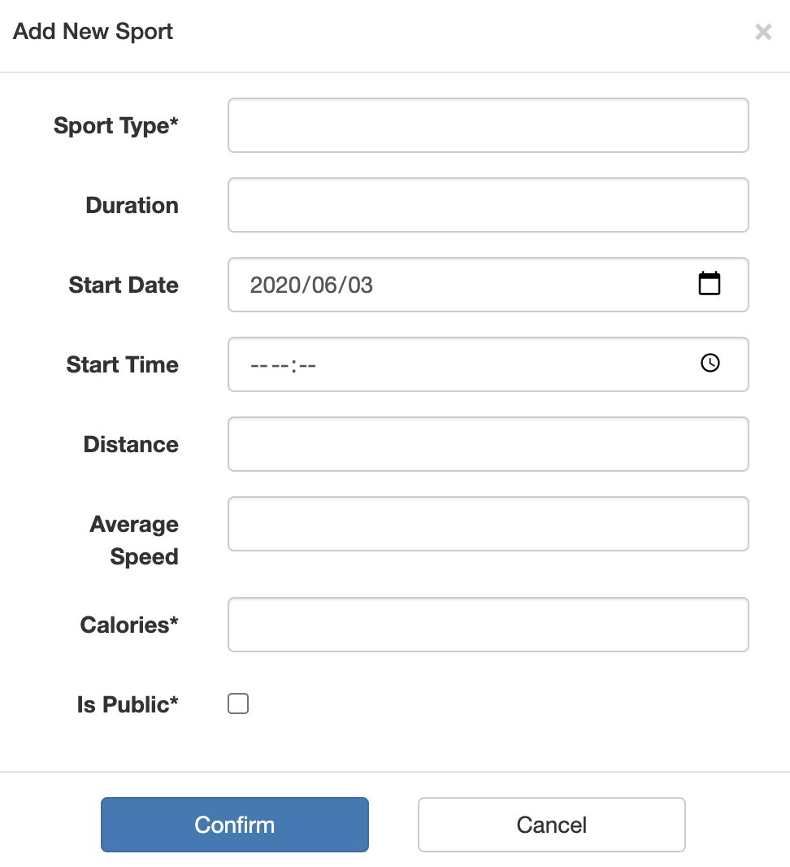

Figure 6. Page of adding my sports

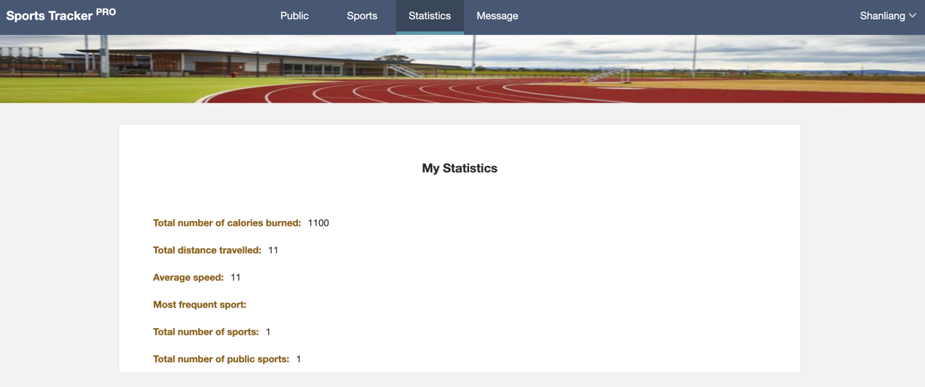

Figure 7. My statistics

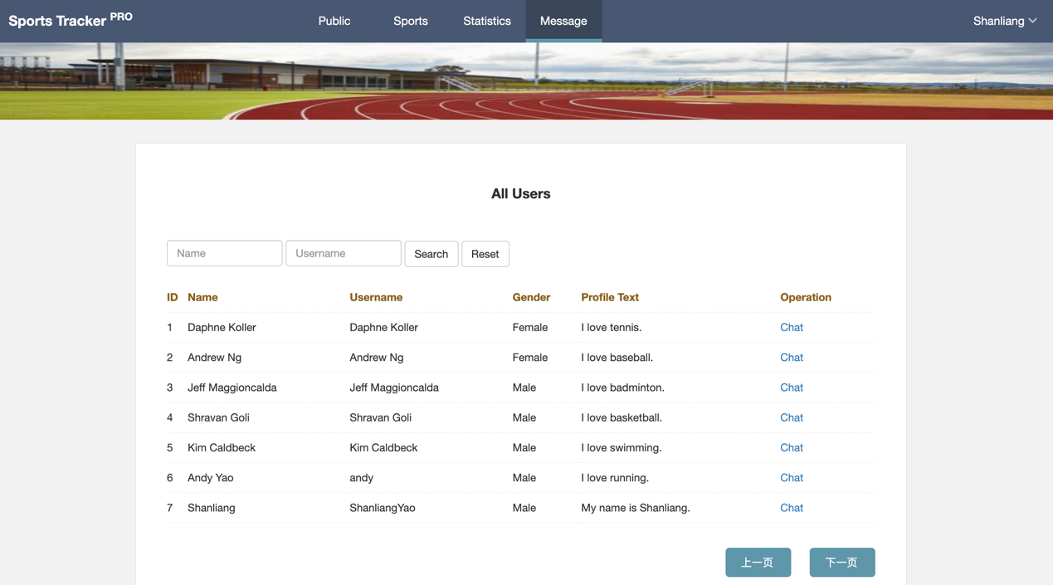

Figure 8. Page of all users

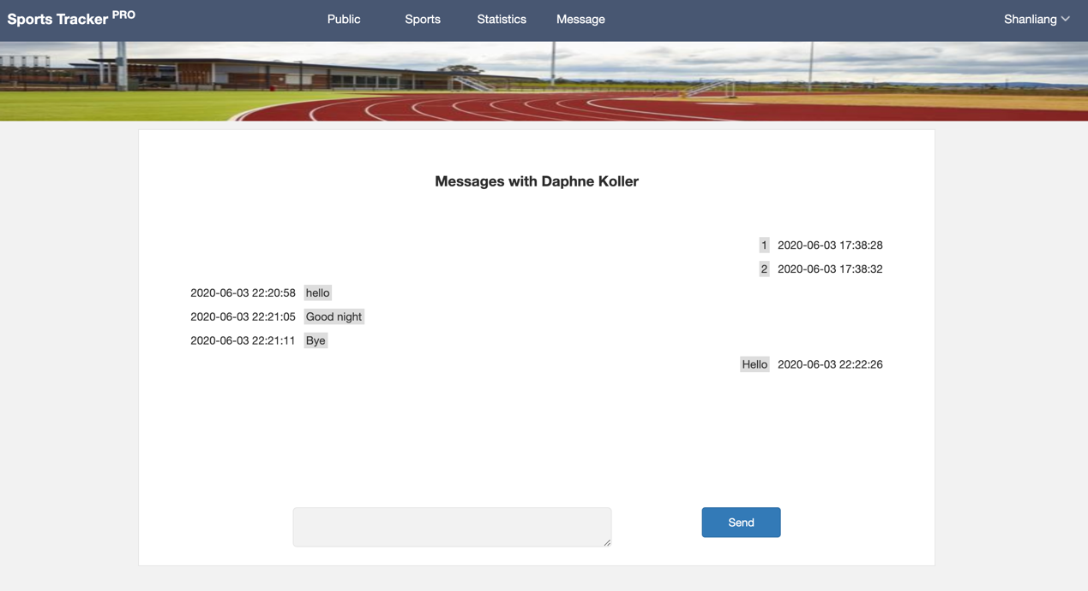

Figure 9. Page of messages