Question 1: (I’m using my own laptop with an nvidia gpu)

a How many GPUs are attached to mcu?

Two GPUs are attached to mcu

b What is the complete product name of each GPU?

GPU 0: NVIDIA GeForce RTX 2080 Ti (UUID: GPU-cca6f7c7-a959-b848-3875-e5eddaabd222)

GPU 1: NVIDIA GeForce RTX 2080 Ti (UUID: GPU-b3c99acd-d0c0-a736-b04e-1be9c8801078)

c What are the minimum, maximum, and default power limits?

nvidia-smi -q -d power

GPU 00000000:03:00.0

Power Readings

Power Management : Supported

Power Draw : 39.61 W

Power Limit : 260.00 W

Default Power Limit : 260.00 W

Enforced Power Limit : 260.00 W

Min Power Limit : 100.00 W

Max Power Limit : 320.00 W

Power Samples

Duration : 0.60 sec

Number of Samples : 31

Max : 40.43 W

Min : 17.26 W

Avg : 36.06 W

GPU 00000000:04:00.0

Power Readings

Power Management : Supported

Power Draw : 24.29 W

Power Limit : 260.00 W

Default Power Limit : 260.00 W

Enforced Power Limit : 260.00 W

Min Power Limit : 100.00 W

Max Power Limit : 320.00 W

Power Samples

Duration : 0.07 sec

Number of Samples : 4

Max : 33.52 W

Min : 22.45 W

Avg : 27.41 W

d What power limit is currently set?

Power Limit : 260.00 W

e What is the GPU shutdown temperature?

nvidia-smi -q -d temperature

GPU 00000000:03:00.0

Temperature

GPU Current Temp : 36 C

GPU Shutdown Temp : 94 C

GPU Slowdown Temp : 91 C

GPU Max Operating Temp : 89 C

GPU Target Temperature : 84 C

Memory Current Temp : N/A

Memory Max Operating Temp : N/A

GPU 00000000:04:00.0

Temperature

GPU Current Temp : 35 C

GPU Shutdown Temp : 94 C

GPU Slowdown Temp : 91 C

GPU Max Operating Temp : 89 C

GPU Target Temperature : 84 C

Memory Current Temp : N/A

Memory Max Operating Temp : N/A

f What is the maximum SM clock?

nvidia-smi -q -d CLOCK

GPU 00000000:03:00.0

Temperature

GPU Current Temp : 36 C

GPU Shutdown Temp : 94 C

GPU Slowdown Temp : 91 C

GPU Max Operating Temp : 89 C

GPU Target Temperature : 84 C

Memory Current Temp : N/A

Memory Max Operating Temp : N/A

GPU 00000000:04:00.0

Temperature

GPU Current Temp : 35 C

GPU Shutdown Temp : 94 C

GPU Slowdown Temp : 91 C

GPU Max Operating Temp : 89 C

GPU Target Temperature : 84 C

Memory Current Temp : N/A

Memory Max Operating Temp : N/A

[tyao0625@mcu ~]$ clear

[tyao0625@mcu ~]$ nvidia-smi -q -d CLOCK

==============NVSMI LOG==============

Timestamp : Thu Mar 10 22:45:23 2022

Driver Version : 470.63.01

CUDA Version : 11.4

Attached GPUs : 2

GPU 00000000:03:00.0

Clocks

Graphics : 1350 MHz

SM : 1350 MHz

Memory : 7000 MHz

Video : 1245 MHz

Applications Clocks

Graphics : N/A

Memory : N/A

Default Applications Clocks

Graphics : N/A

Memory : N/A

Max Clocks

Graphics : 2160 MHz

SM : 2160 MHz

Memory : 7000 MHz

Video : 1950 MHz

Max Customer Boost Clocks

Graphics : N/A

SM Clock Samples

Duration : Not Found

Number of Samples : Not Found

Max : Not Found

Min : Not Found

Avg : Not Found

Memory Clock Samples

Duration : Not Found

Number of Samples : Not Found

Max : Not Found

Min : Not Found

Avg : Not Found

Clock Policy

Auto Boost : N/A

Auto Boost Default : N/A

GPU 00000000:04:00.0

Clocks

Graphics : 1350 MHz

SM : 1350 MHz

Memory : 7000 MHz

Video : 1245 MHz

Applications Clocks

Graphics : N/A

Memory : N/A

Default Applications Clocks

Graphics : N/A

Memory : N/A

Max Clocks

Graphics : 2160 MHz

SM : 2160 MHz

Memory : 7000 MHz

Video : 1950 MHz

Max Customer Boost Clocks

Graphics : N/A

SM Clock Samples

Duration : Not Found

Number of Samples : Not Found

Max : Not Found

Min : Not Found

Avg : Not Found

Memory Clock Samples

Duration : Not Found

Number of Samples : Not Found

Max : Not Found

Min : Not Found

Avg : Not Found

Clock Policy

Auto Boost : N/A

Auto Boost Default : N/A

Question 2:

a How many total cores are available on each GPU?

(068) Multiprocessors, (064) CUDA Cores/MP: 4352 CUDA Cores

Each GPU has 4352 CUDA Cores

b What is the maximum dimension size of a thread block?

Max dimension size of a thread block (x,y,z): (1024, 1024, 64)

c What is the maximum dimension size of a grid size?

Max dimension size of a grid size (x,y,z): (2147483647, 65535, 65535)

d What is the CUDA capability level of the GPUs?

CUDA Capability Major/Minor version number: 7.5

Question 3:

Cu_axpy_1 is only invoking 1 block per grid and 1 thread per block, whereas Cu_axpy_2 invokes 1 block per grid and 256 threads per block. So there’re 255 more threads running in version 2 comparing to version 1. Under the most optimum assumption, based on the output reading of version 1, we assume it’s the performance of exactly 1 thread per second, that is, 0.0375 glops / sec per thread. Because version 2 has 256 more threads, we times the per thread performance with 256 and the result is 9.6 gflps. But in reality we only got 2.5 gflps on version 2. This is also what I saw from my plot shown as follow:

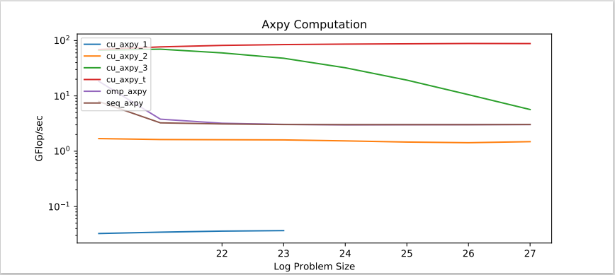

Question 4: