A Set of Histology Markers for Esophageal Carcinoma – TCGA Data Mining
Abstract

Backgound: Esophageal carcinoma is 8th top cancer over the world. In 2020, it caused 604,100 new cases, accounting for 3.1% of total cancer cases following cervix uteri carcinoma. In 2020, it caused 324,422 new cases, accounting for 7.1% of all cancer cases that year. The incidence rate is more than twice world average. Efforts need to be urged in order to improve the specificity and sensitivity of the diagnosis of esophageal carcinoma. There are two common histological forms of esophageal carcinoma: esophageal squamous cell carcinoma (ESCC) and esophageal adenocarcinoma (EAC). They are named after the type of cell that becomes malignant. The prognosis and treatment for patients with esophageal carcinoma depends on an accurate and reliable assessment of the histological type
Methods: In this study, we first screened for the differentially expressed genes (DEGs) and clustered the genes into functional modules based on the weighted distance of WGCNA. Next we calculated its enrichment score of each module. This score was used to train a support vector machine model as a classifier to classify unknown cases. Finally, the performance of the classifier was evaluated and validated on five independent GEO datasets for the histological type and prognosis of oesophageal carcinoma cases
Results: As a results we identified a DNA binding function module that associated with the histological type and prognosis of patients with esophageal carcinoma.
Conclusion: The association between the DNA-binding module and poor prognosis may be due to its inclusion of genes associated with embryonic stem cell differentiation. As a result, their expression varies considerably between cell types or cell cycles. These genes make the module a potential prognostic marker in liquid biopsy.

Keywords: aaaaaaaaa

1. Introduction
Esophageal carcinoma is 8th top cancer over the world. In 2020, it caused 604,100 new cases, accounting for 3.1% of total cancer cases following cervix uteri carcinoma¹. China is an esophageal cancer high risk country. Since 2020, esophageal carcinoma has become the fifth common cancer following liver cancer in China. In 2020, it caused 324,422 new cases, accounting for 7.1% of all cancer cases that year. The incidence rate is more than twice world average². Efforts need to be urged in order to improve the specificity and sensitivity of the diagnosis of esophageal carcinoma.
There are two common histological forms of esophageal carcinoma: esophageal squamous cell carcinoma (ESCC) and esophageal adenocarcinoma (EAC). They are named after the type of cell that becomes malignant. The ESCC forms in the thin, flat cells lining the inside of the esophagus. It is most often found in the upper and middle part of the esophagus. The EAC begins with glandular cells in the lining of the esophagus which produce and release fluid, such as mucus, which usually forms in the lower part of the esophagus close to the stomach. The prognosis and treatment for patients with esophageal carcinoma depends on an accurate and reliable assessment of the histological type and stage, as the risk of lymph node metastasis is associated with these clinical features. Fox example, the risk of high-grade dysplasia in patients with Barrett's oesophagus is close to zero, compared with a risk of only 1% to 2% in patients with stage I tumours³.
Today, circulating tumour cells (CTCs) are gaining interest as a new target for liquid biopsies. In combination with qPCR or single-cell sequencing, it has the potential for diagnosing pan-cancer in µl of blood. By using appropriate markers, not only the types of cancer can be identified, but also other clinical features, such as histological types, prognosis, etc. There are many researchers working on prognosis and drug sensitivity studies. However, so far there are no reliable markers for the histological type of esophageal carcinoma. In this study, we first used the cibersortX tool to screen for the differentially expressed genes (DEGs) and clustered the genes into functional modules based on the weighted distance of WGCNA. Next ssGSVA was applied to each module to calculate its enrichment score. This score was used to train a support vector machine model as a classifier to classify unknown cases. Finally, the performance of the classifier was evaluated and validated on five independent GEO datasets for the histological type and prognosis of oesophageal carcinoma cases. As a results we identified a DNA binding function module that associated with the histological type and prognosis of patients with esophageal carcinoma. This will allow us to determine the histological type of esophageal carcinoma.
2. Methods and Material
2.1 Cohort selection
Initially, the marker mining work used the TCGA esophageal carcinoma dataset as a discovery cohort. The 198 cases with normalized gene expression (pancan normalized) were downloaded from USCS Xena⁴. We also used four GEO datasets (GSE155186, GSE165252, GSE44021, GSE112926) to validate the signature of esophageal carcinoma histologic type and one GEO dataset (GSE53625) to validate the correlation between signature and prognosis.
2.2 Function modules discovery
CibersortX as a machine learning method was applied to infer cell-type-specific gene profiles. It used normalized expression data and the histology information of each case as input to filter out hundreds of genes that formed linear correlation with the lowest p-value (cutoff 10-6). The similarity of each pair of genes was calculated and clustered by WGCNA⁵. The selected function modules in the cluster tree was enriched. The enrichment score for each case was calculated by ssGSEA⁶.
2.3 Feature selection and validation
We performed a forward step-wise support vector machine model to select a module combination that has the maximum mean F1 score using a customized python script⁷. It started from a single module and add one another for each iteration till a maximum mean F1 score was obtained. Meanwhile stratified random cross-validation was applied and repeated twenty times in each iteration to prevent from over-fitting. The final F1 score for each iteration was the average result of all cross-validation repeated results.
2.4 Survival analysis and visualization
Using the "survival" R package, the univariate and multivariate Cox regression analyses were performed for analyzing associations of the levels of DNA binding with overall survival. Consequently, powerful prognostic genes were screened out and then risk scores were calculated for all ESCC patients. Based on the median risk score, all patients were divided into high and low risk groups. We used Kaplan-Meier curves to show the relationship between risk scores and overall survival. The log-rank test was employed to test the statistic difference with the significance level p-value < 0.05. Using the “timeROC” package (version 0.4), the survival receiver operating characteristic curve (ROC) with the area under the curve (AUC) value was visualized. Gene set enrichment analysis (GSEA) was carried out to evaluate association of immune pathways with the TME-related risk score. p-value < 0.05 indicated statistical significance.

3. Results
3.1 Cohort information
The mean-normalized gene RNA expression data for TCGA esophageal cancer was downloaded from the UCSC Xena datahub⁴. It used as a discovery cohort and compared with other sources of esophageal cancer data. The cohort contains 196 cases, but only 181 of them have histological diagnosic information, including of 87 EACs and 94 ESCCs. The other clinical information was displayed in Table 1. Four GEO datasets (GSE155186, GSE165252, GSE44021, GSE112926) were used as the validation cohort. A total of 128 EACs and 139 ESCCs were included.
3.2 Gene set signatures for EAC and ESCC
First, we fed the TCGA normalized expression data and sample types to CibersortX⁸ as reference to generate a signature matrix. CibersortX uses unsupervised machine learning to infer the cell-type- or sample-type specific signature geneset. In total, 808 genes were identified as signatures. Hereby we considered a gene to be down-regulated if its expression was lower than ESCC in EAC cases and up-regulated otherwise. The down- and up-regulated genes in the signature were further clustered into different modules by WGCNA distance to narrow down the signature space capacity. The functions of the modules could be enriched simply by Fisher's exact test or GSEA into different catalogs by g:Profiler online tool. Figure 1 and Supplementary Table S1 show only the most important function modules enriched into GO database⁹ as genesets that could be further used in ssGSVA analysis. The down-regulated genes were clearly more differentiated accomplished. The largest branch - 'epidermis development' - was classified into extracellular regions and intermediate filaments based on cellular component. Other significant modules include DNA binding and cell differentiation. The functions of the up-regulated genes were mainly concerned with digestion, but they were sparsely distributed in the signature space and do not form a clear module. The only exception was brush border assembly, indicating that these genes were most likely to have fluctuating expression in the brush border membrane and microvillus regions.
Next we used ssGSVA to estimate the variation of each function module over GEO validation cohort in an unsupervised manner. It calculates sample-wise genomic enrichment scores as a function of genes inside and outside the gene set. Hereby each function module in the WGCNA contains a gene set. Due to the limited number of gene sets, we were able to enumerate the scores of all the gene set combinations on the different classifiers (Supplementary Table S2). Although adding gene sets to the signature space could increase sample resolution and leads to better sensitivity and specificity, users have to use more probes and more expensive arrays. To gain a better balance of cost and performance, we finally selected the DNA binding gene set as a single signature from five candidate gene sets candidates (DNA binding, cell differentiation, extracellular region, intermediate filament and brush border assembly). Linear kernel support vector machine or SVM classifier was applied to fit and predict the enrichment scores on GEO validation cohort to evaluate the resolution for EAC and ESCC cases. Meanwhile the same method was also employed for TCGA discovery cohort as a positive control. Figure 2 indicates the performance of the SVC model in distinguishing between the two types of esophageal cancer. When using the DNA binding module, the AUC was approximately 0.961 and p-value (Fisher's Exact Test) was less then 10e-26 (Figure 2). It is natural that the classifier has better performance on TCGA discovery cohort as reference than the third-party GEO data. Nonetheless, its sensitivity and specificity were still larger than 0.9 (Table 2).
3.3 DNA binding can acts as a solo stage-irrelevant prognosis factor
Zheng et al. obtained an immune cell atlas (TME signatures) of ESCC consisting of CD4⁺, CD8⁺ T and NK cells etc¹⁰. This atlas contributes to the immunosuppressed state and disease progression, altering the underlying immunosuppression in TME. In addition, the authors also found a turquoise module that was positively correlated with monocyte clustering. This module was also acclaimed to be significantly associated with survival in ESCC patients. The atlas was composed of 12 modules of 459 genes, including a turquoise module of 50 genes (Supplementary Table S3). In order to elucidate the TME variations between EAC and ESCC cases and the performance on predicting prognosis of esophageal cancer, we compared the enrichment scores on same esophageal cancer cases using TME signatures and DNA binding signatures. In terms of TME signature, enrichment scores were significantly higher in EAC than in ESCC cases, suggesting that the two types of esophageal cancer display different immune status. Although TME slightly outperformed the DNA binding signature in terms of sensitivity (95.0% vs. 90.6%) and specificity (96.9% vs. 94.5%) (Supplementary table S1). 459 genes were much more numerous than 22 genes in the DNA binding signature. This means that a larger array or whole transcriptome sequencing had to be employed to get solid results from TME signature.
The survival function module in TME signature contains six genes (IFNGR1, IFNGR2, IDO1, IL10, CD163, CD274) that were supposed to be associated with survival. Interestingly, we found a very weak correlation (log-rank test p-value of 0.19) between ssGSVA scores of the six-gene survival module and survival time in ESCC cases in our TCGA discovery cohort (data not shown). On the contrary, a much more solid association between DNA binding signature scores and survival was identified in esophageal cancer cases in the TCGA discovery cohort and it was further validated in the independent GEO dataset (GSE53625) (Figure 4). A greater enrichment score for DNA binding signature leaded to a poor prognosis. Multivariate Cox regression showed no correlation between DNA binding signature and cancer stage, histology and therapy (Supplementary Table S4). It suggests that the DNA binding signature has a potential to be a solo stage-irrelevant prognosis indicator for esophageal cancer.

4. Discussion
Previously, many researchers have focused on survival prediction in patients with esophageal carcinoma and revealed a variety of markers associated with esophageal carcinoma prognosis. These makers could be mainly classified into three types: lncRNA markers (BC200¹¹, loc285194¹², RP5-1172N10.2 ¹³, MALAT1¹⁴, H19¹⁵), protein markers (p53 and nine other proteins¹⁶, stathmin¹⁷, CD133¹⁸, nucleostemin¹⁹, p97²⁰, KLF17²¹, HMGB3²²), and the cytological markers (M2 macrophages²³).
In this study, we first extracted a superset of 808 DEGs between ESCC and EAC from 181 TCGA esophageal carcinoma cases using the cibersortX⁸ tool. A hierarchical tree was built based on the WGCNA expression pattern distance. The clusters from the tree clearly showed that there were five functional modules of alteration between the two types of esophageal carcinoma. They are DNA binding, cell differentiation, extracellular region, intermediate filament and brush border assembly. These findings confirm the role of different DEGs and function modules in the extracted gene supersets. These five modules were further evaluated by ssGSVA and SVM model (Supplementary table 2). We found that although the combination of all five modules as features would maximize the performance of the classifier model. It has limited or minimal effect on increasing the total specificity and sensitivity compared to the DNA binding alone. Finally only the DNA binding module was used as a histological marker for esophageal carcinoma. In the TCGA discovery cohort, it could achieve 92.5% sensitivity and 97.7% specificity (Table 2). The DNA binding module contained 22 genes including FOXD3, Homeobox family genes and DUSP9 etc. (Supplementary table 1). Some of these genes have been studied separately and have been identified to be associated with tumor development. For example, FOXD3 (encoding the forkhead box protein FoxD3), a transcriptional regulator, is predominantly expressed in embryonic stem cells. It is generally down-regulated during early endoderm formation²⁴ and is a major regulator of the developmental potential of embryonic stem cells and ectodermal cells²⁵. Some researchers have found that FOXD3 is abnormally hypermethylated in human ovarian cancer, making it a potential cancer marker²⁶. All three Homeobox family genes (HOXD10, HOXD11, HOXD13) play an important role in cell differentiation, and their dysregulation leads to hepatocellular carcinoma²⁷, colon cancer²⁸, genital abnormalities, and limb abnormalities²⁹. DUSP9 (dual-specificity phosphatase 9) belongs to the dual-specificity protein phosphatase subfamily. It is a strong negative regulator of transcription factor activating kinases (ERK, JNK and p38) in the mitogen-activated protein kinase (MAPK) pathways³⁰. It is down-regulated and methylated in colorectal cancer³¹ and cenal cell carcinoma. DLX6-AS1 was found to promote neuroblastoma progression³² as an lncRNA, while MLF1 was associated with acute myeloid leukemia and myelodysplastic syndromes³³. To further validate the marker, we also tested it in a validation cohort mixed by four independent GEO datasets. It had a sensitivity of 90.6%, a specificity of 94.5% and could give an AUC value of 0.961 in the ROC analysis. This is identical to the performance in the discovery cohort, meaning that the single DNA binding module combined with SVC model conditioning did not overfit the TCGA data and allowed them to be used as histological markers between EAC and ESCC.
We next compared our DNA-binding module with the TME-signed turquoise module, which is thought to be associated with progression-free survival in ESCC as well as in cervical squamous cell carcinoma and lung squamous cell carcinoma, and as a prognostic biomarker for squamous cell carcinoma in ESCC and other tissues. Unfortunately, we were unable to observe a strong correlation between survival and ssGSVA enrichment score for ESCC cases in the TCGA cohort (log-rank test p-value of 0.19). Meanwhile, we identified that our DNA binding module was enriched for poor prognosis ESCC cases in the TCGA data and was validated in the dataset GSE53625 (log-rank test p value 0.005). The association between the DNA-binding module and poor prognosis may be due to its inclusion of genes associated with embryonic stem cell differentiation. As a result, their expression varies considerably between cell types or cell cycles. These genes make the module a potential prognostic marker in liquid biopsy.
References

Figure legends
Figure 1 The annotated tree clusters based weighted expression pattern for regulated genes. Branches formed by gene modules in the tree were highlighted. Left: down-regulated genes Right: up-regulated genes.

Figure. 2 A and B. The ROC and classification score of DNA binding module for 181 ESCC and EAC cases in TCGA cohort. C and D The ROC and classification score of DNA binding module for 267 ESCC and EAC cases in four GEO datasets (GSE155186, GSE165252, GSE44021, GSE112926).
The

Figure. 3 The ROC and classification score of TME signatures for ESCC and EAC cases.

Figure. 4 The Kaplan-Meier curves of DNA binding module as stage-irrelevant prognosis factor on (a) TCGA cohort. (b) GEO dataset (GSE53625).
Figure

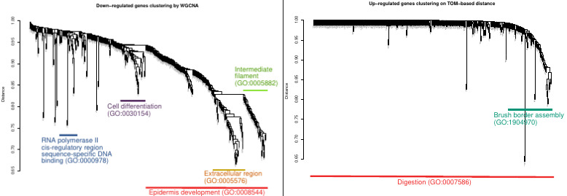
Figure.1

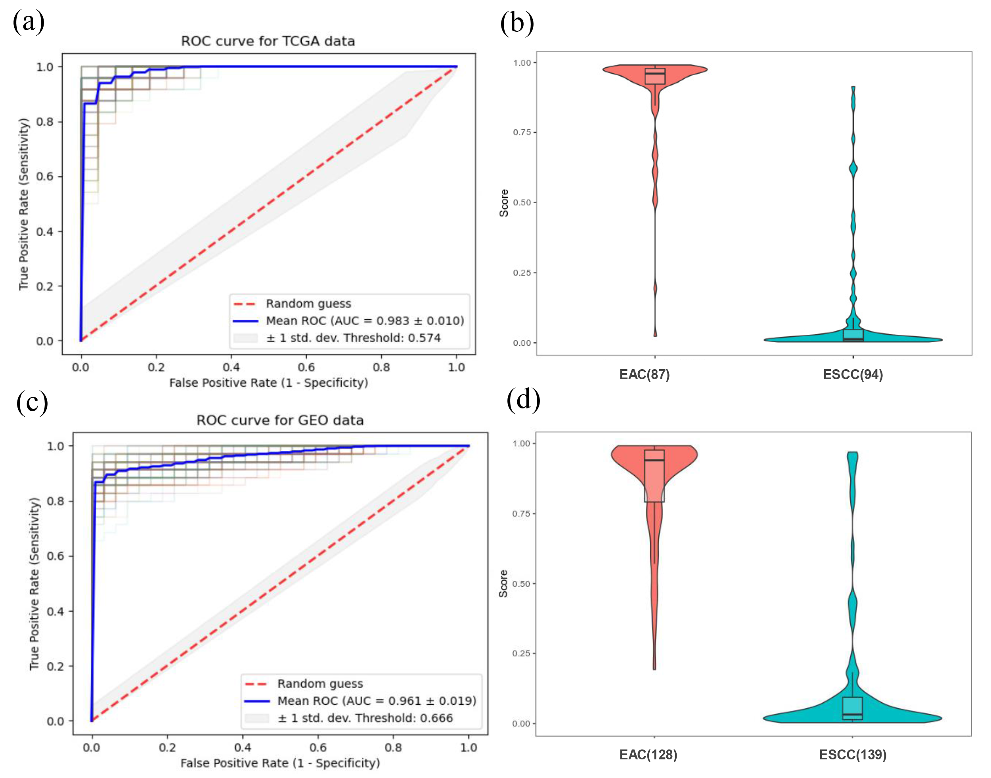
Figure. 2

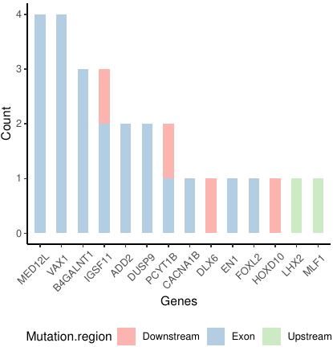

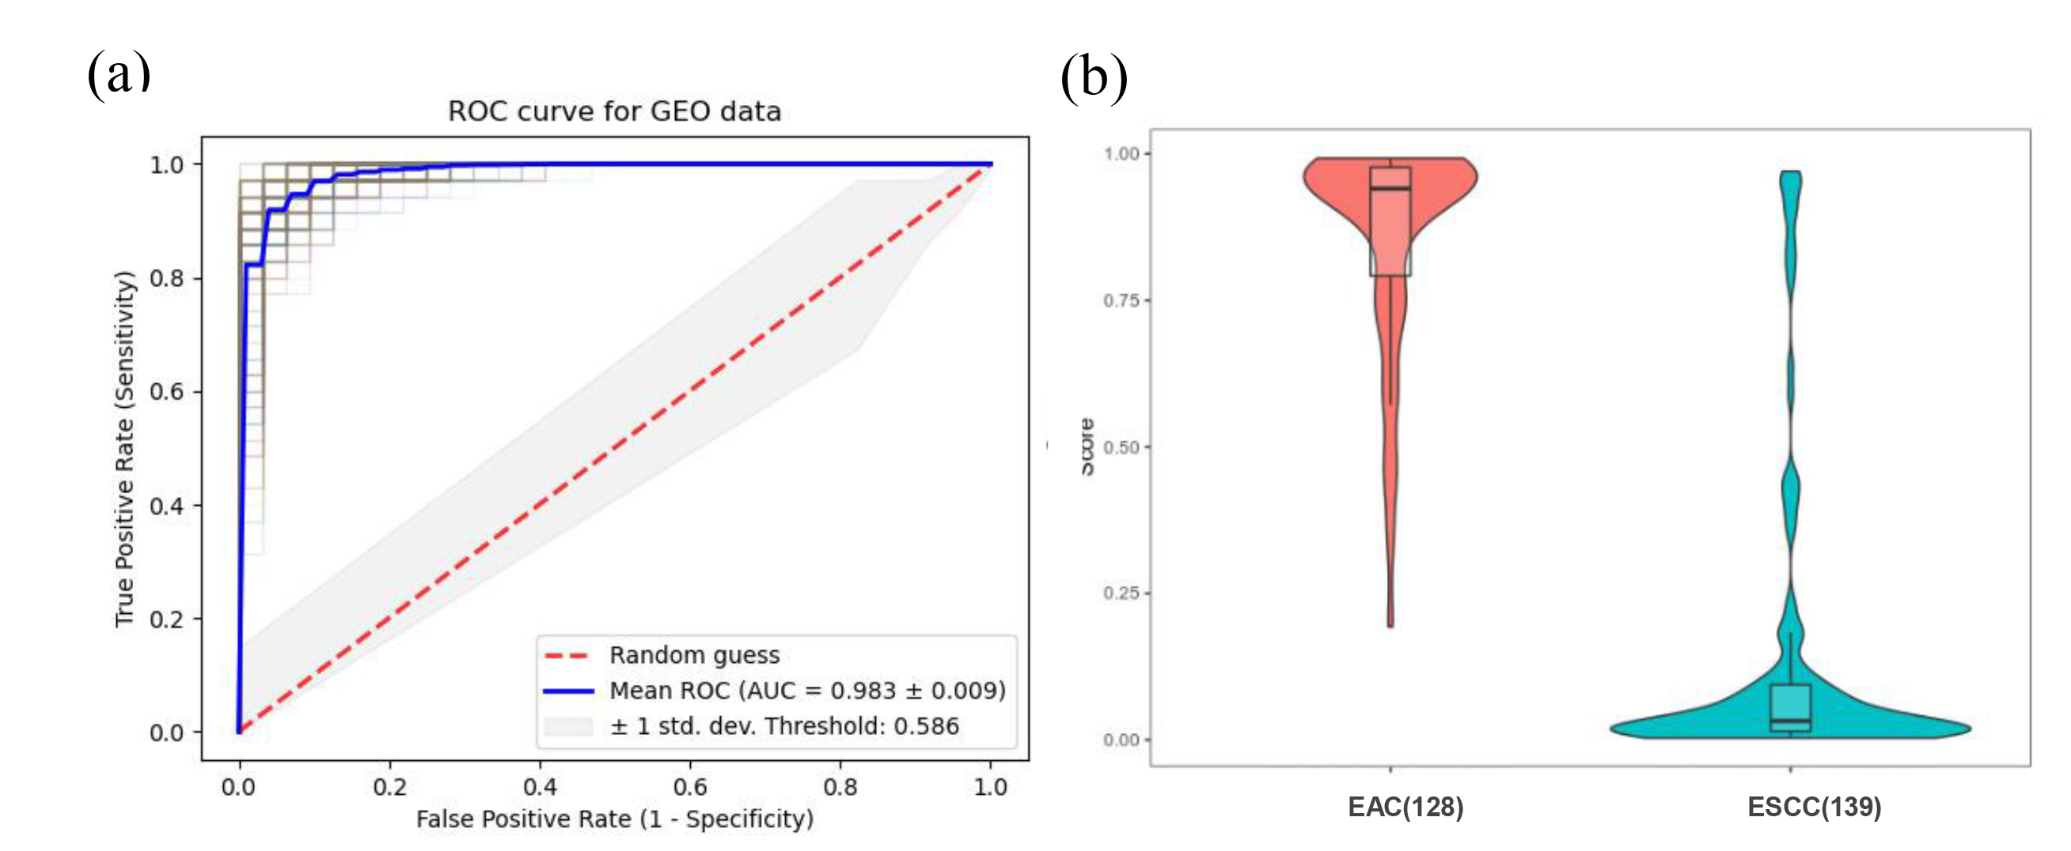
Figure. 3

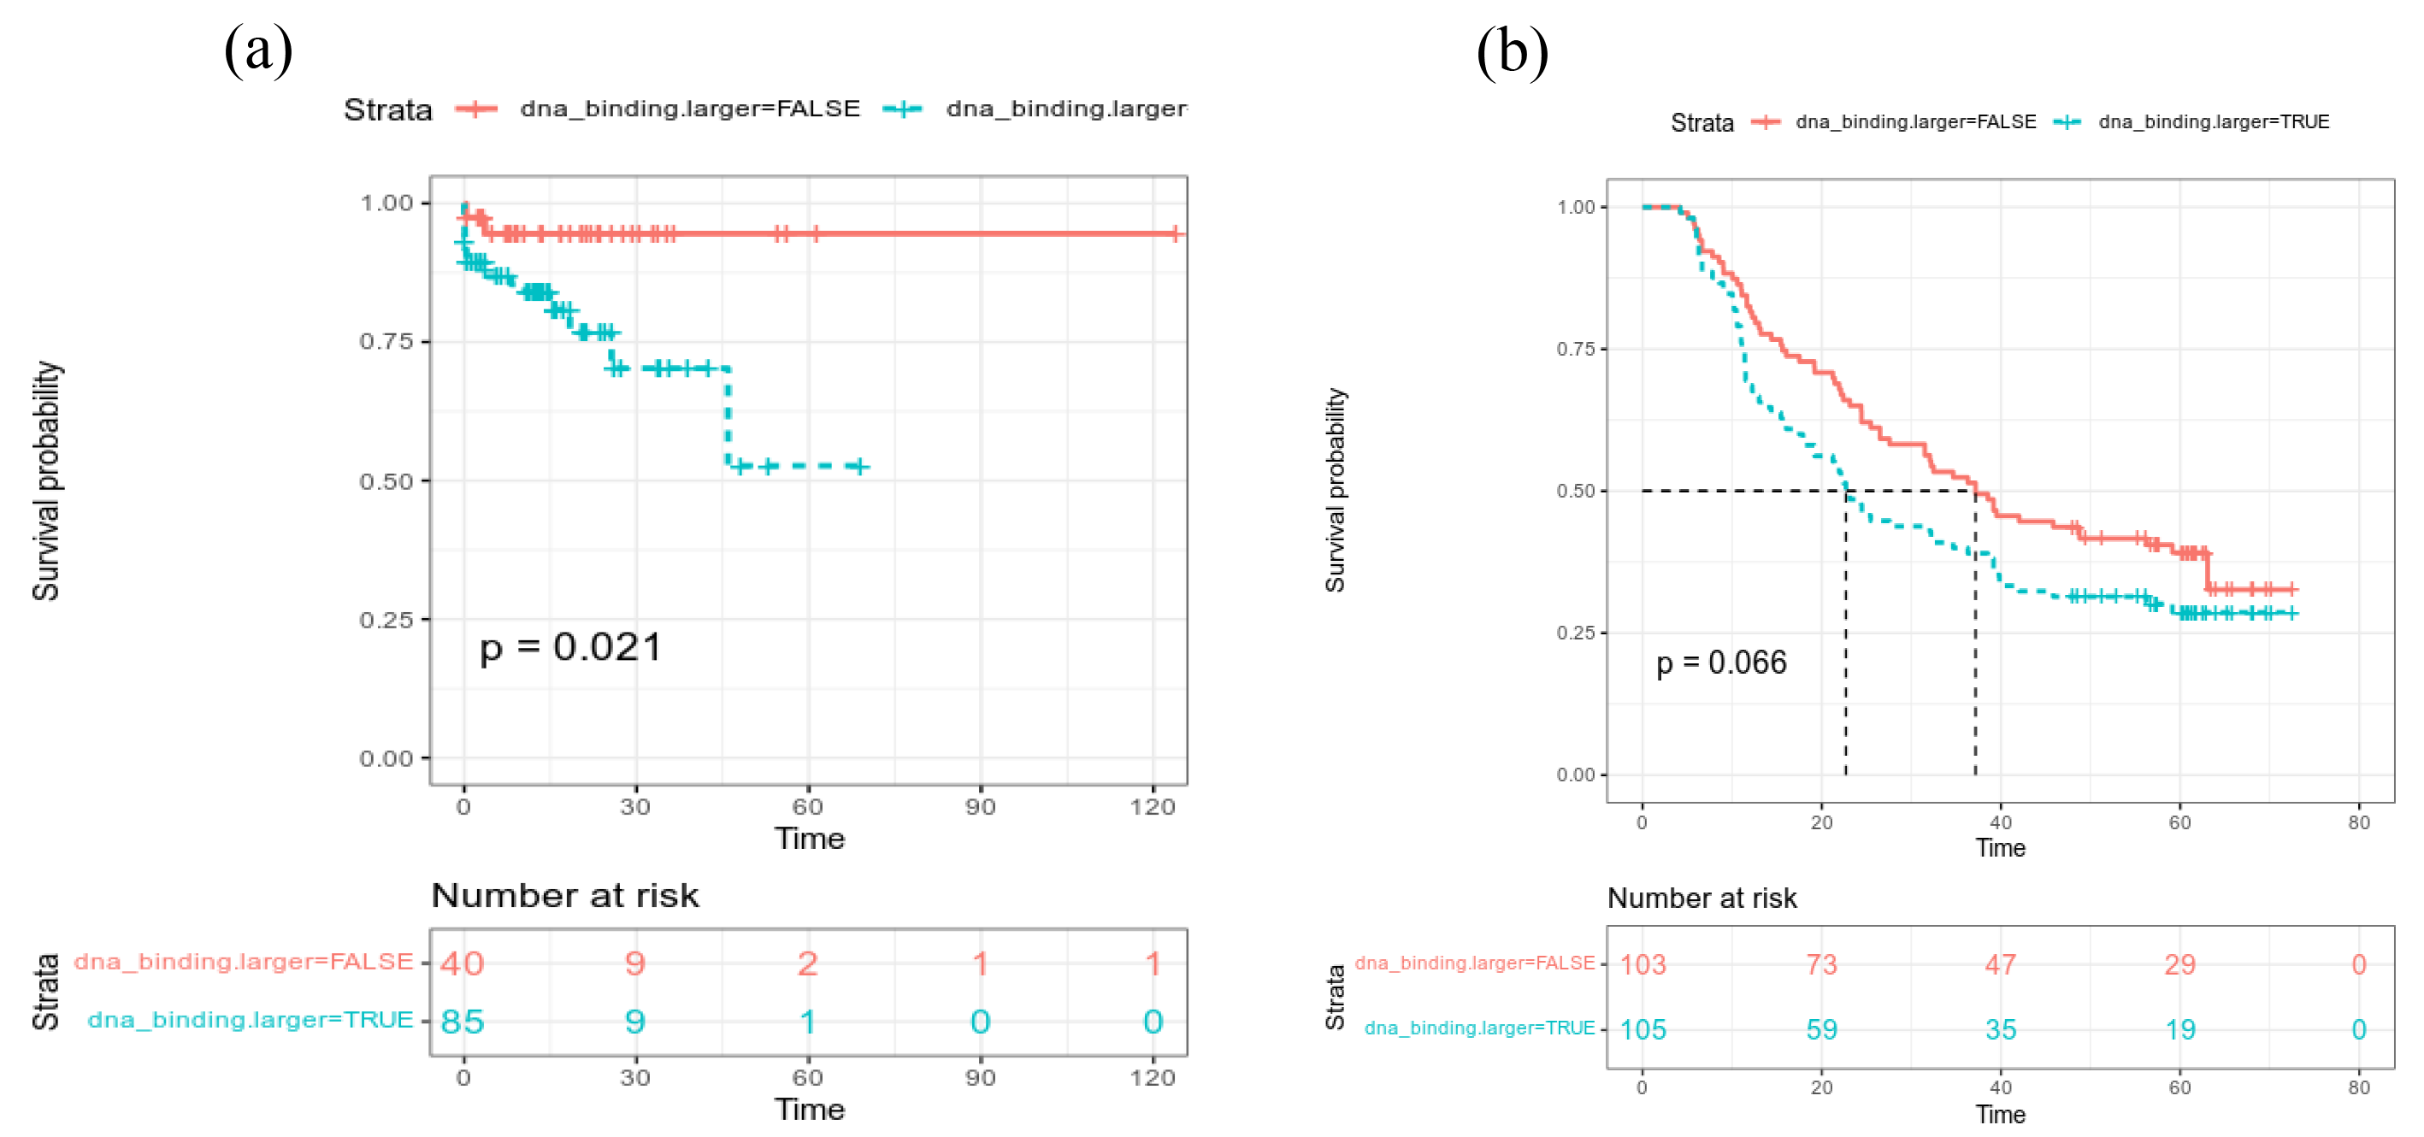
Figure. 4
Table
Table. 1 Clinical features of patients with esophageal carcinoma in TCGA
Clinical features | Count (%) (n = 181)
Status
Alive | 106 (58.6)
Dead | 75 (41.4)
Gender
Male | 156 (86.2)
Female | 25 (13.8)
Survival records
Recorded | 125  (Min. 0 month  Median 13.0 month  Max 123.8 month)
Not Recorded | 56
Stage
I | 18 (9.9)
II | 77 (42.5)
III | 54 (29.8)
IV | 9 (5.0)
Not recorded | 23 (12.7)
Histology
EAC | 87 (48.1)
ESCC | 94 (51.9)
Pharmaceutical
Yes | 52 (28.7)
No | 129 (71.3)
Radiation
Yes | 62 (34.2)
No | 119 (65.8)

Table. 2 Performance of SVM classifier on discovery and validation cohort
Cohort | Sensitivity | Specificity | AUC | F1 Score
Discovery (TCGA) | 92.5% | 97.7% | 0.983 | 0.951
Validation (GEO) | 90.6% | 94.5% | 0.961 | 0.926

