Supplementary Information

for

Comparison of Three Next Generation Sequencers on Their Basecall Error Rates and Bias Patterns

Tianran Yao¹, Huihua Xia¹, Yongyi Lu¹, Wei Chen¹, Guoli Fu¹, Gailing Li¹, Qingbin Chen¹, Yuanye Bao¹, Luyang Zhao¹, Erkai Liu^{1,}*, and Gufeng Wang^{1,}*

1. Shenzhen Salus BioMed Inc. Ltd., Shenzhen, Guangdong, China,

Figures and Captions

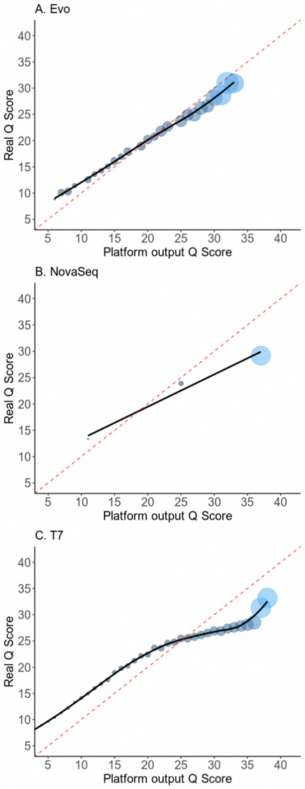

Figure 1. Real Q vs reported Q characterized using human NA12878 samples. Real Q is represented as the -10*log(mismatch rate). The size of the dots represents their relative abundance.

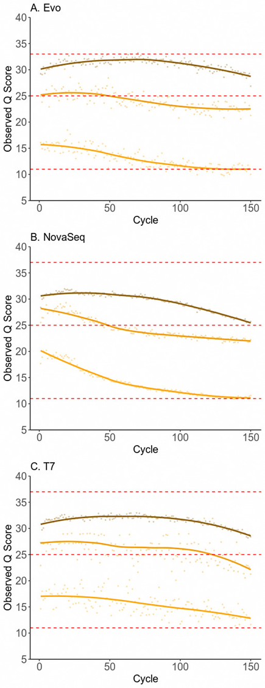

Figure 2. Accuracy of reported Q scores as a function of cycle number using human NA12878 samples. Observed Q scores are represented as the -10*log(mismatch rate).

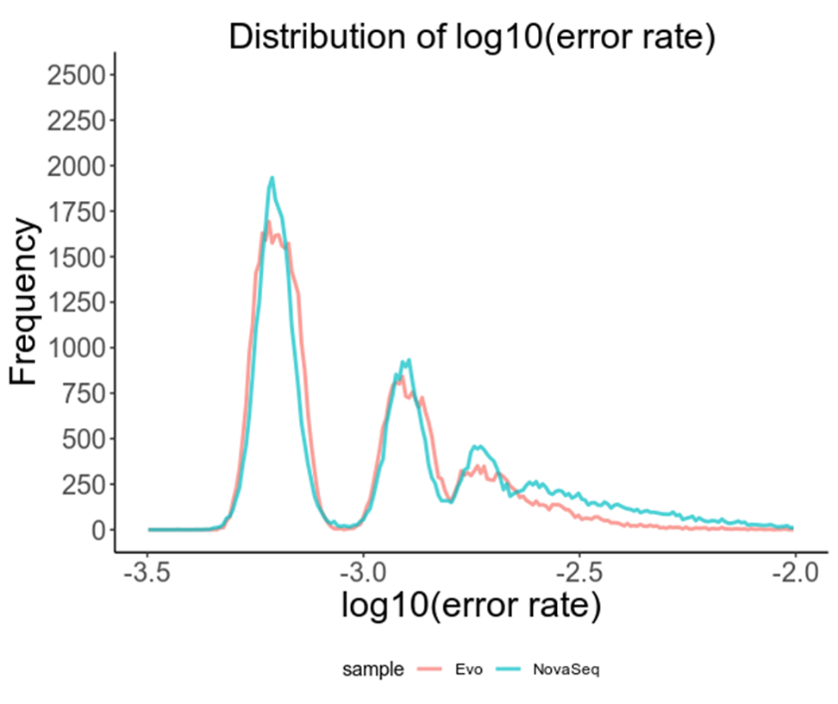

Figure S3. Error rate distributions for 100,000 random sites on E. coli genome. The bioinformatic filtration condition for Salus EVO data was loosened so that its overall error rate is slightly higher than that of NovaSeq.

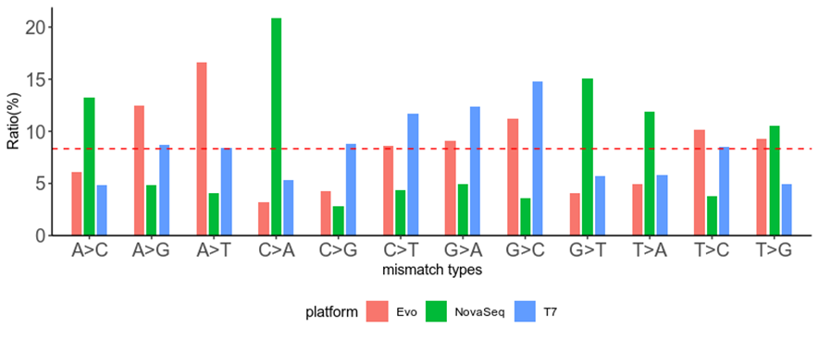

Figure S4. Histograms of 12 single base substitution mismatch types from human NA12878 samples.

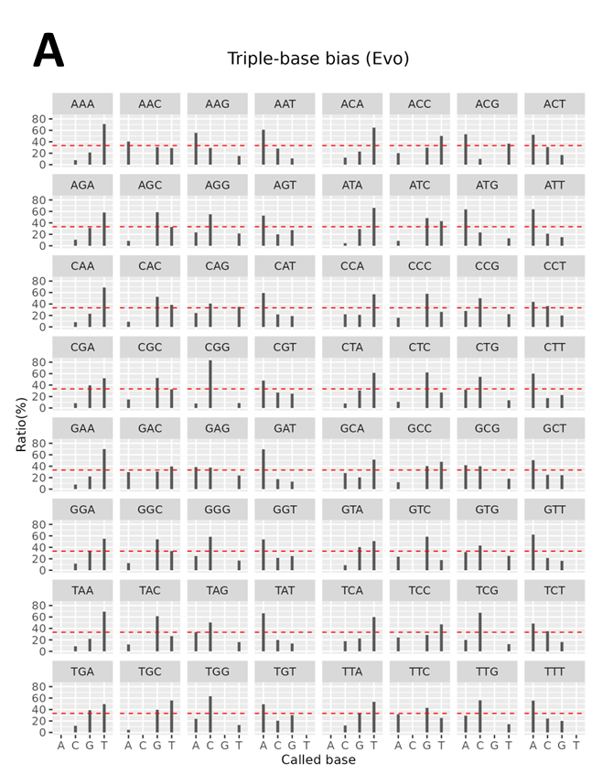
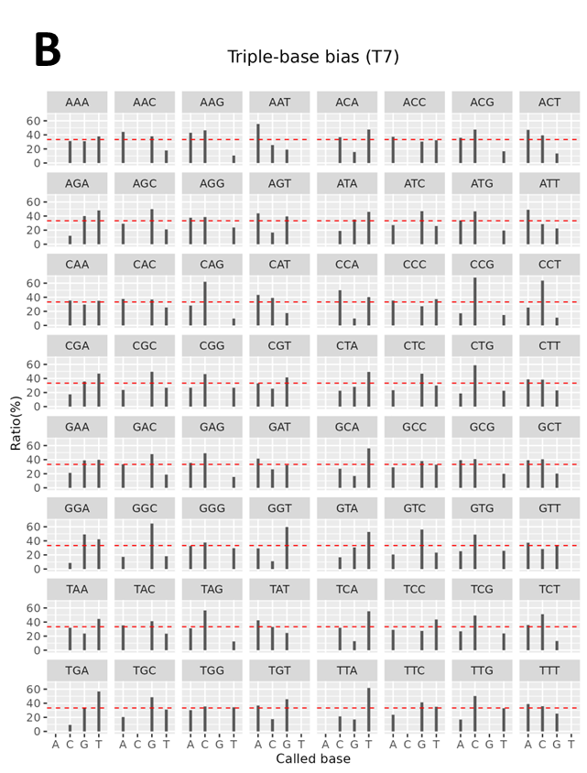

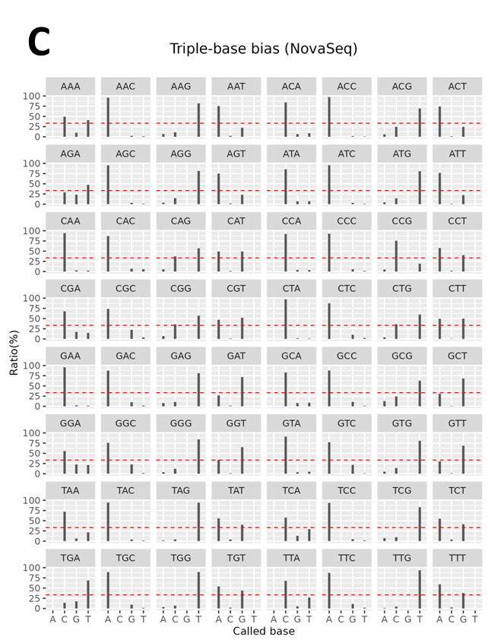

Figure S5. Histograms of 3 single base substitution errors for each of all 64 types of tri-bases with the last one being the erroneous one. Human NA12878 samples. The x-axis shows the base that was mistaken for. (A) Salus EVO. (B) DNBSeq-T7. (C) NovaSeq.

