Comparison of Three Next Generation Sequencers on Their Basecall Error Rates and Bias Patterns

Tianran Yao¹, Huihua Xia¹, Yongyi Lu¹, Wei Chen¹, Guoli Fu¹, Gailing Li¹, Qingbin Chen¹, Yuanye Bao¹, Luyang Zhao¹, Erkai Liu^{1,}*, and Gufeng Wang^{1,}*

1. Shenzhen Salus BioMed Inc. Ltd., Shenzhen, Guangdong, China,

Abstract
We compared basecall error rates and error bias patterns for three high-throughput next generation sequencers: NovaSeq 6000, DNBSeq-T7 and Salus EVO. Their overall error rates fall in the 0.05~0.1% range: EVO (0.065%), T7 (0.068%) and NovaSeq (0.091%). All instruments show a declined accuracy for reported Phred Q values over sequencing cycles, with EVO giving the highest stability. Despite of their similar overall error rates, the three instruments show large difference in their performance on variant calls. Using a threshold of mutation frequency of 0.5%, NovaSeq called 1782 false positive variants out of 100,000 sites where as T7 and EVO called 210 and 104, respectively. Basecall error rate distributions discloses that there are significant non-random errors in the basecalls, which are the major cause for false positive variant calls. Further analysis shows that different sequencers have different error bias patterns including those sequence context-dependent and -independent. The instrument design and the polymerase used in the sequencing-by-synthesis approach determine the basecall accuracy of a sequencer.

Graphical abstract
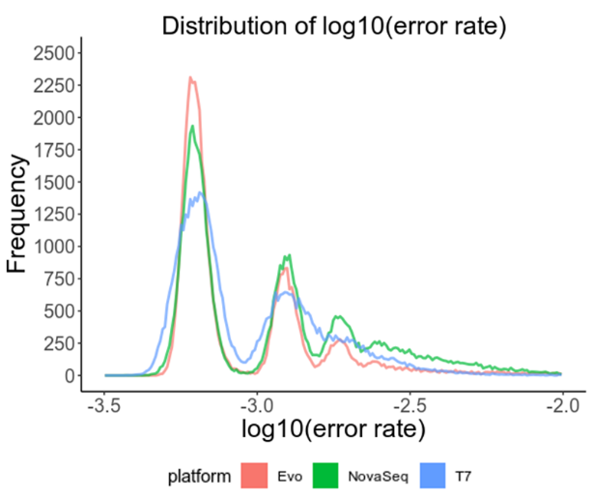

Error rate distributions for three high-throughput sequencers.

keywords: Next generation sequencing, basecall, variant call, false positive, Salus EVO, DNBSeq-T7, NovaSeq 6000

Introduction
Next generation sequencing, also known as massively parallel sequencing, has become an indispensable tool in both clinical diagnosis and basic research. Its applications include but not limited to tumor early-stage screening, individual medicine, and prognosis inference by minimal residual disease (MRD), etc. Many of these applications are based on solid germline and/or somatic variant calls, which largely rely on basecall accuracy of DNA sequencers. However, there are much artifacts and background errors for basecalls coming from each step of the broadly defined “sequencing” including sample preparation, nucleotide extraction, library preparation, and the specifically defined “sequencing” step, i.e., obtaining oligo sequences on a DNA sequencer (1-7). (To avoid confusion, we refer “sequencing” to the specifically defined sequencing step in this manuscript). The fundamental for a DNA sequencer is its ability to obtain accurate oligo sequences, i.e. sequencing accuracy or basecall accuracy.
Current manufacturers usually report the accuracy performance of their NGS sequencers by how much high quality basecalls the sequencer can provide in a sequencing run, e.g., Q30 > 85%, which means that over 85% of the bases called have a Phred Q score over 30, or their error rates <0.1%. The overall basecall error rates are on the 0.1% level for most of current NGS sequencers. While these parameters are important, it has been noted that variant call accuracy in different applications is more susceptible to biased basecall errors rather than by random errors given a similar overall error rate (Scheme 1). For this reason, much effort has been given to characterize their basecall error profiles for different NGS sequencers such as Illumina Genome Analyzer (GA) (8), MiSeq (9) and HiSeq (10), etc. For examples, Hoffman et al. reported that substitution is the major error type for Illumina sequencers in early times (11). Dohm and coworkers discovered that substitution occurs more frequently in the GC-rich regions since the CCG motif is one of the triggers for such single base errors (12). The authors also claimed that the base-specific miscalls A-to-C and C-to-G are observed more often than the others. Many researchers agreed that the quality of the Illumina sequencer reads is significantly lower in the later cycles.
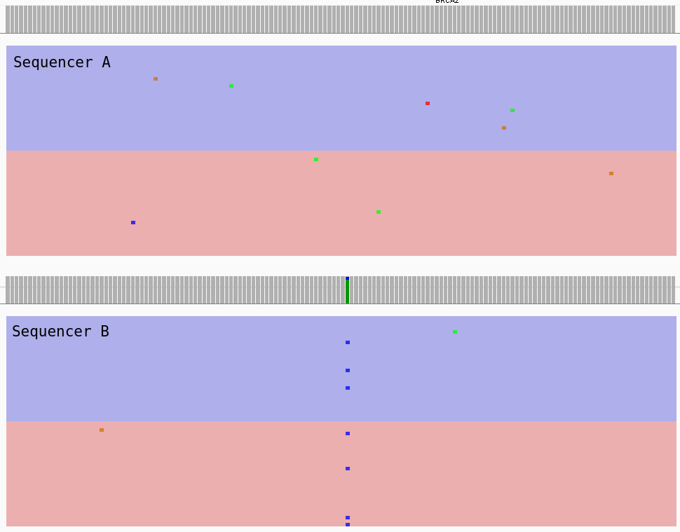
Scheme 1. Illustration of how variant call is more susceptible to biased miscalls. Biased basecall errors at a specific site (Sequencer B) are more likely to generate a false positive variant call as compared to random errors (Sequencer A) given their overall error rates are similar.

Recently, there are new instruments emerging in the sequencing market. Their error rates and error profiles have not been systematically characterized. In this manuscript, we compare three high-throughput sequencers available on the market: 2 samples from NovaSeq 6000 (referred to as NovaSeq), 2 samples from DNBSeq-T7 (referred to as T7), and 6 samples from EVO. Their claimed basecall accuracy is similar: Q30>85% for standard PE150 sequencing. We are especially interested in their basecall error bias patterns, which have a profound impact on the downstream bioinformatic analysis.

Materials and methods
Samples
Monoclonal Escherichia coli ATCC8739 strain was purchased from the Institute of Microbiology, Guangdong Academy of Sciences Guangdong Microbial Culture Collection Center (GDMCC). The bacteria were cultured for ~13 hours (~40 generations) in house before being used. Its genome sequence was assembled using Sanger sequencing at Sangon Biotech (Shanghai) Co., Ltd. Human NA12878 genomic DNA was purchased from Coriell Institute (Haddon Avenue Camden, NJ 08103, USA) and used directly.

Library preparation
Escherichia coli DNA was extracted using the Bacterial Genomic DNA Extraction Kit (TIANGEN Biotech, Beijing, DP302-02). DNA library preparation was using VAHTS Universal Plus DNA Library Prep Kit for Illumina V2 (Vazyme, Nanjing). Library construction from extracted DNAs consisted of the following procedures: DNA fragmentation, end-repair, “A” nucleotide attachment at the 3’end, adapter-ligation for sequencing at both ends, and two cycles of polymerase chain reactions (PCR). All prepared libraries were quantified using 1× dsDNA HS Assay Kit (Vazyme, Nanjing), and analyzed on a LabChip GX Touch/GXII Touch bioanalyzer to examine DNA fragment sizes. The as prepared DNA libraries have a concentration of ~20~40 ng/μL and a length of ~450-550 bp.

Sequencing
The same library was evenly split into ten copies. Four of the copies were sent to Sequanta Technologies Co., Ltd (Shanghai, China) for sequencing on DNBSeq-T7 and Illumina NovaSeq 6000 sequencers. Two for each platforms. Other six of the copies were sequenced on an EVO sequencer using the EVO Sequencing Kit (Cat. No. PRM-PE150) at Salus BioMed. PE150 dual-barcode mode was used for all WGS sequencing.

Bioinformatic analysis
The raw fastq files output from each sequencers were processed by fastp (13) to remove the adapters or reads with low quality. The low-quality reads are defined as those contain 15 or more basecalls with Q scores < 25. Clean reads were aligned to E. coli ATCC8739 and human hg19 genome reference accordingly by bwa-mem2 (14). E. coli genome reference was assembled using Sanger’s sequencing method by Sangon Biotech. Sambamba was used for duplication removal and other reads manipulation (15). Site and base call information was extracted by a python script get_position_info.py (https://github.com/yaotianran/get_position_info).
The mismatch rate of one genome site is defined as the ratio between the mismatch basecalls and the total bases sequenced aligned there. Since E. coli is a haploid microorganism all genome sites were included in the calculation of mismatch rate. For human NA12878 samples, only homozygous locus in GIAB variant calls VCF file (GRCh37 4.2.1 version) were included in the calculation (16).
The error rate is defined as the ratio between the erroneous basecalls and the total bases sequenced. For E. coli samples, the sequencing mismatches against the reference (from Sanger sequencing) could come from minor variants, PCR errors during library preparation, and the true sequencing errors. The mutation rate of E. coli has been well documented to be fewer than 1 in 10⁹ bases per generation (17). The high-fidelity polymerases used in library preparation introduces ~4 in 10⁶ bases (18). Thus, their combined contribution of mismatches was estimated to be on the scale of or less than 0.01%, which is much smaller than sequencing errors of current commercial DNA sequencers. Thus, the mismatch rate can be viewed as predominantly from sequencing errors, and was used as the sequencing error rate directly. For human NA12878 samples, the difference between the cell line genome and the reference is unknown. Thus, a mismatch rate can be calculated using the measured sequence while the absolute error rate is unknown.
For T7 and NovaSeq samples, we picked the one of two with less overall mismatch rate for further analysis. For EVO samples we merged the aligned bam files of six samples to obtain an average result and use GATK to down-sample to approximately same coverage as those from NovaSeq and T7.

Results and Discussion

Overall error rates
E. coli samples were all sequenced or down-sampled to ~1600×. The whole genome of human NA12878 was sequenced at ~30×. After receiving the data from the sequencing service provider, the data was fed to our bioinformatics pipeline including an additional cleaning step as described in the Materials and Methods section. In this way, all data were cleaned with the same standard so that a fair comparison can be made. The frequently used sequencing quality control parameters are listed in Tables 1 and 2 for E. coli and human NA12878 samples, respectively.
For E. coli samples, the raw Q30 values from the vendor for all 3 instruments are above 90%. After our bioinformatic pipeline filtration, all data show excellent quality (Q30>95%) except that DNBSeq-T7 shows a slightly lower clean reads rate (Table 1). The mismatch rates fall in the 0.05~0.1% range, with EVO (0.065%), follow by DNBSeq-T7 (0.068%), and NovaSeq (0.091%). These values are consistent with the literature reports.
The subsequent mismatches were used as sequencing errors directly (see Materials and Methods) for E. coli samples. All discussions about errors of E. coli samples are based on the observed mismatches.

Table 1. Sequencing quality of E. coli samples.
Sequencer | Raw Q30(%) | Clean Q30 (%) | Clean reads rate (%) | Mapping rate (%) | Mismatch (%) | Mean depth
EVO¹ | 92.7 | 95.9 | 91.3 | 100.0 | 0.0652 | 1596
NovaSeq 6000² | 93.4 | 95.3 | 91.9 | 100.0 | 0.0912 | 1601
DNBSEQ-T7² | 94.8 | 97.9 | 84.6 | 99.7 | 0.0676 | 1597
- The data is averaged from merged 6 samples
- Choose one of two samples for further analysis

Table 2. Sequencing quality of human NA12878 samples.
Sequencer | Raw Q30(%) | Clean Q30 (%) | Clean reads rate (%) | Mapping rate (%) | Mismatch (%) | Mean depth
EVO¹ | 92.2 | 96.0 | 87.8 | 100.0 | 0.392 | 30
NovaSeq 6000² | 91.7 | 94.3 | 87.8 | 99.9 | 0.408 | 31
DNBSEQ-T7² | 94.7 | 96.8 | 91.6 | 99.9 | 0.384 | 31
- The data is averaged from merged 6 samples
- Choose one of two samples for further analysis

For human NA12878 samples, the reported data qualities for 3 instruments are similar. However, the mismatch rates for all 3 instruments are similar to each other but significantly higher than those for E. coli samples. The mismatch rate in the 0.3~0.5% level is consistent with literature reports and is mainly contributed by minor mutations of the standard samples used. Thus, errors for human sample measurements are not discussed in this manuscript.

Basecall quality and stability over cycles
It has become a norm that sequencer manufacturers report a quality score (Phred Q value) for each base called, which are widely used by researchers for downstream data quality control and bioinformatic analysis (19-21). However, each manufacturer has his own proprietary algorithm in estimating, calibrating, and reporting the Q scores. The reported quality score stored in fastq files may deviated from the real quality (i.e., observed Q value) (22-24). To test their reliability, the real Q score (defined as -10*log(observed error rate)) for the three sequencers were compared using E. coli samples.

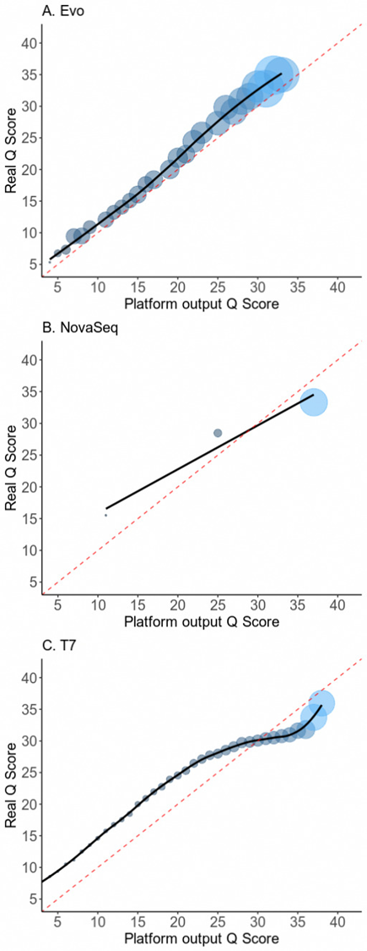

Figure 1. Real Q vs reported Q characterized using E. coli samples. Real Q is represented as the -10*log(observed error rate). The size of the dots represents their relative abundance.

Figure 1 shows observed Q vs reported Q for the 3 instruments using E. coli samples. In general, the observed Q~Q curves for all 3 instruments follow their diagonals, indicating the predictions (i.e. reported Qs) are reasonable. Among these, EVO gives a line most consistent with the diagonal. NovaSeq only reports 3 Q values: 11, 25, 37. The Q = 37 dot is under the diagonal, indicating this reported Q values is slightly overestimated. For DNBSeq-T7, most of the Q values between 5~30 are underestimated, while those between 30~40 are slightly overestimated.
For human NA12878 samples, since absolute error rate is not known, we used mismatch rate in calculating the observed Q’s. We obtained curves with similar trends, respectively, but all shifted towards lower observed Q’s (Figure S1). This is because mismatch rate is higher than the error rate, the estimated “real Q” score is thus significantly lower.

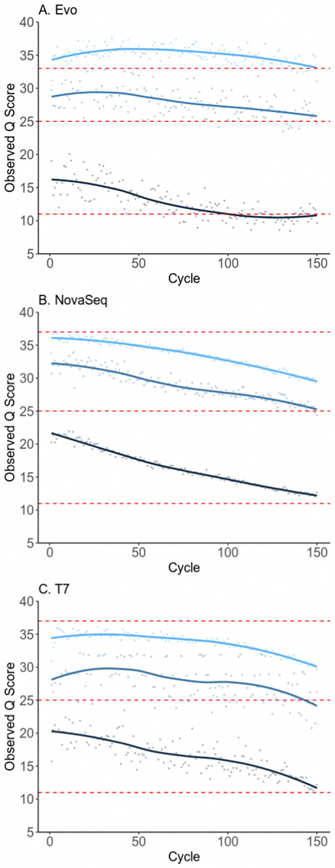
Figure 2. Accuracy of reported Q scores as a function of cycle number using E. coli samples. Observed Q scores are represented as the -10*log(observed error rate).

The accuracy of reported Q values has been shown to vary at different cycles of sequencing (12). We then analyzed the accuracy of the reported Q values at each cycle for the 3 instruments. Since there are many Q values for T7 and EVO, we selected 3 values for each of these two instruments, each representing high, medium, and low qualities, respectively.
Figure 2 shows that in general, the real quality for each reported Q for all instruments decreases with respect to the cycle numbers. However, their decreasing speed is different, with EVO has the most stable observed Q scores.
Using the human NA12878 samples, similar decreasing trends were obtained for all 3 instruments except that all observed Q scores are again down-shifted (Figure S2).

False positive rate for variant calls and single basecall error rate profile
Although the 3 instruments showed similar error rates, however, their performance in variant calls vary hugely. In Table 3, we show the false positive variant calls for E. coli samples using a threshold of mutation frequency > 0.5%. We looked into 100,000 random sites from the E. coli genome, NovaSeq called 1782 false positive variants, MGI called 210 false positive variants, and EVO called only 104 variants. When we limit the sites to those measured at high depth such as ≥1000× or ≥1500×, the conclusion is similar (Table 3).

Table 3. False positive rate for E. coli samples. Mutation Frequency (MF) > 0.005 in 100,000 sites.
 |  | Sites that consist of at least one allele with a MF > 0.005
Sequencer | Mismatch (%) | Total | Depth >= 1000 | Depth >= 1500
NovaSeq | 0.0912 | 1782 | 1757 | 1173
DNBSEQ-T7 | 0.0676 | 210 | 203 | 103
EVO | 0.0652 | 104 | 97 | 59
EVO (Loosened filtration condition) | 0.102 | 1050 | 997 | 682

It is surprising to note that the number of variants called by T7 and EVO is almost one order of magnitude lower than that by NovaSeq. Since the overall error rates vary for the 3 instruments, we loosened the bioinformatic filtration conditions for the data from EVO. Now that it has a mismatch rate of 1.02% (row 4 of Table 3), even a little higher than that of NovaSeq. It is apparent that the error rate has a huge impact on the number of false positive variants called. Still, the false positive variant calls by EVO are almost 2 times fewer than that by NovaSeq.
Why similar basecall error rates can lead to large difference in the number of false positive variants called? To have a closer look, we plotted basecall error rate distributions for 100,000 randomly selected sites from the E. coli genome in Figure 3. In Figure 3B, the x-axis represents the negative logarithm of the error rate of a site on the genome. The more to the right, the higher error rate a site has. The y-axis is the count of sites with that error rate.
The distribution shows a Poisson-like profile, with the largest peak at x = -3.2, which is 1 error out of ~1600 measurements. The second peak is at -2.9, which is 2 errors out of ~1600 measurements. The peaks are expanded because the sequencing depth is different for different sites. The peaks become indistinguishable for ~4 and above errors. For all 3 instruments, there are many sites with 0 errors. Since they cannot be plotted in a logarithm scale, the counts for 0-error sites are plotted in Figure 3A.
The error rate distribution profiles for the 3 sequencers are similar in general but show large difference at high error rate regions. NovaSeq has a remarkably long tail into the high error region, indicating that some of the sites are particularly prone to erroneous calls during sequencing, and these errors are NOT random. The high error rate sites are candidates for false positive variants, which is unfavorable. For T7 and Salus EVO, the tail portion is cleaner, with Salus EVO having the shortest tail among all 3 instruments.
Since the overall error rate of the data from NovaSeq is slightly higher, we again used the EVO data with loosened filtration condition in plotting (error rate ~0.102%, Figure S3). Still EVO data has a flatter tail, which indicates that there are more profound reasons accounting for the high counts of high error sites for NovaSeq.

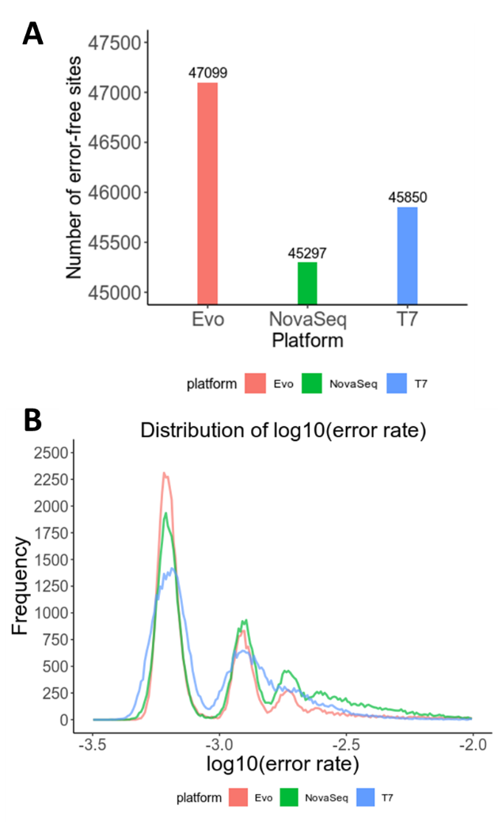
Figure 3. Error rate distributions for 100,000 random sites on E. coli genome. (A) Counts of sites with 0 errors. (B) Histogram of error rates.

Basecall error bias patterns
To find out the reason, we analyzed error profiles in 2 ways: (a) the 12 single base substitution errors and (b) single base substitution errors in tri-base context.
Figure 4 shows the histograms of the 12 single base substitution errors for 3 instruments, where the dashed line at 8.3% indicates the ratio when the error is random. All 3 sequencers have their own bias patterns. NovaSeq has a high tendency to make A-to-C and T-to-G miscalls; similar high A-to-C miscalls has been reported for MiSeq instrument (9). DNBSeq-T7 tends to have C-to-G miscalls. EVO has a relatively higher A-to-T miscall percentage. Among all 3 instruments, EVO visually has the lowest error bias.
To quantitatively evaluate the error bias, we calculated cosine similarity between the observed ratios and the expected ratios (8.3%) for each type of sequencers, where cosine similarity is defined as:
Similarity(A,B) = (A·B) / (||A|| × ||B||) (1)
A and B are two vectors of ratios, ||A|| and ||B|| are the length of the vectors, respectively. The similarity scores are 0.92 for EVO, 0.54 for DNBSeq-T7, and 0.42 for NovaSeq, respectively. Apparently, EVO has an error profile most resembling that caused by random errors.
Using the human NA12878 samples (Figure S4), we obtained completely distinctive mismatch patterns. Since for human samples, the mismatch comes from both basecall errors and sample mutations, the mismatch pattern is not discussed.
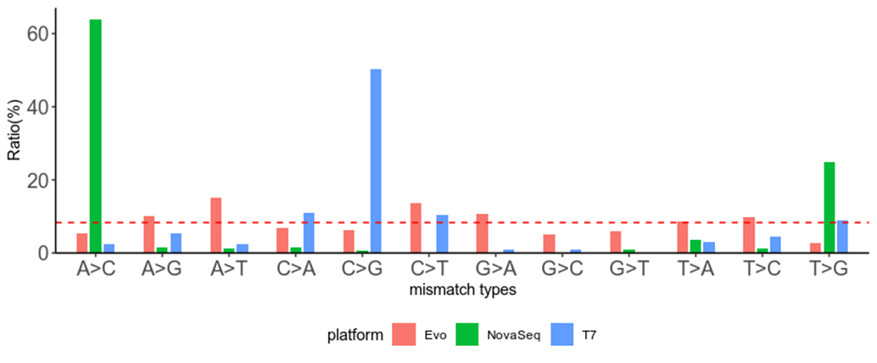
Figure 4. Histograms of 12 single base substitution error types using the E. coli sample.

There are many factors that may affect the single base substitution errors. Examples include instrumental, e.g., poorly designed optics that leads to high cross-talks between a pair of bases thus high error rates for these two bases, and biochemical, e.g., polymerase preference that leads to specific biased errors. To further analyze the root cause of higher error rate at some base sites, we analyzed the errors for all 64 types of tri-bases with the last one being the erroneous one. The histograms for 3 substitution errors are plotted for each of the 64 tri-bases (Figure 5). If the error is random, the 3 bars representing 3 substitution errors for each tri-base should be equally high, at ~33% level.
From Figure 5, we notice 3 things: (a) all instruments have its own error bias pattern, which is understandable: no instrument is perfect. (b) Some of the bias patterns show no relationship to the tri-base context, while some display strong correlation. For example, for EVO, all A-to-T substitution percentages are high irrespective of its sequence context. Similar cases can be found for A-to-C substitutions for NovaSeq, G-to-C substitutions for T-7, etc. However, some errors show strong context dependency. Typical examples include A-to-T errors for T-7 (first column of Figure 5B), where the error percentage is strongly related to the bases before A. Similar examples include C-to-G errors of EVO, etc. Note that similar context-dependent error pattern has been reported for different types of instruments (8,9,25-27). (c) We designed a method to quantitatively evaluate the effect of the two leading bases for the miscalled base. For a certain miscall, e.g. A, if there is no context effect, the error pattern (i.e. the histogram in a small window in Figure 5A) would be the same or very similar irrespective of the bases before base A. As a consequence, the Pearson correlation coefficient between the error patterns of any of the two combinations would be close to 1. Each base has 16 combinations for the 2 leading bases, leading to a total of 16 x 15 = 240 correlation coefficients between each pair of the 16 combinations. There are 4 bases, giving 960 correlation coefficients. Using an arbitrary threshold of 0.8, we counted the total number of “high” correlation coefficients for each type of instruments. There are 544 high correlation coefficients for EVO, 533 for NovaSeq, and 394 for T7. This indicates EVO and NovaSeq have less context effect on the basecall bias.
For context-dependent errors, it is highly likely that these errors are relevant to the polymerase preference used in sequencing-by-sequencing approach. This may suggest that EVO and NovaSeq used polymerase that is less biased.
The histograms of 3 single base substitution mismatches for each of all 64 types of tri-bases using human NA12878 samples are plotted in FigureS5. The mismatch pattern is not discussed here.

Possible reasons for basecall error bias
Sequencing error rates and error bias patterns are two major factors for the performance of a sequencer. Especially, low sequencing error bias is essential for an accurate variant detection (Scheme 1). However, the sequencing error bias patterns, especially under a similar error rate for different instruments, have rarely been systematically compared before. Here, we compared error rates and error bias patterns for 3 high-throughput sequencers.
We show that although the overall error rates for the three sequencers are in the similar range, however, their performance on variant calls is largely different. Among the 3 DNA sequencers, EVO called the least number of false variants. A careful scrutinization shows that under high sequencing depth, basecall error rate distributions all deviate from Poisson-like distribution and show a long tail at high error rate regions, indicating that there are significant non-random errors in basecalling. These high error rate sites are highly likely to be erroneously called as variants, which are false. Within the 3 instruments, EVO shows the cleanest tail.
Further analysis shows that different sequencers have different error patterns. Some errors have little or no correlation with its sequence context while some show a strong dependence. The possible reasons for the context-independent errors can be instrumental and/or biochemical, e.g. instrument design or dye set used. The context-dependent errors are more likely related to the enzyme used in the sequencing-by-synthesis step.

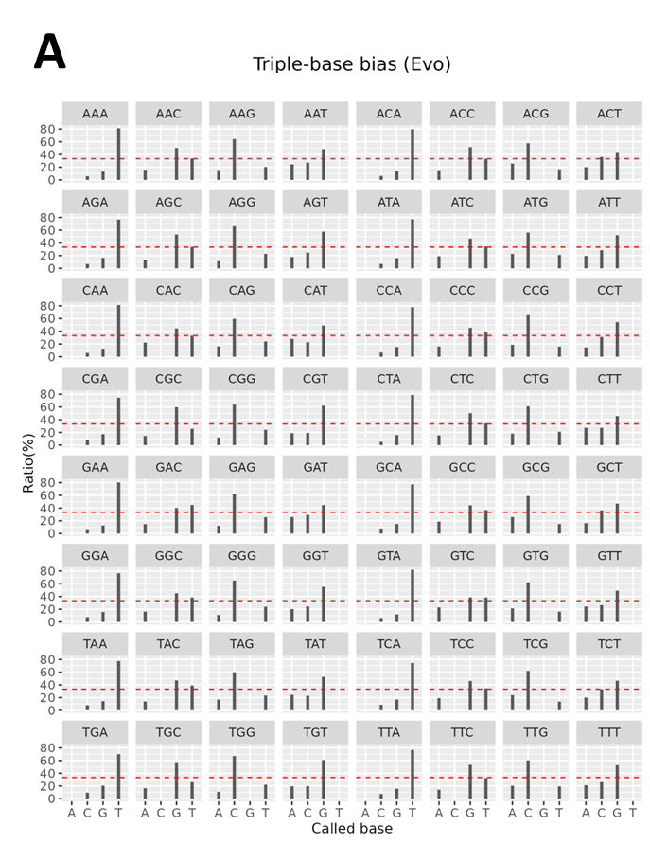
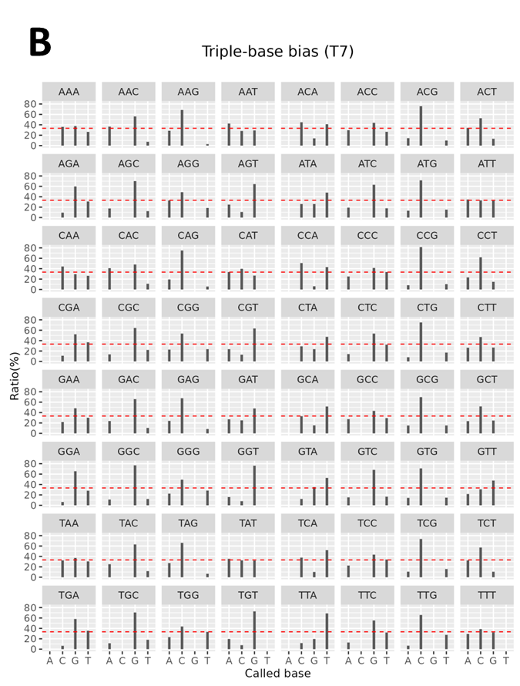
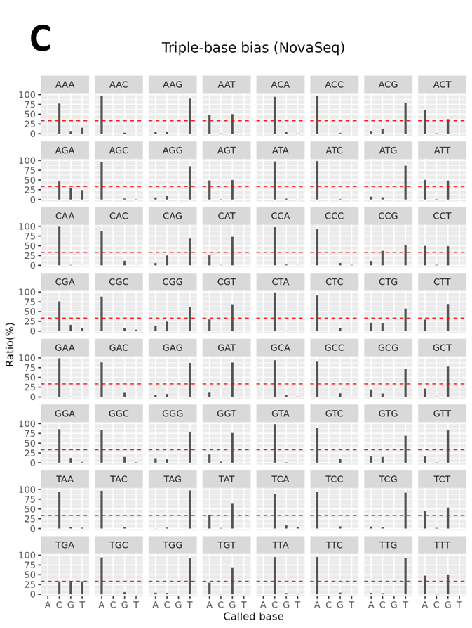
Figure 5. Histograms of 3 single base substitution errors for each of all 64 types of tri-bases with the last one being the erroneous one. The x-axis shows the base that was mistaken for. (A) EVO. (B) DNBSeq-T7. (C) NovaSeq.

Conclusions
We investigated basecall error rates and error bias patterns for three high-throughput sequencers by comparing the base call mismatches against E.coli genome reference. Their overall error rates fall in the 0.05~0.1% range but they show large difference on variant calls. Using a threshold of mutation frequency of 0.5%, NovaSeq’s false positive variant call rate is ~ 10 times higher than that of T7 and ~ 20 times higher than that of EVO. The basecall error rate distributions shows that there are significant non-random errors in basecalling, which are the major cause for false positive variant calls. Different sequencers have different error bias patterns including those sequence context-dependent and -independent. The instrument design and the enzyme used in the sequencing-by-synthesis approach determines the basecall accuracy of a sequencer.

Data availability
The data underlying this article are available in the article and in its online supplementary material. Raw data are available in NCBI BioProject repository via accession number PRJNA1207107. The script was submitted to Github and can be found through the following link:
https://github.com/yaotianran/get_position_info

Acknowledgements
This study was supported by the National Key Science and Technology Special Project for Deep Earth Research, Deep subsurface microbial dynamic evolution and knowledge graph visualization (2024ZD1000603), Spring City Plan: the High-level Talent Promotion and Training Project of Kunming (2022SCP002).

Conflict of interest statement
The authors declare that there is no conflict of interest.

References
1. Lan, Y., Xu, B., Xi, Y., Luo, Y., Guo, X., Huang, Z., Luo, D., Zhu, A., He, P., Li, C. et al. (2024) Accurate Detection of Multiple Tumor Mutations in Formalin-Fixed Paraffin-Embedded Tissues by Coupling Sequence Artifacts Elimination and Mutation Enrichment With MeltArray. Laboratory Investigation, 104, 100300-100300.
2. Guo, Q., Lakatos, E., Bakir, I.A., Curtius, K., Graham, T.A. and Mustonen, V. (2022) The mutational signatures of formalin fixation on the human genome. Nature Communications 2022 13:1, 13, 1-14.
3. Chen, G., Mosier, S., Gocke, C.D., Lin, M.T. and Eshleman, J.R. (2014) Cytosine Deamination is a Major Cause of Baseline Noise in Next Generation Sequencing. Molecular diagnosis & therapy, 18, 587-587.
4. Costello, M., Pugh, T.J., Fennell, T.J., Stewart, C., Lichtenstein, L., Meldrim, J.C., Fostel, J.L., Friedrich, D.C., Perrin, D., Dionne, D. et al. (2013) Discovery and characterization of artifactual mutations in deep coverage targeted capture sequencing data due to oxidative DNA damage during sample preparation. Nucleic Acids Research, 41, e67-e67.
5. McCall, C.M., Mosier, S., Thiess, M., Debeljak, M., Pallavajjala, A., Beierl, K., Deak, K.L., Datto, M.B., Gocke, C.D., Lin, M.T. et al. (2014) False Positives in Multiplex PCR-Based Next-Generation Sequencing Have Unique Signatures. The Journal of Molecular Diagnostics : JMD, 16, 541-541.
6. Do, H. and Dobrovic, A. (2015) Sequence Artifacts in DNA from Formalin-Fixed Tissues: Causes and Strategies for Minimization. Clinical Chemistry, 61, 64-71.
7. Pfeiffer, F., Gröber, C., Blank, M., Händler, K., Beyer, M., Schultze, J.L. and Mayer, G. (2018) Systematic evaluation of error rates and causes in short samples in next-generation sequencing. Scientific Reports 2018 8:1, 8, 1-14.
8. Nakamura, K., Oshima, T., Morimoto, T., Ikeda, S., Yoshikawa, H., Shiwa, Y., Ishikawa, S., Linak, M.C., Hirai, A., Takahashi, H. et al. (2011) Sequence-specific error profile of Illumina sequencers. Nucleic Acids Research, 39, e90-e90.
9. Schirmer, M., Ijaz, U.Z., D'Amore, R., Hall, N., Sloan, W.T. and Quince, C. (2015) Insight into biases and sequencing errors for amplicon sequencing with the Illumina MiSeq platform. Nucleic Acids Research, 43, e37-e37.
10. Foox, J., Tighe, S.W., Nicolet, C.M., Zook, J.M., Byrska-Bishop, M., Clarke, W.E., Khayat, M.M., Mahmoud, M., Laaguiby, P.K., Herbert, Z.T. et al. (2021) Performance assessment of DNA sequencing platforms in the ABRF Next-Generation Sequencing Study. Nature Biotechnology 2021 39:9, 39, 1129-1140.
11. Hoffmann, S., Otto, C., Kurtz, S., Sharma, C.M., Khaitovich, P., Vogel, J., Stadler, P.F. and Hackermüller, J. (2009) Fast Mapping of Short Sequences with Mismatches, Insertions and Deletions Using Index Structures. PLOS Computational Biology, 5, e1000502-e1000502.
12. Dohm, J.C., Lottaz, C., Borodina, T. and Himmelbauer, H. (2008) Substantial biases in ultra-short read data sets from high-throughput DNA sequencing. Nucleic Acids Research, 36, 105-105.
13. Chen, S., Zhou, Y., Chen, Y. and Gu, J. (2018) fastp: an ultra-fast all-in-one FASTQ preprocessor. Bioinformatics, 34, i884-i890.
14. Md, V., Misra, S., Li, H. and Aluru, S. (2019) Efficient architecture-aware acceleration of BWA-MEM for multicore systems. Proceedings - 2019 IEEE 33rd International Parallel and Distributed Processing Symposium, IPDPS 2019, 314-324.
15. Tarasov, A., Vilella, A.J., Cuppen, E., Nijman, I.J. and Prins, P. (2015) Sambamba: fast processing of NGS alignment formats. Bioinformatics, 31, 2032-2034.
16. https://ftp-trace.ncbi.nlm.nih.gov/ReferenceSamples/giab/release/NA12878_HG001/NISTv4.2.1/GRCh37/.
17. Jee, J., Rasouly, A., Shamovsky, I., Akivis, Y., R. Steinman, S., Mishra, B. and Nudler, E. (2016) Rates and mechanisms of bacterial mutagenesis from maximum-depth sequencing. Nature, 534, 693-696.
18. Kinde, I., Wu, J., Papadopoulos, N., Kinzler, K.W. and Vogelstein, B. (2011) Detection and quantification of rare mutations with massively parallel sequencing. Proceedings of the National Academy of Sciences, 108, 9530-9535.
19. Li, R., Wang, Q., Yang, J., Zhu, J., Liu, J., Wu, R. and Sun, H. (2023) Comparison of three massively parallel sequencing platforms for single nucleotide polymorphism (SNP) genotyping in forensic genetics. International Journal of Legal Medicine, 137, 1361-1372.
20. Meng, X., Wang, M., Luo, M., Sun, L., Yan, Q. and Liu, Y. (2023) Systematic evaluation of multiple NGS platforms for structural variants detection. Journal of Biological Chemistry, 299, 105436-105437.
21. Marin, M., Vargas, R., Harris, M., Jeffrey, B., Epperson, L.E., Durbin, D., Strong, M., Salfinger, M., Iqbal, Z., Akhundova, I. et al. (2022) Benchmarking the empirical accuracy of short-read sequencing across the M. tuberculosis genome. Bioinformatics (Oxford, England), 38, 1781-1787.
22. Wang, B., Wan, L., Wang, A. and Li, L.M. (2017) An adaptive decorrelation method removes Illumina DNA base-calling errors caused by crosstalk between adjacent clusters. Scientific Reports 2017 7:1, 7, 1-11.
23. Cabanski, C.R., Cavin, K., Bizon, C., Wilkerson, M.D., Parker, J.S., Wilhelmsen, K.C., Perou, C.M., Marron, J.S. and Hayes, D.N. (2012) ReQON: a Bioconductor package for recalibrating quality scores from next-generation sequencing data. BMC Bioinformatics, 13, 1-10.
24. Ni, S. and Stoneking, M. (2016) Improvement in detection of minor alleles in next generation sequencing by base quality recalibration. BMC Genomics, 17, 1-12.
25. Schirmer, M., D'Amore, R., Ijaz, U.Z., Hall, N. and Quince, C. (2016) Illumina error profiles: Resolving fine-scale variation in metagenomic sequencing data. BMC Bioinformatics, 17, 1-15.
26. Meacham, F., Boffelli, D., Dhahbi, J., Martin, D.I.K., Singer, M. and Pachter, L. (2011) Identification and correction of systematic error in high-throughput sequence data. BMC Bioinformatics, 12, 1-11.
27. Stoler, N. and Nekrutenko, A. (2021) Sequencing error profiles of Illumina sequencing instruments. NAR Genomics and Bioinformatics, 3.

