Rolling Sales Queens

Benjamin Reddy/Yao Steven Jason

February 21, 2017

#require(gdata)  
#require(plyr) #Added by Monnie McGee  
#install the gdata and plyr packages and load in to R.  
setwd("C:\\Users\\Yao\\Dropbox")

So, save the file as a csv and use read.csv instead

qns <- read.csv("rollingsales_queens.csv",skip=4,header=TRUE)

Check the data

head(qns)

## BOROUGH NEIGHBORHOOD BUILDING.CLASS.CATEGORY  
## 1 4 AIRPORT LA GUARDIA 01 ONE FAMILY DWELLINGS   
## 2 4 AIRPORT LA GUARDIA 01 ONE FAMILY DWELLINGS   
## 3 4 AIRPORT LA GUARDIA 02 TWO FAMILY DWELLINGS   
## 4 4 AIRPORT LA GUARDIA 03 THREE FAMILY DWELLINGS   
## 5 4 AIRPORT LA GUARDIA 03 THREE FAMILY DWELLINGS   
## 6 4 AIRPORT LA GUARDIA 03 THREE FAMILY DWELLINGS   
## TAX.CLASS.AT.PRESENT BLOCK LOT EASE.MENT BUILDING.CLASS.AT.PRESENT  
## 1 1 976 61 NA A5  
## 2 1 976 63 NA A5  
## 3 1 976 70 NA B1  
## 4 1 949 15 NA C0  
## 5 1 949 56 NA C0  
## 6 1 949 59 NA C0  
## ADDRESS APARTMENT.NUMBER ZIP.CODE RESIDENTIAL.UNITS  
## 1 21-21 80TH STREET 11370 1   
## 2 21-17 80TH STREET 11370 1   
## 3 21-03 80TH STREET 11370 2   
## 4 19-08 81ST STREET 11370 3   
## 5 19-69 80TH STREET 11370 3   
## 6 19-63 80TH STREET 11370 3   
## COMMERCIAL.UNITS TOTAL.UNITS LAND.SQUARE.FEET GROSS.SQUARE.FEET  
## 1 - 1 1,800 1,224   
## 2 - 1 1,800 1,224   
## 3 - 2 1,800 1,224   
## 4 - 3 2,112 4,300   
## 5 - 3 2,000 2,835   
## 6 - 3 2,000 2,835   
## YEAR.BUILT TAX.CLASS.AT.TIME.OF.SALE BUILDING.CLASS.AT.TIME.OF.SALE  
## 1 1950 1 A5  
## 2 1950 1 A5  
## 3 1950 1 B1  
## 4 1985 1 C0  
## 5 1945 1 C0  
## 6 1945 1 C0  
## SALE.PRICE SALE.DATE  
## 1 $660,000 7/26/2016  
## 2 $275,500 11/18/2016  
## 3 $- 6/13/2016  
## 4 $940,000 4/14/2016  
## 5 $- 8/15/2016  
## 6 $470,000 4/15/2016

summary(qns)

## BOROUGH NEIGHBORHOOD   
## Min. :4 FLUSHING-NORTH : 2575   
## 1st Qu.:4 ASTORIA : 1165   
## Median :4 BAYSIDE : 1132   
## Mean :4 FOREST HILLS : 1052   
## 3rd Qu.:4 JACKSON HEIGHTS: 993   
## Max. :4 FLUSHING-SOUTH : 854   
## (Other) :18549   
## BUILDING.CLASS.CATEGORY  
## 01 ONE FAMILY DWELLINGS :8357   
## 02 TWO FAMILY DWELLINGS :5681   
## 10 COOPS - ELEVATOR APARTMENTS :3867   
## 13 CONDOS - ELEVATOR APARTMENTS :1735   
## 03 THREE FAMILY DWELLINGS :1235   
## 09 COOPS - WALKUP APARTMENTS :1226   
## (Other) :4219   
## TAX.CLASS.AT.PRESENT BLOCK LOT EASE.MENT   
## 1 :15342 Min. : 13 Min. : 1.0 Mode:logical   
## 2 : 7213 1st Qu.: 2694 1st Qu.: 16.0 NA's:26320   
## 4 : 1797 Median : 5938 Median : 39.0   
## 2A : 629 Mean : 6614 Mean : 203.7   
## 1B : 429 3rd Qu.:10076 3rd Qu.: 81.0   
## : 373 Max. :16322 Max. :8007.0   
## (Other): 537   
## BUILDING.CLASS.AT.PRESENT ADDRESS APARTMENT.NUMBER  
## A1 : 3870 120 BEACH 26 STREET : 127 :23536   
## D4 : 3867 63-14 QUEENS BOULEVARD: 66 2A : 48   
## A5 : 2034 31-35 31ST STREET : 63 2B : 48   
## B3 : 1954 112-45 39TH AVENUE : 60 3B : 47   
## B2 : 1850 131-05 40TH ROAD : 55 3A : 45   
## A2 : 1593 42-60 CRESCENT STREET : 54 4A : 35   
## (Other):11152 (Other) :25895 (Other): 2561   
## ZIP.CODE RESIDENTIAL.UNITS COMMERCIAL.UNITS TOTAL.UNITS   
## Min. : 0 1 :5673 0 :12815 1 :6080   
## 1st Qu.:11360 0 :5154 - :12104 1 :5597   
## Median :11375 1 :4959 1 : 562 0 :4264   
## Mean :11261 2 :3030 1 : 489 2 :2980   
## 3rd Qu.:11419 - :2703 2 : 88 2 :2669   
## Max. :11697 2 :2699 2 : 78 - :2144   
## (Other):2102 (Other): 184 (Other):2586   
## LAND.SQUARE.FEET GROSS.SQUARE.FEET YEAR.BUILT   
## 0 : 5754 0 : 6033 Min. : 0   
## - : 2877 - : 3330 1st Qu.:1925   
## 4,000 : 1217 1,600 : 109 Median :1940   
## 2,500 : 822 1224 : 103 Mean :1825   
## 2,000 : 708 1,440 : 82 3rd Qu.:1959   
## 4000 : 687 1,224 : 76 Max. :2016   
## (Other):14255 (Other):16587   
## TAX.CLASS.AT.TIME.OF.SALE BUILDING.CLASS.AT.TIME.OF.SALE  
## Min. :1.000 D4 : 3867   
## 1st Qu.:1.000 A1 : 3861   
## Median :1.000 A5 : 2032   
## Mean :1.529 B3 : 1972   
## 3rd Qu.:2.000 B2 : 1873   
## Max. :4.000 R4 : 1735   
## (Other):10980   
## SALE.PRICE SALE.DATE   
## $- : 8226 4/5/2016 : 210   
## $10 : 209 11/10/2016: 177   
## $450,000 : 156 6/30/2016 : 174   
## $650,000 : 150 2/29/2016 : 170   
## $250,000 : 137 11/22/2016: 161   
## $600,000 : 137 10/28/2016: 158   
## (Other) :17305 (Other) :25270

str(qns) # Very handy function!

## 'data.frame': 26320 obs. of 21 variables:  
## $ BOROUGH : int 4 4 4 4 4 4 4 4 4 4 ...  
## $ NEIGHBORHOOD : Factor w/ 60 levels "AIRPORT LA GUARDIA",..: 1 1 1 1 1 1 1 1 2 2 ...  
## $ BUILDING.CLASS.CATEGORY : Factor w/ 44 levels "01 ONE FAMILY DWELLINGS ",..: 1 1 2 3 3 3 12 12 1 1 ...  
## $ TAX.CLASS.AT.PRESENT : Factor w/ 11 levels " ","1","1A","1B",..: 2 2 2 2 2 2 6 6 2 2 ...  
## $ BLOCK : int 976 976 976 949 949 949 949 949 15828 15829 ...  
## $ LOT : int 61 63 70 15 56 59 1012 1025 53 22 ...  
## $ EASE.MENT : logi NA NA NA NA NA NA ...  
## $ BUILDING.CLASS.AT.PRESENT : Factor w/ 125 levels " ","A0","A1",..: 7 7 11 15 15 15 91 91 3 3 ...  
## $ ADDRESS : Factor w/ 23093 levels "-00 136TH AVENUE",..: 9305 9287 9243 8482 8514 8512 8507 19504 12203 12913 ...  
## $ APARTMENT.NUMBER : Factor w/ 1193 levels " ","0.02","1",..: 1 1 1 1 1 1 225 3 1 1 ...  
## $ ZIP.CODE : int 11370 11370 11370 11370 11370 11370 11370 11370 11691 11691 ...  
## $ RESIDENTIAL.UNITS : Factor w/ 111 levels " - "," 1 ",..: 2 2 14 22 22 22 2 2 2 2 ...  
## $ COMMERCIAL.UNITS : Factor w/ 36 levels " - "," 1 ",..: 1 1 1 1 1 1 1 1 1 1 ...  
## $ TOTAL.UNITS : Factor w/ 120 levels " - "," 1 ",..: 2 2 15 22 22 22 2 2 2 2 ...  
## $ LAND.SQUARE.FEET : Factor w/ 4202 levels " - "," 1,000 ",..: 265 265 265 553 491 491 1 1 1414 881 ...  
## $ GROSS.SQUARE.FEET : Factor w/ 4200 levels " - "," 1,000 ",..: 178 178 178 1781 1348 1348 1 1 156 401 ...  
## $ YEAR.BUILT : int 1950 1950 1950 1985 1945 1945 0 0 2002 2005 ...  
## $ TAX.CLASS.AT.TIME.OF.SALE : int 1 1 1 1 1 1 2 2 1 1 ...  
## $ BUILDING.CLASS.AT.TIME.OF.SALE: Factor w/ 124 levels "A0","A1","A2",..: 6 6 10 14 14 14 90 90 2 2 ...  
## $ SALE.PRICE : Factor w/ 3272 levels " $- "," $1 ",..: 2590 1188 1 3178 1 2018 1859 1459 1177 1377 ...  
## $ SALE.DATE : Factor w/ 359 levels "1/1/2017","1/10/2017",..: 288 71 245 187 306 188 8 68 143 309 ...

clean/format the data with regular expressions More on these later. For now, know that the pattern “[^[:digit:]]” refers to members of the variable name that start with digits. We use the gsub command to replace them with a blank space. We create a new variable that is a “clean’ version of sale.price. And sale.price.n is numeric, not a factor.

library(gdata)  
library(plyr)  
qns$SALE.PRICE.N <- as.numeric(gsub("[^[:digit:]]","", qns$SALE.PRICE))  
count(is.na(qns$SALE.PRICE.N))

## x freq  
## 1 FALSE 18094  
## 2 TRUE 8226

names(qns) <- tolower(names(qns)) # make all variable names lower case  
## Get rid of leading digits  
qns$gross.sqft <- as.numeric(gsub("[^[:digit:]]","", qns$gross.square.feet))  
qns$land.sqft <- as.numeric(gsub("[^[:digit:]]","", qns$land.square.feet))  
qns$year.built <- as.numeric(as.character(qns$year.built))

do a bit of exploration to make sure there’s not anything weird going on with sale prices

attach(qns)  
hist(sale.price.n)

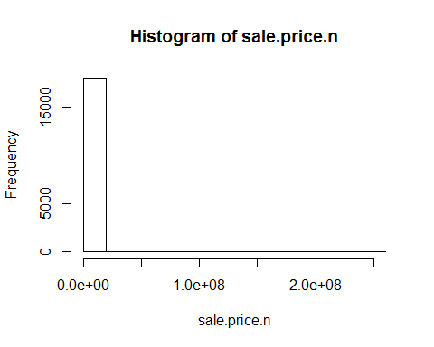

detach(qns)

keep only the actual sales

qns.sale <- qns[qns$sale.price.n!=0,]  
plot(qns.sale$gross.sqft,qns.sale$sale.price.n)

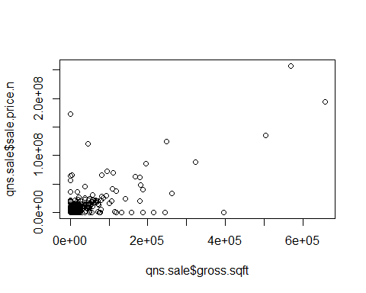

plot(log10(qns.sale$gross.sqft),log10(qns.sale$sale.price.n))

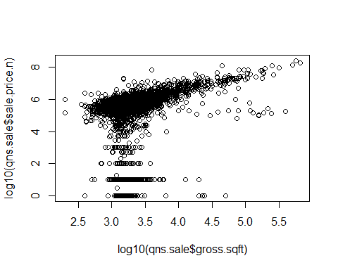

for now, let’s look at 1-, 2-, and 3-family homes

qns.homes <- qns.sale[which(grepl("FAMILY",qns.sale$building.class.category)),]  
dim(qns.homes)

## [1] 10144 24

plot(log10(qns.homes$gross.sqft),log10(qns.homes$sale.price.n))

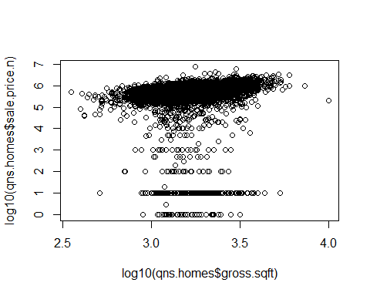

summary(qns.homes[which(qns.homes$sale.price.n<100000),])

## borough neighborhood  
## Min. :4 SOUTH JAMAICA : 26   
## 1st Qu.:4 ST. ALBANS : 22   
## Median :4 JACKSON HEIGHTS : 21   
## Mean :4 SO. JAMAICA-BAISLEY PARK: 21   
## 3rd Qu.:4 SPRINGFIELD GARDENS : 21   
## Max. :4 HOLLIS : 19   
## (Other) :303   
## building.class.category  
## 01 ONE FAMILY DWELLINGS :244   
## 02 TWO FAMILY DWELLINGS :158   
## 03 THREE FAMILY DWELLINGS : 31   
## 04 TAX CLASS 1 CONDOS : 0   
## 05 TAX CLASS 1 VACANT LAND : 0   
## 06 TAX CLASS 1 - OTHER : 0   
## (Other) : 0   
## tax.class.at.present block lot ease.ment   
## 1 :432 Min. : 155 Min. : 1.00 Mode:logical   
## : 1 1st Qu.: 6353 1st Qu.: 18.00 NA's:433   
## 1A : 0 Median :10172 Median : 35.00   
## 1B : 0 Mean : 9174 Mean : 57.31   
## 1C : 0 3rd Qu.:12484 3rd Qu.: 64.00   
## 2 : 0 Max. :16201 Max. :1351.00   
## (Other): 0   
## building.class.at.present address apartment.number  
## A1 :114 48-15 187TH STREET : 3 :433   
## B3 : 72 10325 SPRINGFIELD BLVD: 2 0.02 : 0   
## A2 : 49 117-39 142ND PLACE : 2 1 : 0   
## A5 : 48 178-36 145TH AVENUE : 2 1-A : 0   
## B1 : 40 219 BEACH 91ST STREET : 2 1-B : 0   
## B2 : 37 221-36 107TH AVENUE : 2 1-C : 0   
## (Other): 73 (Other) :420 (Other): 0   
## zip.code residential.units commercial.units total.units   
## Min. :11001 1 :132 - :236 1 :131   
## 1st Qu.:11373 1 :112 0 :192 1 :111   
## Median :11417 2 : 88 1 : 3 2 : 88   
## Mean :11421 2 : 69 1 : 2 2 : 68   
## 3rd Qu.:11432 3 : 17 12 : 0 3 : 18   
## Max. :11694 3 : 14 17 : 0 3 : 16   
## (Other): 1 (Other): 0 (Other): 1   
## land.square.feet gross.square.feet year.built   
## 4,000 : 35 1,120 : 4 Min. : 0   
## 2,500 : 17 512 : 4 1st Qu.:1925   
## 3,000 : 17 1224 : 4 Median :1935   
## 2,000 : 16 1,056 : 3 Mean :1936   
## 2500 : 16 1,188 : 3 3rd Qu.:1950   
## 2000 : 15 1,534 : 3 Max. :2014   
## (Other):317 (Other):412   
## tax.class.at.time.of.sale building.class.at.time.of.sale sale.price   
## Min. :1 A1 :114 $10 :170   
## 1st Qu.:1 B3 : 72 $1 : 42   
## Median :1 A2 : 49 $100 : 26   
## Mean :1 A5 : 48 $25,000 : 21   
## 3rd Qu.:1 B1 : 40 $1,000 : 20   
## Max. :1 B2 : 38 $10,000 : 16   
## (Other): 72 (Other) :138   
## sale.date sale.price.n gross.sqft land.sqft   
## 11/28/2016: 6 Min. : 1 Min. : 400 Min. : 613   
## 3/7/2016 : 6 1st Qu.: 10 1st Qu.:1232 1st Qu.: 2107   
## 10/14/2016: 5 Median : 100 Median :1535 Median : 2758   
## 12/19/2016: 5 Mean :14321 Mean :1697 Mean : 3116   
## 2/22/2016 : 5 3rd Qu.:20000 3rd Qu.:2010 3rd Qu.: 4000   
## 3/1/2016 : 5 Max. :93000 Max. :5341 Max. :10293   
## (Other) :401 NA's :1 NA's :1

remove outliers that seem like they weren’t actual sales

qns.homes$outliers <- (log10(qns.homes$sale.price.n) <=5) + 0  
qns.homes <- qns.homes[which(qns.homes$outliers==0),]  
plot(log10(qns.homes$gross.sqft),log10(qns.homes$sale.price.n))

