Phonon-Drag-AugmentedPiecewiseJohnson–CookModelingfor
Cold-SprayImpact
April11,2026
1 Introduction
Cold-sprayparticleimpactinvolveslargeplasticdeformation,severestrain-rateamplificationnear thecontactinterface,andrapidconversionofplasticworkintoheat[4,6]. Inthisregime,a constitutivelawmustreproduceatleastfourcoupledeffects:strainhardening,low-to-moderate strain-rate strengthening, thermal softening, and an additional high-rate resistance once the plastic strainrateexceedsatransitionscale.AconventionalJohnson–Cook(JC)lawprovidesapractical startingpointforthefirstthreeoftheseeffects,butitsstandardlogarithmicratetermisgenerally tooweaktoreproducethesharpriseofflowstressobservedintheextreme-rateregime.
Recentimpactandindentationstudiesreinforcethispoint.High-velocitymicroparticleimpact experimentsandsimulationsshowthatrebound,flattening,jetting,andadhesiondonotevolve smoothlyunderasingleweakrate-sensitivelaw;instead,theyexhibitamarkedtransitionasthe impactseverityincreases[7,8].Inaddition,indentation-basedultra-high-strain-ratereconstruc-tionsindicatethatrepresentativeflowstrengthrisesstronglyintherangefromabout105to106 s−1andabove,whichisnotwellcapturedbythestandardJClogarithmicratetermalone[3,2]. Theseobservationsprovidethepracticalconstitutivemotivationforintroducingaseparatehigh-ratestrengtheningbranch.
The motivation for the present work is therefore twofold.First, a low-rate JC branch is retained becauseitremainsacompactandinterpretableengineeringdescriptionofrate-andtemperature-dependent plastic flow.Second, a separate high-rate branch is introduced to represent the additional drag-dominant strengthening associated with fast dislocation motion in a thermally activated crys-tallattice.Thisadditionalbranchisnotintendedasafulldislocation-dynamicsmodel.Instead,it isaphysics-informedcontinuumclosuredesignedforimpactsimulationsinwhichatractablecon-stitutiveformisneeded,butwherethetransitiontodrag-controlledbehaviormuststillbetiedto physicallyinterpretablescalessuchastheBurgersvector,theshearmodulus,andacharacteristic transversesoundspeed[1,5].
Acentraldesignchoiceinthisworkisthattheeffectivetransitionstrainrateistreatedas amaterial-dependentconstitutivethreshold,notasadirectfunctionoftheexternallyprescribed impactvelocity. Theimpactvelocitydeterminestheactuallyattainedstrain-ratefieldinthe particle and substrate, whereas the constitutive transition rate determines when the drag-dominant strengtheningmechanismbeginstocontribute.Thisdistinctionprovedimportantduringmodel developmentandispreservedexplicitlyinthefinalformulation.
The paper is organized as follows.Section 2 introduces the phonon-drag-motivated constitutive closure and its coupling to the JC baseline and the Taylor–Quinney heat-generation term.Section 3 summarizesthenumericalimplementationusedintheperidynamicimpactsolver.Theemphasis
1

throughoutisonpreservingatransparentlinkbetweenthecontinuumconstitutiveformandthe materialscalesusedtointerpretthetransitiontothehigh-rateregime.
2 Method
2.1 Material-DependentPhonon-DragClosure
Theconstitutiveformiswritteninpiecewiseformbecausetheliteraturesurveyedforcold-spray impactdoesnotsupportasingleweaklogarithmicratesensitivityoverthefullloadingrange. High-velocitymicroparticleimpactstudiesindicateadistincttransitionfromordinaryplasticflow toaregimecharacterizedbyrapidstrengthening,jetting,stronginterfaceplasticity,andamarked changeinreboundoradhesionbehaviorastheimpactseverityincreases[3,7,8,2]. Thisis consistentwiththemodel-developmentconclusionreachedearlierinthepresentwork:thelow-rateJohnson–Cookbranchshouldberetainedwhereitslogarithmicratetermremainsadequate, whileanadditionaldrag-controlledincrementmustbeintroducedoncethelocalplasticstrainrate exceedsatransitionthreshold.Thetotalflowstressisthereforewritteninthefollowingpiecewise form.Atthehighestlevel,theconstitutivestructuremaybesummarizedas
σflow= | σJC,low, | ˙εp≤˙εeff c, | (1)
 | σJC,low + σdrag, | ˙εp>˙εeff c,
Thissummaryequationisexpandedbelow.Forplasticstrainratesbelowthetransitionthreshold, thestandardlow-rateJohnson–Cookbranchisretained[4],
 | σ= | A + Bεn | 1 + Cln | ˙εp | (1 −T∗mth) , |  |  | ˙ε≤˙εeff , | (2)
where | flow | p | 1 | ˙ε0 |  |  |  | p c
 |  | T∗= clamp |  | T−Tref |  | , 0, 1 | . |  | (3)
 |  |  |  | Tm −Tref
In Eq. (2), A, B, and n control the hardening response, C1controls the low-rate logarithmic strain-rate sensitivity, and mthcontrols thermal softening.This same low-rate JC contribution is retained asthebaselinetermevenafterthetransitioniscrossed.
Forplasticstrainratesabovethetransitionthreshold,thelow-rateJohnson–Cookbranchis continuedandthedragcontributionisaddedasacontinuousincrement,
σ= | A + Bεn | 1 + Cln | ˙εp | (1 −T∗mth) + σ, | ˙ε>˙εeff . | (4)
flow | p | 1 | ˙ε0 | drag | p c
Thiswasthefinalmodeldecisioninthepresentdevelopment:thehigh-ratebranchshouldnot consistofdragalone,butneitherisitnecessarytofreezethelow-rateJCtermoncethedrag incrementbecomesdominant.Instead,thelow-rateJCbranchremainsasthebaselinestressand thedragtermcontributesonlytheadditionalhigh-rateincrement.BecauseEq.(21)iszeroat˙εeff c, thepiecewiselawremainscontinuousatthetransitionpoint.ThelimitingcaseK0=0therefore reduces to the continued low-rate JC branch, which is the correct zero-increment limit of the present closure.
2

2.2 Phonon-Drag-ControlledRateEffect
Thethermalphononsinacrystalarescatteredbyglidingdislocations,therebyresultinginadrag force on the dislocations [1].By analogy with linear drag, the dislocation drag force per unit length maybewrittenas
F= Bv, (5)
whereBisadragcoefficientandvisthedislocationvelocity.Equation(5)isusedhereasthe physicalstartingpoint,notasthefinalconstitutivelaw.Thepresentobjectiveistoconstructa continuumclosureforthedrag-controlledhigh-rateresistancethatappearsinEq.(4).
Followingthetotal–particular–totallogicadoptedduringmodeldevelopment,thedragcontri-butionisfirstintroducedinthegenericmacroscopicform
σdrag= K0 × (rateterm), (6)
whereK0isthebaselinemagnitudeofthemacroscopicdragresistance.Inthepresentlogarithmic closure,K0carriesunitsofstressanddirectlysetstheamplitudeofthedrag-inducedstressincre-ment.The remaining task is therefore to determine the temperature scaling and the over-threshold ratemeasure.
Thetemperature-dependentamplitudeiswrittenintheseparableform
Kmat | = K | G(T) | a | , | (7)
0 | 0 | G0
whereG0isthereferenceshearmodulusandaisatemperature-sensitivityexponent.Asdiscussed previously,thecharacteristictransversesoundspeedistreatedasaconstant,
cT= cT0= constant, (8)
whilethetemperaturedependenceisretainedonlyintheshearmodulus,
G(T) = G | 1 −β | T−T0 | . | (9)
0 | G | Tm −T0
Hence,cT0suppliesthevelocityscaleforhigh-ratedislocationmotion,whereasG(T)controlsthe temperature-dependentamplitudeofthedragresistance.
The macroscopic plastic strain rate is linked to dislocation motion through the Orowan picture, forwhich
˙εp∼ρmbv, (10)
whereρmisthemobiledislocationdensityandbistheBurgersvector[5].Inthepresentcontin-uumclosure,thedetaileddislocation-densityevolutionisnotresolvedexplicitly.Instead,Eq.(10) motivatestheuseof˙εp,b,andcT0todefinethetransition-ratescale.
Blaschkeetal.[1]showedthattheanharmonicinteractionandscatteringofphononsbya movingdislocation,namelythephononwind,impartsadragforcevB(v, T, ρ)onthedislocation. Their analysis further shows that the drag coefficient is only approximately velocity-independent in thelow-velocityregime,whereasitincreasesnonlinearlyasthedislocationvelocityapproachesthe transversesoundspeedcT .Inthatsense,thesound-speedscaleprovidesthephysicallymotivated upper-boundkinematicreferencefordrag-dominantstrengthening. IfEq.(10)isevaluatedat thesonic-limitvelocityscale,thecorrespondingmicroscopicratescaleisfirstwritteninthemore completeform
˙εlimit∼ρmbcT0. (11)
3

Equation(11)isthedirectOrowan-basedestimate.However,thepresentcontinuumformulation does not evolve the detailed mobile dislocation density, and the unresolved density scale is absorbed intothebridgecalibrationintroducedbelow.Attheorder-of-magnitudelevel,thiscorrespondsto replacingtheunresolvedmicroscopicdensityfactorbyacharacteristicinverseareascale,ρm∼O(b−2),sothat
ρmbcT0∼cT0 b. (12)
Accordingly,themicroscopictransition-ratescaleusedinthepresentclosureiswrittenas
˙εmicro c | ∼cT0 b. | (13)
Equation (13) should therefore be interpreted as a recast order-of-magnitude estimate derived from Eq.(11),ratherthanasadirectone-stepsubstitutionfromdislocationvelocitytostrainrate.At thecontinuumlevel,theexperimentallyrelevanttransitionoccursatamuchsmallerrate. An effectivecriticalstrainrateisthereforeintroducedfirst,
˙εeff | = | 1 | cT0 , | (14)
c |  | Λph | b
andthebridgefactorΛphisthenspecifiedbelow.Thisorderingisimportant:theconstitutivelaw isdefinedfirstintermsoftheeffectivetransitionrate,andthebridgefactorissubsequentlyused toconnectthattransitionratetothemicroscopicsonic-limitestimate.
Thecriticalstrainrateistreatedhereasamaterial-dependenttransitionthresholdratherthan aloading-condition-dependentquantity.Theimpactvelocitycontrolstheactuallyattainedplastic strain-ratefield,butitshouldnotdirectlyredefinetheintrinsictransitionrateitself.Accordingly,˙εeff c is taken as a fixed constitutive parameter once the material and discretization scales are selected.
Toensurethatthehigh-ratebranchiscontinuousatthetransitionpointwithoutproducingan excessivelysteephigh-ratetail,therateamplificationiswritteninlogarithmicform,
A( ˙ε) = | ln | ˙εp |  | , | (15)
˙εp |  | ˙εeff c | +
where[x]+=max(x, 0).Thedragincrementthereforevanishesexactlyatthetransitionrateand thengrowsonlylogarithmicallyaboveit.CombiningEqs.(6),(7),and(15)yieldstheworking
dragclosure | σ= K | G(T) | a | ln | ˙εp |  | , | (16)
 | drag0 | G0 |  |  | ˙εeff c | +
InEq.(16),thelogarithmicover-thresholdtermcontrolstheshapeofthehigh-raterise.This wasadoptedspecificallytoavoidtheoverlyslowmid-rategrowthandoverlysteepultra-high-rate growthproducedbytheearliermultiplicativerate-powerform.
Thebridgefactorisintroducedtoconnectthecontinuumtransitionratetothemicroscopic scaleinEq.(13).Asimplelinearscaleratiod/bistoosmalltoreducethetransitionratetothe experimentally relevant range, while a volume-type ratio (d/b)3over-suppresses the transition rate.
Inthepresentformulation,anarea-typebridgeisadopted,
Λ= | d | 2 | , | (17)
ph | b
wheredisthecontinuumdiscretizationlength.Forthecurrentimplementation,
d = 1.0e −6m, | b = 2.56e −10m, | (18)
4

whichgives
Λph≈1.53 × 107, (19)
andtherefore
˙εeff c | ≈5.7 × 105s−1. | (20)
SubstitutingEq.(14)intoEq.(16)finallygivesthefullysubstituteddraglaw,
σ= K | G(T) | a | ln | Λ | ˙εpb |  | , | (21)
drag0 | G0 |  |  | ph | cT0 | +
Equation(21)isthefinalclosedformusedintheconstitutivemodel.
2.3 Taylor–QuinneyandJohnson–CookCoupling
ThethermomechanicalcouplingisintroducedthroughtheTaylor–Quinneyrelation[6,9].The adiabatictemperatureriseassociatedwithplasticworkiswrittenas
∆T=βTQ σflow ∆εp ρcp | , | (22)
whereβTQistheTaylor–Quinneycoefficient,ρisthedensity,andcpisthespecificheat.Equa-tion(22)feedsbackintotheconstitutivemodelthroughtwopaths:thethermalsofteningfactorin Eq.(2)andthemodulus-ratioterminEq.(21).
Table1summarizesthemeaningsofthemainmodelparameters.Asrequestedduringmodel writing,thetableisrestrictedtoparametermeaningonly;theroleofeachparameterinthecon-stitutivelawisdescribeddirectlybelowthecorrespondingequationsratherthanbeingduplicated inthetable.
Table1:Meaningofthemainmodelparameters.
Symbol | Meaning
A  B  n  C1  ˙ε0  mth  βTQ  K0  a  Λph  b  cT0  G0  βG  d | Referenceyieldstress  Strain-hardeningcoefficient  Strain-hardeningexponent  Low-ratelogarithmicstrain-ratecoefficient  Referenceplasticstrainrate  Thermalsofteningexponent  Taylor–Quinneycoefficient  Baselinemacroscopicdragstressscale  Exponentfordrag-amplitudetemperaturesensitivity Macro-to-microbridgefactor  Burgersvector  Characteristictransversesoundspeed  Referenceshearmodulus  Shear-modulusthermaldegradationcoefficient  Continuumdiscretizationlengthusedinthebridgefactor
Table2listsrepresentativematerialscalesforCuandAlthatwerediscussedduringmodel construction.
5

Table2:Representativematerialscalesusedtointerpretthedragtransition.
 | Material | ρ(kg/m3) | b(nm) | G0(GPa) | cT0(m/s) | cT0/b(s−1)
 | Cu | 8960 | 0.256 | 44.8 | 2.24 × 103 | 8.75 × 1012
 | Al | 2700 | 0.286 | 26.3 | 3.12 × 103 | 1.09 × 1013
3 | NumericalImplementation
3.1 | ImplementedJohnson–CookPlusEq.16DragLaw
The current branch no longer uses the earlier logarithmic K0 drag increment.In the implementation usedhere,theflowstressisevaluatedas
 | σ= | A + Bεn | 1 + C ln | max( ˙εp,˙ε0) |  | (1 −T∗mth)+σ, | (23)
with | flow | p |  | ˙ε0 |  | d
 |  | T∗= clamp |  | T−Tref | , 0, 1 | , | (24)
 |  |  |  | Tm −Tref
andthedragcontributiontakendirectlyfromEq.16ofthethesis,
σd= | Bd  ρmb2˙εp. | (25)
HereBd,themobiledislocationdensityρm,andtheBurgersvectorbareallsuppliedexplicitlyin the JSON input file.No internal evaluation of Eq. 17 is performed in the code path for this branch.
3.2 DiscreteUpdateandInputParameters
Thepointwiseplasticstrainrateisevaluatedfromthelaggedpointplasticstrainhistory,
˙ε= max | εn+1 p | −εn p | ! | , | (26)
 |  |  | , 0
p | ∆t
and this rate is used in both the low-rate Johnson–Cook logarithmic factor and the additive Eq. 16 dragterm.Theadiabatictemperatureupdateremains
∆T=βTQ σflow ∆εp ρcp | . | (27)
ThethermalfactorthereforestillentersthroughT∗intheJohnson–Cookterm,whilethedrag termiscontrolledonlybythethreeexplicitinputsBd,ρm,andb.
3.3 VerificationandReferencePlots
Themodifiedimplementationwascheckedinthreeways:
1.thefullcodebasewasrebuiltsuccessfully,includingtheColdSprayImpactThermalexecutable;
2.ashortsolversmoketestwasrunwiththeupdatedJSONkeystoconfirmthattheexecutable acceptsthenewdraginputsatruntime;
6

3.anOctavereferencescript,scripts/plot_eq16_drag_model.m,reproducedtheexactimple-mentedformulaandwroteatabulatednumericalchecktolatex/figures/jc_eq16_drag_ verification.tsv.
The verification table records the drag slope Bd/(ρmb2), the drag stress at˙εp= 107s−1, the expected factor-of-twoincreasewhenthestrainrateisdoubled,andtheclosureresidualσflow −σJC,low −σd, whichshouldremainnumericallyzerouptoroundoff.Thereferencecurvesbelowweregenerated fromthecurrentvaluesstoredinthethermal-impactinputdeck.
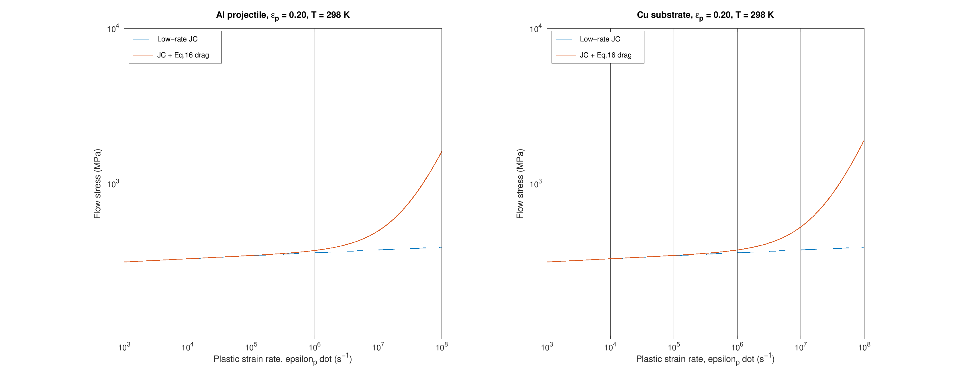
Figure1:Referencestress–strain-ratecurvesgeneratedfromtheimplementedJohnson–Cookplus Eq.16draglaw.Eachpanelcomparesthelow-rateJohnson–Cookbaselinetotheupdatedmodel withtheadditiveEq.16dragtermatthereferencetemperature.
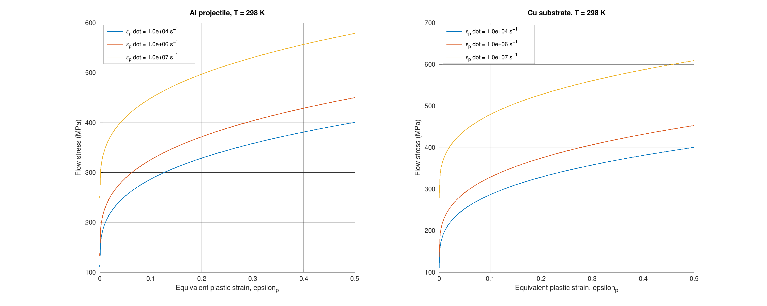
Figure2:Referencestress–straincurvesfromthesameimplementationatthereferencetempera-tureforseveralfixedplasticstrainrates.Theverticalseparationbetweencurvescomesfromthe combinedlow-rateJohnson–CookratefactorandtheadditiveEq.16dragterm.
7

4 Conclusion
ApiecewiseJohnson–Cookconstitutiveframeworkwithaphonon-drag-motivatedhigh-rateincre-menthasbeenreconstructedfromthemodel-developmentlogicestablishedinthepresentstudy. Thefinalformpreservestheconventionallow-rateJCbranch,introducesafixedeffectivetransi-tionstrainratetiedtothematerialscalescT0andbthroughthebridgefactorΛph,andaddsa logarithmicdragincrementthatiscontinuousatthetransition.
Severalmodelingdecisionswereessential.First,thecharacteristicsound-speedscalewaskept constant,whilethetemperaturedependencewasretainedonlyintheshear-modulusfactorG(T). Second,thecriticalstrainratewastreatedasamaterial-dependentconstitutivethresholdrather than a direct function of impact velocity.Third, the high-rate branch was written as the continuing low-rateJCbaselineplusadragincrement,ratherthanasadrag-onlystress. Thispreserved continuityandavoidedthenonphysicalstressdropthatappearswhenthedragtermaloneisused abovethetransition.
Theresultingclosureisnotafullmicroscopicdislocationmodel,butitprovidesacompactand physicallyinterpretableconstitutiveformforhigh-ratecold-sprayimpactsimulations.Itseparates the roles of hardening,low-rate JC rate sensitivity,thermal softening,transition-rate bridging,and high-rate drag amplification in a way that can be implemented directly in the numerical solver and calibratedagainstimpactdata.
References
[1]D.N.Blaschke,E.Mottola,andD.L.Preston.Dislocationdragfromphononwindinan isotropiccrystalatlargevelocities.PhilosophicalMagazine,100(5):571–600,2020.
[2]J. Chen, G. Luo, S. Chen, et al. Approximation of ultra-high strain rate stress-strain relationship fromsphericalprojectileimpactindentation.InternationalJournalofPlasticity,page104656, 2026.
[3]MostafaHassanietal. Materialhardnessatstrainratesbeyond106s−1viahighvelocity microparticleimpactindentation.ActaMaterialia,2019.
[4]G.R.JohnsonandW.H.Cook.Aconstitutivemodelanddataformetalssubjectedtolarge strains,highstrainrates,andhightemperatures.InProceedingsofthe7thInternationalSym-posiumonBallistics,pages541–547,1983.
[5]E.Orowan.Problemsofplasticgliding.ProceedingsofthePhysicalSociety,52(1):8–22,1940.
[6]G.I.TaylorandH.Quinney. Thelatentenergyremaininginametalaftercoldworking. ProceedingsoftheRoyalSocietyofLondon.SeriesA,143(849):307–326,1934.
[7]A.A.Tiamiyu,Y.Sun,K.A.Nelson,andC.A.Schuh.Site-specificstudyofjetting,bonding, andlocaldeformationduringhigh-velocitymetallicmicroparticleimpact. ActaMaterialia, 202:159–169,2021.
[8]H.Zhang,B.Ren,S.Yue,etal.Numericalassessmentofcriticalvelocityandsprayangle windowforsingleparticleadhesionincoldsprayusingperidynamicsimulations.Journalof ThermalSprayTechnology,2025.
[9]A.Zubelewicz.Century-longtaylor–quinneyinterpretationofplasticity-inducedheatingreex- amined.ScientificReports,9:9088,2019.
8

