# 论文：Multi-Garment Net: Learning to Dress 3D People from Images

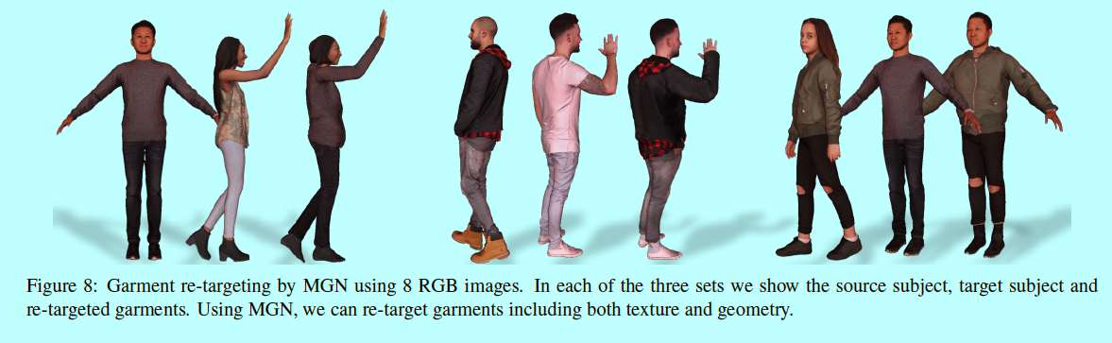

论文目的：根据1-8帧的视频，预测体型以及试衣。可以将衣服和体型适用于新的体型和姿势。MGN的目的在于，为任意形体任意姿势的人穿衣。

前人的工作：Although a few recent methods attempt reconstruction of people with clothing, they lack

realism and control. This limitation is in great part due to the fact that they use a single surface (mesh or voxels) to represent both clothing and body. Hence they can not capture the clothing separately from the subject in the image,let alone map it to a novel body shape.主要是单表面，没有区别身体和衣服。

数据集：有712个3D不同人在不同姿势下穿衣的数据集

总体步骤：

1.从3D数据库学习

2.从图片中重建

具体步骤：

1.分类，区别衣服和皮肤，先对模板进行处理， we first minimize the distance between template and the scan boundaries, while trying to preserve the Laplacian of the template surface.

2.然后基于PCA模型得到衣服

3.最后用SMPL重新给人体穿衣。

成果：

1. 新的方式：分离身体和衣服。
2. 从多个着衣真人中自动记录单个衣服模板。
3. 自顶向下的方法确保预测结果适配输入图片。
4. 展示应用以前不太可能从图片转变成3D衣服贴图和几何。
5. 公布包含SMPL在内的MGN。

两个方面：

1. capture of clothing and body shape
2. data-driven clothing models.

# 论文：Deep Exemplar-based Colorization

论文目的：Given a reference color image, our convolutional neural network directly maps a grayscale image to an output colorized image.给定一个参照颜色图片，通过卷积神经网络直接将灰度图片映射成一个涂色的图片。

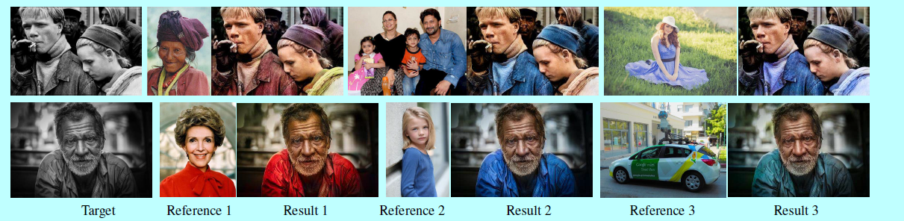

额外功能：

1. 即使输入的参照图片和灰度图没有太多的关系，还是可以较好的上色。
2. 可以用于视频上色。

前人的工作：

These methods can colorize a new photo fully automatically without requiring any scribbles or reference. Unfortunately, none of these methods allow multi-modal colorization .By learning from the data, their models mainly use the dominant colors they have learned, hindering any kind of user controllability. Another drawback is that it must be trained on a very large reference image database containing all potential objects.

不需要草图和参照就可以自动涂色，但是不能多通道涂色，主要用所学的颜色涂色，需要学习太多数据。

步骤：

First, the Similarity sub-net is a pre-processing step which provides the input of the end-to-end colorization network. It measures the semantic similarity between the reference and the target using a VGG-19 network pre-trained on the gray-scale image object recognition task. It provides a more robust and reliable similarity metric to varying semantic image appearances than previous metrics based on low-level features.

Then, the Colorization sub-net provides a more general colorization solution for either similar or dissimilar patch/pixel pairs. 1) Chrominance loss, which encourages the network to selectively propagate the correct reference colors for relevant patch/pixel, satisfying chrominance consistency; 2) Perceptual loss, which enforces a close match between the result and the true color image of high-level feature representations.

贡献：

(1) The first deep learning approach for exemplar-based colorization, which allows controllability and is robust to reference selection.

(2) A novel end-to-end double-branch network architecture which jointly learns faithful local colorization to a meaningful reference and plausible color prediction when a reliable reference is unavailable.

(3) A reference image retrieval algorithm for reference recommendation, with which we can also attain a fully automatic colorization.

(4) A method capable of transferability to unnatural images, even though the network is trained purely on a natural image dataset.

(5) An extension to video colorization.

具体的相关工作：

1. 基于草图的，需要人力以及提供好的草图
2. 基于样例的，需要找到好的样例
3. 基于学习的，需要学习大量数据，没有用户介入，不适定问题
4. 混合模式，从基于草图和基于学习混合

# 论文：SinGAN: Learning a Generative Model from a Single Natural Image

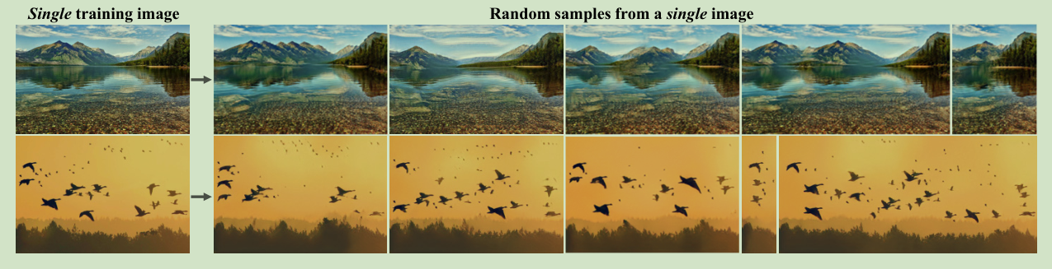

论文目的：Our model is trained to capture the internal distribution of patches within the image, and is then able to generate high quality, diverse samples that carry the same visual content as the image. 从一张图片，生成多种多样的带有相同内容的图片。

与前人不同之处：In contrast to previous single image GAN schemes, our approach is not limited to texture images, and is not conditional.

额外功能：SinGAN can be used in various image manipulation tasks, including: transforming a paint into a realistic photo, rearranging and editing objects in the image, harmonizing a new object into an image, image super-resolution and creating an animation from a single input. 用于将图画转成现实照片，编辑重组图片中的物品，放大分辨率，将新的物体融入到图片中，由一张输入得到动态效果。

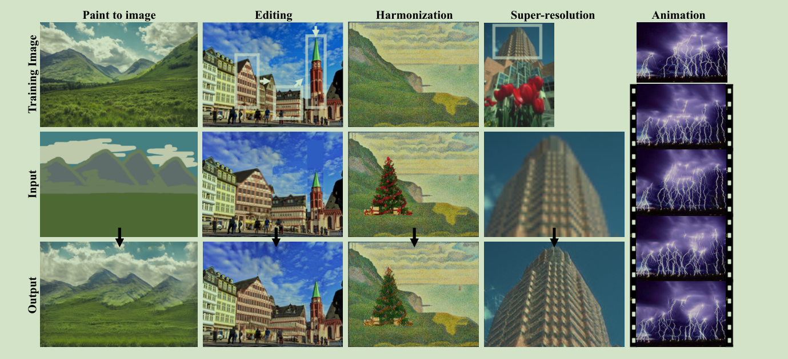

# 论文：Style Transfer for Anime Sketches with Enhanced Residual U-net and Auxiliary Classifier GAN

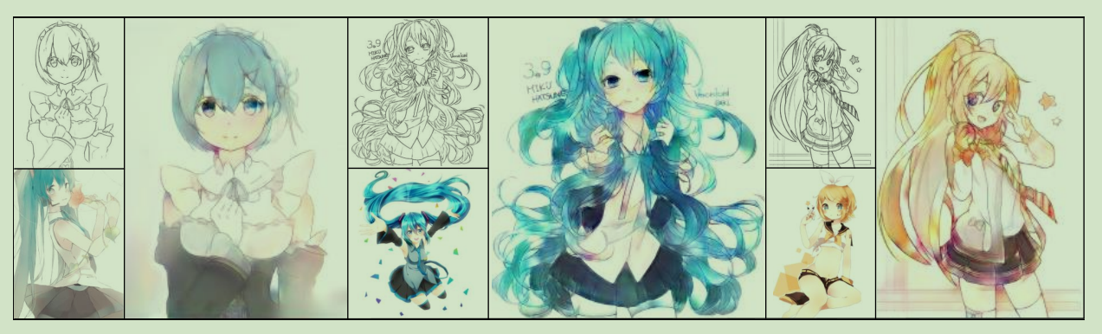

论文目的：为一个素描选择一种风格，自动涂色。

方法：AC-GAN

主要贡献：

1. A feed-forward network to apply the style of a painting to a sketch.
2. An enhanced residual U-net capable of handling paired images with unbalanced information quantity.
3. An effective way to train residual U-net with two additional loss.
4. A discriminator modified from AC-GAN suitable to deal with paintings of different style.

相关工作：

Neural Style Transfer：不能够很好的实现组合一个素描和一个风格图片，结果会奇怪

Pix2Pix：使用cGAN，同时需要语义信息和低级特征

Paintschainer：舍弃cGAN，使用unconditional discriminator，放入素描得到涂色后的图，还可以点选获得更好的效果

自我小结：

第一周主要看了一些论文的前两部分，大概对论文的整体情况有所了解，不涉及具体的实现。选题应该是以第二篇和第四篇为主，即一张灰度图，还有一张风格参照图，生成最终的图片。

这两篇文章的具体实现方法，以及一些专有名词还不是很了解。下周应该主打这两篇文章，了解一些论文中出现的专业术语。