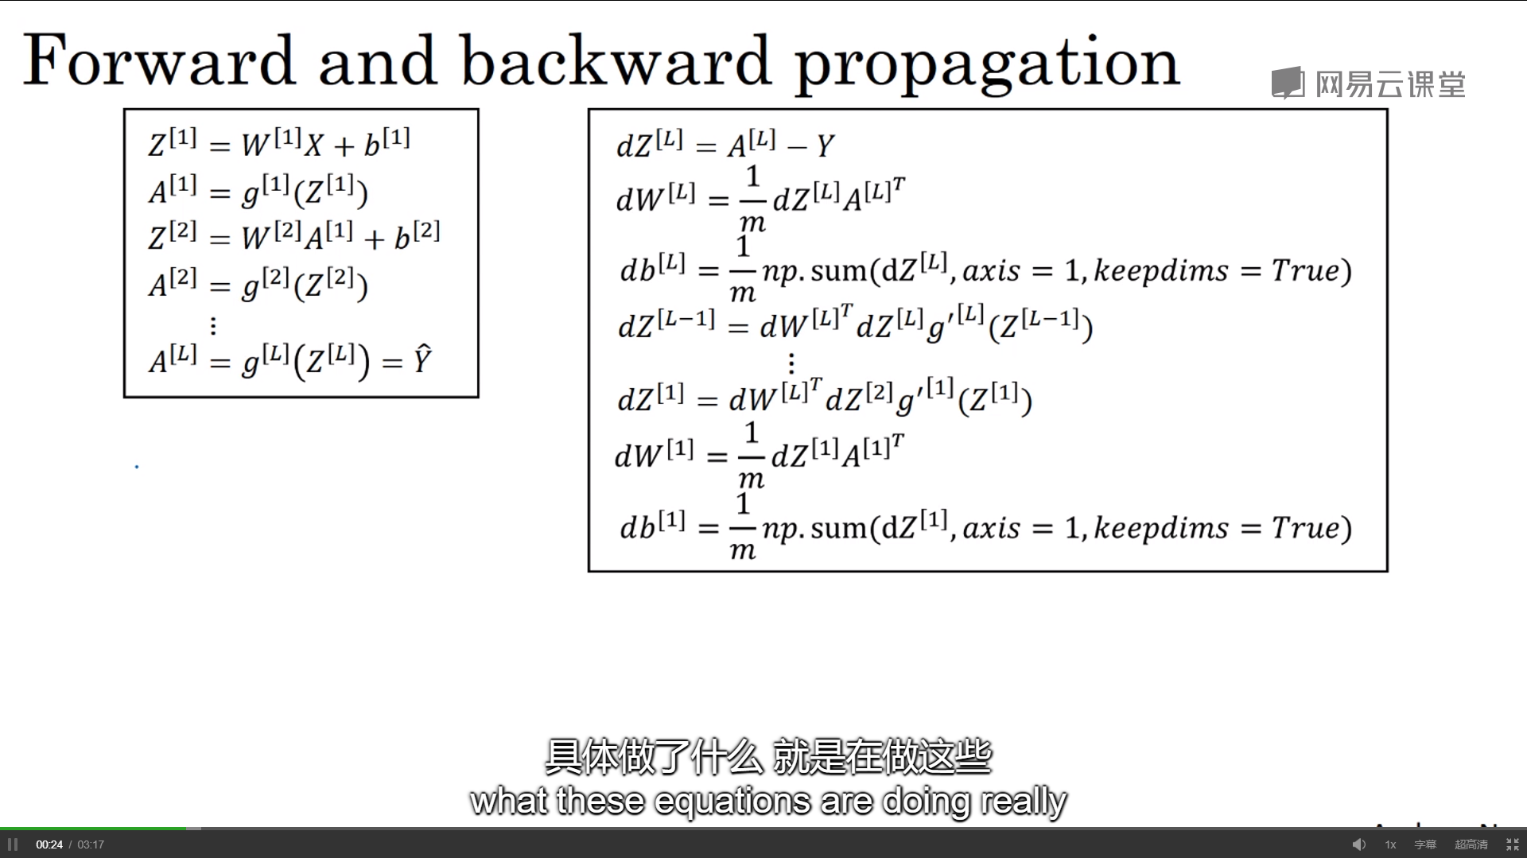

<https://study.163.com/instructor/1029176012.htm>

<https://blog.csdn.net/u013733326/article/details/79827273>

<https://github.com/stormstone/deeplearning.ai>