|  |  |  |  |  |  |  |  |  |  |  |  |  |  |  |  |
| --- | --- | --- | --- | --- | --- | --- | --- | --- | --- | --- | --- | --- | --- | --- | --- |
| 0 | 0 | 0 | 0 | 0 | 0 | 0 | 0 | 0 | 0 | 0 | 0 | 0 | 0 | 0 | 0 |
| 0 | 0.1 | 0.1 | 0.1 | 0.1 | 0.1 | 0.1 | 0.1 | 0.1 | 0.1 | 0.1 | 0.1 | 0.1 | 0.1 | 0.1 | 0 |
| 0 | 0.2 | 0.2 | 0.2 | 0.2 | 0.2 | 0.2 | 0.2 | 0.2 | 0.2 | 0.2 | 0.2 | 0.2 | 0.2 | 0.2 | 0 |
| 0 | 0.4 | 0.4 | 0.4 | 0.4 | 0.4 | 0.4 | 0.4 | 0.4 | 0.4 | 0.4 | 0.4 | 0.4 | 0.4 | 0.4 | 0 |
| 0 | 0.8 | 0.8 | 0.8 | 0.8 | 0.8 | 0.8 | 0.8 | 0.8 | 0.8 | 0.8 | 0.8 | 0.8 | 0.8 | 0.8 | 0 |
| 0 | 1 | 1 | 1 | 1 | 1 | 1 | 1 | 1 | 1 | 1 | 1 | 1 | 1 | 1 | 0 |
| 0 | 0.8 | 0.8 | 0.8 | 0.8 | 0.8 | 0.8 | 0.8 | 0.8 | 0.8 | 0.8 | 0.8 | 0.8 | 0.8 | 0.8 | 0 |
| 0 | 0.4 | 0.4 | 0.4 | 0.4 | 0.4 | 0.4 | 0.4 | 0.4 | 0.4 | 0.4 | 0.4 | 0.4 | 0.4 | 0.4 | 0 |
| 0 | 0.2 | 0.2 | 0.2 | 0.2 | 0.2 | 0.2 | 0.2 | 0.2 | 0.2 | 0.2 | 0.2 | 0.2 | 0.2 | 0.2 | 0 |
| 0 | 0.1 | 0.1 | 0.1 | 0.1 | 0.1 | 0.1 | 0.1 | 0.1 | 0.1 | 0.1 | 0.1 | 0.1 | 0.1 | 0.1 | 0 |
| 0 | 0 | 0 | 0 | 0 | 0 | 0 | 0 | 0 | 0 | 0 | 0 | 0 | 0 | 0 | 0 |

Pretrained Layers

Output:

1 x 224 x 224

Input:

3 x 224 x 224

Convolution +

Dropout +

Batch Normalisation +

ReLu

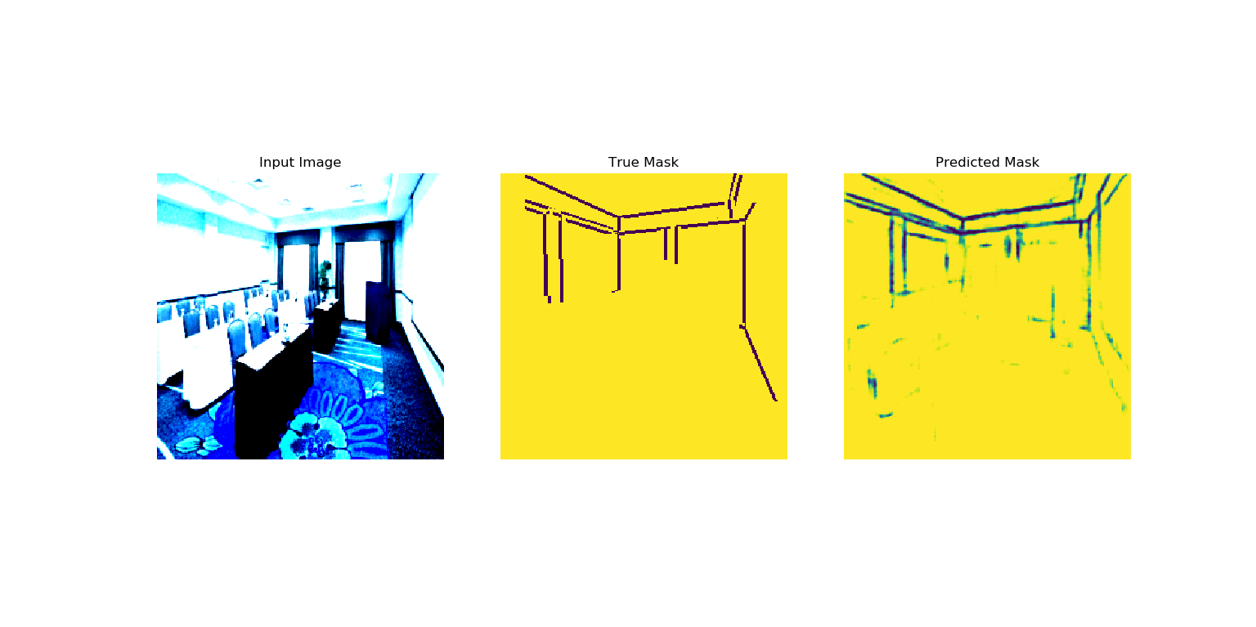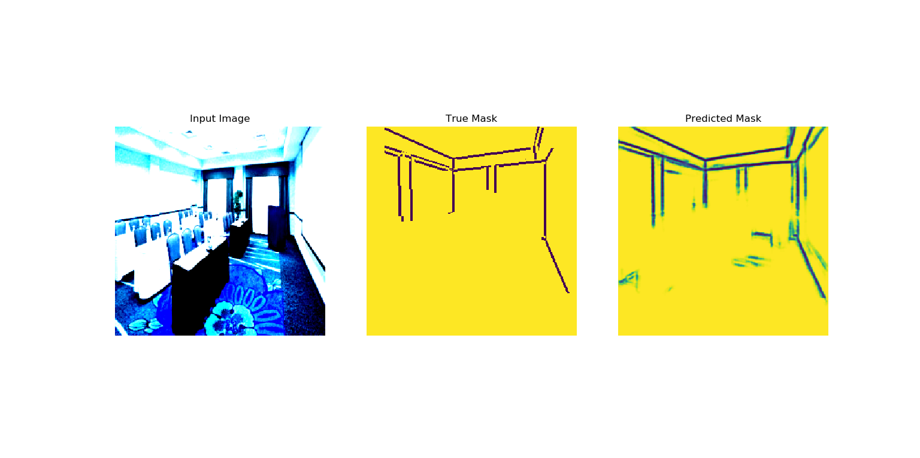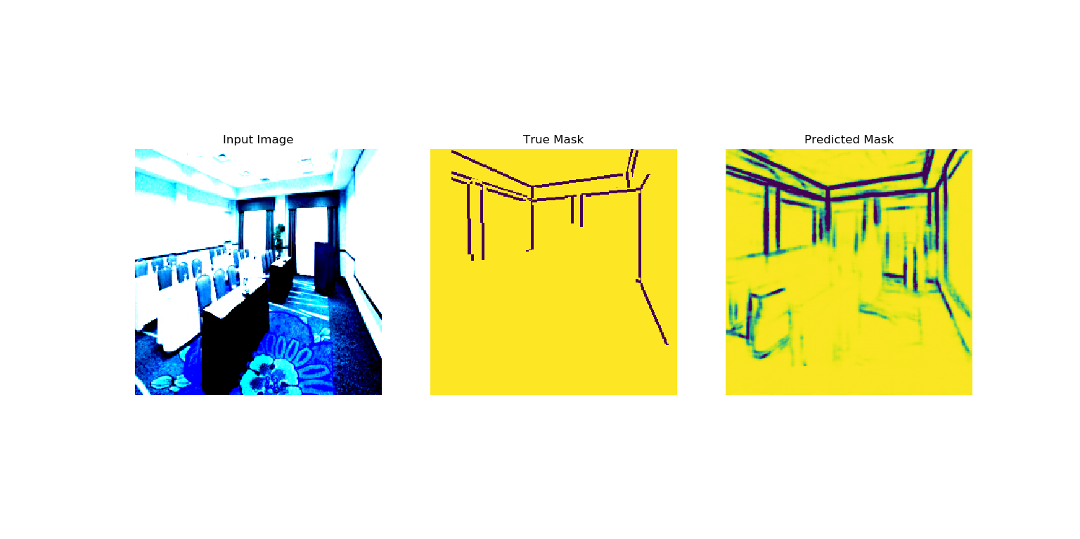

**DenseNet**

**U-Net**

**SegNet**



**Input Image**

**True Mask**

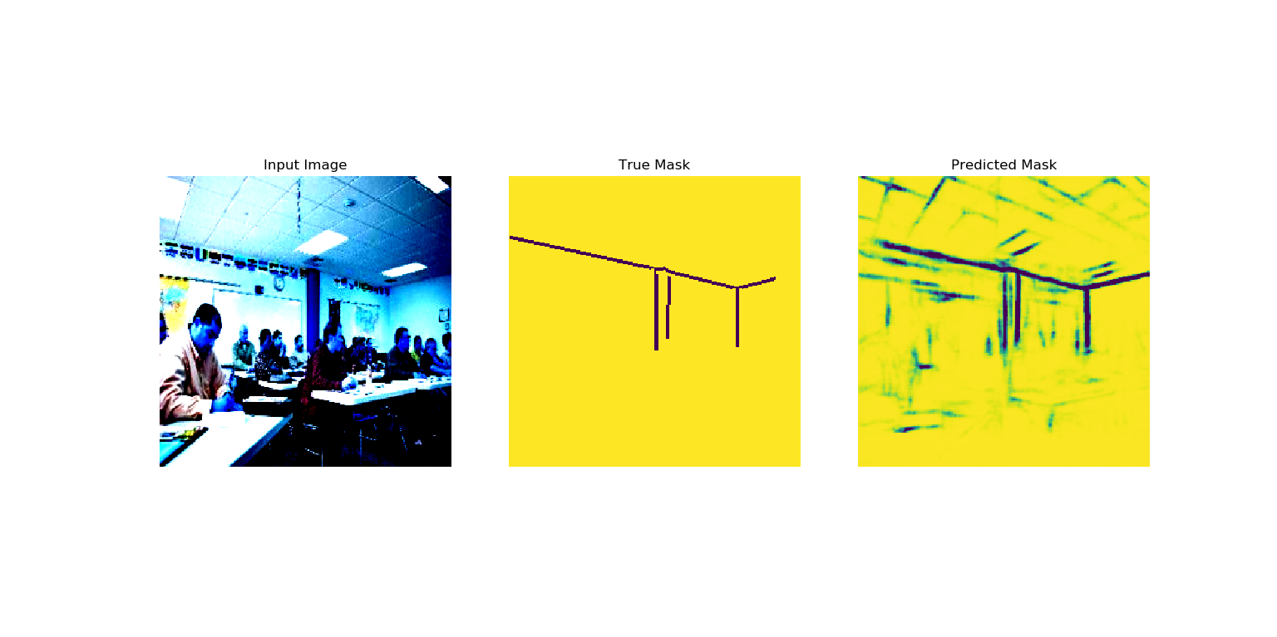

**DenseNet**

**U-Net**

**SegNet**

**Input Image**

**True Mask**

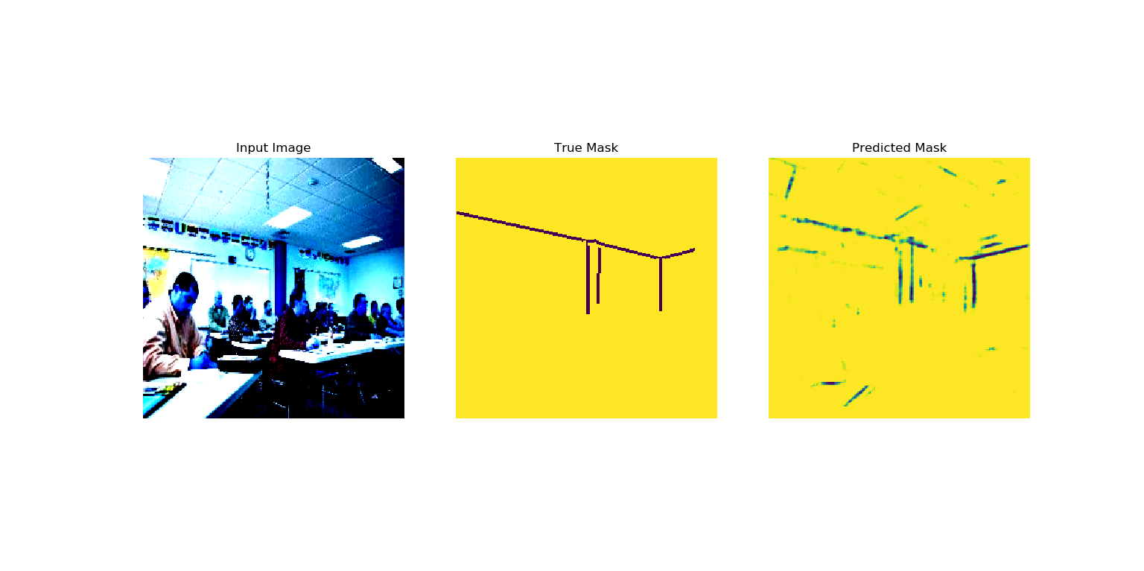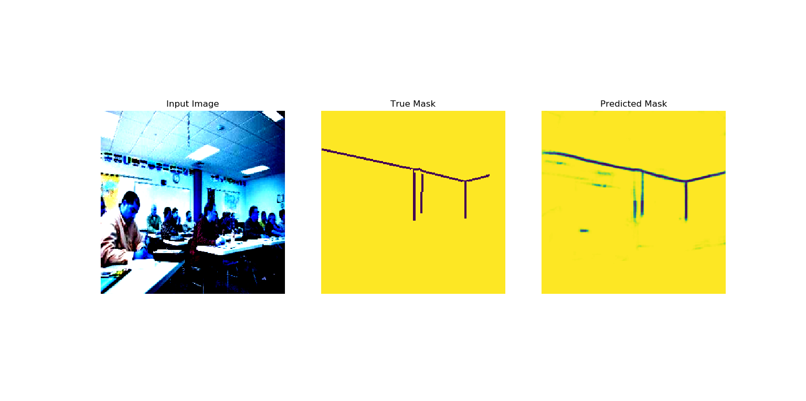

3

64

64

256 x 256

1

64

64

64

256 x 256

Clone and Concatenate

2x2 Max Pool

2x2 Transposed Convolution

3x3 Convolution + Dropout + Batch Normalisation + Leaky ReLU

256

512

512

32 x 32

256

256

128

64 x 64

256

256

256

64 x 64

128

128

128

128 x 128

64

128

128

128 x 128