开发环境:
CentOS7 x64, maya2015x64, CMake, CodeBlocks

命令算法说明:
void peltOverlap::numOverlapUVFaces(const MString& shadingGroup, MStringArray& flattenFaces)
{
MFloatArray face1Orig, face1Vec, face2Orig, face2Vec, center, radius;

// Loop through face i
unsigned int numOverlap = 0;
createBoundingCircle(flattenFaces, center, radius);

for(unsigned int i = 0; i < flattenFaces.length() && numOverlap < fNthPairs; i++)
{
// for face[i]
//construct point and edge(line section) for face[i]
if(!createRayGivenFace(flattenFaces[i], face1Orig, face1Vec))
continue;

// center point of face[i]
const float cui = center[2*i];
const float cvi = center[2*i+1];

//radius of face[i]
const float ri = radius[i];

//test face[i] and other faces
for(unsigned int j = i+1; j < flattenFaces.length() && numOverlap < fNthPairs; j++)
{
// center point of face[j]
const float &cuj = center[2*j];
const float &cvj = center[2*j+1];

//radius of face[j]
const float &rj = radius[j];

// Quick rejection if bounding circles don't overlap
// 如果两个线段的中心点的距离大于它们的外接圆的半径和, 则这两个线段不可能相交
float du = cuj - cui;
float dv = cvj - cvi;
float dsqr = du*du + dv*dv;
if (dsqr >= (ri+rj)*(ri+rj))
continue;

//construct point and edge(line section) for face[j]
if(!createRayGivenFace(flattenFaces[j], face2Orig, face2Vec))
continue;

// test if the two line sections cross with each other
if (checkCrossingEdges(face1Orig, face1Vec, face2Orig, face2Vec)) {
numOverlap++;
appendToResult(flattenFaces[i]);
appendToResult(flattenFaces[j]);
continue;
}
}
}
}

使用说明:
1. 打开场景(例如testuv/test/test.ma),
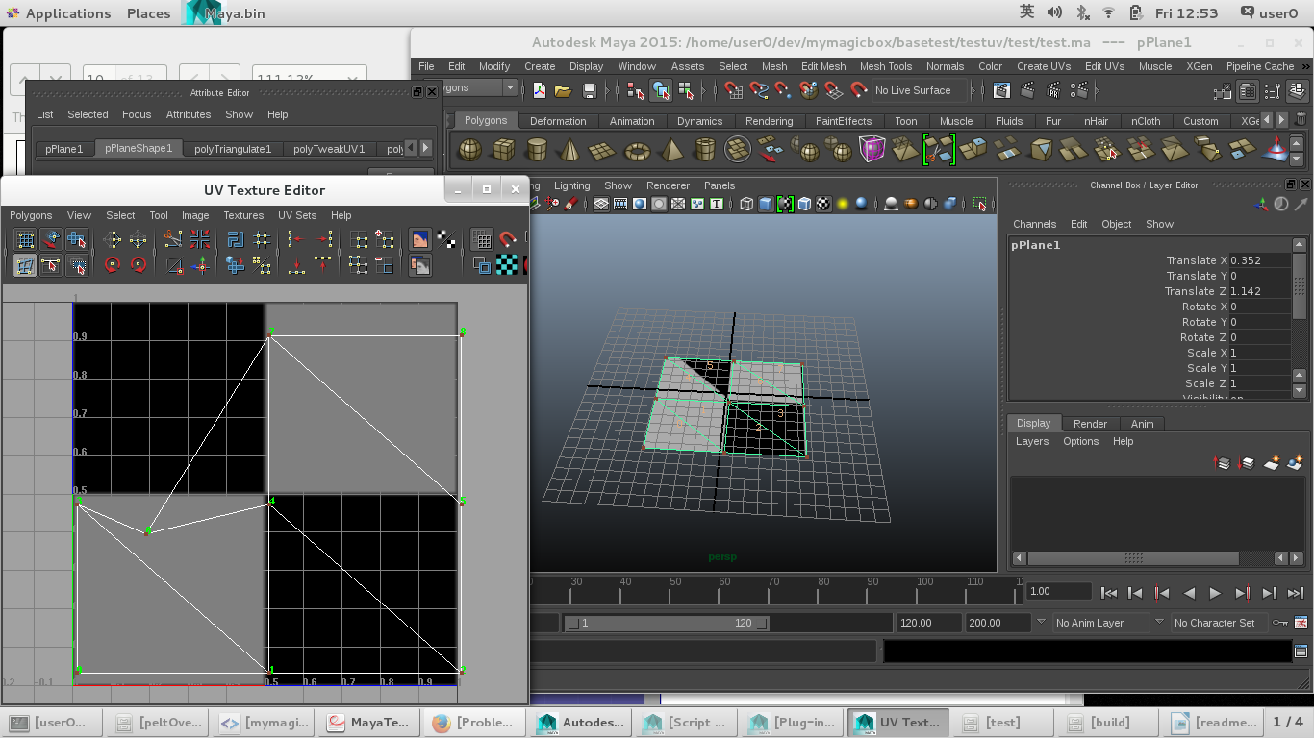
2. 加载插件testuv.so
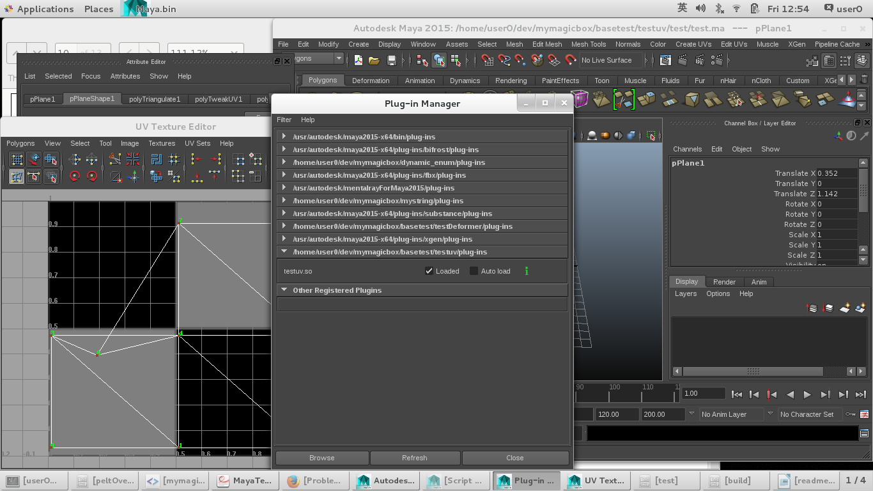

3. source下面的mel函数(这些函数可以在testuv/scripts/utility.mel里找到)
proc string[] getSGsFromShape( string $shape )
{
string $shadingEngines[];
if ( `objExists $shape` )
{
string $dest[] = `listConnections -destination true -source false
-plugs false -type "shadingEngine" $shape`;

// listConnections can return duplicates within its list.
// The select below is a quick trick to avoid dupes in the
// returned array.
if ( size( $dest ) )
{
string $select[] = `ls -sl`;
select -r -ne $dest;
$shadingEngines = `ls -sl`;
select -r $select;
}
}
return $shadingEngines;
}

proc slectTheOverlapFaces(string $sgName)
{
select -cl;
string $faces[] = `peltOverlap $sgName`;
select -cl;
for($f in $faces)
{
select -tgl $f;
}
}
//Example:
//string $shadingEngines[] = getSGsFromShape("pPlaneShape1");
//slectTheOverlapFaces($shadingEngines[0]);

4. 输入参数是mesh名(比如"pPlaneShape1"):
string $shadingEngines[] = getSGsFromShape("pPlaneShape1");
slectTheOverlapFaces($shadingEngines[0]);

5. 结果是如果uv有穿插, 那些面片就会被选择
