开发环境:
Win7 x64, maya2014x64, MSVC2010

命令算法说明:
用RTT(render to texture)的方法把图片渲染到纹理, 同时用camera的旋转值控制图片的旋转.
具体函数是:quadricShapeUI::test2_rtt()
void quadricShapeUI::test2_rtt(const quadricGeom *geom)const
{
glPushAttrib(GL_ALL_ATTRIB_BITS);

//仅初始化一次glew
static bool rtt_inited = false;
if( !rtt_inited )// initialize RTT buffers if it is not initialized
{
if (GLEW_OK != glewInit())
{
__debug("Couldn't initialize GLEW");
}
initRTTFrameBuffer();
rtt_inited = true;
}

//渲染图片到纹理
glPushAttrib(GL_ALL_ATTRIB_BITS);
renderTeapotScene(geom->camRotateX, geom->camRotateY); // Render our teapot scene into our frame buffer
glPopAttrib();

//把纹理贴到面片上
glBindTexture(GL_TEXTURE_2D, fbo_texture); // Bind our frame buffer texture

glNormal3f( 0.0f, 0.0f, 1.0f);
glBegin(GL_QUADS);

glTexCoord2f(0.0f, 0.0f);
glVertex3f(-10.0f, -10.0f, -2.0f); // The bottom left corner

glTexCoord2f(1.0f, 0.0f);
glVertex3f(10.0f, -10.0f, -2.0f); // The bottom right corner

glTexCoord2f(1.0f, 1.0f);
glVertex3f(10.0f, 10.0f, -2.0f); // The top right corner

glTexCoord2f(0.0f, 1.0f);
glVertex3f(-10.0f, 10.0f, -2.0f); // The top left corner
glEnd();

glBindTexture(GL_TEXTURE_2D, 0); // Unbind any textures

glPopAttrib();
}
也尝试过修改uv去做(见函数quadricShapeUI::test1_manipulateUV()),但结果不好.
使用说明:
0. 复制testProjection.mod到'我的文档/maya/2015-x64/modules'目录下, 并修改字符串
E:/dev/mymagicbox/basetest/testProjection为插件所在的根目录
以及
E:/dev/mymagicbox/basetest/testProjection/bin为根目录下的bin目录

1. 打开场景(例如testProjection/test/test_proj.ma),加载插件testProjection.mll
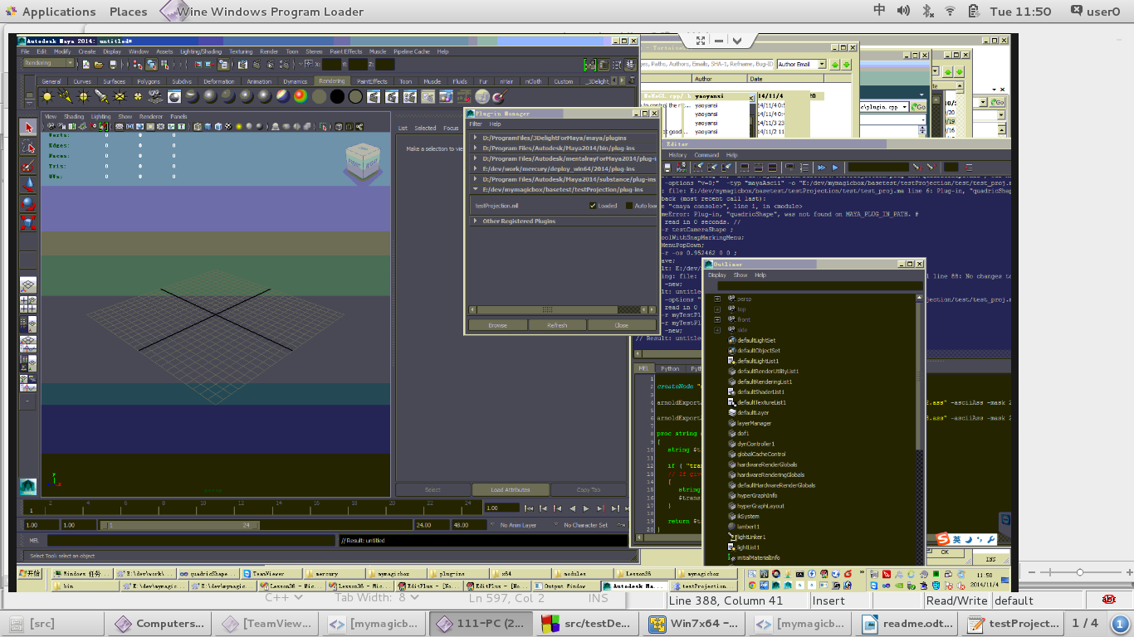
2. 运行命令, createNode "quadricShape", 创建一个物体myTestPlane
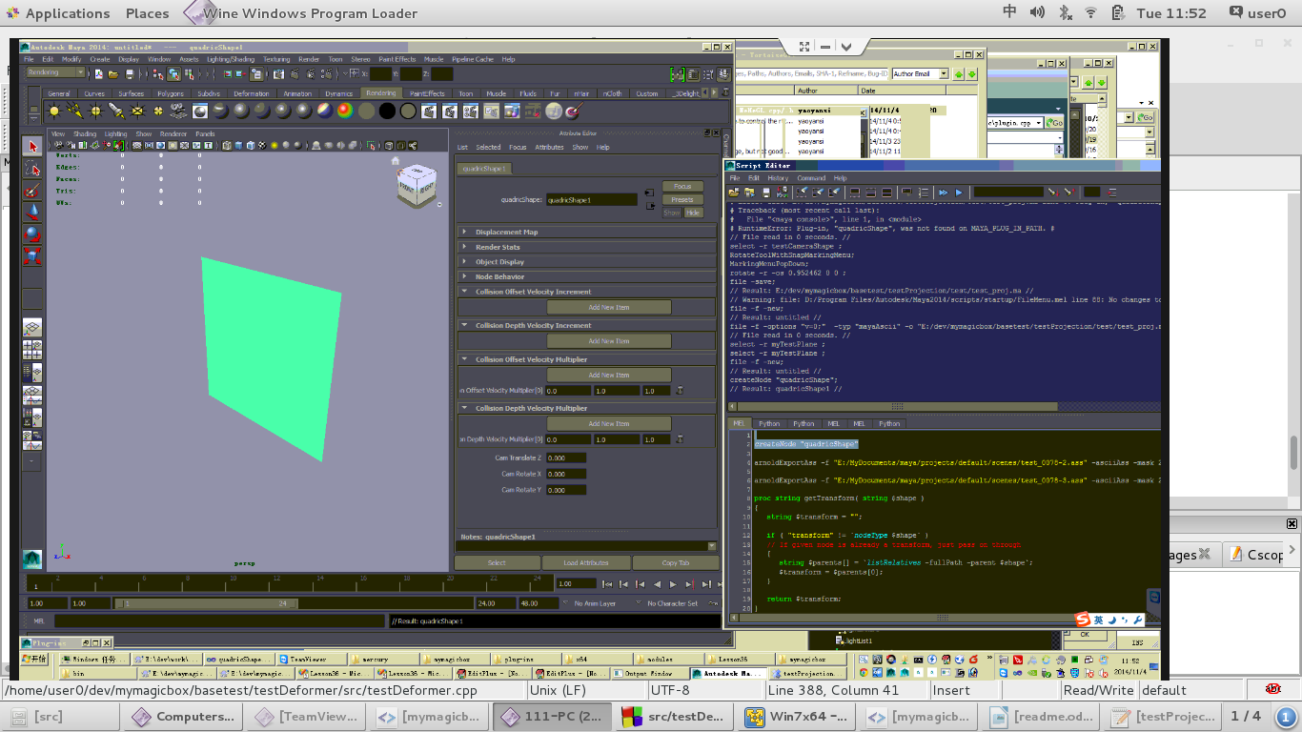

3. 给物体上贴一个带纹理的材质
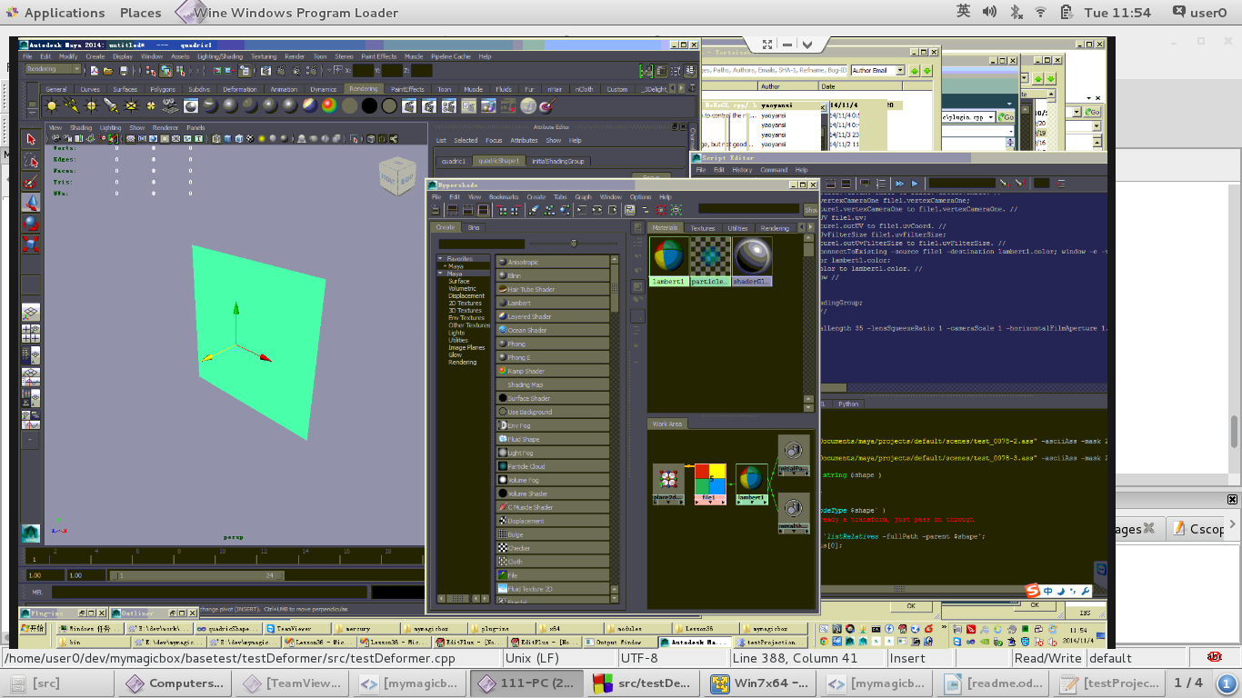

4. 创建一个相机testCamera.
把testCamera.rotateX连到myTestPlaneShape.camRotateX;
把testCamera.rotateY连到myTestPlaneShape.camRotateY
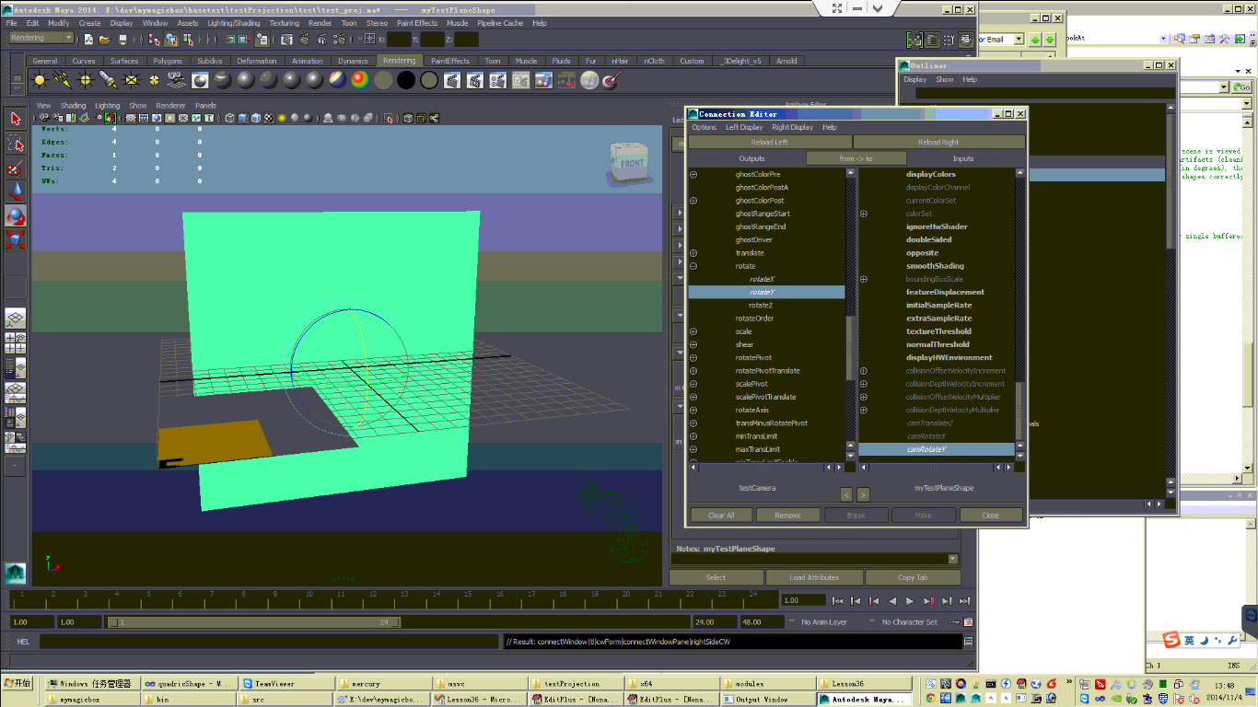

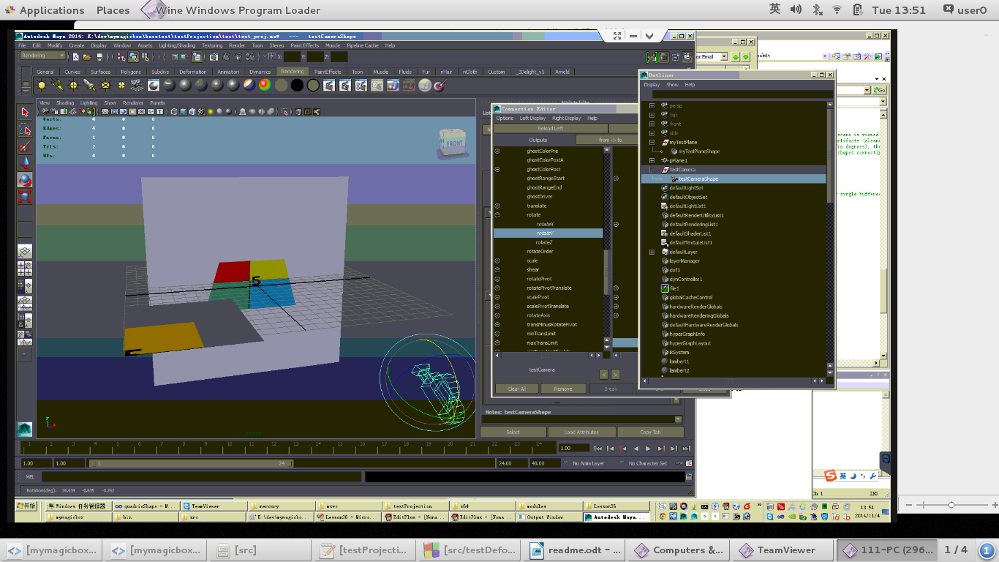
5. 选择testCamera并旋转, 就可以看到效果

