如何用多个driver mesh控制另一个mesh
- 建立3个driver mesh pShpere1, pSphere2, pSphere3
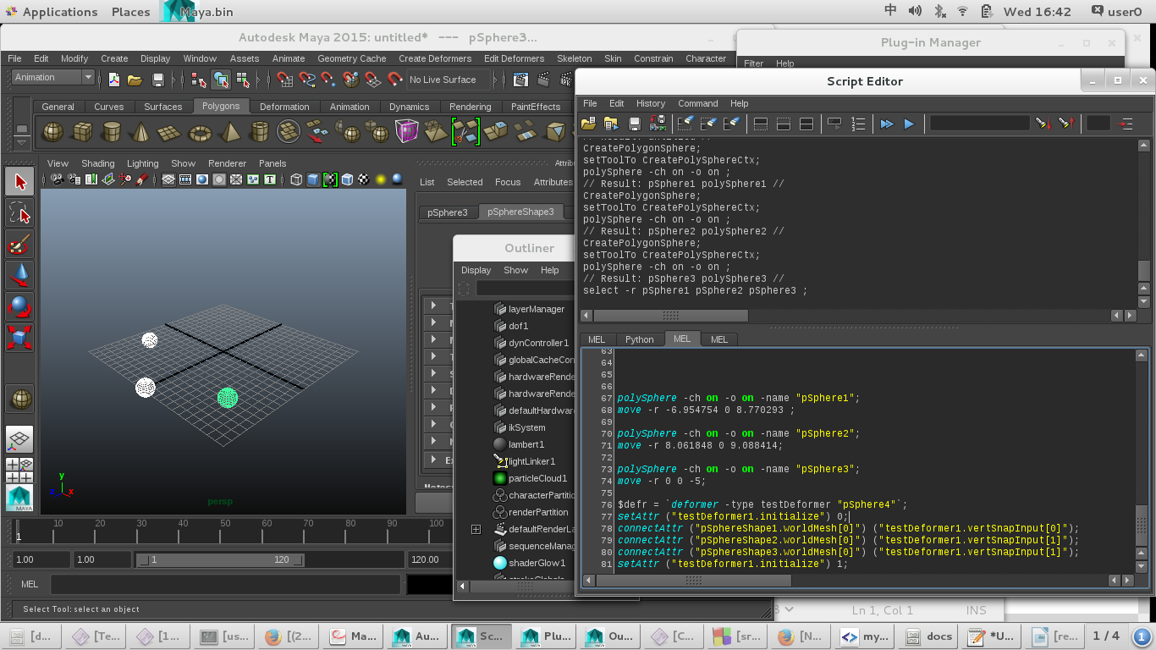
建立1个driven mesh pShpere4
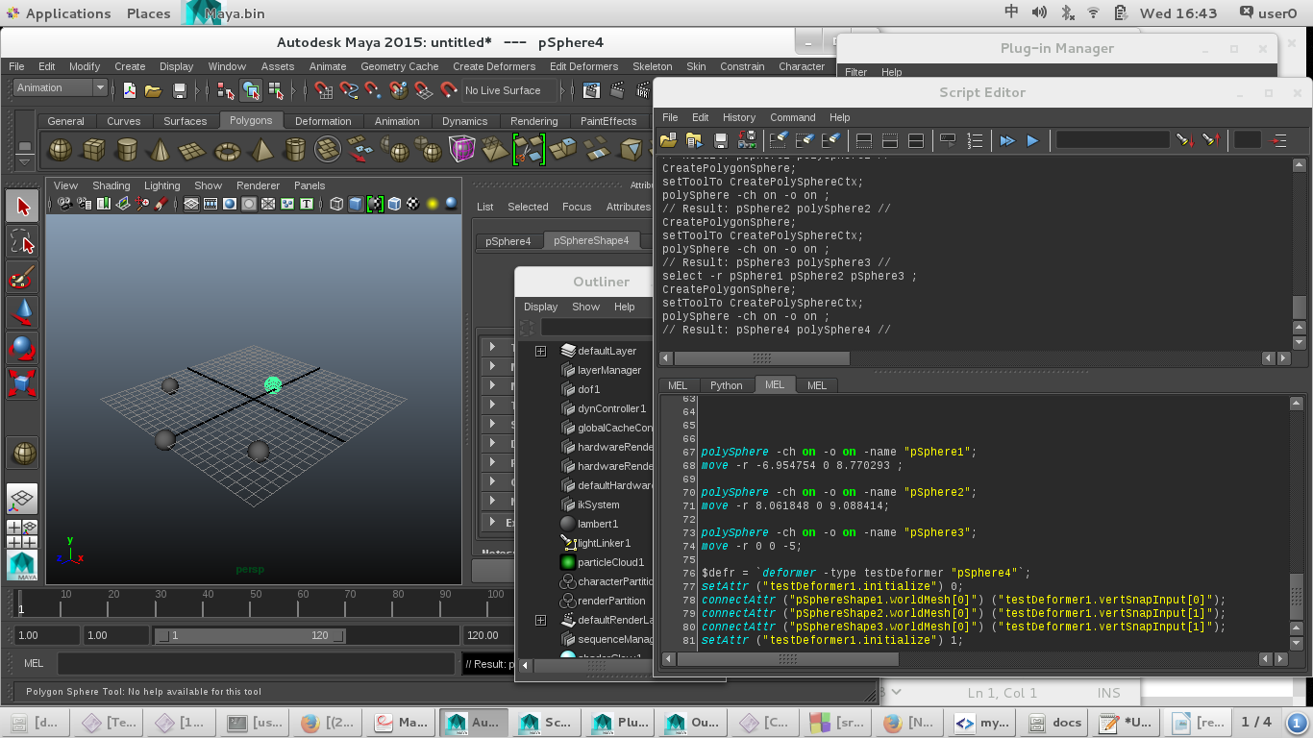
- 执行命令:
$defr = `deformer -type testDeformer "pSphere4"`;
setAttr ("testDeformer1.initialize") 0;
connectAttr ("pSphereShape1.worldMesh[0]") ("testDeformer1.vertSnapInput[0]");
connectAttr ("pSphereShape2.worldMesh[0]") ("testDeformer1.vertSnapInput[1]");
connectAttr ("pSphereShape3.worldMesh[0]") ("testDeformer1.vertSnapInput[2]");
setAttr ("testDeformer1.initialize") 1;
结果:
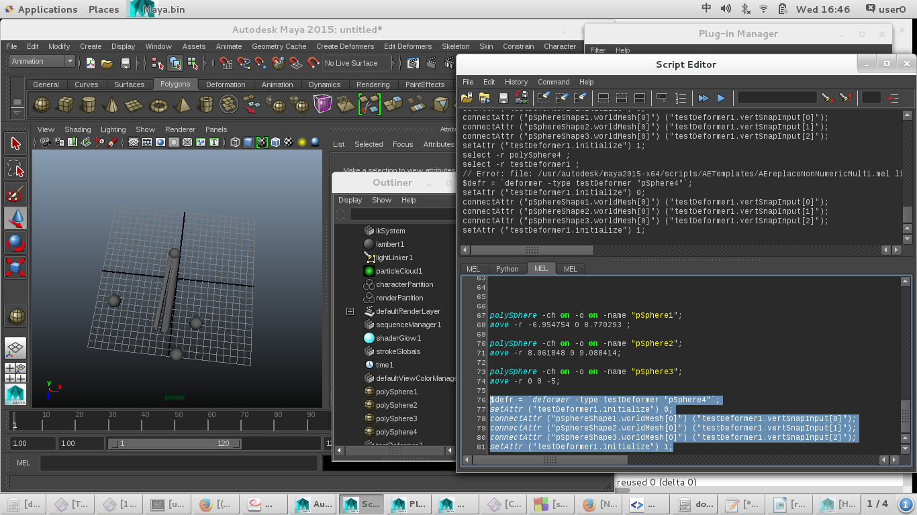
移动driver mesh pSphere3后的结果:

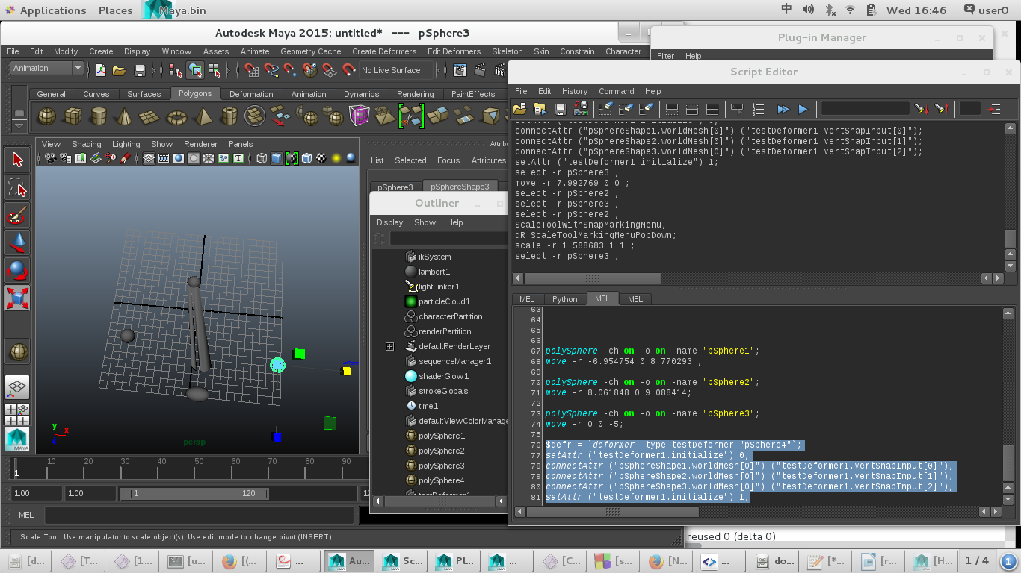
放缩driver mesh pSphere2
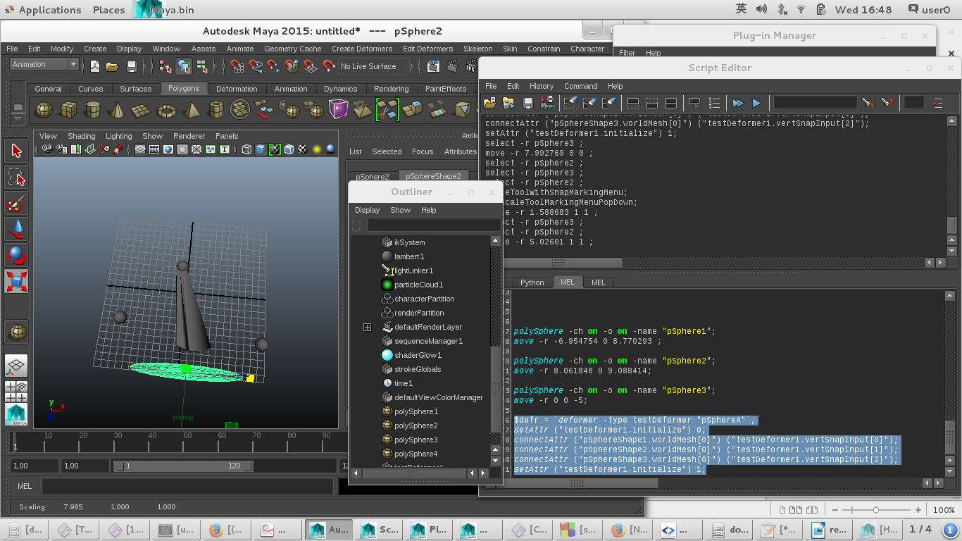
场景里只有1一个testDeform节点:
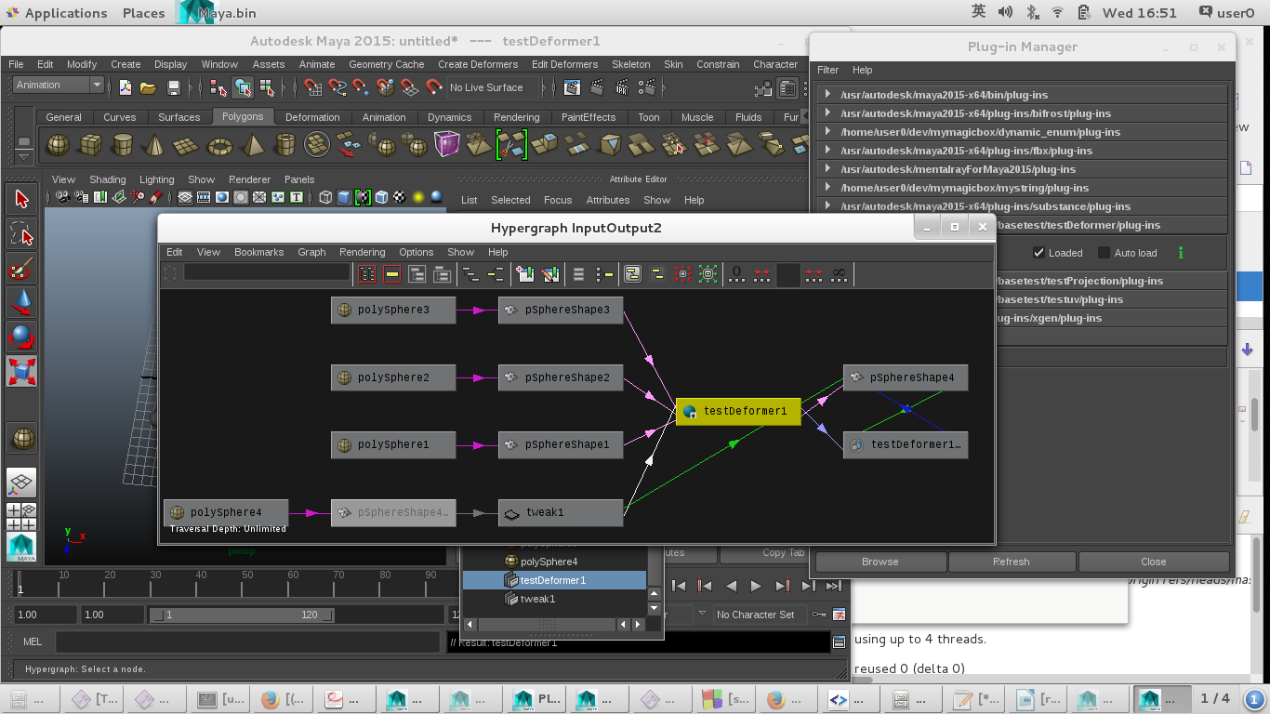
详细可参考/test/test_4spheres.ma

