**Read Me**

Junyao ZHANG

**Q1:**

Because we want to visualize the data to show Total parking meters per AREA, so I choose to use Column Chart to visualize the data by Tableau. And before visualizing, we first need to do the preprocessing.

**Step 1:**

Dealing with the data and choose the variables we will use.

Python was used in this part (but as a new learner, my code seems to be a little complex), the attachment is **pre_operate.py**.

The thought of my code is that I put the original data (I named it **1.xls**) which is downloaded from the website under **E** disk, and after running the code, we will get two more excel files, which are **2.xls** and **3.xls**. In 2.xls, we select the needed data, which are POST_ID, JURISDICTI, ON_OFF_STR, OSP_ID, STREETNAME and LOCATION. The reason is that if we want to get the total parking meters per AREA, the first thing we need to do is to identify each AREA, and this time I choose to use these two identifiers: (1) whether the parking meter is on the street (ON and OFF); (2) whether the parking meter is on the port (PORT and SFMTA).

So in **3.xls**, there are four sheets, they are PORT&ON, PORT&OFF, SFMTA&ON and SFMTA&OFF.

[For the later steps, we need to use a function to calculate the latitude and longitude separately. But don’t forget to change the type of them to number.]

**Step 2:**

In this part, I use PowerPivot in Excel (name it **4.xls**) to count the total number of each area, and calculate the average value of each area’s latitude and longitude.

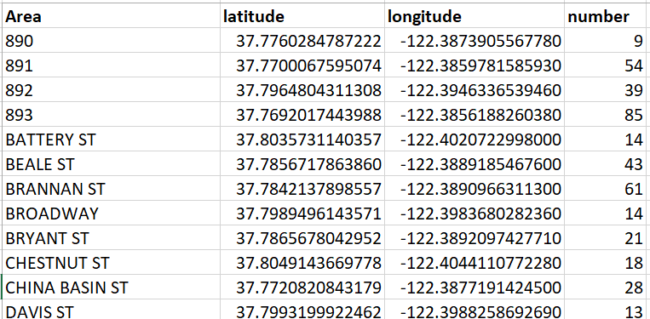

**Step 3：**

Use tableau to visualize the data.

The attachment is **total parking meters per area.twb** and **total parking meters per area.pdf**.

[Pdf only shows a part of the whole map.]

**Q2:**

I am ready to work on python, and I will try my best to learn it during this semester. I quite enjoying learning new things, and I believe I can have adequate time and energy to work on it :).

And I have worked on the HTML/CSS/JavaScript projects on database class in my second year of university. And I am quite interested in this part, especially for front-end. I think I have a good sense in designing and programming.

Thanks for your reading!